

NATIONAL UNIVERSITY OF MODERN LANGUAGES

VISUAL PROGRAMMING Final Lab Exam

NAME: Abdul Rafay
Roll No: FL23791
PROGRAM: BSSE (6th Semester)
COURSE: Visual Programming
SUBMITTED TO: Sir M Irtaza

DATE: 5/4/2026 DAY: Tuesday

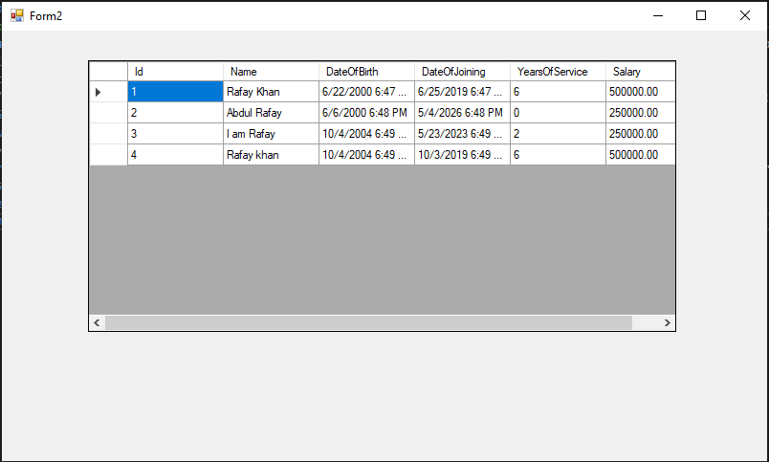
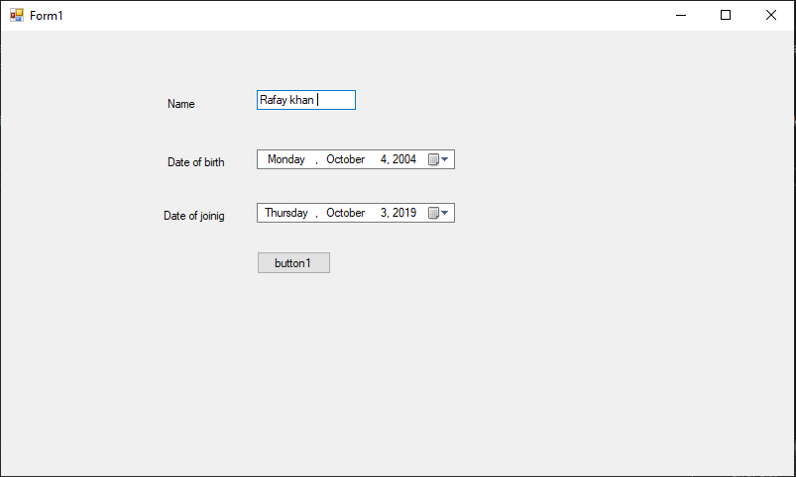
Form Layouts

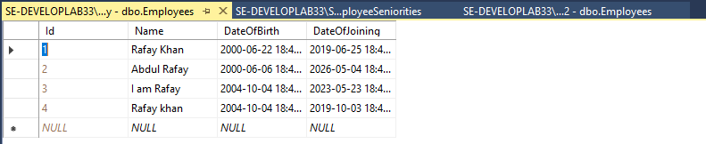
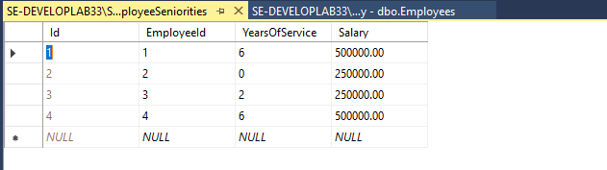
Sql Workbench Data

Form1.cs
using System;
using System.Collections.Generic;
using System.ComponentModel;
using System.Data;
using System.Drawing;
using System.Linq;
using System.Text;
using System.Threading.Tasks;
using System.Windows.Forms;

namespace WindowsFormsApp3
{
public partial class Form1 : Form
{
public Form1()
{
InitializeComponent();
}

private void Form1_Load(object sender, EventArgs e)
{

}

private void label1_Click(object sender, EventArgs e)
{

}

private void button1_Click(object sender, EventArgs e)
{
using (var db = new AppDbContext())
{
db.Database.CreateIfNotExists();
var emp = new Employee
{
Name = textBox1.Text,
DateOfBirth = dateTimePicker1.Value,
DateOfJoining = dateTimePicker2.Value
};

db.Employees.Add(emp);
db.SaveChanges();

var seniority = EmployeeService.CalculateSeniority(emp);

db.EmployeeSeniorities.Add(seniority);
db.SaveChanges();

MessageBox.Show("Employee Saved Successfully!");

Form2 form2 = new Form2();
form2.Show();
}
}
}
}

Form 2.cs
using System;
using System.Linq;
using System.Windows.Forms;

namespace WindowsFormsApp3
{
public partial class Form2 : Form
{
public Form2()
{
InitializeComponent();
}

private void Form2_Load(object sender, EventArgs e)
{
using (var db = new AppDbContext())
{
var data = db.Employees
.Select(emp => new
{
emp.Id,
emp.Name,
emp.DateOfBirth,
emp.DateOfJoining,

Years = emp.Seniorities.Select(s => s.YearsOfService).FirstOrDefault(),
Salary = emp.Seniorities.Select(s => s.Salary).FirstOrDefault()
})
.ToList();

dataGridView1.DataSource = data;
}
}

private void dataGridView1_CellContentClick(object sender, DataGridViewCellEventArgs e)
{

}
}
}

Employee.cs
using System;
using System.Collections.Generic;
using System.ComponentModel.DataAnnotations;

public class Employee
{
[Key]
public int Id { get; set; }
public string Name { get; set; }
public DateTime DateOfBirth { get; set; }
public DateTime DateOfJoining { get; set; }
public virtual ICollection<EmployeeSeniority> Seniorities { get; set; }
}

Employee Seniority.cs
using System.ComponentModel.DataAnnotations;
using System.ComponentModel.DataAnnotations.Schema;

public class EmployeeSeniority
{
[Key]
public int Id { get; set;
[ForeignKey("Employee")]
public int EmployeeId { get; set;
public int YearsOfService { get; set;
public decimal Salary { get; set;
public virtual Employee Employee { get; set; }
}

Employee Service.cs
using System;

public class EmployeeService
{
public static EmployeeSeniority CalculateSeniority(Employee emp)
{
int years = DateTime.Now.Year - emp.DateOfJoining.Year;

if (emp.DateOfJoining > DateTime.Now.AddYears(-years))
years--;

decimal salary = 0;

if (years >= 5)
salary = 500000;
else
salary = 250000;

return new EmployeeSeniority
{
EmployeeId = emp.Id,
YearsOfService = years,
Salary = salary
};
}
}

