

NATIONAL UNIVERSITY OF MODERN LANGUAGES

Human Computer Interaction Lab Report - 8

NAME: M Abdul Rafay
ROLL NO: FL23791
PROGRAM: BSSE (5th Semester)
COURSE: Human Computer Interaction
SUBMITTED TO: Sir Khateeb

DATE: Sept, 27/2025 DAY: SATURDAY
- Task No 1: Make the cube rotate automatically (without key presses) using the idle function.

#include <stdio.h>
#include <math.h>
#ifdef __APPLE__
#include <GLUT/glut.h>
#else
#include <GL/glut.h>

double rotate_y = 0;
double rotate_x = 0;

// Cube color (starts white)
GLfloat cubeColor[3] = { 1.0f, 1.0f, 1.0f };

void display();
void specialKeys(int key, int x, int y);
void keyboard(unsigned char key, int x, int y);
void idle();

void display() {
glClear(GL_COLOR_BUFFER_BIT | GL_DEPTH_BUFFER_BIT);
glLoadIdentity();

// Rotate automatically
glRotatef(rotate_x, 1.0, 0.0, 0.0);
glRotatef(rotate_y, 0.0, 1.0, 0.0);

// Draw cube with selected color
glBegin(GL_QUADS);

// FRONT face
glColor3f(cubeColor[0], cubeColor[1], cubeColor[2]);
glVertex3f(-0.5, -0.5, 0.5);
glVertex3f(0.5, -0.5, 0.5);
glVertex3f(0.5, 0.5, 0.5);
glVertex3f(-0.5, 0.5, 0.5);

// BACK face
glColor3f(cubeColor[0] * 0.8, cubeColor[1] * 0.8, cubeColor[2] * 0.8);
glVertex3f(-0.5, -0.5, -0.5);
glVertex3f(-0.5, 0.5, -0.5);
glVertex3f(0.5, 0.5, -0.5);
glVertex3f(0.5, -0.5, -0.5);

// LEFT face
glColor3f(0.0, cubeColor[1], cubeColor[2]);
glVertex3f(-0.5, -0.5, -0.5);
glVertex3f(-0.5, -0.5, 0.5);
glVertex3f(-0.5, 0.5, 0.5);
glVertex3f(-0.5, 0.5, -0.5);

// RIGHT face
glColor3f(cubeColor[0], 0.0, cubeColor[2]);
glVertex3f(0.5, -0.5, -0.5);
glVertex3f(0.5, 0.5, -0.5);
glVertex3f(0.5, 0.5, 0.5);
glVertex3f(0.5, -0.5, 0.5);

// TOP face
glColor3f(cubeColor[0], cubeColor[1], 0.0);
glVertex3f(-0.5, 0.5, -0.5);
glVertex3f(-0.5, 0.5, 0.5);
glVertex3f(0.5, 0.5, 0.5);
glVertex3f(0.5, 0.5, -0.5);

// BOTTOM face
glColor3f(0.0, cubeColor[1], cubeColor[2]);
glVertex3f(-0.5, -0.5, -0.5);
glVertex3f(0.5, -0.5, -0.5);
glVertex3f(0.5, -0.5, 0.5);
glVertex3f(-0.5, -0.5, 0.5);

glEnd();
glFlush();
glutSwapBuffers();
}
void specialKeys(int key, int x, int y) {
if (key == GLUT_KEY_RIGHT)
rotate_y += 5;
else if (key == GLUT_KEY_LEFT)
rotate_y -= 5;
else if (key == GLUT_KEY_UP)
rotate_x += 5;
else if (key == GLUT_KEY_DOWN)
rotate_x -= 5;

glutPostRedisplay();
}
void keyboard(unsigned char key, int x, int y) {
switch (key) {
case 'r': case 'R': // Red
cubeColor[0] = 1.0; cubeColor[1] = 0.0; cubeColor[2] = 0.0;
break;
case 'g': case 'G': // Green
cubeColor[0] = 0.0; cubeColor[1] = 1.0; cubeColor[2] = 0.0;
break;
case 'b': case 'B': // Blue
cubeColor[0] = 0.0; cubeColor[1] = 0.0; cubeColor[2] = 1.0;
break;
case 'y': case 'Y': // Yellow
cubeColor[0] = 1.0; cubeColor[1] = 1.0; cubeColor[2] = 0.0;
break;
case 27: // ESC to exit
exit(0);
break;
}
glutPostRedisplay();
}
void idle() {
rotate_x += 0.2; // speed for X-axis
rotate_y += 0.3; // speed for Y-axis
glutPostRedisplay();
}
int main(int argc, char* argv[]) {
glutInit(&argc, argv);
glutInitDisplayMode(GLUT_DOUBLE | GLUT_RGB | GLUT_DEPTH);
glutInitWindowSize(600, 600);
glutCreateWindow("Rotating Color Cube");

glEnable(GL_DEPTH_TEST);

glutDisplayFunc(display);
glutSpecialFunc(specialKeys);
glutKeyboardFunc(keyboard);
glutIdleFunc(idle); // <-- automatic rotation

glClearColor(0, 0, 0, 1); // background black

glutMainLoop();
return 0;
}

Output :
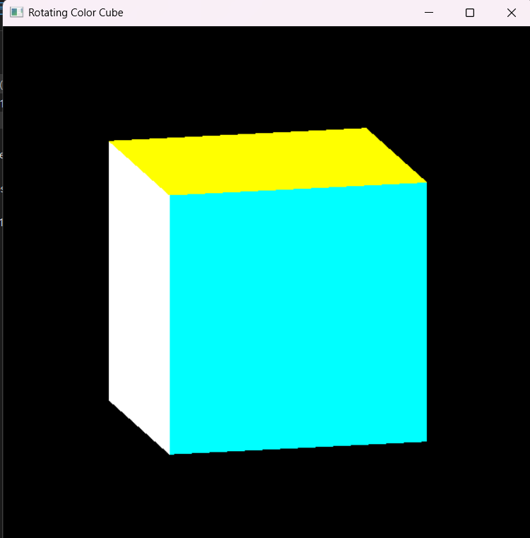

Task No 2 : Change Cube Color with Keyboard Key Press

#include <GL/glut.h>
GLfloat angle = 0.0f;

void Draw() {
glClear(GL_COLOR_BUFFER_BIT);
glColor3f(1.0, 1.0, 1.0);

glPushMatrix();
glTranslatef(0.5f, 0.5f, 0.0f); // move pivot to center
glRotatef(angle, 0.0f, 0.0f, 1.0f); // rotate around Z-axis
glBegin(GL_LINES);
glVertex2f(-0.3f, 0.0f);
glVertex2f(0.3f, 0.0f);
glEnd();
glPopMatrix();

glFlush();
angle += 0.1f; // rotation speed
if (angle > 360.0f) angle -= 360.0f;

glutPostRedisplay();
}

void Initialize() {
glClearColor(0.0, 0.0, 0.0, 1.0);
glMatrixMode(GL_PROJECTION);
glLoadIdentity();
glOrtho(0.0, 1.0, 0.0, 1.0, -1.0, 1.0);
}

int main(int argc, char** argv) {
glutInit(&argc, argv);
glutInitDisplayMode(GLUT_SINGLE | GLUT_RGB);
glutInitWindowSize(300, 300);
glutCreateWindow("Rotating Line Animation");
Initialize();
glutDisplayFunc(Draw);
glutMainLoop();
return 0;
}
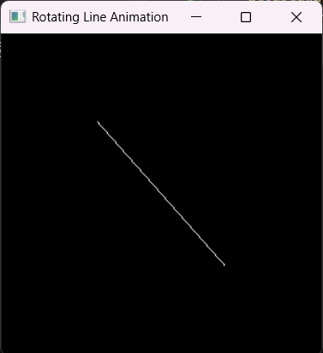
Output:

