

NATIONAL UNIVERSITY OF MODERN LANGUAGES

Artificial Intelligence Lab Report No - 1

NAME: Abdul Rafay
ROLL NO: FL23791
PROGRAM: BSSE (6th Semester)
COURSE: Artificial Intelligence
SUBMITTED TO: Mam Amna Sajjad

DATE: 2 Feb 2026 DAY: Thursday

AI Lab Task – Python String Operations
Objective
To learn basic Python string operations including:
- Printing a statement
- Counting characters
- Converting to uppercase
- Converting to lowercase
- Printing characters one by one
- Printing a statement in reverse
Introduction
In this lab task, we used Python programming in Google Colab to perform different operations on strings. Strings are sequences of characters and are widely used in Artificial Intelligence for text processing and data handling.
Lab Task Code
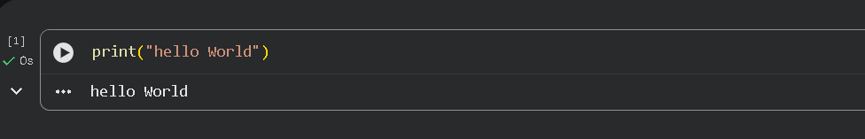
1. Print a Statement
2. Count Number of Characters
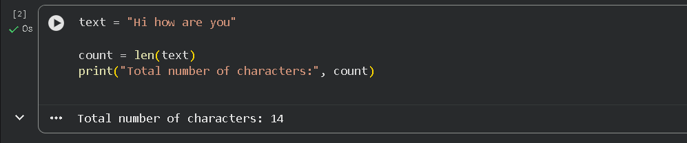
3. Convert to Uppercase
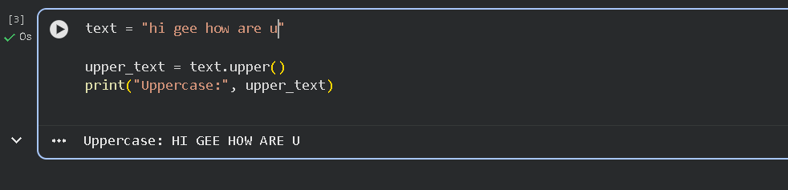
4. Convert to Lowercase
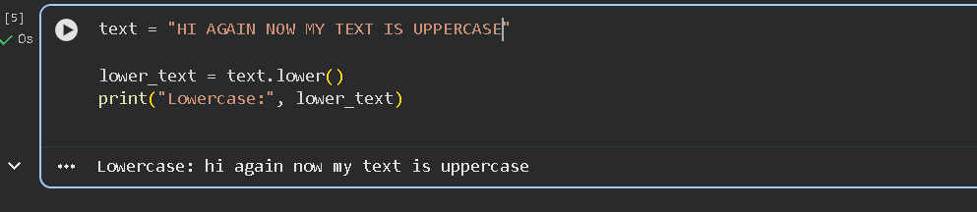
5. Print Characters One by One
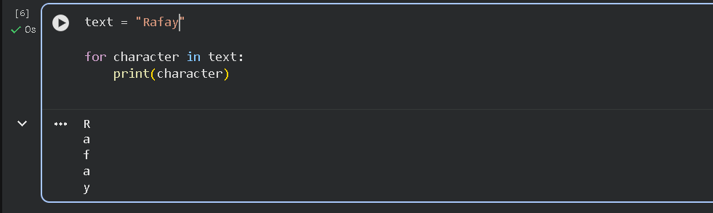
6. Print Statement in Reverse
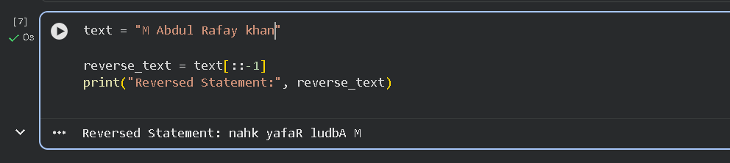
Explanation
- print() → Displays output on the screen.
- len() → Counts total characters in a string.
- .upper() → Converts text into uppercase letters.
- .lower() → Converts text into lowercase letters.
- for loop → Prints each character separately.
- [::-1] → Reverses the string using slicing.

