

NATIONAL UNIVERSITY OF MODERN LANGUAGES

VISUAL PROGRAMMING LAB REPORT - 1

NAME: Abdul Rafay (Fl23791)
Ali Atif (FL23824)
Nazish Khan (Fl23843)
Zohaib Ijaz (FL23811)
PROGRAM: BSSE (6th Semester)
COURSE: Visual Programming
SUBMITTED TO: Sir M Irtaza

DATE: 22 February 2026 DAY: Sunday

Design and Implementation of a Ticket Booking System Using Windows Forms (.NET Framework)
- Objective
The objective of this lab is to design and develop a desktop-based Ticket Booking System using Windows Forms in C#. The system allows users to:
- Sign up with their details
- Select travel cities and date
- Confirm ticket booking
- Display booking details on final screen
- Introduction
This project is a Windows Forms desktop application developed using C# and .NET Framework. The system simulates a basic ticket booking process. It consists of three forms:
- Signup Form
- Booking Form
- Confirmation Form
The application demonstrates form navigation, data passing between forms, input validation, and basic GUI design.
- Software & Tools Used
- Microsoft Visual Studio
- C# Programming Language
- .NET Framework
- Windows Forms
- Form Details
Form1 – Signup Form
Purpose:
Collect user information (Name, Email, Password).
Controls Used:
- Labels
- TextBoxes
- Button (Signup)
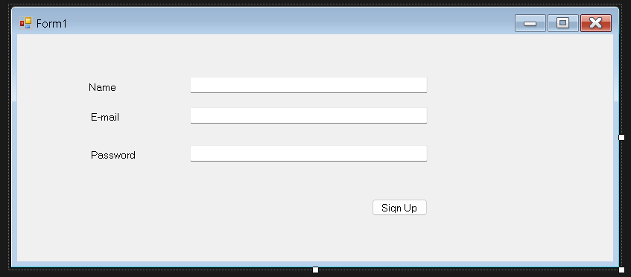
Code – Form1
using System;
using System.Collections.Generic;
using System.ComponentModel;
using System.Data;
using System.Drawing;
using System.Linq;
using System.Text;
using System.Threading.Tasks;
using System.Windows.Forms;

namespace bookingapp
{
public partial class Form1 : Form
{
public Form1()
{
InitializeComponent();
}

private void Form1_Load(object sender, EventArgs e)
{

}

private void signupBtn_Click(object sender, EventArgs e)
{
string name = nameInput.Text;
string email = emailInput.Text;
string password = passwordInput.Text;

if(name == "" || email == "" || password == "")
{
MessageBox.Show("invalid inputs");
}else
{
Form2 bookingform = new Form2(name);
this.Hide();
bookingform.ShowDialog();
}
}
}
}
Form2 – Booking Form
Purpose:
Allow user to select:
- Departure city
- Destination city
- Travel date
Controls Used:
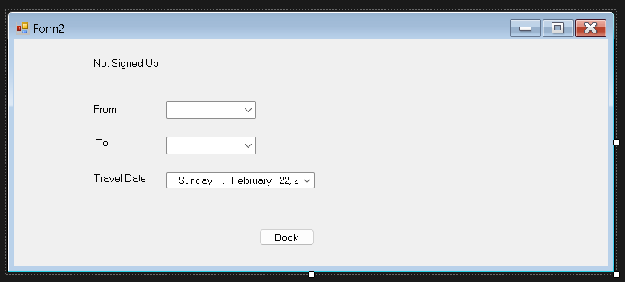
- Labels
- ComboBoxes
Code – Form2
using System;
using System.Collections.Generic;
using System.ComponentModel;
using System.Data;
using System.Drawing;
using System.Linq;
using System.Text;
using System.Threading.Tasks;
using System.Windows.Forms;

namespace bookingapp
{
public partial class Form2 : Form
{
private string name;
public Form2(string name)
{
InitializeComponent();
this.name = name;
}

private void Form2_Load(object sender, EventArgs e)
{

label1.Text = "Welcome " + name;

cmbFrom.Items.Add("Karachi");
cmbFrom.Items.Add("Lahore");
cmbFrom.Items.Add("Islamabad");

cmbTo.Items.Add("Karachi");
cmbTo.Items.Add("Lahore");
cmbTo.Items.Add("Islamabad");
}

private void btnBook_Click(object sender, EventArgs e)
{
string from = cmbFrom.Text;
string to = cmbTo.Text;
string date = datePicker.Value.ToShortDateString();

if (from == "" || to == "")
{
MessageBox.Show("Please select cities");
return;
}

if (from == to)
{
MessageBox.Show("From and To cannot be same");
return;
}

Form3 confirm = new Form3(name, from, to, date);
this.Hide();
confirm.ShowDialog();
}

private void cmbTo_SelectedIndexChanged(object sender, EventArgs e)
{

}
}
Form3 – Confirmation Form
Purpose:
Display booking confirmation and ticket details.
Controls Used:
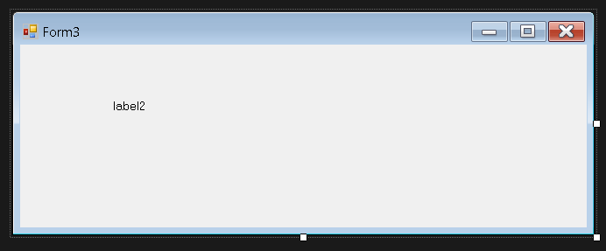
- Label (for displaying booking details)

Code – Form3
using System;
using System.Collections.Generic;
using System.ComponentModel;
using System.Data;
using System.Drawing;
using System.Linq;
using System.Text;
using System.Threading.Tasks;
using System.Windows.Forms;
using System.Xml.Linq;

namespace bookingapp
{
public partial class Form3 : Form
{
public Form3(string name, string from, string to, string date)
{
InitializeComponent();

lbDetails.Text =
"Booking Confirmed\n\n" +
"Name: " + name + "\n" +
"From: " + from + "\n" +
"To: " + to + "\n" +
"Date: " + date;

}

private void Form3_Load(object sender, EventArgs e)
{

}
}



