
NATIONAL UNIVERSITY OF MODERN LANGUAGES
Computer Networks Final CCP

NAME: M Abdul Rafay (FL23791)
M Usman Tanveer (FL23848)
Ali Asad (FL23845)
M Abubakar (FL23846)
Zulkifal (SP23660)

PROGRAM: BSSE (5th Semester)
COURSE: Computer Networks
SUBMITTED TO: Mam Anam Taskeen

DATE: 13/12/2025 DAY: Saturday

Contents
Understanding and Implementing UDP Protocol in Computer Networks 3
Abstract 3
Objectives 3
Task 1: Understanding UDP 3
1.1 Definition of UDP 3
1.2 Main Characteristics of UDP 3
1.3 Comparison Between UDP and TCP 4
1.4 Scenarios Where UDP is Preferred 4
Task 2: Advantages and Disadvantages of UDP 4
2.1 Advantages of UDP 4
2.2 Disadvantages of UDP 5
2.3 Applications Where UDP is Suitable 5
Task 3: Implementing UDP Communication 5
3.1 Network Scenario Design 5
3.2 UDP Server Implementation (Node.js) 5
3.3 UDP Client Implementation (Node.js) 6
3.4 Explanation of Key Components 6
Task 4: Real-World Applications of UDP 6
Task 5: Critical Analysis 7
5.1 Trade-offs of Using UDP 7
5.2 Recommendations 7
Task 6: Conclusion and Reflection 7
6.1 Conclusion 7
6.2 Reflection 7
6.3 Significance of UDP 7
References 7

Understanding and Implementing UDP Protocol in Computer Networks

Abstract
The User Datagram Protocol (UDP) is one of the core transport layer protocols used in computer networks. Unlike Transmission Control Protocol (TCP), UDP follows a connectionless communication model and does not provide mechanisms for reliability, flow control, or congestion control. This makes UDP a lightweight and fast protocol, particularly suitable for applications where low latency and speed are more important than guaranteed delivery.
This project aims to provide a comprehensive understanding of UDP by exploring its features, advantages, disadvantages, and real-world applications. In addition, a practical implementation of UDP-based client-server communication is developed to reinforce theoretical concepts. The project also critically analyzes the trade-offs involved in selecting UDP over other transport layer protocols and reflects on the importance of UDP in modern networking systems.

Objectives
The objectives of this project are:
- To understand the characteristics and working of the UDP protocol
- To compare UDP with TCP at the transport layer
- To analyze the advantages and disadvantages of UDP
- To implement UDP communication using a client-server model
- To study real-world applications that rely on UDP
- To evaluate the role of UDP in complex computing systems
Course Learning Outcome (CLO) Alignment

Task 1: Understanding UDP

1.1 Definition of UDP
User Datagram Protocol (UDP) is a transport layer protocol defined in RFC 768. It enables applications to send messages, called datagrams, to other hosts on an IP network without requiring a prior connection. UDP does not guarantee message delivery, ordering, or duplication protection.

1.2 Main Characteristics of UDP
- Connectionless protocol
- No acknowledgment mechanism
- No retransmission of lost packets
- No congestion control
- Low protocol overhead
- Faster data transmission

1.3 Comparison Between UDP and TCP
Feature | UDP | TCP
Connection Establishment | Not required | Required (3-way handshake)
Reliability | Not reliable | Reliable
Error Handling | Minimal | Extensive
Flow Control | No | Yes
Overhead | Low | High
Speed | Very fast | Relatively slower

1.4 Scenarios Where UDP is Preferred
- Online Gaming
Real-time interaction requires fast transmission. Small packet losses do not significantly affect gameplay.
- Live Audio/Video Streaming
UDP allows continuous streaming without delays caused by retransmission.

Task 2: Advantages and Disadvantages of UDP

2.1 Advantages of UDP
- Low Latency
UDP avoids connection setup, resulting in faster communication.
- Low Overhead
The UDP header is only 8 bytes, making it lightweight.
- Efficient for Real-Time Applications
Suitable for applications where speed is critical.

2.2 Disadvantages of UDP
- No Guaranteed Delivery
Packets may be lost without notification.
- No Flow or Congestion Control
Can lead to network congestion.
- No Error Recovery
Corrupted packets are discarded.

2.3 Applications Where UDP is Suitable
- Video conferencing
- DNS services
- Online multiplayer games

Task 3: Implementing UDP Communication

3.1 Network Scenario Design
The implemented system consists of:
- A UDP Server that listens for incoming messages
- A UDP Client that sends messages to the server
- Communication over localhost using UDP

3.2 UDP Server Implementation (Node.js)
const dgram = require("dgram");
const server = dgram.createSocket("udp4");

server.on("message", (msg, rinfo) => {
console.log(`Received from client: ${msg}`);
server.send("Message received successfully", rinfo.port, rinfo.address);
});

server.bind(41234, () => {
console.log("UDP Server is running...");
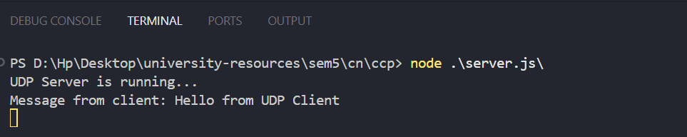
});

3.3 UDP Client Implementation (Node.js)
const dgram = require("dgram");
const client = dgram.createSocket("udp4");

const message = Buffer.from("Hello Server, this is UDP Client");

client.send(message, 41234, "localhost", () => {
console.log("Message sent to server");
});

client.on("message", (msg) => {
console.log(`Received from server: ${msg}`);
client.close();
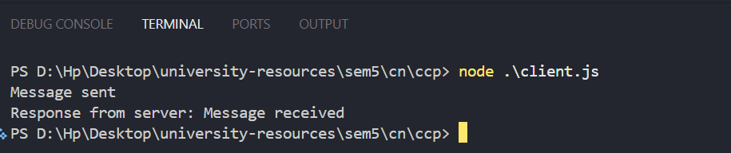
});

3.4 Explanation of Key Components
- dgram.createSocket("udp4") creates a UDP socket
- send() transmits datagrams
- on("message") listens for incoming data
- No connection establishment is required

Task 4: Real-World Applications of UDP
Application: Video Streaming Services
Video streaming platforms such as YouTube Live, Netflix, and Zoom rely heavily on UDP-based protocols.
Why UDP is Preferred
- Low latency ensures real-time delivery
- Packet loss does not significantly affect playback
- TCP retransmissions cause delays and buffering

Task 5: Critical Analysis

5.1 Trade-offs of Using UDP
UDP offers high speed and efficiency at the cost of reliability. While TCP ensures error-free communication, its overhead makes it unsuitable for real-time applications. UDP shifts responsibility for reliability to the application layer.

5.2 Recommendations
Use UDP when:
- Real-time performance is required
- Minor data loss is acceptable
Avoid UDP when:
- Data accuracy is critical
- Secure and reliable delivery is needed

Task 6: Conclusion and Reflection

6.1 Conclusion
This project enhanced understanding of UDP as a transport layer protocol. Through analysis and implementation, the strengths and limitations of UDP were explored in depth.

6.2 Reflection
The major challenge was understanding how UDP operates without reliability mechanisms. Implementing the client-server model helped clarify these concepts practically.

6.3 Significance of UDP
UDP plays a crucial role in modern networking by enabling fast and efficient communication in real-time applications.

References
- Kurose, J., & Ross, K. Computer Networking: A Top-Down Approach
- RFC 768 – User Datagram Protocol
- Tanenbaum, A. Computer Networks

