
NATIONAL UNIVERSITY OF MODERN LANGUAGES
Human Computer Interaction lab Report – 12

NAME: Abdul Rafay
ROLL NO: FL23791
PROGRAM: BSSE (5th Semester)
COURSE: HUMAN COMPUTER INTERACTION
SUBMITTED TO: Sir Khateeb khan

DATE: 30 Sep 2025 DAY: Tuesday

Lab Tasks
Understand Rigid body behavior and movement using a 3D Cylinder object in Unity.
Solution:
using System.Collections;
using System.Collections.Generic;
using UnityEngine;

public class CylinderMovement : MonoBehaviour
{
Rigidbody rb;

void Start()
{
rb = GetComponent<Rigidbody>();
}

void FixedUpdate()
{
rb.velocity = new Vector3(0, rb.velocity.y, 2f);

rb.AddTorque(new Vector3(50f, 0, 0));
}
}
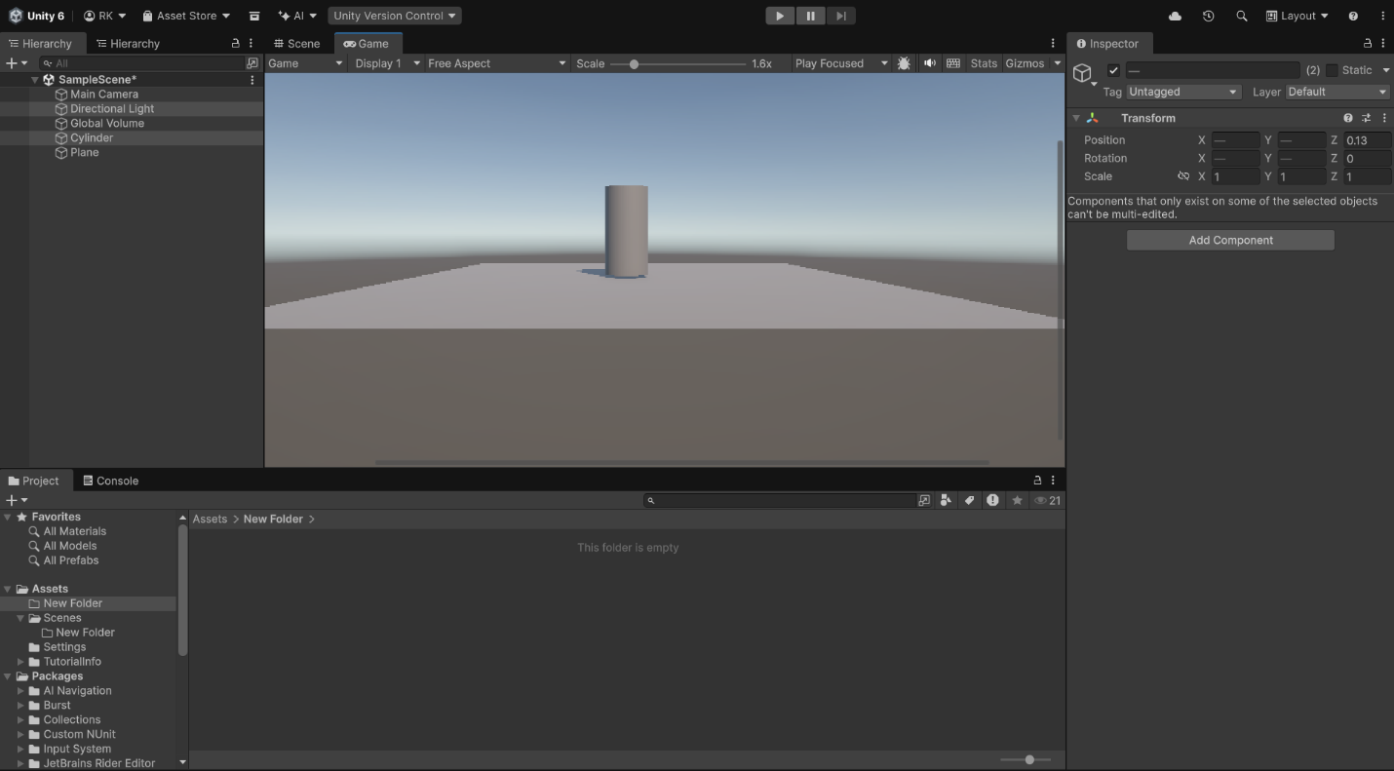
output:

