
NATIONAL UNIVERSITY OF MODERN LANGUAGES
Web Engineering Lab Report 10

Submitted by: Abdul Rafay
Roll No: Fl23843
PROGRAM: BSSE (5th Semester)
COURSE: Web Engineering
SUBMITTED TO: Mam Meher Un Nissa

DATE: 1/12/2025 DAY: Sunday

Lab Report 10
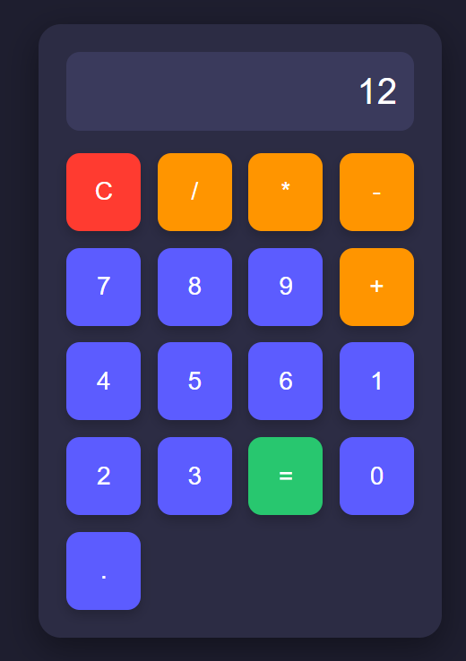
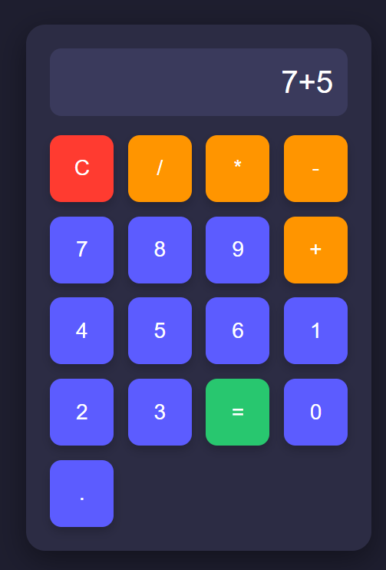
Lab Task: Make a simple calculator

Code :
<!DOCTYPE html>
<html lang="en">
<head>
<meta charset="UTF-8" />
<meta name="viewport" content="width=device-width, initial-scale=1.0" />
<title>Simple Calculator</title>

<style>
body {
font-family: 'Segoe UI', Tahoma, Geneva, Verdana, sans-serif;
background: #1e1e2f;
display: flex;
justify-content: center;
align-items: center;
height: 100vh;
margin: 0;
}

.calculator {
background: #2c2c44;
padding: 25px;
width: 100%;
max-width: 360px;
border-radius: 20px;
box-shadow: 0 10px 30px rgba(0,0,0,0.4);
box-sizing: border-box;
}

#display {
width: 100%;
height: 70px;
margin-bottom: 20px;
font-size: 32px;
text-align: right;
padding: 15px;
border: none;
background: #3a3a5c;
color: #fff;
border-radius: 12px;
box-sizing: border-box;
}

.buttons {
display: grid;
grid-template-columns: repeat(4, 1fr);
gap: 15px;
}

button {
padding: 22px;
font-size: 22px;
border: none;
border-radius: 12px;
cursor: pointer;
transition: 0.2s;
color: #fff;
box-shadow: 0 5px 10px rgba(0,0,0,0.2);
}

button:hover {
transform: translateY(-2px);
box-shadow: 0 8px 15px rgba(0,0,0,0.3);
}

/* Number buttons */
button:not(.operator):not(.equal):not(.clear) {
background: #5c5cff;
}

button:not(.operator):not(.equal):not(.clear):hover {
background: #3a3aff;
}

/* Operator buttons */
.operator {
background: #ff9500;
}

.operator:hover {
background: #e08900;
}

/* Equal button */
.equal {
background: #28c76f;
}

.equal:hover {
background: #20a65d;
}

/* Clear button */
.clear {
background: #ff3b30;
}

.clear:hover {
background: #cc2b24;
}
</style>
</head>

<body>

<div class="calculator">
<input type="text" id="display" disabled>

<div class="buttons" id="btnContainer">
<!-- Buttons will be generated with JS loop -->
</div>
</div>

<script>
const buttons = [
'C','/','*','-',
'7','8','9','+',
'4','5','6','',
'1','2','3','=',
'0','.'
];

const container = document.getElementById("btnContainer");
const display = document.getElementById("display");

const operators = ['/', '*', '-', '+'];

for (let i = 0; i < buttons.length; i++) {
if (buttons[i] === '') continue; // skip empty placeholders
let btn = document.createElement("button");
btn.textContent = buttons[i];

if (buttons[i] === "=") btn.classList.add("equal");
else if (buttons[i] === "C") btn.classList.add("clear");
else if (operators.includes(buttons[i])) btn.classList.add("operator");

btn.addEventListener("click", () => {
if (buttons[i] === "=") {
try {
display.value = eval(display.value);
} catch {
display.value = "Error";
}
} else if (buttons[i] === "C") {
display.value = "";
} else {
display.value += buttons[i];
}
});

container.appendChild(btn);
}
</script>

</body>
</html>

