
NATIONAL UNIVERSITY OF MODERN LANGUAGES
Computer Networks lab Report - 10

NAME: Abdul Rafay
ROLL NO: FL23791
PROGRAM: BSSE (5th Semester)
COURSE: Computer Networks
SUBMITTED TO: Mam Anam Taskeen

DATE: 15, Sep 2025 DAY: Monday

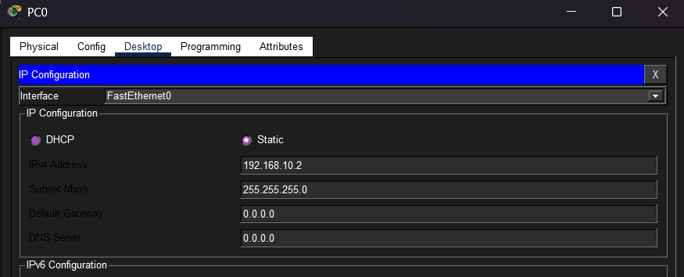
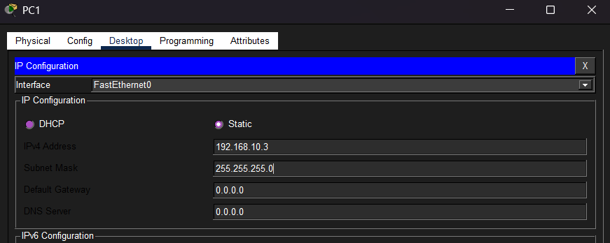
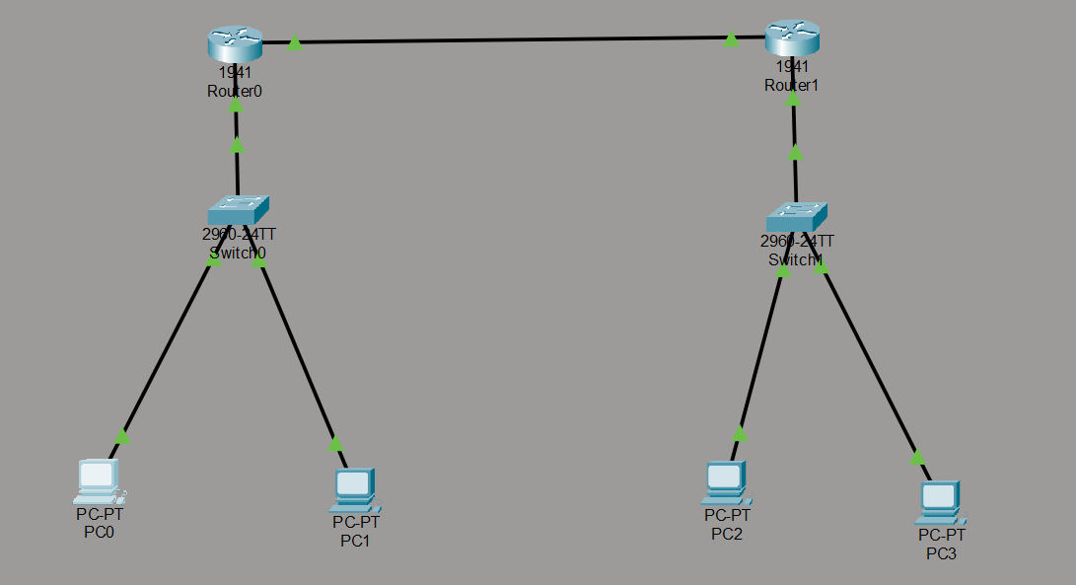
LAB 10 : Static Routing
