
NATIONAL UNIVERSITY OF MODERN LANGUAGES
Software Construction And Development lab Report - 8

NAME: M Abdul Rafay (FL23791)
M Usman Tanveer (FL23848)
Zulkifal (SP23660)
Elisha Abbasi (SP23606)

PROGRAM: BSSE (5th Semester)
COURSE: Software Construction and Development
SUBMITTED TO: Sir Ahsan Arif

DATE: 9/21/2025 DAY: Sunday

Lab Task
Task 1. Implement a car rental system using Naming conventions and follow Hungarian Notation as standard. Include fields for car details, rental duration, and customer information and methods for editing and printing these details.
Code :
import java.util.Scanner;

class Car {
String strCarName;
String strCarModel;
String strCarNumber;

void editCarDetails(String name, String model, String number) {
strCarName = name;
strCarModel = model;
strCarNumber = number;
}

void printCarDetails() {
System.out.println("Car Name: " + strCarName);
System.out.println("Car Model: " + strCarModel);
System.out.println("Car Number: " + strCarNumber);
}
}

class Customer {
String strCustomerName;
String strCustomerPhone;

void editCustomerDetails(String name, String phone) {
strCustomerName = name;
strCustomerPhone = phone;
}

void printCustomerDetails() {
System.out.println("Customer Name: " + strCustomerName);
System.out.println("Customer Phone: " + strCustomerPhone);
}
}

class Rental {
int intDays;
double dblPricePerDay;

void editRentalDetails(int days, double price) {
intDays = days;
dblPricePerDay = price;
}

void printRentalDetails() {
System.out.println("Rental Days: " + intDays);
System.out.println("Price per Day: " + dblPricePerDay);
System.out.println("Total Price: " + (intDays * dblPricePerDay));
}
}

public class CarRentalSystem {
public static void main(String[] args) {
Scanner objScanner = new Scanner(System.in);

Car objCar = new Car();
Customer objCustomer = new Customer();
Rental objRental = new Rental();

System.out.print("Enter Car Name: ");
String strName = objScanner.nextLine();

System.out.print("Enter Car Model: ");
String strModel = objScanner.nextLine();

System.out.print("Enter Car Number: ");
String strNumber = objScanner.nextLine();

objCar.editCarDetails(strName, strModel, strNumber);

System.out.print("Enter Customer Name: ");
String strCustName = objScanner.nextLine();

System.out.print("Enter Customer Phone: ");
String strCustPhone = objScanner.nextLine();

objCustomer.editCustomerDetails(strCustName, strCustPhone);

System.out.print("Enter Rental Days: ");
int intDays = objScanner.nextInt();

System.out.print("Enter Price per Day: ");
double dblPrice = objScanner.nextDouble();

objRental.editRentalDetails(intDays, dblPrice);

System.out.println("\n--- Car Details ---");
objCar.printCarDetails();

System.out.println("\n--- Customer Details ---");
objCustomer.printCustomerDetails();

System.out.println("\n--- Rental Details ---");
objRental.printRentalDetails();
}
}
Output:

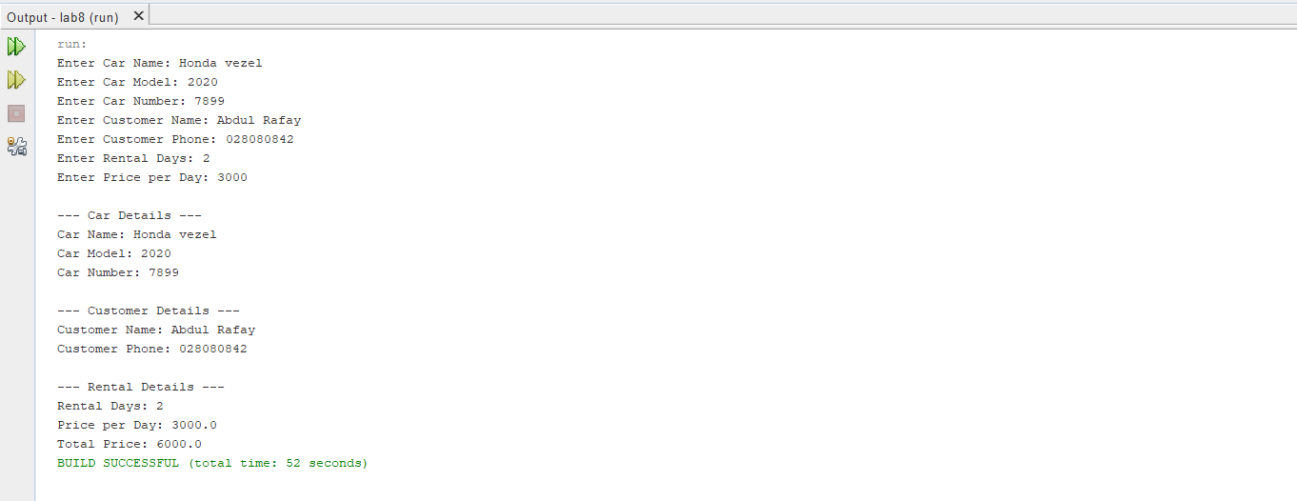
Task 2. Implement Zakat Calculator using Naming conventions and follow snake case Notation as standard
Code :
import java.util.Scanner;

public class ZakatCalculator {
public static void main(String[] args) {
Scanner input = new Scanner(System.in);

double total_amount;
double zakat_rate = 0.025;

System.out.print("Enter your total amount: ");
total_amount = input.nextDouble();

double zakat_amount = total_amount * zakat_rate;

System.out.println("Zakat Amount: " + zakat_amount);
}
}
Output:
