
NATIONAL UNIVERSITY OF MODERN LANGUAGES
Web Engineering lab Report - 2

NAME: Abdul Rafay
ROLL NO: FL23791
PROGRAM: BSSE (5th Semester)
COURSE: Web Engineering
SUBMITTED TO: Mam Mehr-un-Nisa

DATE: 10, Sep 2025 DAY: Sunday

Lab Tasks
Lab Task 1. Create a Wiki page related to a topic of your choice. Create at least two HTML pages for references and link the main Wiki page to those references. Use necessary File paths to images and Add formatted textual information on your Wiki. Include a table like the following in your Wiki page
<!DOCTYPE html>
<html>
<head>
<title>My Wiki Page</title>
</head>
<body>
<h1>My Simple Wiki About Computers</h1>
<p>Computers are electronic devices that help us <b>store</b>, <i>process</i>, and <strong>retrieve</strong> information.</p>
<img src="./Unconfirmed 977899.crdownload" width="200" alt="Computer Image">
<h2>Reference Pages</h2>
<ul>
<li><a href="page1.html">History of Computers</a></li>
<li><a href="page2.html">Types of Computers</a></li>
</ul>
<h2>Simple Table</h2>
<table border="1" cellpadding="8">
<tr>
<th>Part</th>
<th>Description</th>
</tr>
<tr>
<td>CPU</td>
<td>Central Processing Unit</td>
</tr>
<tr>
<td>RAM</td>
<td>Memory used by programs</td>
</tr>
</table>
</body>
</html>
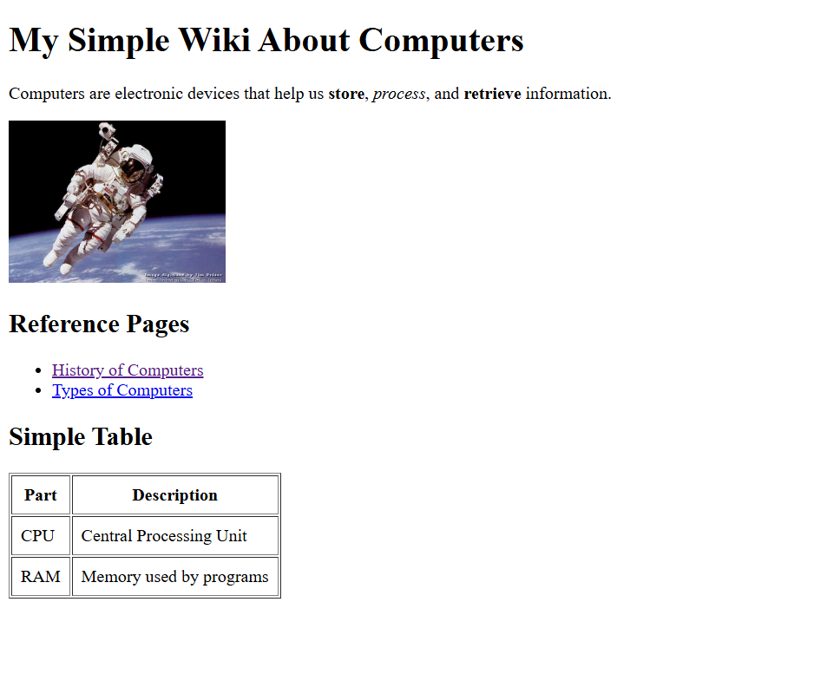
Output:

Lab Task 2. Create a Simple web page about any latest topic of your choice e.g “ emerging software technologies now days”. Following things should be considered 1. Use all the appropriate Html Commands 2. Write Description of topic 3. Use animated images as well as use those images as a link 4. Make usage of mailto
<!DOCTYPE html>
<html>
<head>
<title>Emerging Software Technologies</title>
</head>
<body>
<h1>Emerging Software Technologies</h1>
<p>Today, new software technologies such as <strong>AI</strong>, <em>Machine Learning</em>,
<mark>Blockchain</mark> and <small>Cloud Computing</small> are growing fast.</p>
<h2>Animated Image as a Link</h2>
<a href="https://www.google.com">
<img src="https://media.giphy.com/media/du3J3cXyzhj75IOgvA/giphy.gif" width="200">
</a>
<h2>Contact Me</h2>
<p>Click below to send me an email:</p>
<a href="mailto:example@mail.com">Send Email</a>
</body>
</html>
Output
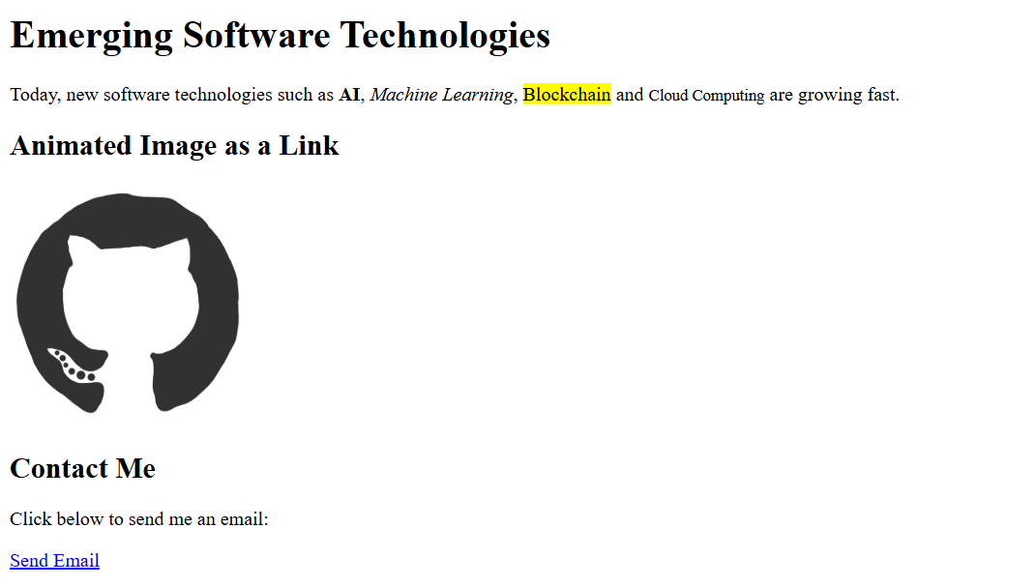

Lab Task 3. Explore HTML Emojis from the following link: https://www.w3schools.com/html/html_emojis.asp
<!DOCTYPE html>
<html>
<head>
<title>Emoji Page</title>
</head>
<body>
<h1>Some Emojis</h1>
<p>Smile: &#128512;</p>
<p>Heart: &#10084;</p>
<p>Fire: &#128293;</p>
<p>Star: &#11088;</p>
</body>
</html>
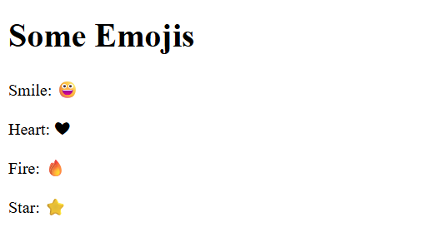
Output:

