
NATIONAL UNIVERSITY OF MODERN LANGUAGES
Web Engineering lab Report - 3

NAME: Abdul Rafay
ROLL NO: FL23791
PROGRAM: BSSE (5th Semester)
COURSE: Web Engineering
SUBMITTED TO: Mam Mehr-un-Nisa

DATE: 10, Sep 2025 DAY: Sunday

Lab Tasks
Lab Task 1
Using table tag, Create a web page CV with your skills. Give it a name About me.html
<!DOCTYPE html>
<html>
<head>
<title>About Me - CV</title>
</head>
<body>
<h1>My CV</h1>
<table border="1" cellpadding="10">
<tr>
<th colspan="2">Personal Information</th>
</tr>
<tr>
<td>Name</td>
<td>Abdul Rafay</td>
</tr>
<tr>
<td>Email</td>
<td>rafaykhan2k22@gmail.com</td>
</tr>
<tr>
<td>Degree</td>
<td>BS Software Engineering</td>
</tr>

<tr>
<td>University</td>
<td>NUML</td>
</tr>
<tr>
<td>Semester</td>
<td>5th Semester</td>
</tr>
<tr>
<td>CGPA</td>
<td>3.67</td>
</tr>
<tr>
<th colspan="2">Skills</th>
</tr>
<tr>
<td>Technical Skills</td>
<td>
<ul>
<li>HTML</li>
<li>CSS</li>
<li>JavaScript</li>
<li>Python</li>
<li>C++</li>
</ul>
</td>
</tr>

<tr>
<td>Soft Skills</td>
<td>
<ul>
<li>Communication</li>
<li>Problem Solving</li>
<li>Teamwork</li>
</ul>
</td>
</tr>
</table>
</body>
</html>
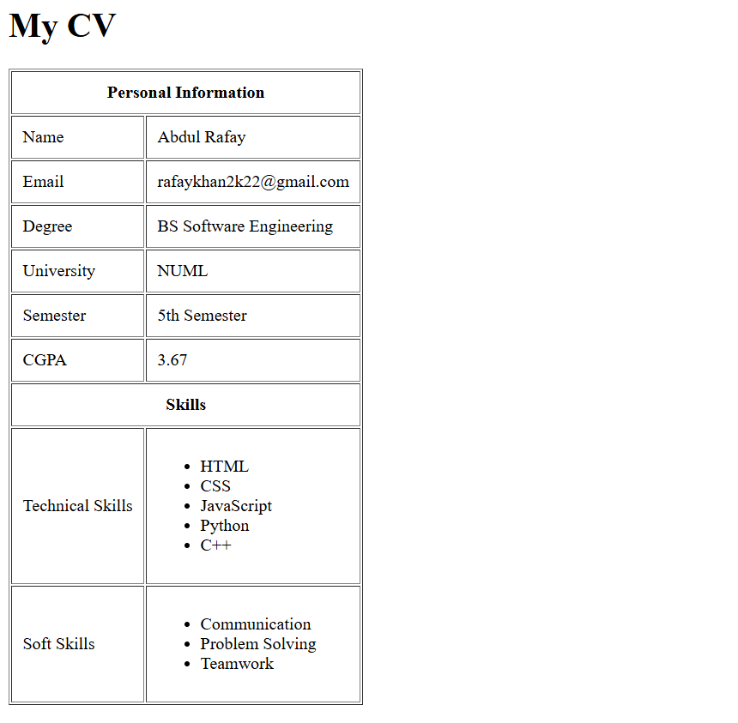
Ouput:
Lab Task 2. Create a web page containing description list , table styling, rowspan ,column span and column group
<!DOCTYPE html>
<html>
<head>
<title>HTML Table & Description List</title>
</head>
<body>
<h1>Description List Example</h1>
<dl>
<dt><b>HTML</b></dt>
<dd>Hyper Text Markup Language</dd>
<dt><b>CSS</b></dt>
<dd>Cascading Style Sheets</dd>
<dt><b>JS</b></dt>
<dd>JavaScript – programming language for web pages</dd>
</dl>
<hr>
<h1>Table with Styling, Rowspan, Colspan, Colgroup</h1>
<table border="1" cellpadding="10">
<!-- Column Group -->
<colgroup>
<col span="1" style="background-color: lightyellow;">
<col span="2" style="background-color: lightblue;">
</colgroup>
<tr>
<th colspan="3">Student Information</th>
</tr>

<tr>
<th>Name</th>
<th>Class</th>
<th>Marks</th>
</tr>
<tr>
<td rowspan="2">Ali</td>
<td>10th</td>
<td>85</td>
</tr>
<tr>
<td>9th</td>
<td>78</td>
</tr>
<tr>
<td>Ayesha</td>
<td colspan="2">Result Pending</td>
</tr>
</table>
</body>
</html>

Output:
