
NATIONAL UNIVERSITY OF MODERN LANGUAGES
Web Engineering lab Report - 4

NAME: Abdul Rafay
ROLL NO: FL23791
PROGRAM: BSSE (5th Semester)
COURSE: Web Engineering
SUBMITTED TO: Mam Mehr-un-Nisa

DATE: 10, Sep 2025 DAY: Sunday

Lab Tasks
Lab task 1. Design a signup form for creating an account of student in the database system
<!DOCTYPE html>
<html>
<head>
<title>Student Signup Form</title>
</head>
<body>
<h2>Student Signup Form</h2>
<form>
<label>Full Name:</label><br>
<input type="text" name="fullname" required><br><br>
<label>Email:</label><br>
<input type="email" name="email" required><br><br>
<label>Password:</label><br>
<input type="password" name="password" required>br><br>
<label>Confirm Password:</label><br>
<input type="password" name="cpassword" required><br><br>
<label>Program:</label><br>
<input type="text" name="program" placeholder="BS Software Engineering"><br><br>
<label>Semester:</label><br>
<input type="number" name="semester" min="1" max="8"><br><br>
<label>Phone Number:</label><br>
<input type="text" name="phone"><br><br>
<button type="submit">Create Account</button>
</form>
</body>
</html>
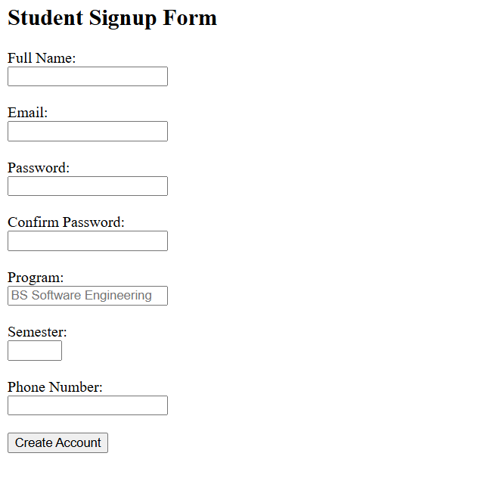
Output:

Lab Task 2. Design a signup form for numl
<!DOCTYPE html>
<html>
<head>
<title>NUML University Signup</title>
</head>
<body>
<center>
<img src="numl-logo.png" alt="NUML Logo" width="120">
<h2>NUML University – Signup Form</h2>
</center>
<form>
<label>Student Name:</label><br>
<input type="text" name="name" required><br><br>
<label>Registration Number:</label><br>
<input type="text" name="regno" placeholder="e.g. 22-SE-123" required><br><br>
<label>Email:</label><br>
<input type="email" name="email" required><br><br>
<label>Department:</label><br>
<input type="text" name="dept" placeholder="Software Engineering" required><br><br>
<label>Semester:</label><br>
<input type="number" name="sem" min="1" max="8" required><br><br>
<label>Password:</label><br>
<input type="password" name="password" required><br><br>
<button type="submit">Signup</button>
</form>
</body>
</html>
Output:
