
NATIONAL UNIVERSITY OF MODERN LANGUAGES
Web Engineering lab Report - 5

NAME: Abdul Rafay
ROLL NO: FL23791
PROGRAM: BSSE (5th Semester)
COURSE: Web Engineering
SUBMITTED TO: Mam Mehr-un-Nisa

DATE: 10, Sep 2025 DAY: Sunday

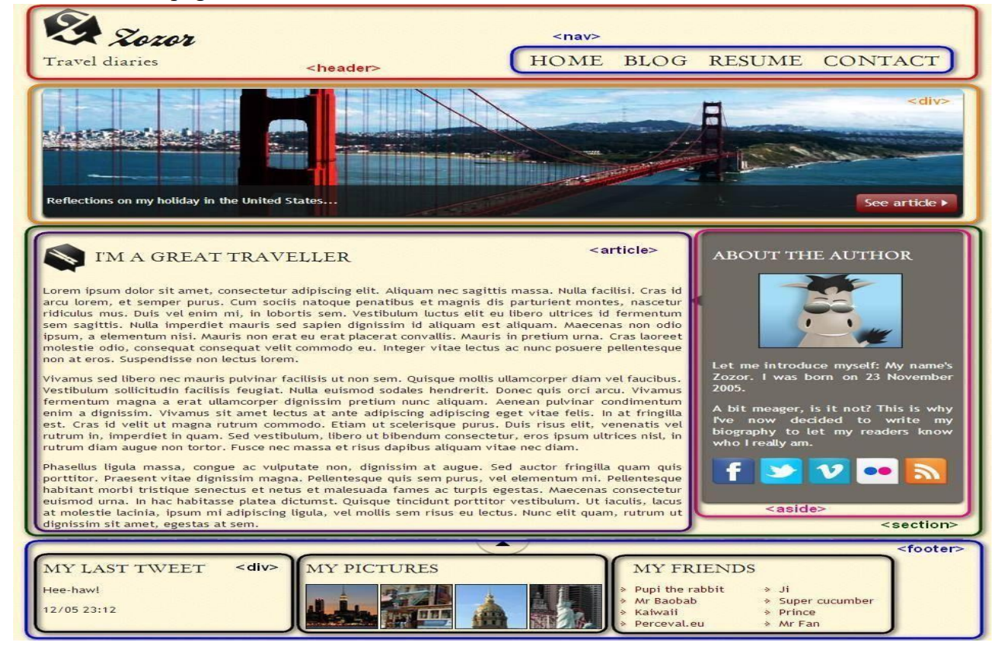
Lab Task : Convert the following image into HTML 5 & CSS. Use semantic elements. HTML Code elements and Quotation blocks to improve the SEO of webpage.

<!DOCTYPE html>
<html lang="en">
<head>
<meta charset="UTF-8" />
<meta name="viewport" content="width=device-width, initial-scale=1.0" />
<title>Zozor – Travel Diaries</title>
<link rel="stylesheet" href="style.css" />
</head>
<body>
<!-- HEADER SECTION -->
<header>
<div class="logo">
<img src="logo.png" alt="Zozor Logo">
<h1>Zozor</h1>
<p>Travel diaries</p>
</div>
<nav>
<ul>
<li><a href="#">Home</a></li>
<li><a href="#">Blog</a></li>
<li><a href="#">Resume</a></li>
<li><a href="#">Contact</a></li>
</ul>
</nav>
</header>
<!-- HERO IMAGE -->
<div class="hero">
<img src="bridge.jpg" alt="Golden Gate Bridge">
<button class="see-article">See Article</button>
</div>
<!-- CONTENT WRAPPER -->
<section class="wrapper">
<!-- ARTICLE SECTION -->
<article>
<h2>I'M A GREAT TRAVELLER</h2>
<p>Lorem ipsum dolor sit amet, consectetur adipiscing elit. Aliquam nec sagittis massa...</p>
<blockquote>
Travelling – it leaves you speechless, then turns you into a storyteller.
</blockquote>
<p>Vivamus sed libero nec mauris pulvinar facilisis ut non sem. Quisque mollis...</p>
</article>
<!-- ABOUT AUTHOR SIDEBAR -->
<aside class="author-box">
<h2>About the Author</h2>
<img src="author.png" alt="Author Image" class="author-img">

<p>Hello! I am Zozor, born on 23 November 2005. I write travel diaries so readers can know who I really am.</p>
<div class="social">
<img src="fb.png" alt="">
<img src="twitter.png" alt="">
<img src="vimeo.png" alt="">
<img src="flickr.png" alt="">
<img src="rss.png" alt="">
</div>
</aside>
</section>
<!-- FOOTER SECTION -->
<footer>
<div class="footer-box">
<h3>My Last Tweet</h3>
<p>Hee-haw!</p>
<small>12/05 – 23:12</small>
</div>
<div class="footer-box">
<h3>My Pictures</h3>
<div class="pics">
<img src="img1.jpg">
<img src="img2.jpg">
<img src="img3.jpg">
<img src="img4.jpg">
</div>
</div>
<div class="footer-box">
<h3>My Friends</h3>
<ul>
<li>Pupi the rabbit</li>
<li>Mr Baobab</li>
<li>Kaiwaii</li>
<li>Prince</li>
<li>Mr Fan</li>
</ul>
</div>
</footer>
</body>
</html>
CSS code :
body {
font-family: Georgia, serif;
margin: 0;
background: #fdf6e3;
}
header {
display: flex;
justify-content: space-between;
padding: 20px;
background: #fffbe6;
border-bottom: 4px solid #d4c18a;
}
.logo h1 {
margin: 0;
}
nav ul {
list-style: none;
display: flex;
gap: 30px;
}
nav ul li a {
text-decoration: none;
font-size: 18px;
font-weight: bold;
color: #333;
}
.hero {
position: relative;
}
.hero img {
width: 100%;
height: 350px;
object-fit: cover;
}
.see-article {
position: absolute;
bottom: 20px;
right: 30px;
padding: 10px 20px;
background: brown;
color: white;
border: none;
border-radius: 5px;
}
.wrapper {
display: flex;
padding: 20px;
}

article {
width: 70%;
padding: 20px;
background: #fff;
margin-right: 20px;
border-radius: 10px;
border: 2px solid #7a4e8b;
}
blockquote {
font-style: italic;
background: #f3e9ff;
padding: 10px;
border-left: 5px solid purple;
}
.author-box {
width: 30%;
padding: 20px;
background: #ddd;
border-radius: 10px;
border: 2px solid #5a3360;
}
.author-img {
width: 100%;
border-radius: 10px;
}
.social img {
width: 30px;
margin-right: 8px;
}
footer {
display: flex;
justify-content: space-around;
padding: 20px;
background: #fff;
border-top: 4px solid #d4c18a;
}
.footer-box {
width: 30%;
}
.pics img {
width: 60px;
margin-right: 5px;
border-radius: 5px;
}
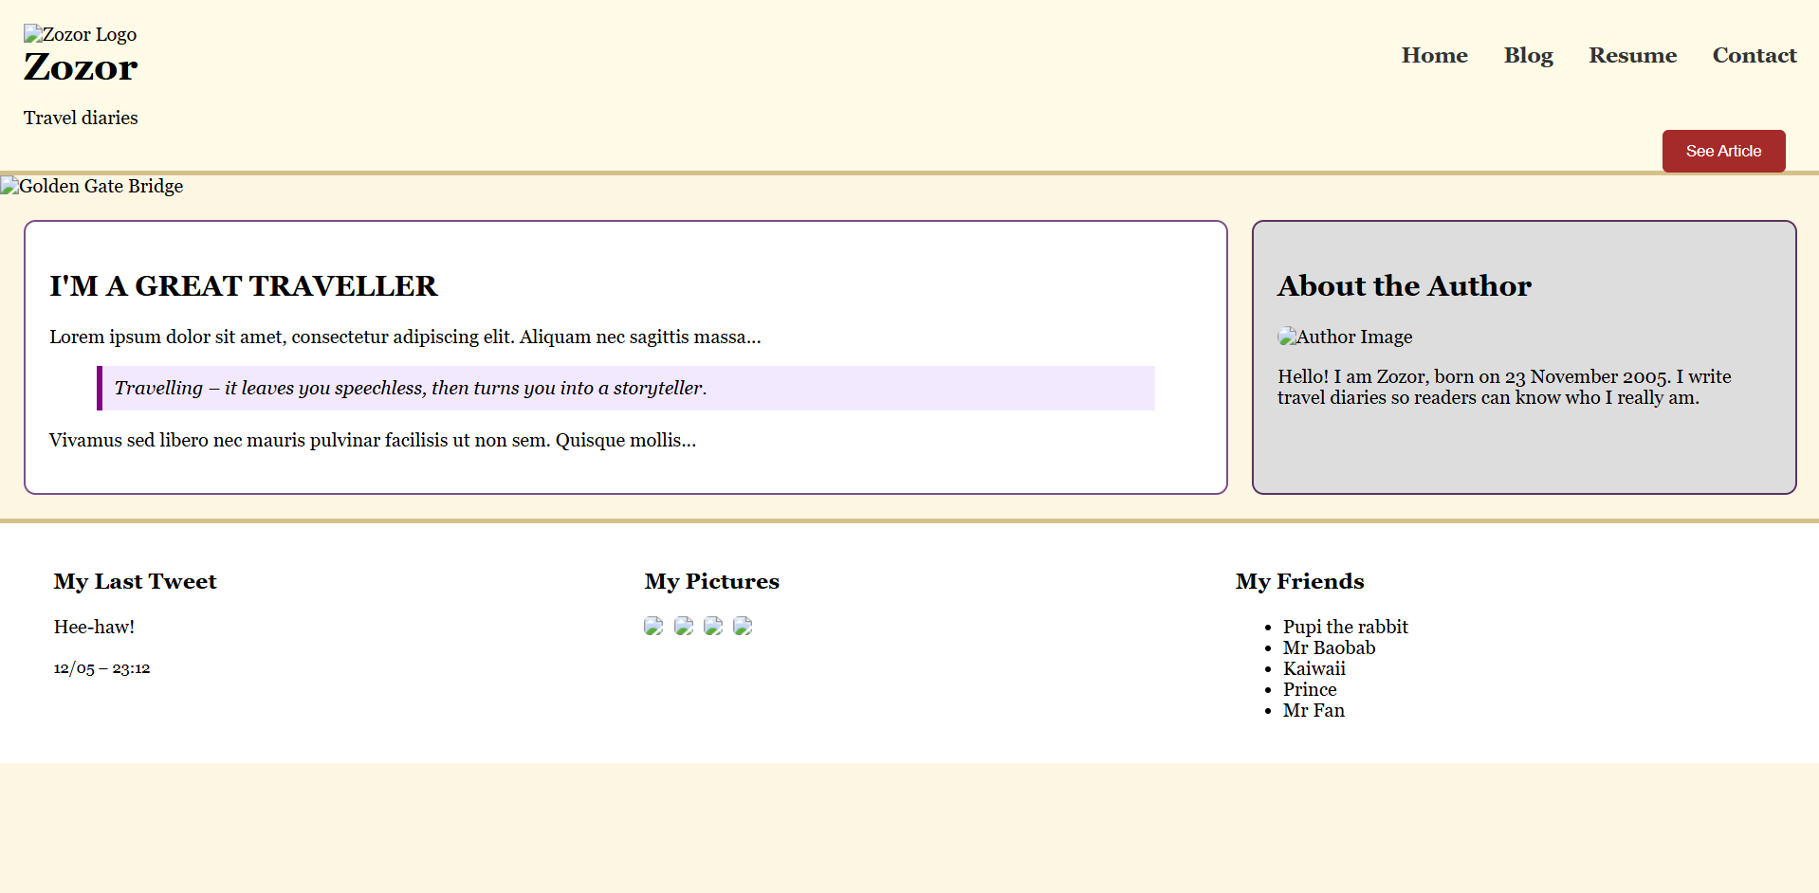
Output:

