
NATIONAL UNIVERSITY OF MODERN LANGUAGES
Web Engineering lab Report - 6

NAME: Abdul Rafay
ROLL NO: FL23791
PROGRAM: BSSE (5th Semester)
COURSE: Web Engineering
SUBMITTED TO: Mam Mehr-un-Nisa

DATE: 10, Sep 2025 DAY: Sunday

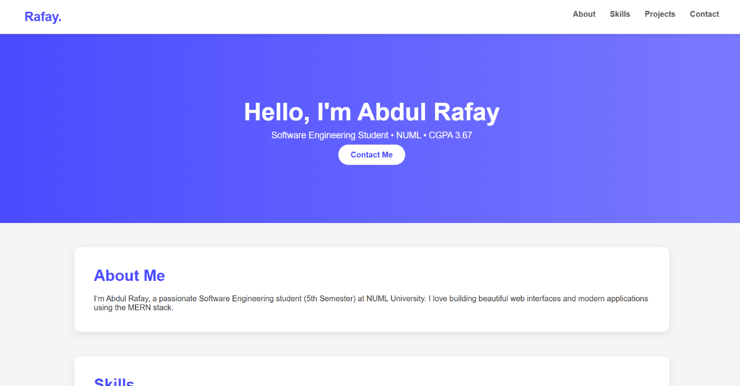
Lab Task : Create a Personal portfolio page in HTML and CSS like following

<!DOCTYPE html>
<html lang="en">
<head>
<meta charset="UTF-8" />
<meta name="viewport" content="width=device-width, initial-scale=1.0" />
<title>Abdul Rafay – Portfolio</title>
<link rel="stylesheet" href="style.css" />
</head>

<body>

<!-- NAVBAR -->
<header class="navbar">
<div class="logo">Rafay.</div>
<nav>
<a href="#about">About</a>
<a href="#skills">Skills</a>
<a href="#projects">Projects</a>
<a href="#contact">Contact</a>
</nav>
</header>

<!-- HERO SECTION -->
<section class="hero">
<h1>Hello, I'm <span>Abdul Rafay</span></h1>
<p>Software Engineering Student • NUML • CGPA 3.67</p>
<a href="#contact" class="btn">Contact Me</a>
</section>

<!-- ABOUT -->
<section id="about" class="section">
<h2>About Me</h2>
<p>
I’m Abdul Rafay, a passionate Software Engineering student (5th Semester)
at NUML University. I love building beautiful web interfaces and modern
applications using the MERN stack.
</p>
</section>

<!-- SKILLS -->
<section id="skills" class="section">
<h2>Skills</h2>
<div class="skills">
<span>HTML</span>
<span>CSS</span>
<span>JavaScript</span>
<span>React</span>
<span>Node.js</span>
<span>MongoDB</span>
<span>Python</span>
<span>C++</span>
</div>
</section>

<!-- PROJECTS -->
<section id="projects" class="section">
<h2>Projects</h2>
<div class="project">
<h3>Personal Portfolio</h3>
<p>A clean, beautiful personal portfolio website built with HTML & CSS.</p>
</div>
<div class="project">
<h3>Student Management System</h3>
<p>A CRUD-based student record system using Node.js, Express & MongoDB.</p>
</div>
</section>

<!-- CONTACT -->
<section id="contact" class="section">
<h2>Contact</h2>
<p>Email: <strong>rafaykhan2k22@gmail.com</strong></p>
</section>

<footer>
<p>© 2025 Abdul Rafay — All Rights Reserved.</p>
</footer>

</body>
</html>
CSS code :
* {
margin: 0;
padding: 0;
box-sizing: border-box;
font-family: "Poppins", sans-serif;
}

body {
background: #f5f5f5;
color: #333;
}

/* NAVBAR */
.navbar {
display: flex;
justify-content: space-between;
padding: 20px 50px;
background: #fff;
box-shadow: 0 2px 10px rgba(0,0,0,0.1);
position: sticky;
top: 0;
}

.logo {
font-size: 26px;
font-weight: bold;
color: #4b4bff;
}

.navbar a {
margin-left: 25px;
text-decoration: none;
color: #555;
font-weight: 600;
}

.navbar a:hover {
color: #4b4bff;
}

/* HERO SECTION */
.hero {
text-align: center;
padding: 130px 20px;
background: linear-gradient(to right, #4b4bff, #7a7aff);
color: white;
}

.hero h1 {
font-size: 50px;
margin-bottom: 10px;
}

.hero h1 span {
color: #fff;
font-weight: bold;
}

.hero p {
font-size: 18px;
margin-bottom: 20px;
}

.btn {
background: white;
color: #4b4bff;
padding: 12px 25px;
border-radius: 30px;
text-decoration: none;
font-weight: bold;
}

.btn:hover {
background: #eee;
}

/* SECTIONS */
.section {
width: 80%;
margin: 50px auto;
background: white;
padding: 40px;
border-radius: 12px;
box-shadow: 0 5px 15px rgba(0,0,0,0.08);
}

.section h2 {
font-size: 32px;
margin-bottom: 20px;
color: #4b4bff;
}

/* SKILLS */
.skills {
display: flex;
flex-wrap: wrap;
gap: 12px;
}

.skills span {
background: #4b4bff;
color: white;
padding: 10px 20px;
border-radius: 30px;
font-size: 14px;
}

/* PROJECTS */
.project {
background: #f0f2ff;
padding: 20px;
margin-bottom: 15px;
border-left: 5px solid #4b4bff;
border-radius: 8px;
}

/* FOOTER */
footer {
text-align: center;
padding: 20px;
margin-top: 20px;
color: #777;
}

