
NATIONAL UNIVERSITY OF MODERN LANGUAGES
Web Engineering lab Report - 7

NAME: Abdul Rafay
ROLL NO: FL23791
PROGRAM: BSSE (5th Semester)
COURSE: Web Engineering
SUBMITTED TO: Mam Mehr-un-Nisa

DATE: 10, Sep 2025 DAY: Sunday

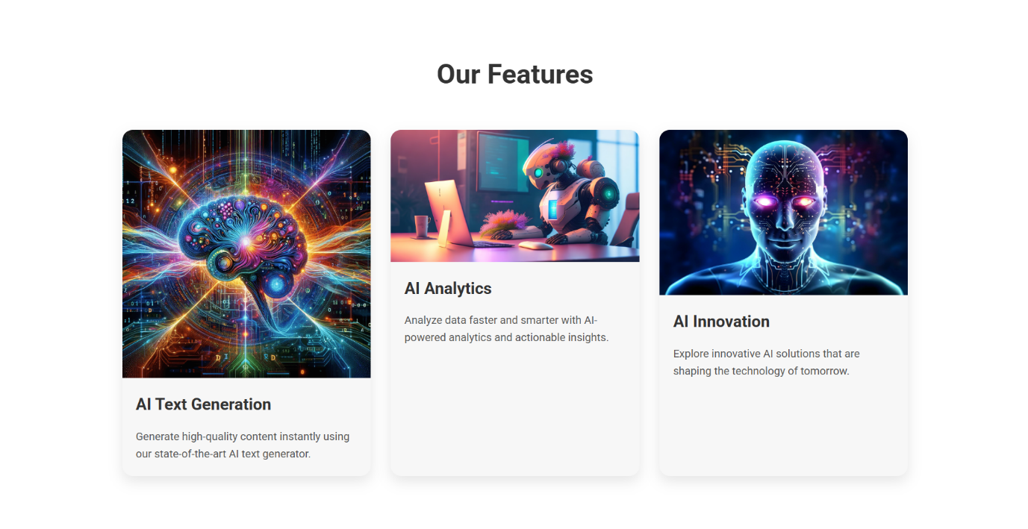
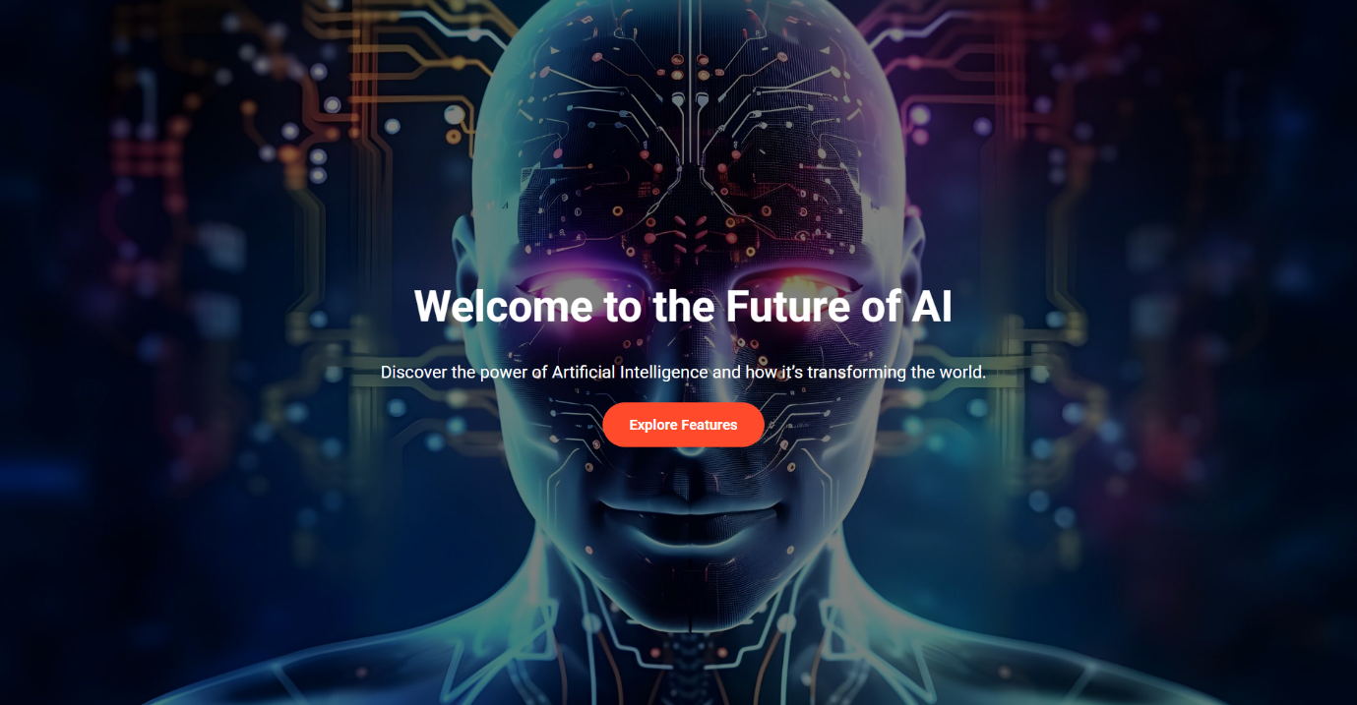
Lab Task : Create web pages on any emerging topic using positioning elements
Figure 1 made by myself not ai generated ( copied images link from the internet )

Code :
<!DOCTYPE html>
<html lang="en">
<head>
<meta charset="UTF-8">
<meta name="viewport" content="width=device-width, initial-scale=1.0">
<title>AI Landing Page</title>
<link href="https://fonts.googleapis.com/css2?family=Roboto:wght@400;700&display=swap" rel="stylesheet">
<style>
* {
margin: 0;
padding: 0;
box-sizing: border-box;
font-family: 'Roboto', sans-serif;
}

body {
line-height: 1.6;
color: #333;
}

header {
background: url('https://static.vecteezy.com/system/resources/previews/030/762/925/large_2x/artificial-intelligence-abstract-background-the-future-of-artificial-intelligence-generative-ai-free-photo.jpg') no-repeat center center/cover;
height: 100vh;
display: flex;
flex-direction: column;
justify-content: center;
align-items: center;
color: #fff;
text-align: center;
position: relative;
}

header::after {
content: '';
position: absolute;
top: 0; left: 0;
width: 100%; height: 100%;
background-color: rgba(0,0,0,0.5);
}

header .content {
position: relative;
z-index: 1;
max-width: 800px;
padding: 0 20px;
}

header h1 {
font-size: 3rem;
margin-bottom: 20px;
}

header p {
font-size: 1.2rem;
margin-bottom: 30px;
}

header .btn {
background: #ff4b2b;
color: #fff;
padding: 15px 30px;
text-decoration: none;
font-weight: bold;
border-radius: 50px;
transition: 0.3s;
}

header .btn:hover {
background: #ff416c;
}

section {
padding: 80px 20px;
max-width: 1200px;
margin: 0 auto;
}

section h2 {
text-align: center;
font-size: 2.5rem;
margin-bottom: 50px;
}

.features {
display: flex;
flex-wrap: wrap;
justify-content: space-around;
gap: 30px;
}

.feature-card {
flex: 1 1 300px;
background: #f7f7f7;
border-radius: 15px;
overflow: hidden;
box-shadow: 0 8px 20px rgba(0,0,0,0.1);
transition: transform 0.3s;
}

.feature-card:hover {
transform: translateY(-10px);
}

.feature-card img {
width: 100%;
display: block;
}

.feature-card .feature-content {
padding: 20px;
}

.feature-card h3 {
font-size: 1.5rem;
margin-bottom: 15px;
}

.feature-card p {
font-size: 1rem;
color: #555;
}

footer {
background: #222;
color: #fff;
padding: 40px 20px;
text-align: center;
}

footer p {
margin-bottom: 10px;
}

@media (max-width: 768px) {
header h1 {
font-size: 2.2rem;
}
section h2 {
font-size: 2rem;
}
.features {
flex-direction: column;
align-items: center;
}
}
</style>
</head>
<body>

<header>
<div class="content">
<h1>Welcome to the Future of AI</h1>
<p>Discover the power of Artificial Intelligence and how it’s transforming the world.</p>
<a href="#features" class="btn">Explore Features</a>
</div>
</header>

<section id="features">
<h2>Our Features</h2>
<div class="features">
<div class="feature-card">
<img src="https://typli.ai/ai-text-generator.png" alt="AI Text Generator">
<div class="feature-content">
<h3>AI Text Generation</h3>
<p>Generate high-quality content instantly using our state-of-the-art AI text generator.</p>
</div>
</div>

<div class="feature-card">
<img src="https://media.licdn.com/dms/image/v2/D4D12AQE6JlCOS0JjrQ/article-cover_image-shrink_720_1280/article-cover_image-shrink_720_1280/0/1689050009065?e=2147483647&v=beta&t=9n4b22jjQW-dTFsFCjdS_nwPKHjkBCwBg8Ag6Y4F9dc" alt="AI Analytics">
<div class="feature-content">
<h3>AI Analytics</h3>
<p>Analyze data faster and smarter with AI-powered analytics and actionable insights.</p>
</div>
</div>

<div class="feature-card">
<img src="https://static.vecteezy.com/system/resources/previews/030/762/925/large_2x/artificial-intelligence-abstract-background-the-future-of-artificial-intelligence-generative-ai-free-photo.jpg" alt="AI Innovation">
<div class="feature-content">
<h3>AI Innovation</h3>
<p>Explore innovative AI solutions that are shaping the technology of tomorrow.</p>
</div>
</div>
</div>
</section>

<footer>
<p>&copy; 2025 AI Landing Page. All rights reserved.</p>
<p>Designed by Abdul Rafay</p>
</footer>

</body>
</html>

