
NATIONAL UNIVERSITY OF MODERN LANGUAGES
Human Computer Interaction lab Report – 3

NAME: Abdul Rafay
ROLL NO: FL23791
PROGRAM: BSSE (5th Semester)
COURSE: HUMAN COMPUTER INTERACTION
SUBMITTED TO: Sir Khateeb khan

DATE: 30 Sep 2025 DAY: Tuesday

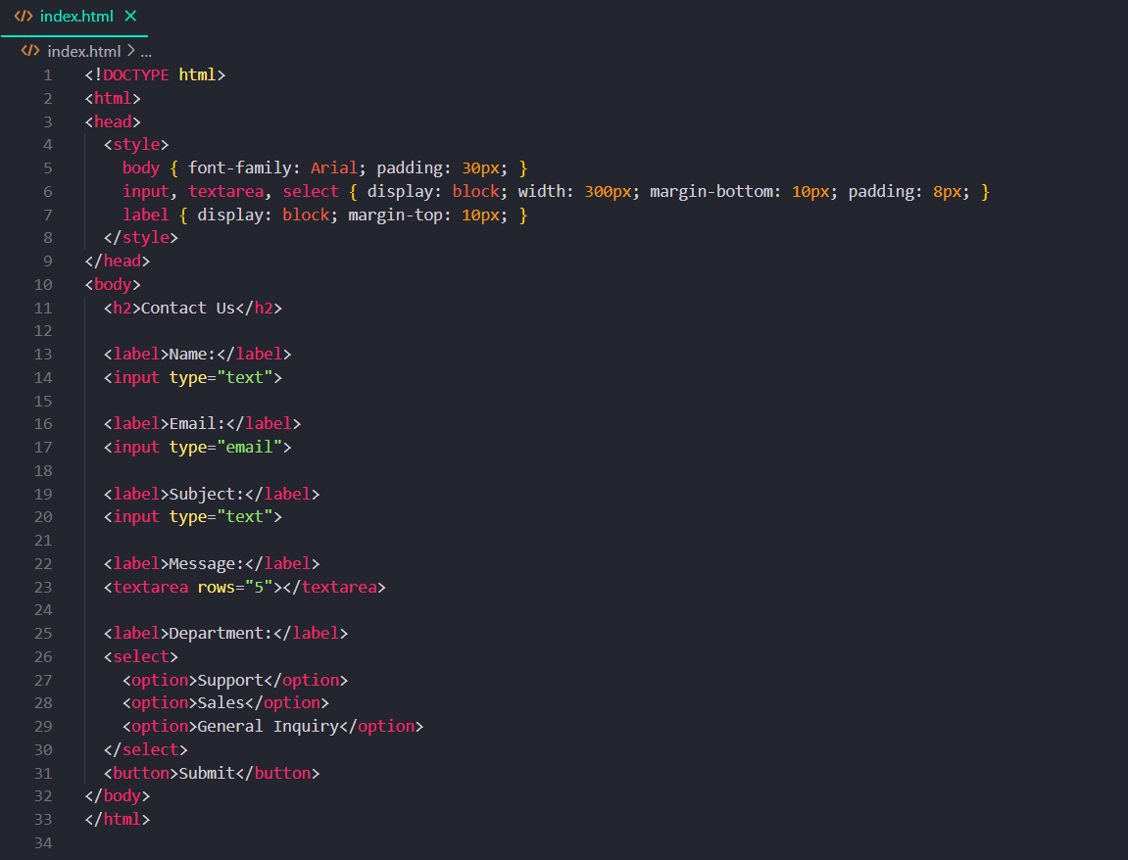
LAB TASK 1: Evaluate a Web Form

Screen Complexity Calculation (Original Form)
UI Element | Count | Weight | Total
Heading (h2) | 1 | 1.5 | 1.5
Labels | 5 | 1 | 5
Text Inputs | 2 | 2 | 4
Email Input | 1 | 2 | 2
Textarea (Message) | 1 | 2 | 2
Dropdown | 1 | 3 | 3
Button | 1 | 2 | 2
Total SCS |  |  | 19.5

Screen Complexity = 19.5

LAB TASK 2: Redesign Page to Reduce Complexity
Strategies:
- Use grouped fields with labels inside inputs.
- Add icons inside inputs for intuitive hints.
- Replace dropdowns with radio buttons (if few options).
- Use collapsible sections if many fields

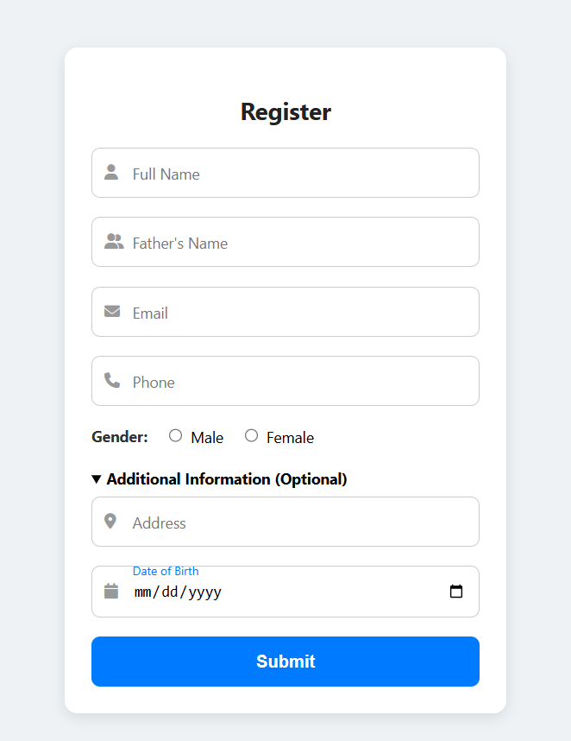

LAB TASK 4: Calculate and analyse the screen complexity of images given.

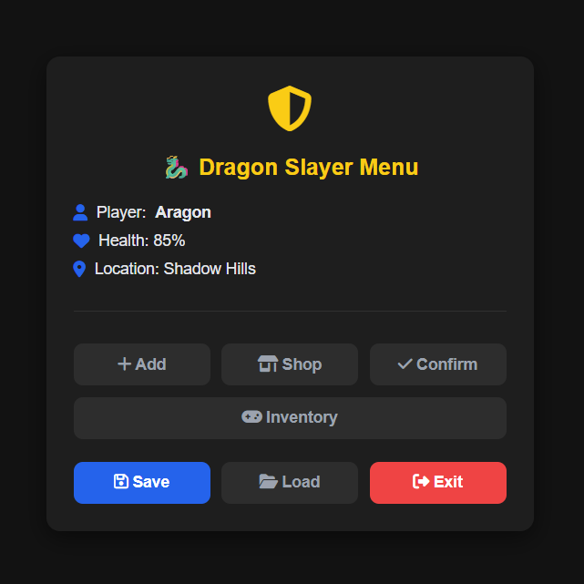
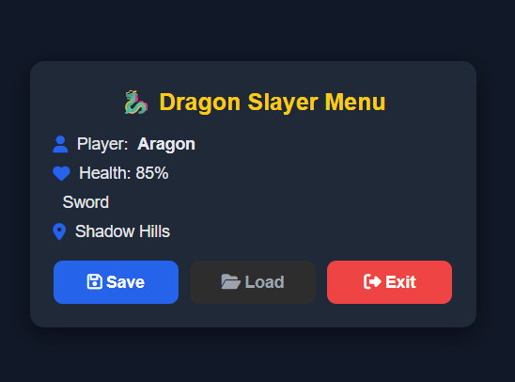
LAB TASK 5: write html code to Visually Redesign.

Task 6: Evaluate a Web Form
Original Form Elements
UI Element | Count | Details
Heading (h2) | 1 | "Contact Us"
Labels | 4 | Name, Email, Phone, Message
Text Input Fields | 3 | Name, Email, Phone
Textarea | 1 | Message box
Button | 1 | Submit button

Grouping
- Group 1: Personal Info (Name, Email, Phone)
- Group 2: Message Section (Message box)
- Group 3: Submit Action (Button)
Screen Complexity Calculation
Type | Count | Examples
Graphical Elements (A) | 5 | 3 input boxes, 1 textarea, 1 button box
Alphanumeric (B) | 6 | Heading, 4 labels, button text
SC=A+B=5+6=11

Reduced Complexity (After Grouping & Redesign)

UI Element | Count | Details
Heading (h2) | 1 | "Contact Us"
Labels (Grouped) | 3 | Personal Info, Message, Submit
Input Fields | 3 | Name, Email, Phone
Textarea | 1 | Message box
Button | 1 | Submit
- Graphical Elements (A) = 5 (same as before)
- Alphanumeric Elements (B) = 5 (reduced, because labels are grouped)
SC=A+B=5+5=10

Task 7: Use Html to Visually Redesign
Recreate the original and redesigned layout.
Show how grouping reduces visual load
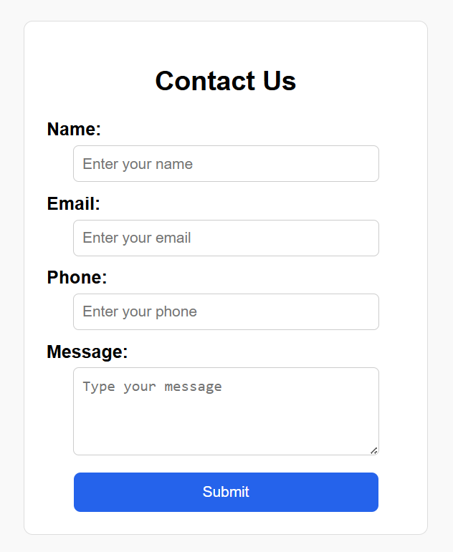

Redesign:
