
NATIONAL UNIVERSITY OF MODERN LANGUAGES
Human Computer Interaction lab Report – 6

NAME: Abdul Rafay
ROLL NO: FL23791
PROGRAM: BSSE (5th Semester)
COURSE: HUMAN COMPUTER INTERACTION
SUBMITTED TO: Sir Khateeb khan

DATE: 15 Oct 2025 DAY: Tuesday

Class Task: Program to capture the create a viewport in the output window.
#include <GL/glut.h> // Header File For The GLut Library
void draw() {
// Make background color yellow
glClearColor(1.0, 1.0, 0.0, 0.0);
glClear(GL_COLOR_BUFFER_BIT);
// Sets up viewport spanning the entire window (500x500)
glViewport(0, 0, 500, 500);
// Sets up the PROJECTION matrix
glMatrixMode(GL_PROJECTION);
glLoadIdentity();
gluOrtho2D(-500.0, 500.0, -500.0, 500.0); // sets up world window (left, right, bottom, top)
// Draw BLUE rectangle
glColor3f(0, 0, 1);
glRectf(-250.0, -250.0, 250.0, 250.0);
// Display rectangles
glutSwapBuffers();
}
// Keyboard method to allow ESC key to quit
void keyboard(unsigned char key, int x, int y) {
if (key == 27) exit(0);
}
int main(int argc, char** argv) {
glutInit(&argc, argv);
// Double Buffered RGB display
glutInitDisplayMode(GLUT_RGB | GLUT_DOUBLE);
// Set window size
glutInitWindowSize(500, 500);
glutCreateWindow("Single viewport spans the window");
// Declare the display and keyboard functions
glutDisplayFunc(draw);
glutKeyboardFunc(keyboard);
// Start the Main Loop
glutMainLoop();
return 0;
}
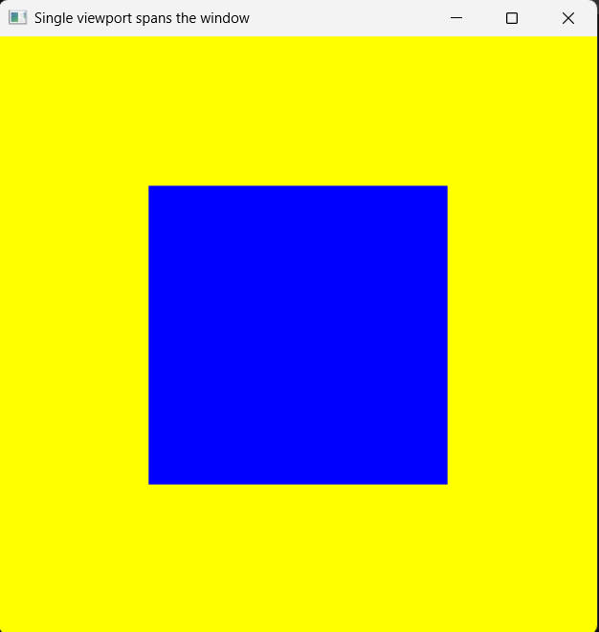
Output :

Lab Tasks
- Draw a static blue rectangle only in the bottom-left viewport using world coordinates.
#include <GL/glut.h> // GLUT header
#include <GL/glu.h> // GLU header for gluOrtho2D
#include <stdlib.h> // for exit()
void draw() {
// Clear the background with yellow color
glClearColor(1.0, 1.0, 0.0, 1.0);
glClear(GL_COLOR_BUFFER_BIT);
// ---------------------------
// Bottom-left viewport setup
// ---------------------------
glViewport(0, 0, 250, 250); // bottom-left quarter of 500x500 window
// Set up projection for this viewport
glMatrixMode(GL_PROJECTION);
glLoadIdentity();
gluOrtho2D(-500.0, 500.0, -500.0, 500.0); // world coordinates
// Set modelview (for drawing)
glMatrixMode(GL_MODELVIEW);
glLoadIdentity();
// Draw blue rectangle (in world coordinates)
glColor3f(0.0, 0.0, 1.0); // blue color
glRectf(-250.0, -250.0, 250.0, 250.0);
// Swap buffers to display
glutSwapBuffers();
}
// Keyboard: press ESC to quit
void keyboard(unsigned char key, int x, int y) {
if (key == 27) exit(0);
}
int main(int argc, char** argv) {
glutInit(&argc, argv);
glutInitDisplayMode(GLUT_RGB | GLUT_DOUBLE);
glutInitWindowSize(500, 500);
glutCreateWindow("Blue Rectangle in Bottom-Left Viewport");

glutDisplayFunc(draw);
glutKeyboardFunc(keyboard);

glutMainLoop();
return 0;
}
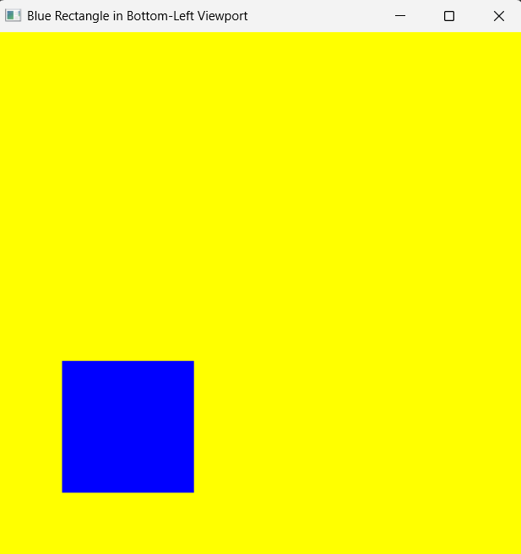
Output:

- Create two viewports side-by-side:
Left: shows the full world (-100 to 100).
Right: shows a zoomed-in view (-50 to 50).
#include <GL/glut.h>
#include <GL/glu.h>
#include <stdlib.h>

// Draw a simple shape (a blue rectangle with coordinate axes)
void drawScene()
{
// Draw coordinate axes (in gray)
glColor3f(0.6f, 0.6f, 0.6f);
glBegin(GL_LINES);
glVertex2f(-100.0f, 0.0f);
glVertex2f(100.0f, 0.0f);
glVertex2f(0.0f, -100.0f);
glVertex2f(0.0f, 100.0f);
glEnd();
// Draw a blue rectangle in world coordinates
glColor3f(0.0f, 0.0f, 1.0f);
glRectf(-30.0f, -20.0f, 30.0f, 20.0f);
}
void display()
{
glClearColor(1.0, 1.0, 0.0, 1.0); // Yellow background
glClear(GL_COLOR_BUFFER_BIT);
// ---------------------------
// Left Viewport (Full World)
// ---------------------------
glViewport(0, 0, 250, 500); // Left half of the window
glMatrixMode(GL_PROJECTION);
glLoadIdentity();
gluOrtho2D(-100.0, 100.0, -100.0, 100.0); // full world view
glMatrixMode(GL_MODELVIEW);
glLoadIdentity();

drawScene(); // draw same scene
// ---------------------------
// Right Viewport (Zoomed-In)
// ---------------------------
glViewport(250, 0, 250, 500); // Right half of the window
glMatrixMode(GL_PROJECTION);
glLoadIdentity();
gluOrtho2D(-50.0, 50.0, -50.0, 50.0); // zoomed-in view
glMatrixMode(GL_MODELVIEW);
glLoadIdentity();
drawScene(); // draw same scene again (but zoomed)
glutSwapBuffers();
}
// Keyboard handler (ESC to exit)
void keyboard(unsigned char key, int x, int y)
{
if (key == 27)
exit(0);
}
int main(int argc, char** argv)
{
glutInit(&argc, argv);
glutInitDisplayMode(GLUT_RGB | GLUT_DOUBLE);
glutInitWindowSize(500, 500);
glutCreateWindow("Two Side-by-Side Viewports");

glutDisplayFunc(display);
glutKeyboardFunc(keyboard);

glutMainLoop();
return 0;
}
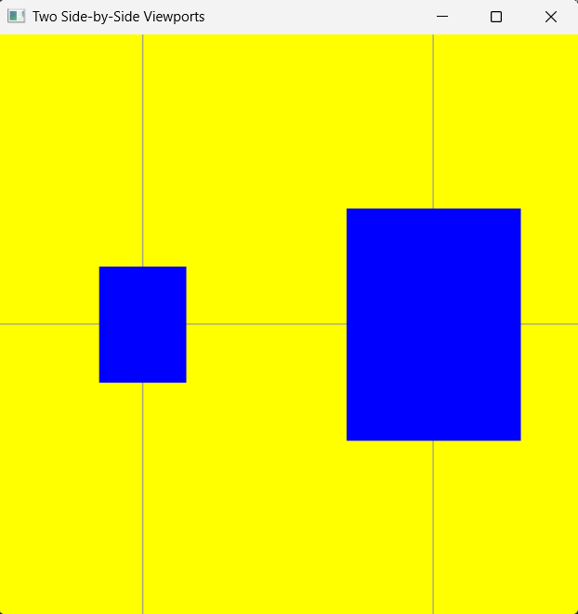
Output:

