
NATIONAL UNIVERSITY OF MODERN LANGUAGES
Software Construction And Development lab Report - 2

NAME: M Abdul Rafay (FL23791)
M Usman Tanveer (FL23848)
Zulkifal (SP23660)
Elisha Abbasi (SP23606)

PROGRAM: BSSE (5th Semester)
COURSE: Software Construction and Development
SUBMITTED TO: Sir Ahsan Arif

DATE: 9/21/2025 DAY: Sunday

Lab Tasks
Task 1: Create class diagram to model the structural view of online bookstore system.
- Identify the main classes
- Define attributes and methods for each class.
- Establish relationships (associations, inheritance, and dependencies) between classes.
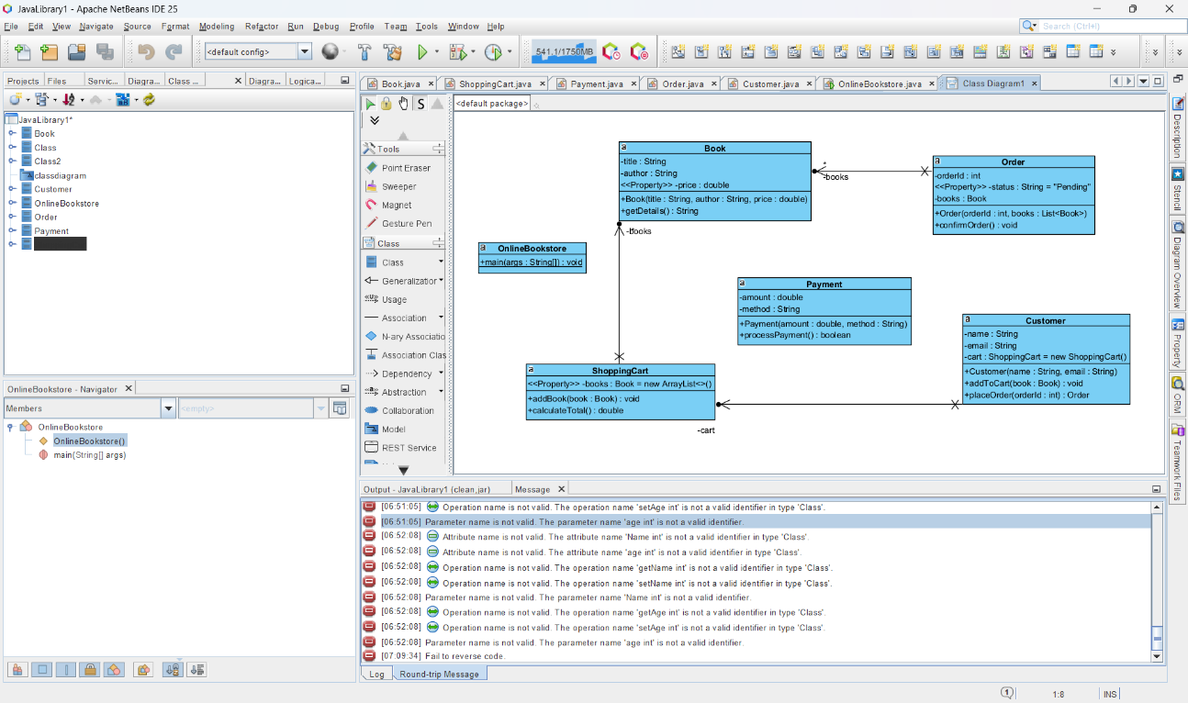
- Use appropriate visibility indicators (public, private, protected)

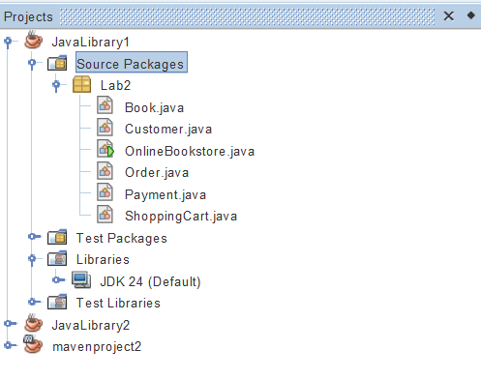
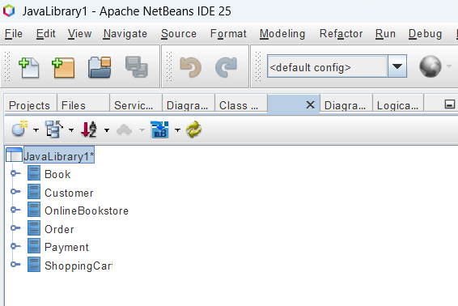

Task 2: Sequence Diagram
