
NATIONAL UNIVERSITY OF MODERN LANGUAGES
Software Construction And Development lab Report - 5

NAME: M Abdul Rafay (FL23791)
M Usman Tanveer (FL23848)
Zulkifal (SP23660)
Elisha Abbasi (SP23606)

PROGRAM: BSSE (5th Semester)
COURSE: Software Construction and Development
SUBMITTED TO: Sir Ahsan Arif

DATE: 9/29/2025 DAY: Monday

Lab Task
Case study:
Ali logs into the Daraz platform to purchase a smartphone. He navigates to the search bar and enters the product name “smartphone.” The Daraz system retrieves relevant products from its Product Catalog, displaying various smartphone options that match the search query. After browsing through the list, Ali selects a particular smartphone, reviews its details, including price, features, and customer ratings. Once satisfied, he adds the smartphone to his Shopping Cart. Ali proceeds to the checkout page, where the Order Manager validates the smartphone’s availability and calculates the total cost, including any discounts or promotions. Ali selects his delivery address and preferred shipping method, and the Shipping Service provides an estimated delivery time and cost. He chooses credit card as payment method, and enters the payment details. The Payment Gateway securely processes the payment, and upon successful confirmation, the Order Manager finalizes the purchase. A confirmation message is sent to Ali via email or SMS through the Notification Service, and the smartphone is dispatched for delivery.
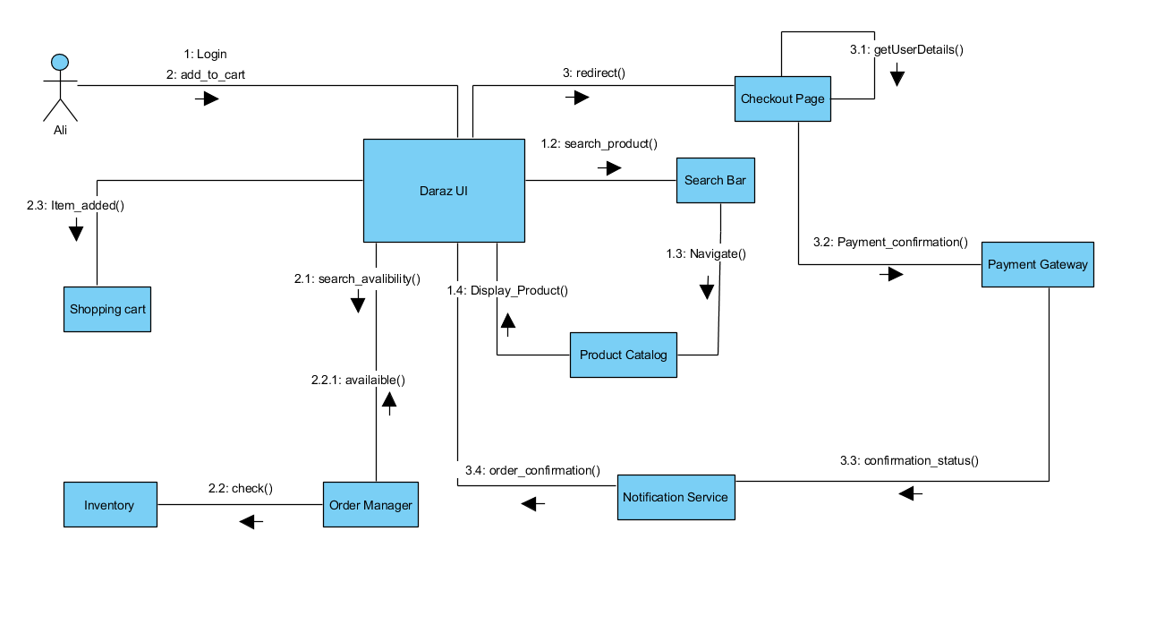
Lab Task
Create the communication diagram for the above-mentioned scenario.

