
NATIONAL UNIVERSITY OF MODERN LANGUAGES
Software Construction And Development Assigment- 1

NAME: Abdul Rafay
ROLL NO: FL23791
PROGRAM: BSSE (5th Semester)
COURSE: Software Construction and Development
SUBMITTED TO: Sir Ahsan Arif

DATE: 1, Oct 2025 DAY: Wednesday

Question no 1: Brief Description of the Project
The NHS COVID Vaccination Management System is a digital system that helps manage vaccination appointments and vaccine stock. Citizens can book or rebook vaccination appointments at registered vaccination centers. The system makes sure that all booking rules are followed, such as age limits, time gap between doses, and vaccine brand restrictions. Vaccination center administrators can manage vaccine stock, working hours, and available appointments. Vaccination staff can update the citizen’s vaccination record after giving the shot, and the system automatically reduces the vaccine stock. In this way, the system ensures smooth booking, proper use of vaccine stock, and updated citizen records.
Question no 2: Scope of the System
Stakeholders
- Citizens – Book or rebook vaccination appointments, receive reminders, and keep their vaccination history updated.
- Vaccination Center Administrators – Manage vaccine stock, working hours, and appointment slots.
- Vaccination Staff – Record consent, administer vaccines, and update citizen vaccination records.
- NHS (System Owners) – Oversee the whole system to ensure efficiency and accurate reporting.

Needs
- Citizens need an easy way to book or rebook appointments online.
- Administrators need tools to update vaccine stock and appointment schedules.
- Staff need a simple method to record vaccination details.
- The system needs to automatically check booking rules (age, vaccine brand, and time gap between doses).

Goals
- To provide a smooth and fair appointment booking system for all citizens.
- To prevent overbooking by controlling available appointments per slot.
- To keep accurate vaccine stock records that update automatically after each vaccination.
- To make sure vaccination rules (age, brand, and time gap) are applied correctly.
- To reduce manual work and errors for administrators and staff.

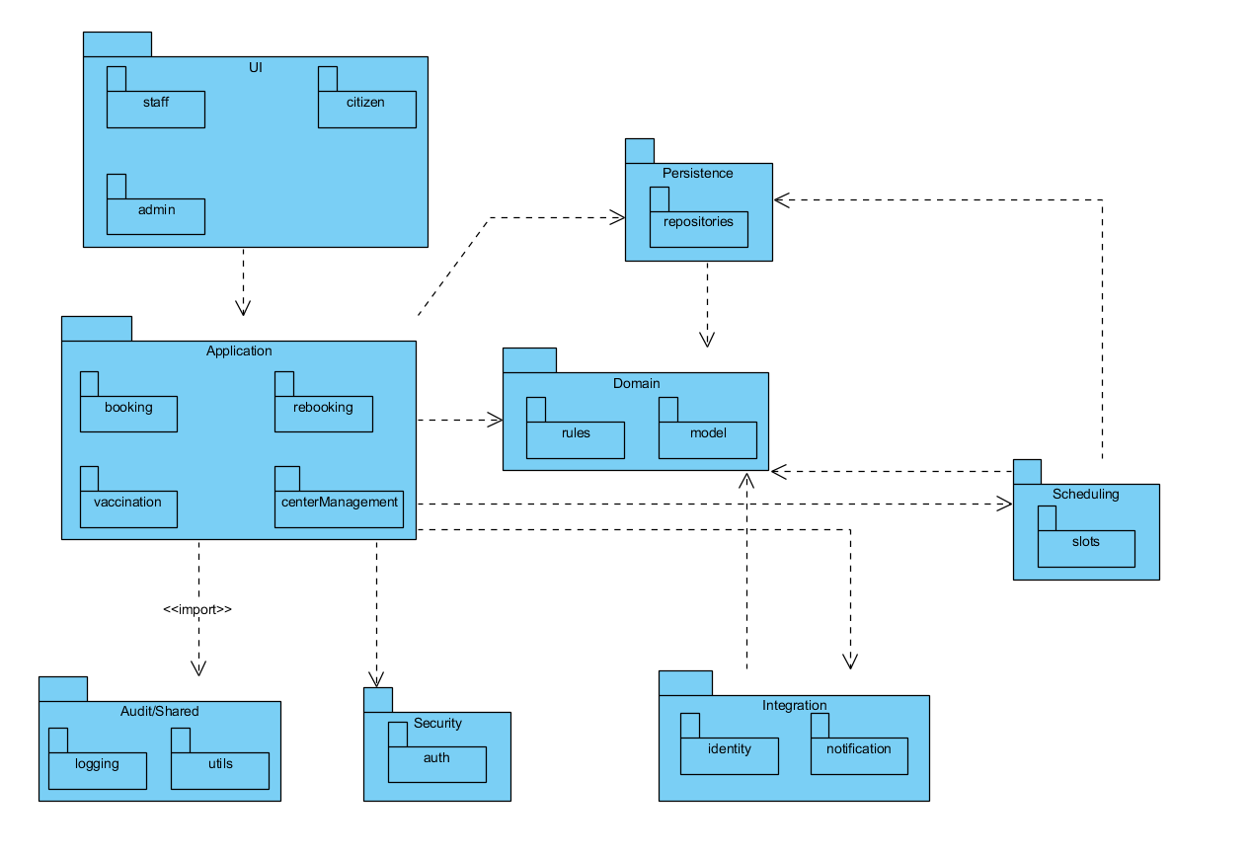
Question No 3: Implementation of Package diagram for the above-mentioned scenario.

