
NATIONAL UNIVERSITY OF MODERN LANGUAGES
Analysis Of Algorithm Presentation Project Report

NAME: Abdul Rafay (FL23791)
Nazish Khan (FL23843)
Ali Atif (FL23824)
Zohaib Ijaz (FL23811)

ROLL NO: FL23791
PROGRAM: BSSE (5th Semester)
COURSE: Analysis Of Algorithm
SUBMITTED TO: Sir Waris Ali

DATE: 9/16/2025 DAY: Tuesday

Longest Common Subsequence and Matrix Chain Multiplication

1. Introduction
Algorithm Design and Analysis is a fundamental subject in computer science that focuses on developing efficient solutions to computational problems. This report covers two important dynamic programming problems: Longest Common Subsequence (LCS) and Matrix Chain Multiplication (MCM). Both problems demonstrate how optimal solutions can be obtained by breaking complex problems into simpler overlapping subproblems.

2. Longest Common Subsequence (LCS)

2.1 Definition
The Longest Common Subsequence (LCS) problem involves finding the longest sequence that appears in the same order (not necessarily contiguously) in two given sequences. It is commonly applied to string comparison problems.
Example:
- Sequence 1: ABC
- Sequence 2: CAB
- LCS: AB

2.2 Importance of LCS
The LCS problem is widely used in:
- File comparison tools
- Version control systems
- DNA sequence analysis
- Text similarity checking

2.3 Dynamic Programming Approach
To solve the LCS problem efficiently, a dynamic programming table is used. The idea is to store results of subproblems so that they are not recomputed.

Conditions Used
- If i = 0 or j = 0, then C[i][j] = 0
- If Xi = Yj, then
C[i][j] = C[i-1][j-1] + 1
- Otherwise,
C[i][j] = max(C[i-1][j], C[i][j-1])

2.4 Example
Given Sequences:
- Seq1: ABCDEFG
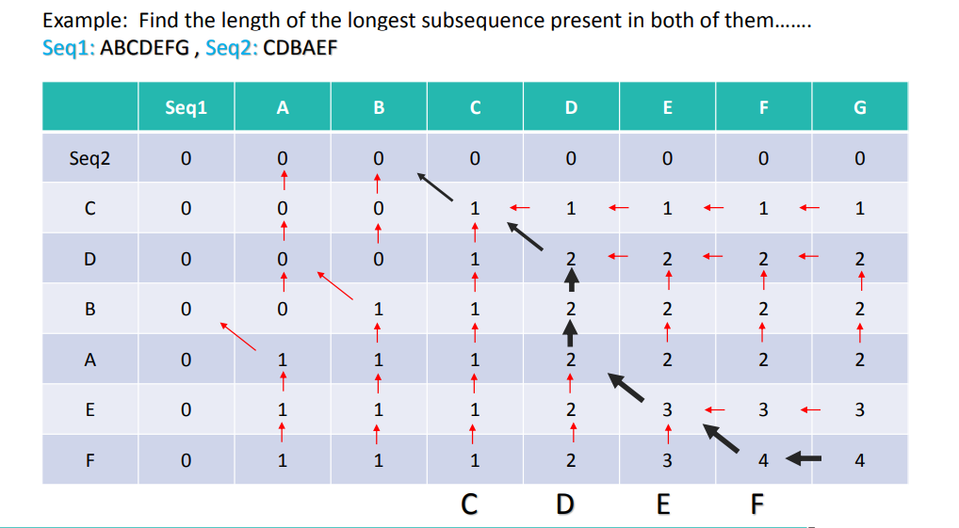
- Seq2: CDBAEF

2.5 Algorithm for LCS
- Find lengths of both sequences
- Create two matrices B and C
- Initialize first row and column with zero
- Compare characters of both sequences
- Fill the table using recurrence relations
- Return the length and sequence of LCS

3. Matrix Chain Multiplication (MCM)

3.1 Definition
Matrix Chain Multiplication is the problem of finding the most efficient way to multiply a chain of matrices by choosing an optimal order of parenthesization.
Important Note:
Matrix multiplication is associative but not commutative, meaning the order of multiplication affects the cost.

3.2 Objective
The main goal of MCM is to minimize the total number of scalar multiplications, not to change the result of the multiplication.

3.3 Applications of MCM
- Compiler design (code optimization)
- Database query optimization
- Scientific computing

3.4 Cost Calculation
If matrix A has dimensions (p × q) and matrix B has dimensions (q × r),
then cost of multiplication = p × q × r.

3.5 Example
Given matrices:
- A1 = (5 × 4)
- A2 = (4 × 6)
- A3 = (6 × 2)
Two possible ways:
- (A1 A2) A3 → Cost = 180
- A1 (A2 A3) → Cost = 88
Optimal Solution: A1 (A2 A3)

3.6 Dynamic Programming Formula
Let m[i][j] represent the minimum cost of multiplying matrices from Ai to Aj.
$$m(i,j)=\underset{i≤k<j}{min⁡}\{m(i,k)+m(k+1,j)+p_{i-1}×p_{k}×p_{j}\}$$
Base Case:
$$m(i,i)=0$$

3.7 Parenthesization Count
The number of ways to parenthesize n matrices is given by the Catalan number formula.

3.8 Final Result
Using dynamic programming tables M (cost table) and S (split table), the minimum cost and optimal parenthesization are determined efficiently.
Optimal Parenthesization Example:
$$\left((A_{1}(A_{2}A_{3}))A_{4}\right)$$

4. Comparison of LCS and MCM
Feature | LCS | MCM
Technique | Dynamic Programming | Dynamic Programming
Goal | Maximize sequence length | Minimize cost
Input | Sequences | Matrix dimensions
Output | LCS length/sequence | Optimal parenthesization

5. Conclusion
Both Longest Common Subsequence and Matrix Chain Multiplication are classic examples of dynamic programming problems. They show how complex problems can be solved efficiently by storing intermediate results. Understanding these algorithms helps in building a strong foundation for advanced topics in algorithm optimization and software development.

