

NATIONAL UNIVERSITY OF MODERN LANGUAGES
Computer Networks Lab No 7

NAME: M Abdul Rafay
ROLL NO: FL23791
PROGRAM: BSSE (5th Semester)
COURSE: Computing Networks
SUBMITTED TO: Mam Anam Taskeen

LAB 7: Cisco Discovery Protocol (CDP) and Servers

Task 1: CDP Neighbor Information
In this task, CDP is used to discover directly connected Cisco devices and their details.
Commands Used
Router# show cdp neighbors
Router# show cdp neighbors detail
These commands display:
- Neighbor device IDs
- Interface details
- Platform and capability information
- IP addresses of connected devices
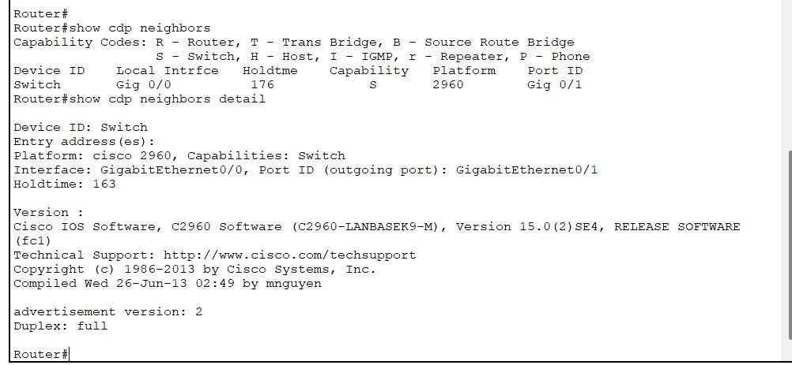
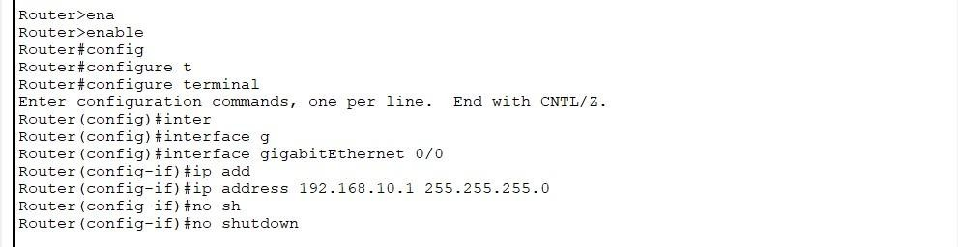

Task 2: Disable CDP Globally
To disable Cisco Discovery Protocol on the entire router, the following command is used:
Router# no cdp run
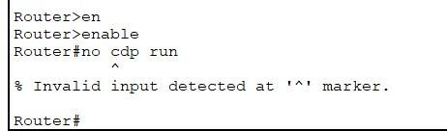
This command stops CDP advertisements and prevents the router from sharing device information.

Task 3: Disable CDP on a Specific Interface
CDP can also be disabled on a single interface instead of the whole router.
Configuration Commands
Router(config)# interface FastEthernet 0/1
Router(config-if)# no cdp enable
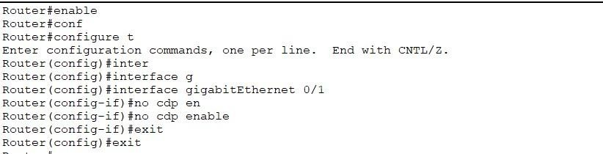
This ensures CDP is not active on the selected interface only.

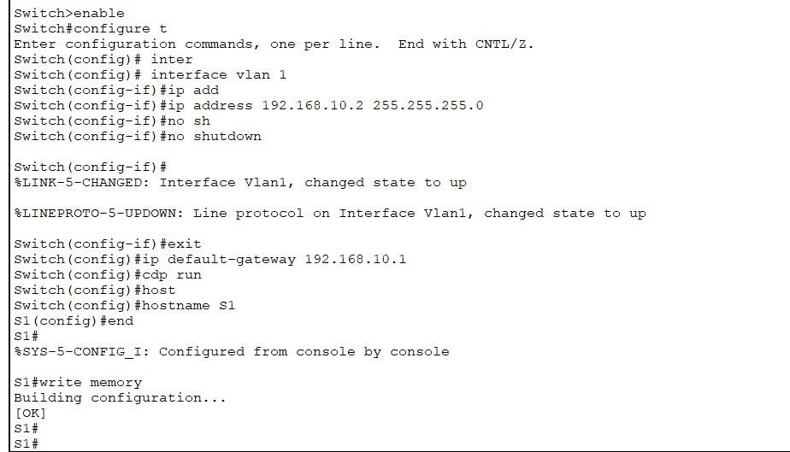
Switch configuration

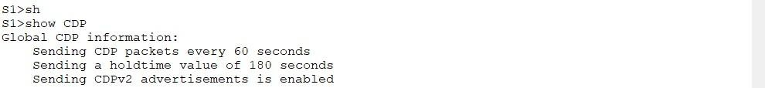
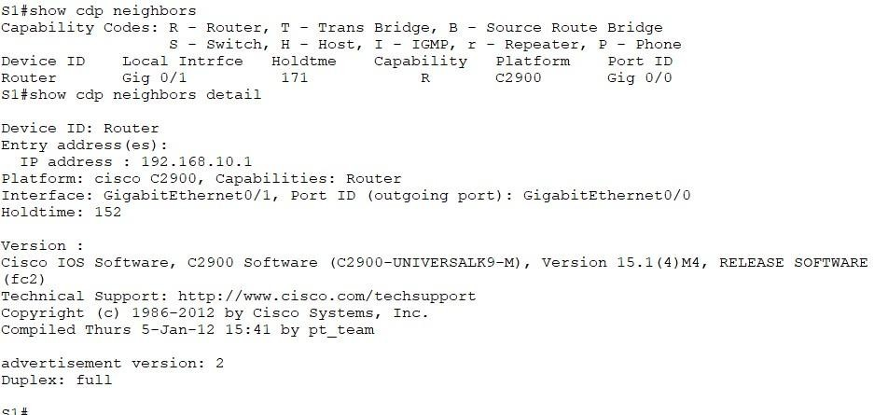
CDP Checking

Server configuration
Step 1 — Give the Server a Static IP
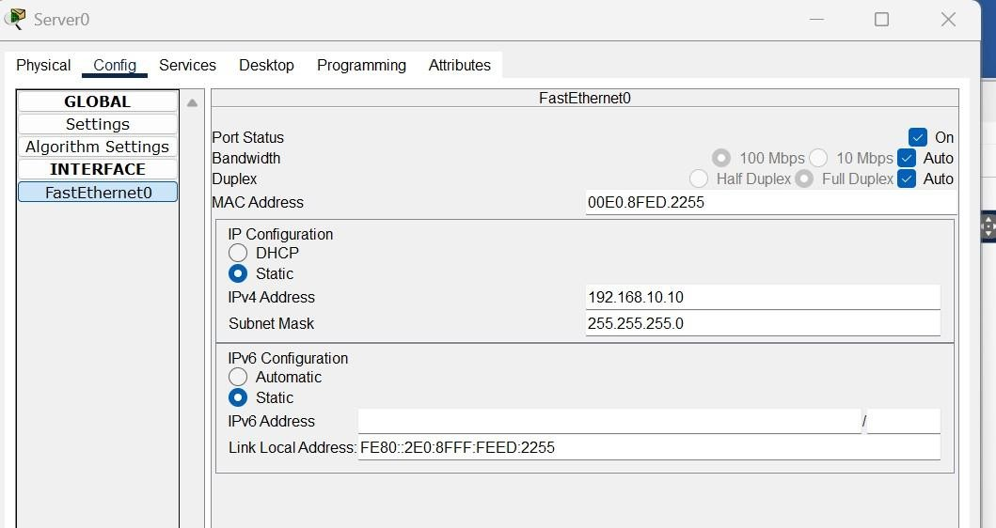
1. On the Server → Config > FastEthernet

Step 2 — Enable DHCP Service
1. Server > Services > DHCP

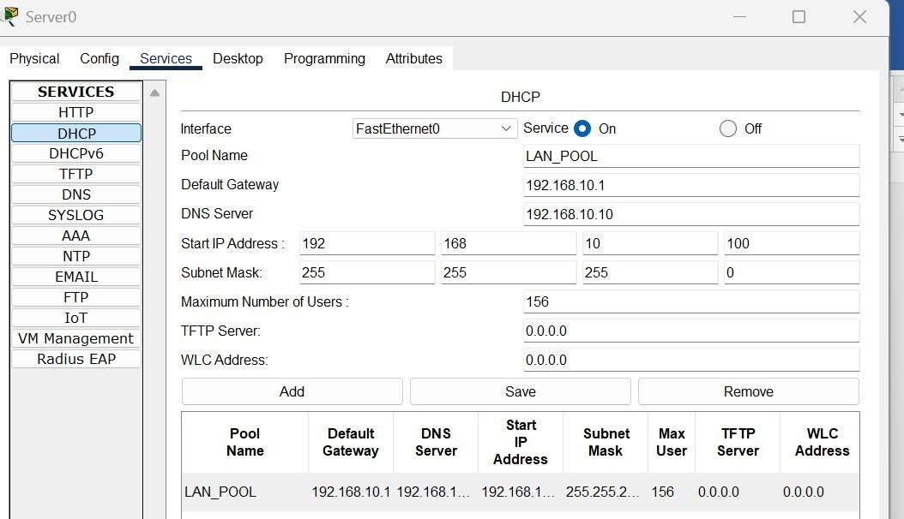

Step 3 — Set PCs to Obtain IP via DHCP
For PC1 and PC2:
Desktop > IP Configuration > select DHCP
