
NATIONAL UNIVERSITY OF MODERN LANGUAGES
Human Computer Interaction Final Exam

NAME: Abdul Rafay
ROLL NO: FL23791
PROGRAM: BSSE (5th Semester)
COURSE: HUMAN COMPUTER INTERACTION
SUBMITTED TO: Sir Khateeb khan

DATE: 30 Sep 2025 DAY: Tuesday

Question 01: Designing Icons for “Smart Campus” Mobile Application
Tool Used
Figma
(Icons designed following mobile UI standards)
Icon Sizes
- 24 × 24 px
- 48 × 48 px
Design Consistency
- Same color theme
- Same stroke style
- Simple and minimal design
- Suitable for mobile screens
1. Attendance Icon
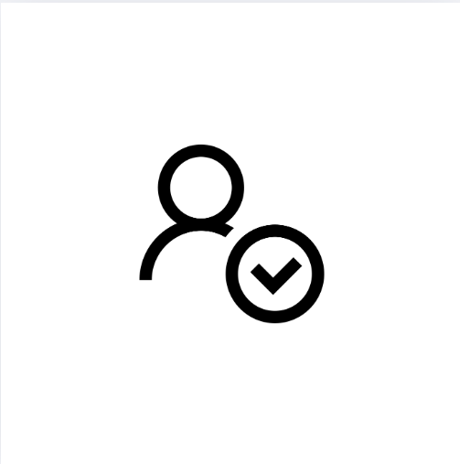
Meaning:
Represents student attendance records.
The checkmark/calendar symbol shows presence and tracking of attendance.
2. Time Table Icon

Meaning:
Represents class schedules and daily lectures.
The clock/table layout indicates time management and planning.
3. Fee Payment Icon
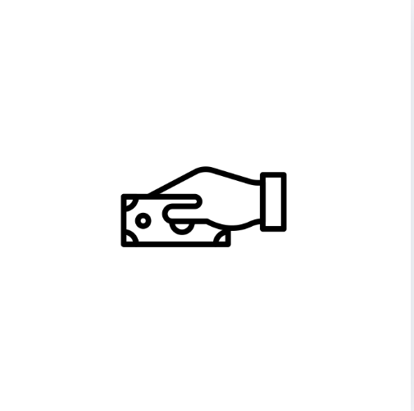
Meaning:
Represents payment of university fees.
The currency/card symbol shows financial transactions clearly.

4. Notifications Icon

Meaning:
Represents alerts and important announcements.
The bell icon indicates new updates and messages for students.

HCI Concepts Applied
- Visibility: Icons are clearly visible and understandable
- Affordance: Icons suggest their function naturally
- Consistency: Same style and size across all icons
Question 02: Interactive Cube with Visual Feedback (Unity)
Objective
To demonstrate the HCI principle of feedback by changing the cube’s color when it moves using keyboard input.

Scene Description
- A Cube is placed on a flat surface
- The cube moves left and right using arrow keys
- Color changes temporarily when movement occurs
Components Used
- Cube GameObject
- Plane (Ground)
- Rigidbody (for physics)
- Two Materials (Normal & Feedback)
- C# Script (for movement and color change)
Working of the System
- Left Arrow ⬅ → Cube moves left
- Right Arrow ➡ → Cube moves right
- During movement:
  - Cube color changes to show visual feedback
  - After 0.5 seconds, color returns to normal

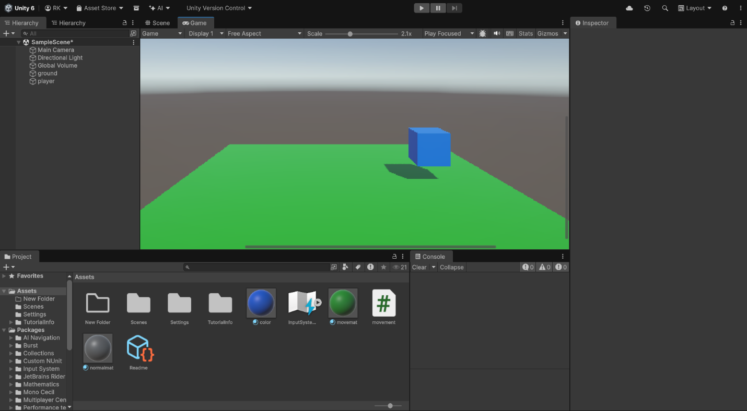
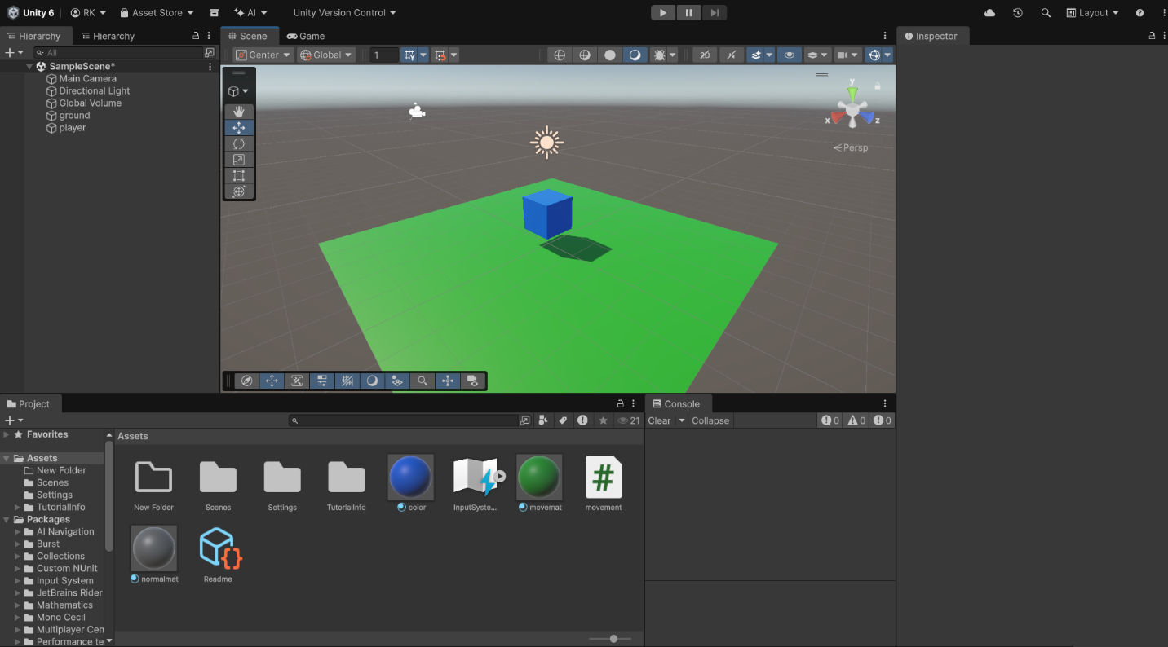
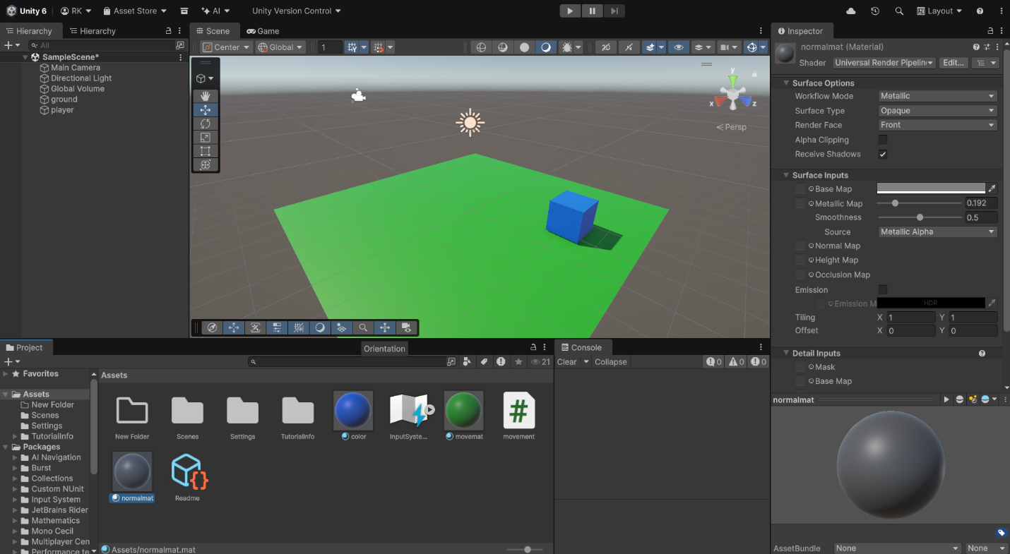
Code:
using System.Collections;
using UnityEngine;
using UnityEngine.InputSystem;

public class CubeMovement : MonoBehaviour
{
public float speed = 5f;
public Material normalMaterial;
public Material moveMaterial;

Rigidbody rb;
Renderer rend;

void Start()
{
rb = GetComponent<Rigidbody>();
rend = GetComponent<Renderer>();
rend.material = normalMaterial;
}

void Update()
{
if (Keyboard.current.leftArrowKey.isPressed)
{
rb.linearVelocity = new Vector3(-speed, rb.linearVelocity.y, 0);
StartCoroutine(ChangeColor());
}
else if (Keyboard.current.rightArrowKey.isPressed)
{
rb.linearVelocity = new Vector3(speed, rb.linearVelocity.y, 0);
StartCoroutine(ChangeColor());
}
else
{
rb.linearVelocity = new Vector3(0, rb.linearVelocity.y, 0);
}
}

IEnumerator ChangeColor()
{
rend.material = moveMaterial;
yield return new WaitForSeconds(0.5f);
rend.material = normalMaterial;
}
}

