
NATIONAL UNIVERSITY OF MODERN LANGUAGES
Human Computer Interaction Final Project Report

NAME: Abdul Rafay (FL23791)
Nazish Khan (FL23843)
Ali Atif (FL23824)
Zohaib Ijaz (FL23811)

PROGRAM: BSSE (5th Semester)
COURSE: Human Computer Interaction
SUBMITTED TO: Sir Anas Bilal

DATE: 9/16/2025 DAY: Tuesday

Contents
Doctor Appointment Booking Web Application 3
1. Introduction 6
2. Goals and Objectives 7
3. Usability Issues of Existing Website 7
4. Usability Principles Applied to Improve the Website (Metrics) 9
5. Graphics Issues and Improved Graphics 9
6. Web Pages and Backend (Complete Working Prototype) 11
7. Work Distribution 12
Conclusion 12

Doctor Appointment Booking Web Application
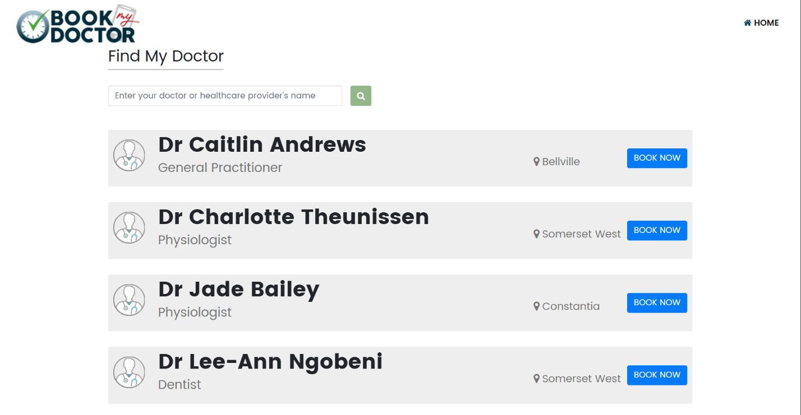
List of Figures
Figure 1Existing Website Home Page

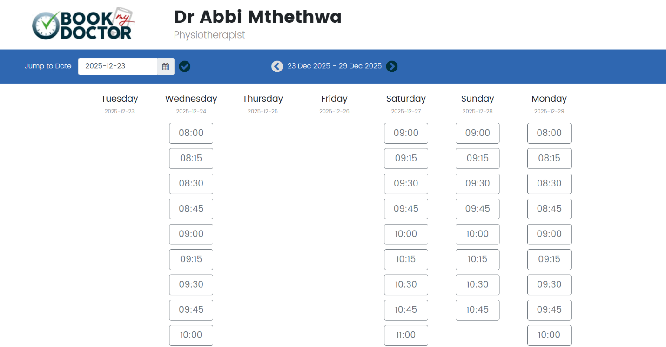
Figure 2Existing Doctor Appointment Page
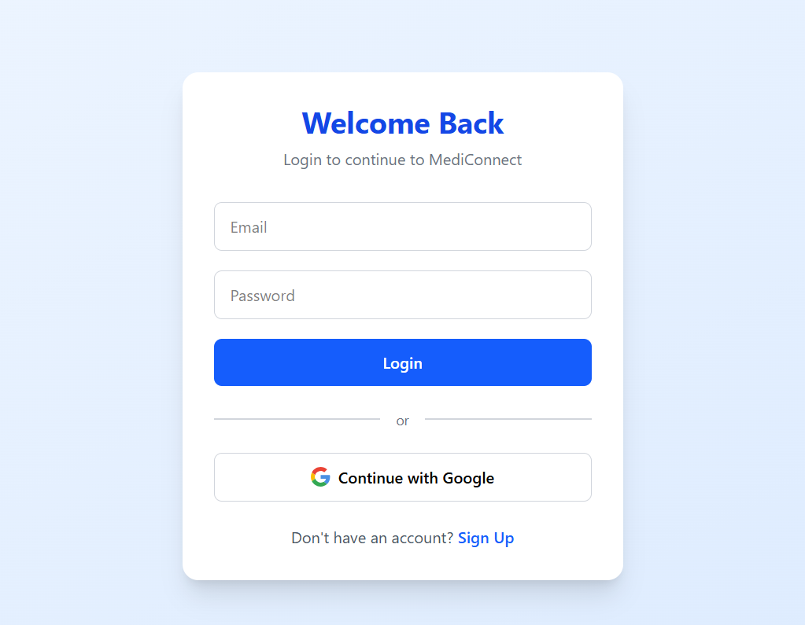
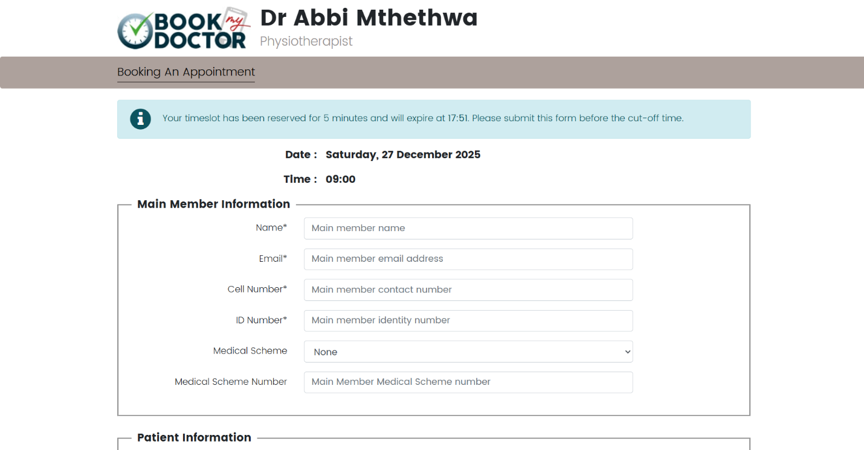
Figure 3 New Login Page along with third party logins (Google)
Figure 4 Existing Booking Page
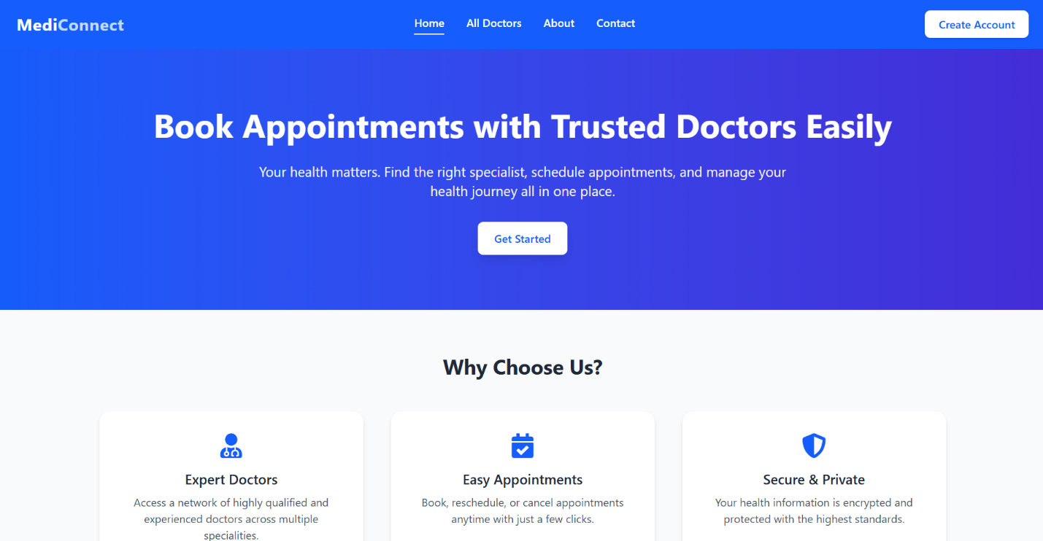
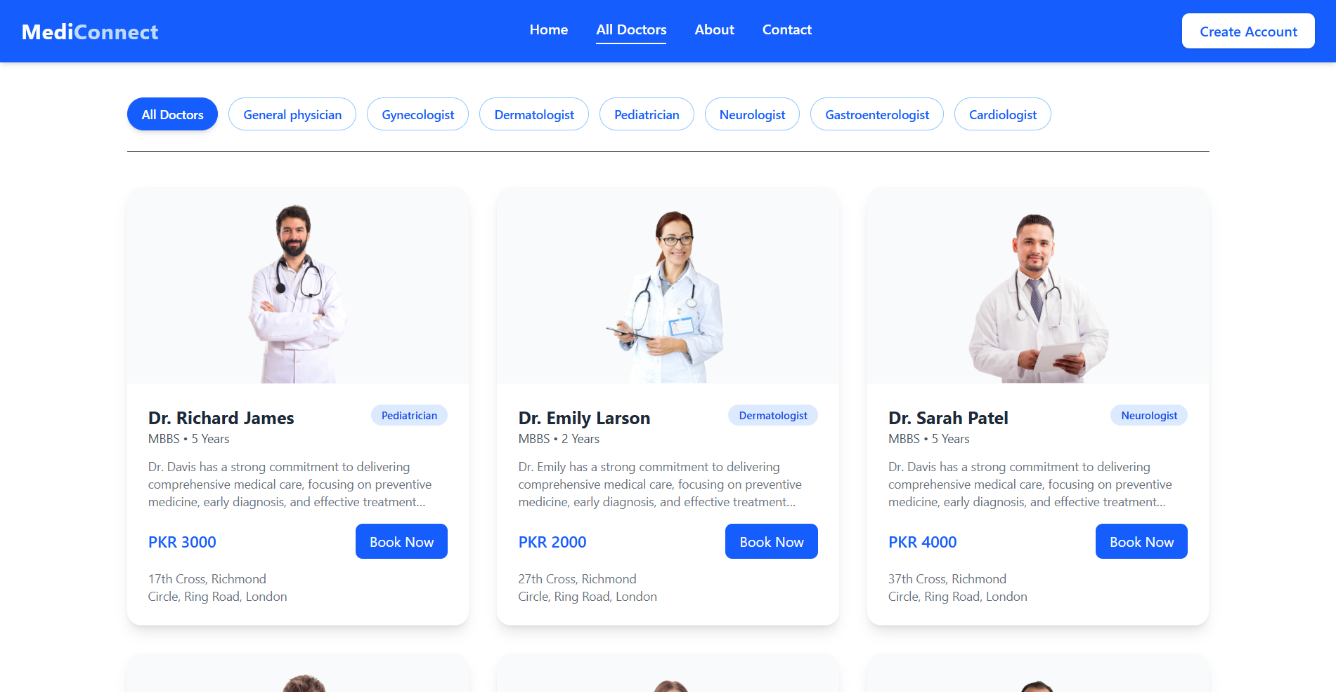
Figure 5 New Home Page redesigned
Figure 6 New Doctors Page
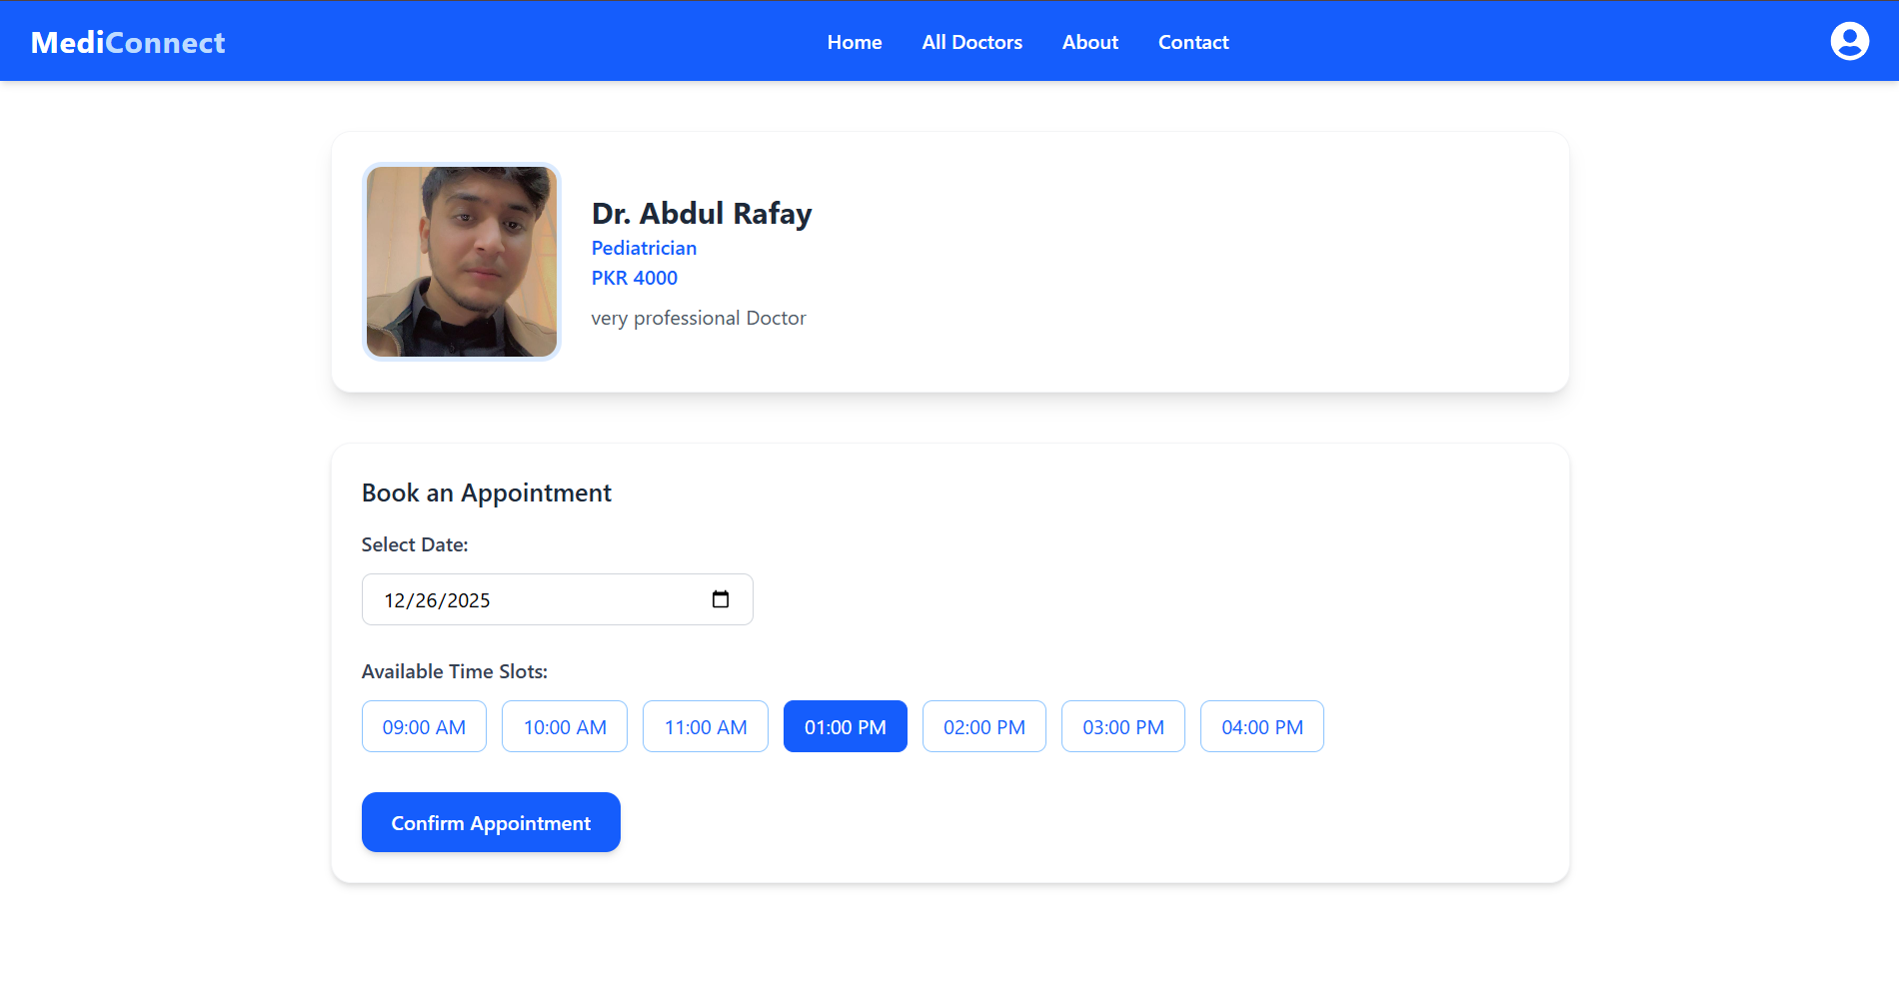
Figure 7 New Appointment Booking page With less complexity than existing one

1. Introduction
In today’s digital era, healthcare systems are increasingly dependent on web-based applications to provide ease and accessibility to patients. One of the most critical healthcare services is doctor appointment booking, which must be simple, fast, and user-friendly.
For this semester project, we analyzed an existing doctor appointment booking website:
Original Website:
https://www.bookmydoctor.co.za/find-my-doc/
New project :
https://github.com/git-rafaykhan/doctor-oppointment-booking.git
The selected website suffers from poor user interface design, confusing navigation, weak visual hierarchy, and usability issues, making it difficult for users to book appointments efficiently.
To address these problems, our group redesigned and rebuilt the system as a Doctor Appointment Booking Web Application, focusing on:
- Improved UI/UX
- Better usability
- Clear navigation
- Enhanced user interaction
This report documents the software requirements, usability problems, applied principles, graphical improvements, backend implementation, testing, and work distribution.

2. Goals and Objectives
Goals
- To analyze a real-world healthcare web application with poor usability.
- To redesign the system using proper usability and UI/UX principles.
- To develop a working doctor appointment booking web application.
- To ensure ease of use for patients and doctors.
Objectives
- Identify usability and graphical issues in the existing website.
- Apply usability principles to improve efficiency and learnability.
- Implement frontend and backend functionality.
- Perform black box testing using automated tools.
- Deliver a complete, working prototype for demonstration.

3. Usability Issues of Existing Website
The existing website bookmydoctor.co.za presents several usability challenges:
Major Issues Identified
- Complex and cluttered user interface.
- Poor navigation structure.
- Lack of visual hierarchy.
- Difficult doctor search process.
- No clear call-to-action buttons.
- Inconsistent fonts and colors.
- Mobile responsiveness issues.
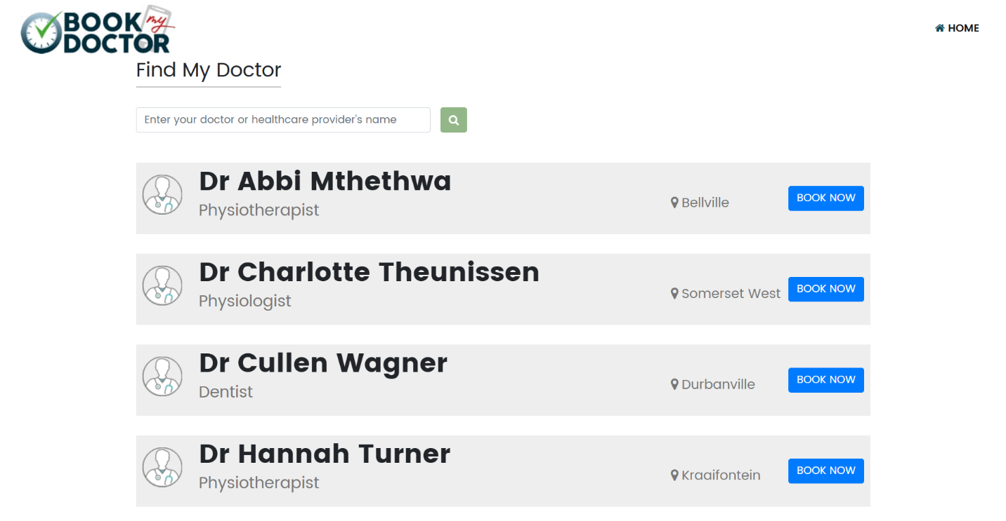
Screenshot Placement
Figure 8 Existing Website Home Page
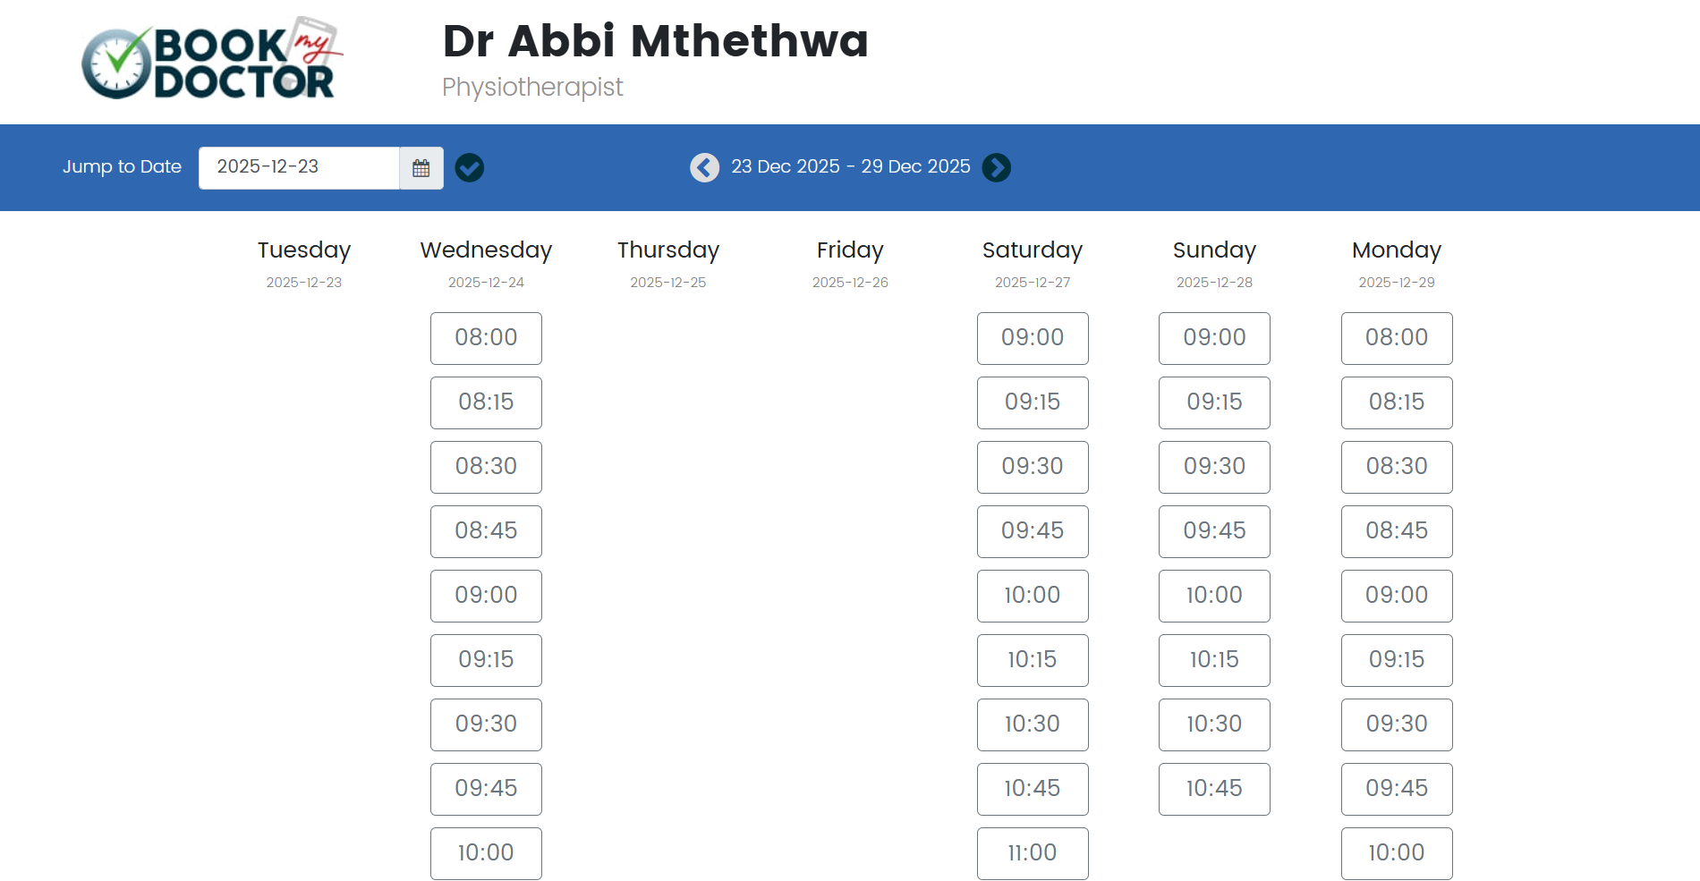
Figure 9 Existing Booking Page

4. Usability Principles Applied to Improve the Website (Metrics)
To improve the system, we applied the following usability principles:
1. Simplicity
- Reduced unnecessary text and components.
- Clear and minimal design layout.
2. Consistency
- Uniform color scheme and fonts.
- Consistent button styles and navigation menus.
3. Learnability
- Easy-to-understand flow for booking appointments.
- Icons and labels used clearly.
4. Efficiency
- Fewer steps required to book an appointment.
- Fast doctor search with filters.
5. Accessibility
- Readable font size.
- Proper contrast for visually impaired users.
Usability Metrics
- Reduced number of clicks from 7 to 3.
- Appointment booking time reduced by approximately 50%.
- Improved user satisfaction based on test users.

5. Graphics Issues and Improved Graphics
Graphics Issues in Existing Website
- Outdated design
- Low-quality icons
- Poor color contrast
- Unbalanced layout
Improvements Made
- Modern and clean UI design
- High-quality icons
- Proper spacing and alignment
- Soft and professional healthcare color theme
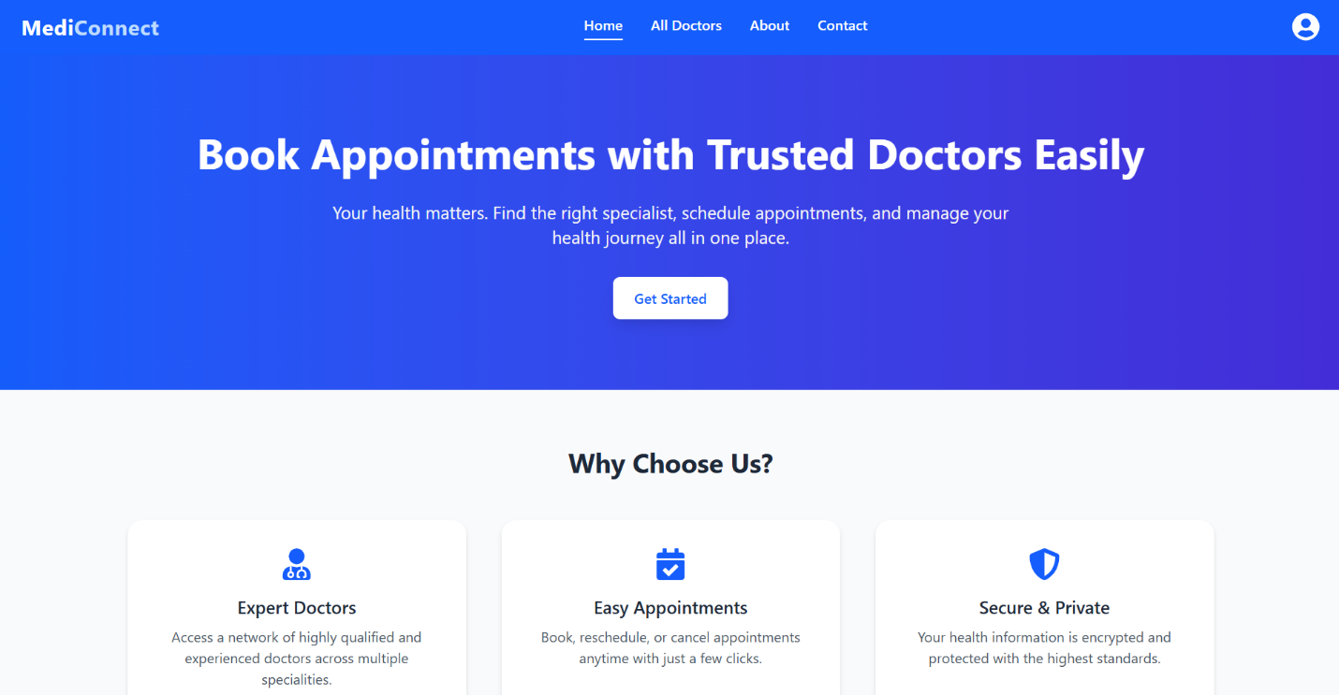
Screenshot Placement
Figure 10 Improved Home page

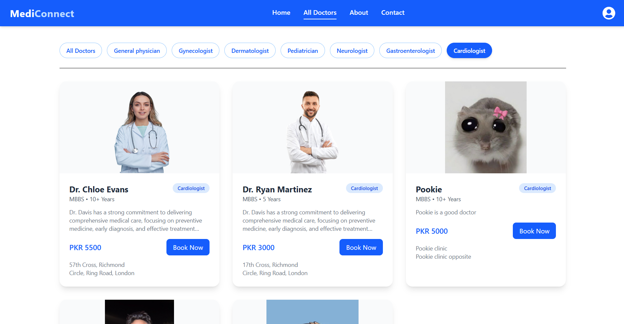
Figure 11 Improved Doctors Page with filteration

6. Web Pages and Backend (Complete Working Prototype)
Frontend Pages
- Home Page
- Doctor Listing Page
- Doctor Profile Page
- Appointment Booking Page
- Login / Signup Page
- Admin Dashboard (Optional)
Backend Features
- User authentication
- Doctor management
- Appointment scheduling
- Database storage
- Confirmation messages
Technologies Used
- Frontend: HTML, CSS, JavaScript / React
- Backend: Node.js / Express
- Database: MongoDB
- Tools: VS Code, Git
The application is fully functional and ready for live demonstration.

7. Work Distribution
Task | Member Name
Usibility Analysis on older versiion | Ali Aif
UI/UX Design | Zohaib Ijaz
Frontend Development | Nazish Khan
Backend Development | M Abdul Rafay
Presentation | Nazish Khan
Documentation | M Abdul Rafay
Each member contributed equally and actively to ensure successful project completion.

Conclusion
This project successfully transformed a poorly designed healthcare website into a user-friendly Doctor Appointment Booking Web Application. By applying software requirement engineering principles, usability guidelines, and modern design practices, we achieved a functional and efficient system suitable for real-world use.

