
NATIONAL UNIVERSITY OF MODERN LANGUAGES
Web Engineering All Lab Reports

NAME: M Abdul Rafay
ROLL NO: FL23791
PROGRAM: BSSE (5th Semester)
COURSE: Web Engineering
SUBMITTED TO: Mam Mehr u Nisa

DATE: 30 Nov 2025 DAY: Sunday

Lab Report 2
Lab Tasks
Lab Task 1. Create a Wiki page related to a topic of your choice. Create at least two HTML pages for references and link the main Wiki page to those references. Use necessary File paths to images and Add formatted textual information on your Wiki. Include a table like the following in your Wiki page
<!DOCTYPE html>
<html>
<head>
<title>My Wiki Page</title>
</head>
<body>
<h1>My Simple Wiki About Computers</h1>
<p>Computers are electronic devices that help us <b>store</b>, <i>process</i>, and <strong>retrieve</strong> information.</p>
<img src="./Unconfirmed 977899.crdownload" width="200" alt="Computer Image">
<h2>Reference Pages</h2>
<ul>
<li><a href="page1.html">History of Computers</a></li>
<li><a href="page2.html">Types of Computers</a></li>
</ul>
<h2>Simple Table</h2>
<table border="1" cellpadding="8">
<tr>
<th>Part</th>
<th>Description</th>
</tr>
<tr>
<td>CPU</td>
<td>Central Processing Unit</td>
</tr>
<tr>
<td>RAM</td>
<td>Memory used by programs</td>
</tr>
</table>
</body>
</html>
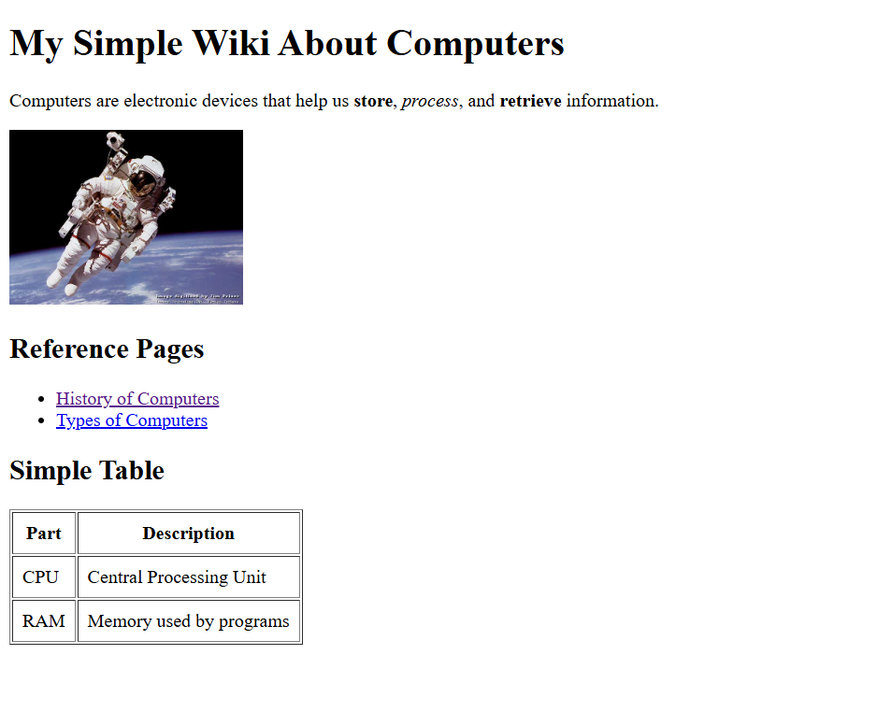
Output:

Lab Task 2. Create a Simple web page about any latest topic of your choice e.g “ emerging software technologies now days”. Following things should be considered 1. Use all the appropriate Html Commands 2. Write Description of topic 3. Use animated images as well as use those images as a link 4. Make usage of mailto
<!DOCTYPE html>
<html>
<head>
<title>Emerging Software Technologies</title>
</head>
<body>
<h1>Emerging Software Technologies</h1>
<p>Today, new software technologies such as <strong>AI</strong>, <em>Machine Learning</em>,
<mark>Blockchain</mark> and <small>Cloud Computing</small> are growing fast.</p>
<h2>Animated Image as a Link</h2>
<a href="https://www.google.com">
<img src="https://media.giphy.com/media/du3J3cXyzhj75IOgvA/giphy.gif" width="200">
</a>
<h2>Contact Me</h2>
<p>Click below to send me an email:</p>
<a href="mailto:example@mail.com">Send Email</a>
</body>
</html>
Output
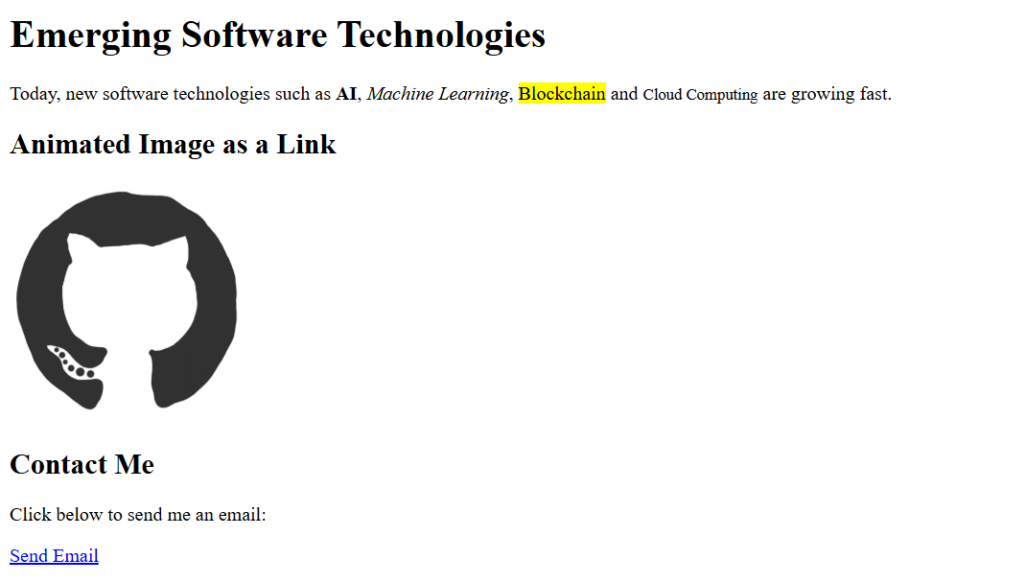

Lab Task 3. Explore HTML Emojis from the following link: https://www.w3schools.com/html/html_emojis.asp
<!DOCTYPE html>
<html>
<head>
<title>Emoji Page</title>
</head>
<body>
<h1>Some Emojis</h1>
<p>Smile: &#128512;</p>
<p>Heart: &#10084;</p>
<p>Fire: &#128293;</p>
<p>Star: &#11088;</p>
</body>
</html>
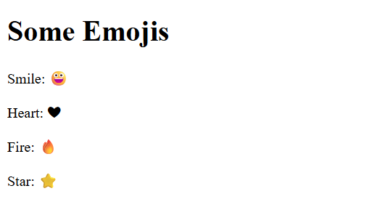
Output:

Lab Report 3
Lab Tasks
Lab Task 1
Using table tag, Create a web page CV with your skills. Give it a name About me.html
<!DOCTYPE html>
<html>
<head>
<title>About Me - CV</title>
</head>
<body>
<h1>My CV</h1>
<table border="1" cellpadding="10">
<tr>
<th colspan="2">Personal Information</th>
</tr>
<tr>
<td>Name</td>
<td>Abdul Rafay</td>
</tr>
<tr>
<td>Email</td>
<td>rafaykhan2k22@gmail.com</td>
</tr>
<tr>
<td>Degree</td>
<td>BS Software Engineering</td>
</tr>

<tr>
<td>University</td>
<td>NUML</td>
</tr>
<tr>
<td>Semester</td>
<td>5th Semester</td>
</tr>
<tr>
<td>CGPA</td>
<td>3.67</td>
</tr>
<tr>
<th colspan="2">Skills</th>
</tr>
<tr>
<td>Technical Skills</td>
<td>
<ul>
<li>HTML</li>
<li>CSS</li>
<li>JavaScript</li>
<li>Python</li>
<li>C++</li>
</ul>
</td>
</tr>

<tr>
<td>Soft Skills</td>
<td>
<ul>
<li>Communication</li>
<li>Problem Solving</li>
<li>Teamwork</li>
</ul>
</td>
</tr>
</table>
</body>
</html>
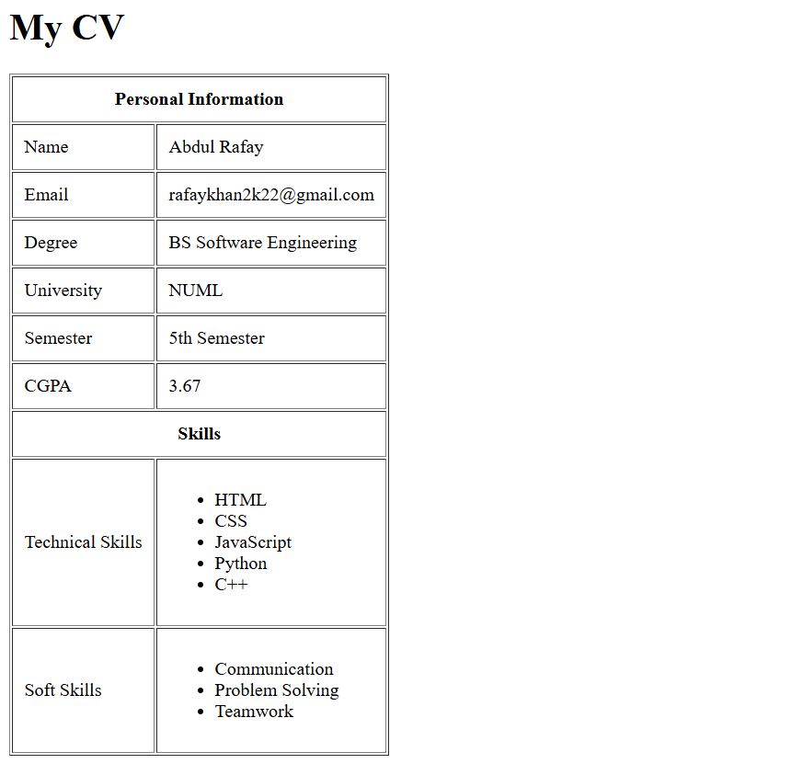
Ouput:
Lab Task 2. Create a web page containing description list , table styling, rowspan ,column span and column group
<!DOCTYPE html>
<html>
<head>
<title>HTML Table & Description List</title>
</head>
<body>
<h1>Description List Example</h1>
<dl>
<dt><b>HTML</b></dt>
<dd>Hyper Text Markup Language</dd>
<dt><b>CSS</b></dt>
<dd>Cascading Style Sheets</dd>
<dt><b>JS</b></dt>
<dd>JavaScript – programming language for web pages</dd>
</dl>
<hr>
<h1>Table with Styling, Rowspan, Colspan, Colgroup</h1>
<table border="1" cellpadding="10">
<!-- Column Group -->
<colgroup>
<col span="1" style="background-color: lightyellow;">
<col span="2" style="background-color: lightblue;">
</colgroup>
<tr>
<th colspan="3">Student Information</th>
</tr>

<tr>
<th>Name</th>
<th>Class</th>
<th>Marks</th>
</tr>
<tr>
<td rowspan="2">Ali</td>
<td>10th</td>
<td>85</td>
</tr>
<tr>
<td>9th</td>
<td>78</td>
</tr>
<tr>
<td>Ayesha</td>
<td colspan="2">Result Pending</td>
</tr>
</table>
</body>
</html>
Output:
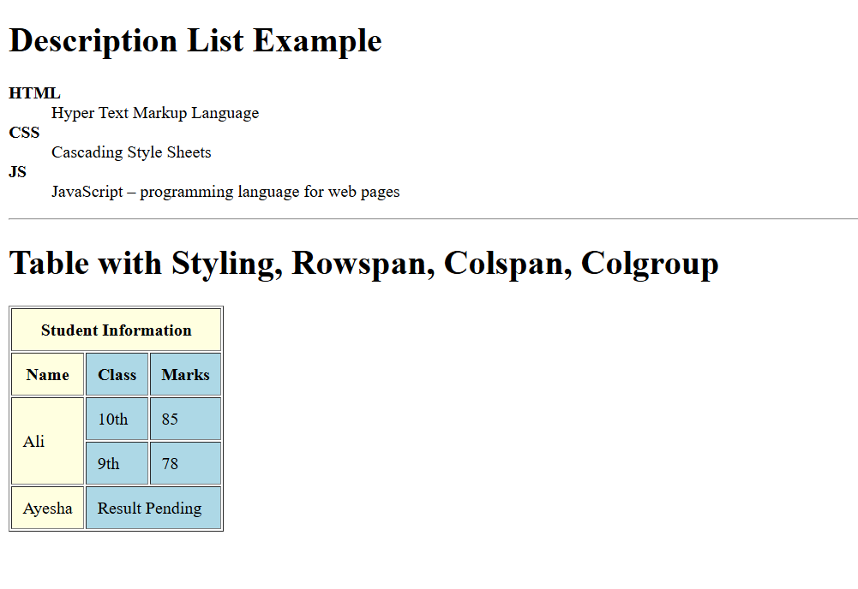

Lab Report 4
Lab Tasks
Lab task 1. Design a signup form for creating an account of student in the database system
<!DOCTYPE html>
<html>
<head>
<title>Student Signup Form</title>
</head>
<body>
<h2>Student Signup Form</h2>
<form>
<label>Full Name:</label><br>
<input type="text" name="fullname" required><br><br>
<label>Email:</label><br>
<input type="email" name="email" required><br><br>
<label>Password:</label><br>
<input type="password" name="password" required>br><br>
<label>Confirm Password:</label><br>
<input type="password" name="cpassword" required><br><br>
<label>Program:</label><br>
<input type="text" name="program" placeholder="BS Software Engineering"><br><br>
<label>Semester:</label><br>
<input type="number" name="semester" min="1" max="8"><br><br>
<label>Phone Number:</label><br>
<input type="text" name="phone"><br><br>
<button type="submit">Create Account</button>
</form>
</body>
</html>
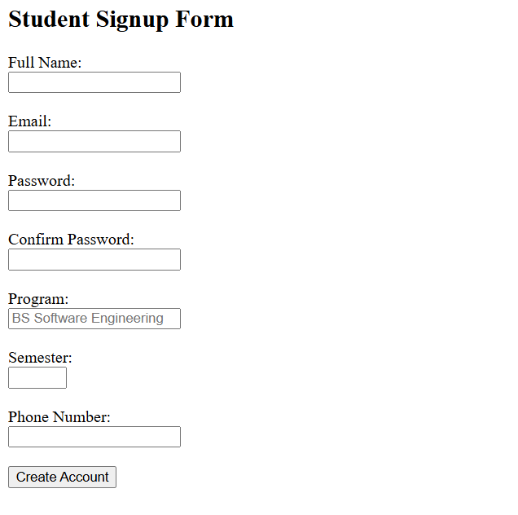
Output:

Lab Task 2. Design a signup form for numl
<!DOCTYPE html>
<html>
<head>
<title>NUML University Signup</title>
</head>
<body>
<center>
<img src="numl-logo.png" alt="NUML Logo" width="120">
<h2>NUML University – Signup Form</h2>
</center>
<form>
<label>Student Name:</label><br>
<input type="text" name="name" required><br><br>
<label>Registration Number:</label><br>
<input type="text" name="regno" placeholder="e.g. 22-SE-123" required><br><br>
<label>Email:</label><br>
<input type="email" name="email" required><br><br>
<label>Department:</label><br>
<input type="text" name="dept" placeholder="Software Engineering" required><br><br>
<label>Semester:</label><br>
<input type="number" name="sem" min="1" max="8" required><br><br>
<label>Password:</label><br>
<input type="password" name="password" required><br><br>
<button type="submit">Signup</button>
</form>
</body>
</html>
Output:
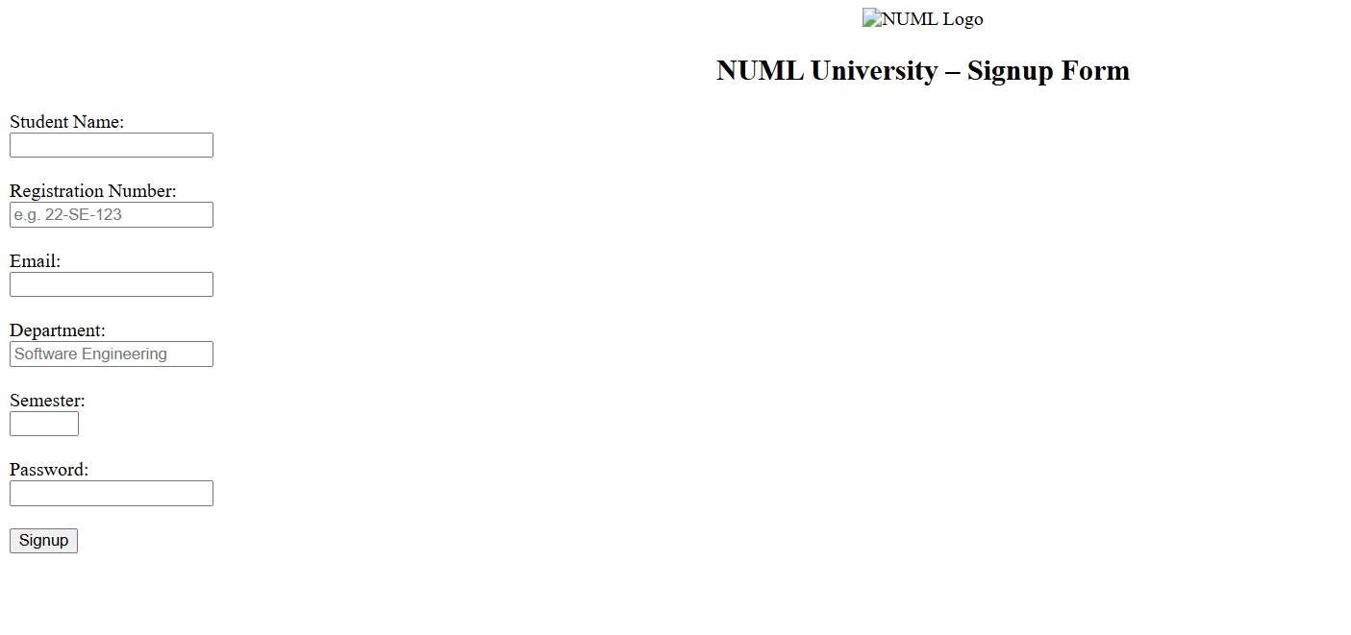

Lab Report 5
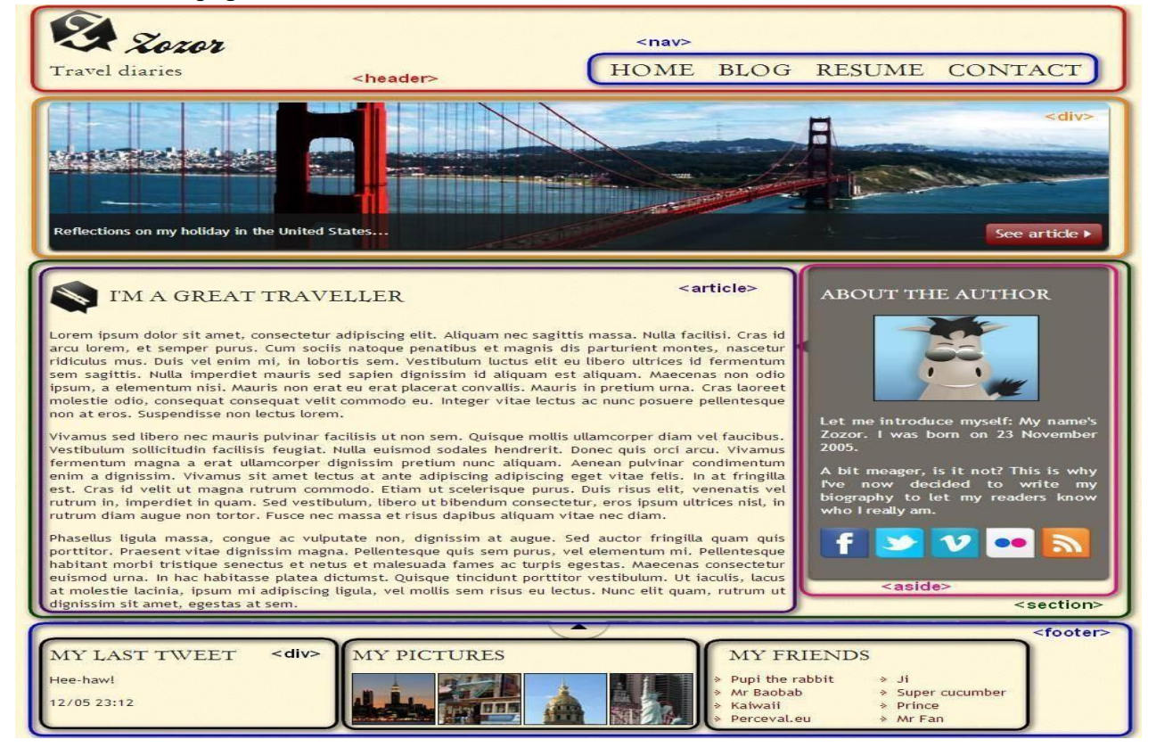
Lab Task : Convert the following image into HTML 5 & CSS. Use semantic elements. HTML Code elements and Quotation blocks to improve the SEO of webpage.

<!DOCTYPE html>
<html lang="en">
<head>
<meta charset="UTF-8" />
<meta name="viewport" content="width=device-width, initial-scale=1.0" />
<title>Zozor – Travel Diaries</title>
<link rel="stylesheet" href="style.css" />
</head>
<body>
<!-- HEADER SECTION -->
<header>
<div class="logo">
<img src="logo.png" alt="Zozor Logo">
<h1>Zozor</h1>
<p>Travel diaries</p>
</div>
<nav>
<ul>
<li><a href="#">Home</a></li>
<li><a href="#">Blog</a></li>
<li><a href="#">Resume</a></li>
<li><a href="#">Contact</a></li>
</ul>
</nav>
</header>
<!-- HERO IMAGE -->
<div class="hero">
<img src="bridge.jpg" alt="Golden Gate Bridge">
<button class="see-article">See Article</button>
</div>
<!-- CONTENT WRAPPER -->
<section class="wrapper">
<!-- ARTICLE SECTION -->
<article>
<h2>I'M A GREAT TRAVELLER</h2>
<p>Lorem ipsum dolor sit amet, consectetur adipiscing elit. Aliquam nec sagittis massa...</p>
<blockquote>
Travelling – it leaves you speechless, then turns you into a storyteller.
</blockquote>
<p>Vivamus sed libero nec mauris pulvinar facilisis ut non sem. Quisque mollis...</p>
</article>
<!-- ABOUT AUTHOR SIDEBAR -->
<aside class="author-box">
<h2>About the Author</h2>
<img src="author.png" alt="Author Image" class="author-img">

<p>Hello! I am Zozor, born on 23 November 2005. I write travel diaries so readers can know who I really am.</p>
<div class="social">
<img src="fb.png" alt="">
<img src="twitter.png" alt="">
<img src="vimeo.png" alt="">
<img src="flickr.png" alt="">
<img src="rss.png" alt="">
</div>
</aside>
</section>
<!-- FOOTER SECTION -->
<footer>
<div class="footer-box">
<h3>My Last Tweet</h3>
<p>Hee-haw!</p>
<small>12/05 – 23:12</small>
</div>
<div class="footer-box">
<h3>My Pictures</h3>
<div class="pics">
<img src="img1.jpg">
<img src="img2.jpg">
<img src="img3.jpg">
<img src="img4.jpg">
</div>
</div>
<div class="footer-box">
<h3>My Friends</h3>
<ul>
<li>Pupi the rabbit</li>
<li>Mr Baobab</li>
<li>Kaiwaii</li>
<li>Prince</li>
<li>Mr Fan</li>
</ul>
</div>
</footer>
</body>
</html>
CSS code :
body {
font-family: Georgia, serif;
margin: 0;
background: #fdf6e3;
}
header {
display: flex;
justify-content: space-between;
padding: 20px;
background: #fffbe6;
border-bottom: 4px solid #d4c18a;
}
.logo h1 {
margin: 0;
}
nav ul {
list-style: none;
display: flex;
gap: 30px;
}
nav ul li a {
text-decoration: none;
font-size: 18px;
font-weight: bold;
color: #333;
}
.hero {
position: relative;
}
.hero img {
width: 100%;
height: 350px;
object-fit: cover;
}
.see-article {
position: absolute;
bottom: 20px;
right: 30px;
padding: 10px 20px;
background: brown;
color: white;
border: none;
border-radius: 5px;
}
.wrapper {
display: flex;
padding: 20px;
}

article {
width: 70%;
padding: 20px;
background: #fff;
margin-right: 20px;
border-radius: 10px;
border: 2px solid #7a4e8b;
}
blockquote {
font-style: italic;
background: #f3e9ff;
padding: 10px;
border-left: 5px solid purple;
}
.author-box {
width: 30%;
padding: 20px;
background: #ddd;
border-radius: 10px;
border: 2px solid #5a3360;
}
.author-img {
width: 100%;
border-radius: 10px;
}
.social img {
width: 30px;
margin-right: 8px;
}
footer {
display: flex;
justify-content: space-around;
padding: 20px;
background: #fff;
border-top: 4px solid #d4c18a;
}
.footer-box {
width: 30%;
}
.pics img {
width: 60px;
margin-right: 5px;
border-radius: 5px;
}
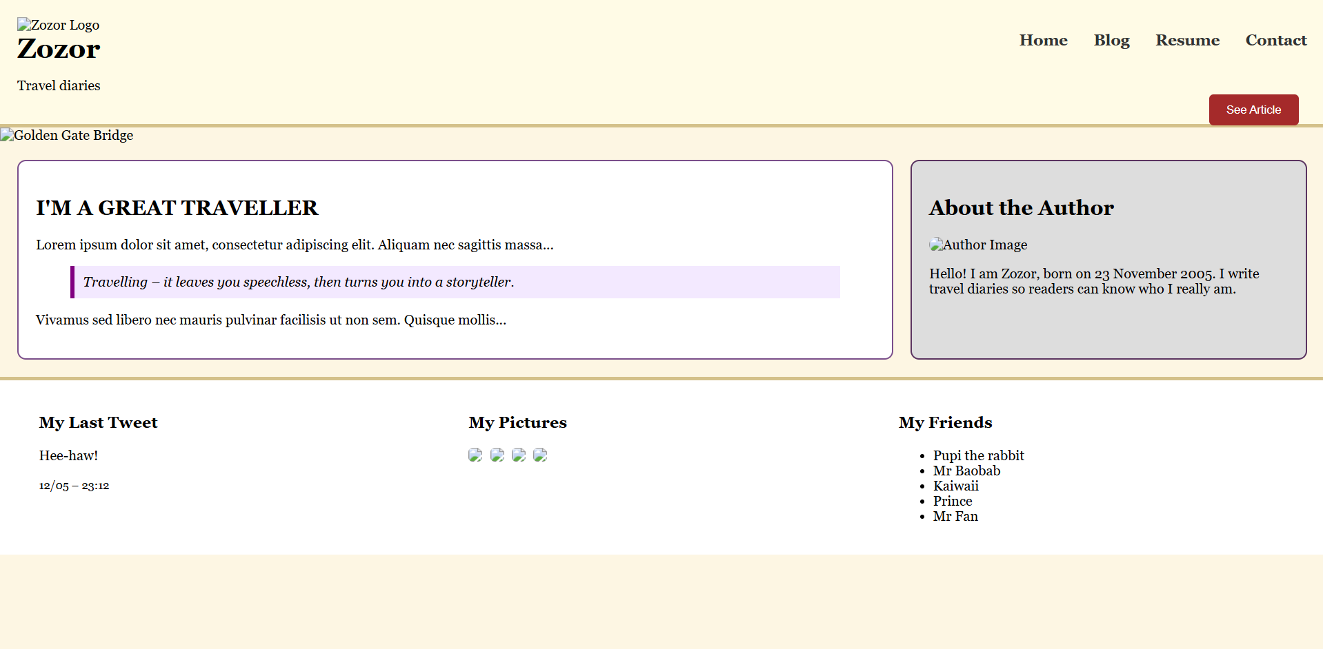
Output:

Lab Report 6
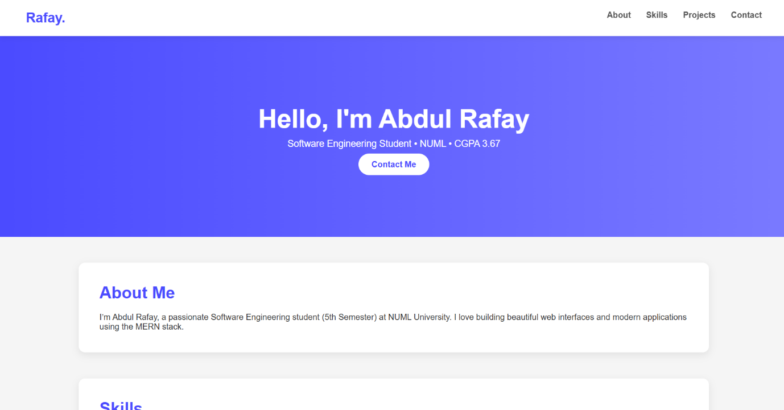
Lab Task : Create a Personal portfolio page in HTML and CSS like following

<!DOCTYPE html>
<html lang="en">
<head>
<meta charset="UTF-8" />
<meta name="viewport" content="width=device-width, initial-scale=1.0" />
<title>Abdul Rafay – Portfolio</title>
<link rel="stylesheet" href="style.css" />
</head>

<body>

<!-- NAVBAR -->
<header class="navbar">
<div class="logo">Rafay.</div>
<nav>
<a href="#about">About</a>
<a href="#skills">Skills</a>
<a href="#projects">Projects</a>
<a href="#contact">Contact</a>
</nav>
</header>

<!-- HERO SECTION -->
<section class="hero">
<h1>Hello, I'm <span>Abdul Rafay</span></h1>
<p>Software Engineering Student • NUML • CGPA 3.67</p>
<a href="#contact" class="btn">Contact Me</a>
</section>

<!-- ABOUT -->
<section id="about" class="section">
<h2>About Me</h2>
<p>
I’m Abdul Rafay, a passionate Software Engineering student (5th Semester)
at NUML University. I love building beautiful web interfaces and modern
applications using the MERN stack.
</p>
</section>

<!-- SKILLS -->
<section id="skills" class="section">
<h2>Skills</h2>
<div class="skills">
<span>HTML</span>
<span>CSS</span>
<span>JavaScript</span>
<span>React</span>
<span>Node.js</span>
<span>MongoDB</span>
<span>Python</span>
<span>C++</span>
</div>
</section>

<!-- PROJECTS -->
<section id="projects" class="section">
<h2>Projects</h2>
<div class="project">
<h3>Personal Portfolio</h3>
<p>A clean, beautiful personal portfolio website built with HTML & CSS.</p>
</div>
<div class="project">
<h3>Student Management System</h3>
<p>A CRUD-based student record system using Node.js, Express & MongoDB.</p>
</div>
</section>

<!-- CONTACT -->
<section id="contact" class="section">
<h2>Contact</h2>
<p>Email: <strong>rafaykhan2k22@gmail.com</strong></p>
</section>

<footer>
<p>© 2025 Abdul Rafay — All Rights Reserved.</p>
</footer>

</body>
</html>
CSS code :
* {
margin: 0;
padding: 0;
box-sizing: border-box;
font-family: "Poppins", sans-serif;
}

body {
background: #f5f5f5;
color: #333;
}

/* NAVBAR */
.navbar {
display: flex;
justify-content: space-between;
padding: 20px 50px;
background: #fff;
box-shadow: 0 2px 10px rgba(0,0,0,0.1);
position: sticky;
top: 0;
}

.logo {
font-size: 26px;
font-weight: bold;
color: #4b4bff;
}

.navbar a {
margin-left: 25px;
text-decoration: none;
color: #555;
font-weight: 600;
}

.navbar a:hover {
color: #4b4bff;
}

/* HERO SECTION */
.hero {
text-align: center;
padding: 130px 20px;
background: linear-gradient(to right, #4b4bff, #7a7aff);
color: white;
}

.hero h1 {
font-size: 50px;
margin-bottom: 10px;
}

.hero h1 span {
color: #fff;
font-weight: bold;
}

.hero p {
font-size: 18px;
margin-bottom: 20px;
}

.btn {
background: white;
color: #4b4bff;
padding: 12px 25px;
border-radius: 30px;
text-decoration: none;
font-weight: bold;
}

.btn:hover {
background: #eee;
}

/* SECTIONS */
.section {
width: 80%;
margin: 50px auto;
background: white;
padding: 40px;
border-radius: 12px;
box-shadow: 0 5px 15px rgba(0,0,0,0.08);
}

.section h2 {
font-size: 32px;
margin-bottom: 20px;
color: #4b4bff;
}

/* SKILLS */
.skills {
display: flex;
flex-wrap: wrap;
gap: 12px;
}

.skills span {
background: #4b4bff;
color: white;
padding: 10px 20px;
border-radius: 30px;
font-size: 14px;
}

/* PROJECTS */
.project {
background: #f0f2ff;
padding: 20px;
margin-bottom: 15px;
border-left: 5px solid #4b4bff;
border-radius: 8px;
}

/* FOOTER */
footer {
text-align: center;
padding: 20px;
margin-top: 20px;
color: #777;
}

Lab Report 7
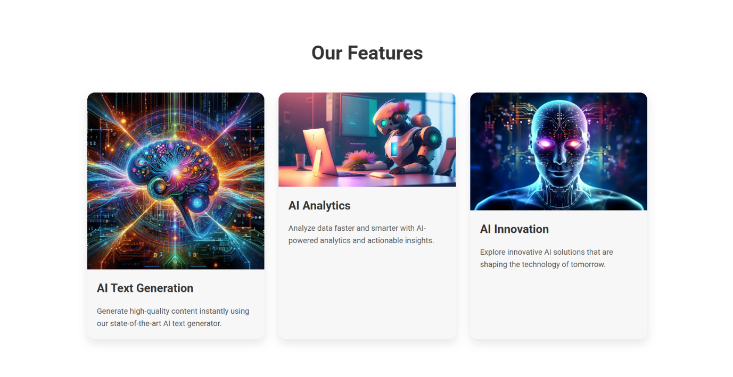

Lab Task : Create web pages on any emerging topic using positioning elements
Figure 1 made by myself not ai generated ( copied images link from the internet )

Code :
<!DOCTYPE html>
<html lang="en">
<head>
<meta charset="UTF-8">
<meta name="viewport" content="width=device-width, initial-scale=1.0">
<title>AI Landing Page</title>
<link href="https://fonts.googleapis.com/css2?family=Roboto:wght@400;700&display=swap" rel="stylesheet">
<style>
* {
margin: 0;
padding: 0;
box-sizing: border-box;
font-family: 'Roboto', sans-serif;
}

body {
line-height: 1.6;
color: #333;
}

header {
background: url('https://static.vecteezy.com/system/resources/previews/030/762/925/large_2x/artificial-intelligence-abstract-background-the-future-of-artificial-intelligence-generative-ai-free-photo.jpg') no-repeat center center/cover;
height: 100vh;
display: flex;
flex-direction: column;
justify-content: center;
align-items: center;
color: #fff;
text-align: center;
position: relative;
}

header::after {
content: '';
position: absolute;
top: 0; left: 0;
width: 100%; height: 100%;
background-color: rgba(0,0,0,0.5);
}

header .content {
position: relative;
z-index: 1;
max-width: 800px;
padding: 0 20px;
}

header h1 {
font-size: 3rem;
margin-bottom: 20px;
}

header p {
font-size: 1.2rem;
margin-bottom: 30px;
}

header .btn {
background: #ff4b2b;
color: #fff;
padding: 15px 30px;
text-decoration: none;
font-weight: bold;
border-radius: 50px;
transition: 0.3s;
}

header .btn:hover {
background: #ff416c;
}

section {
padding: 80px 20px;
max-width: 1200px;
margin: 0 auto;
}

section h2 {
text-align: center;
font-size: 2.5rem;
margin-bottom: 50px;
}

.features {
display: flex;
flex-wrap: wrap;
justify-content: space-around;
gap: 30px;
}

.feature-card {
flex: 1 1 300px;
background: #f7f7f7;
border-radius: 15px;
overflow: hidden;
box-shadow: 0 8px 20px rgba(0,0,0,0.1);
transition: transform 0.3s;
}

.feature-card:hover {
transform: translateY(-10px);
}

.feature-card img {
width: 100%;
display: block;
}

.feature-card .feature-content {
padding: 20px;
}

.feature-card h3 {
font-size: 1.5rem;
margin-bottom: 15px;
}

.feature-card p {
font-size: 1rem;
color: #555;
}

footer {
background: #222;
color: #fff;
padding: 40px 20px;
text-align: center;
}

footer p {
margin-bottom: 10px;
}

@media (max-width: 768px) {
header h1 {
font-size: 2.2rem;
}
section h2 {
font-size: 2rem;
}
.features {
flex-direction: column;
align-items: center;
}
}
</style>
</head>
<body>

<header>
<div class="content">
<h1>Welcome to the Future of AI</h1>
<p>Discover the power of Artificial Intelligence and how it’s transforming the world.</p>
<a href="#features" class="btn">Explore Features</a>
</div>
</header>

<section id="features">
<h2>Our Features</h2>
<div class="features">
<div class="feature-card">
<img src="https://typli.ai/ai-text-generator.png" alt="AI Text Generator">
<div class="feature-content">
<h3>AI Text Generation</h3>
<p>Generate high-quality content instantly using our state-of-the-art AI text generator.</p>
</div>
</div>

<div class="feature-card">
<img src="https://media.licdn.com/dms/image/v2/D4D12AQE6JlCOS0JjrQ/article-cover_image-shrink_720_1280/article-cover_image-shrink_720_1280/0/1689050009065?e=2147483647&v=beta&t=9n4b22jjQW-dTFsFCjdS_nwPKHjkBCwBg8Ag6Y4F9dc" alt="AI Analytics">
<div class="feature-content">
<h3>AI Analytics</h3>
<p>Analyze data faster and smarter with AI-powered analytics and actionable insights.</p>
</div>
</div>

<div class="feature-card">
<img src="https://static.vecteezy.com/system/resources/previews/030/762/925/large_2x/artificial-intelligence-abstract-background-the-future-of-artificial-intelligence-generative-ai-free-photo.jpg" alt="AI Innovation">
<div class="feature-content">
<h3>AI Innovation</h3>
<p>Explore innovative AI solutions that are shaping the technology of tomorrow.</p>
</div>
</div>
</div>
</section>

<footer>
<p>&copy; 2025 AI Landing Page. All rights reserved.</p>
<p>Designed by Abdul Rafay</p>
</footer>

</body>
</html>

Lab Report 9
Task 1: Implement the given JavaScript concepts and code snippets Code:
<!DOCTYPE html>
<html>
<head>
<title>Lab 9 JavaScript Practice</title>
</head>
<body>

<h2>JavaScript Conditional Statements</h2>
<p id="greeting"></p>

<button onclick="checkTime()">Check Time Greeting</button>

<hr>

<h2>Switch Statement</h2>
<p id="day"></p>

<hr>

<h2>Loops</h2>
<p id="loopOutput"></p>

<script>
/* IF - ELSE IF - ELSE */
function checkTime() { var hour = new Date().getHours(); var message;

if (hour < 10) { message = "Good Morning"; } else if (hour < 20) { message = "Good Day";
} else { message = "Good Evening";
}

document.getElementById("greeting").innerHTML = message;
}

/* SWITCH STATEMENT */
var today;
switch (new Date().getDay()) { case 0: today = "Sunday"; break; case 1: today = "Monday"; break; case 2: today = "Tuesday"; break; case 3: today = "Wednesday"; break; case 4: today = "Thursday"; break; case 5: today = "Friday"; break; case 6: today = "Saturday"; break;
}
document.getElementById("day").innerHTML = "Today is " + today; /* LOOPS */ var text = "";

/* FOR LOOP */
for (var i = 1; i <= 3; i++) { text += "For Loop Count: " + i + "<br>";
}

/* WHILE LOOP */
var j = 1; while (j <= 3) { text += "While Loop Count: " + j + "<br>";
j++; }

/* DO WHILE LOOP */
var k = 1; do { text += "Do-While Loop Count: " + k + "<br>"; k++;
} while (k <= 3);

document.getElementById("loopOutput").innerHTML = text;
</script>

</body>
</html>
Output:
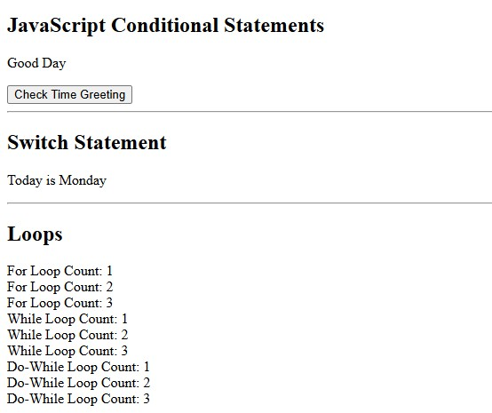

Task 2: Identify differences between JavaScript Output Methods
Method | Description
innerHTML | Writes output inside an HTML element
document.write() | Writes directly to the webpage (not recommended after load)
window.alert() | Shows popup message
console.log() | Prints output in browser console

Code:
<!DOCTYPE html>
<html lang="en">
<head>
<meta charset="UTF-8">
<title>Lab 9 Task 2 - JavaScript Output Methods</title>
</head>
<body>

<h1>JavaScript Output Methods</h1>

<!-- innerHTML output -->
<h2>1. innerHTML Output</h2>
<p id="output"></p>

<script> // 1. innerHTML document.getElementById("output").innerHTML =
"This text is displayed using innerHTML";

// 2. document.write() document.write("<h2>2. document.write Output</h2>"); document.write("This text is displayed using document.write()");

// 3. alert() window.alert("This is an alert box output");

// 4. console.log() console.log("This message is displayed in the browser console");
</script>

</body>
</html>
Output:
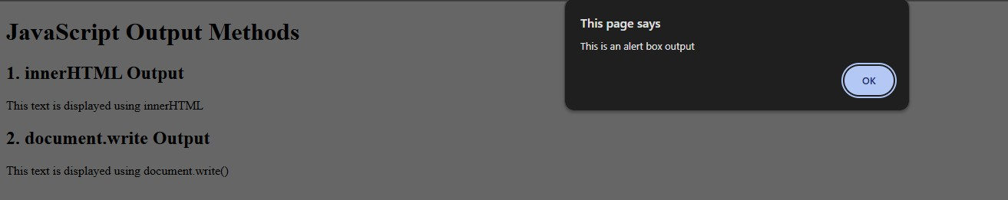

Task 3: JavaScript Output Display Demonstration Code:
<!DOCTYPE html>
<html>
<body>

<h2>JavaScript Output Methods</h2>

<p id="output"></p>

<script>
document.getElementById("output").innerHTML = "Displayed using innerHTML"; console.log("Displayed in console"); window.alert("Displayed using alert");
</script>

</body>

Lab Report 10
Lab Task: Make a simple calculator
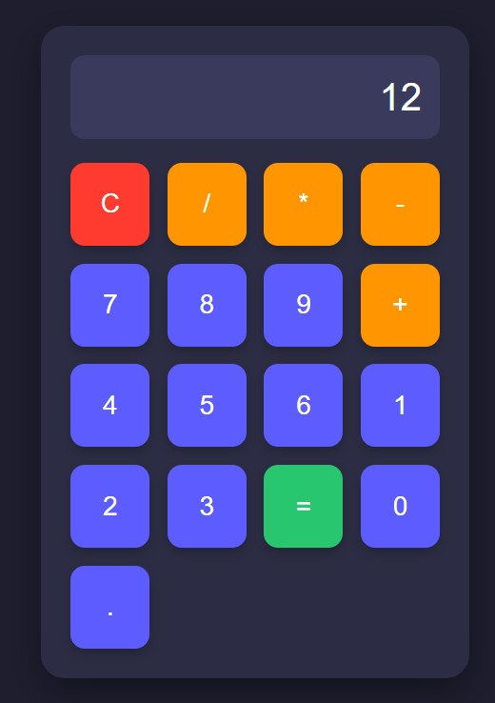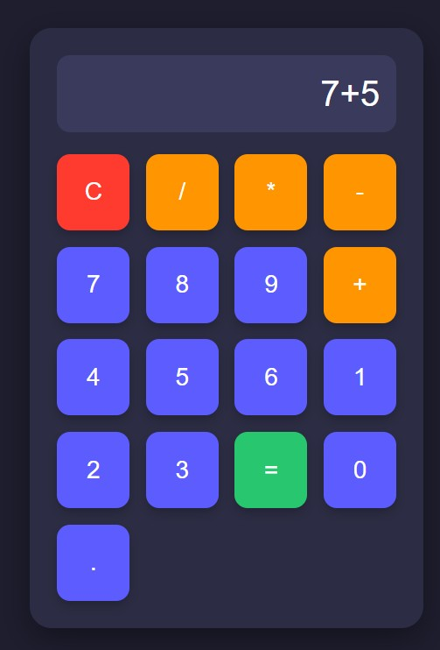

Code :
<!DOCTYPE html>
<html lang="en">
<head>
<meta charset="UTF-8" />
<meta name="viewport" content="width=device-width, initial-scale=1.0" />
<title>Simple Calculator</title>

<style> body { font-family: 'Segoe UI', Tahoma, Geneva, Verdana, sans-serif; background: #1e1e2f; display: flex; justify-content: center; align-items: center; height: 100vh; margin: 0;
}

.calculator { background: #2c2c44; padding: 25px; width: 100%; max-width: 360px; border-radius: 20px; box-shadow: 0 10px 30px rgba(0,0,0,0.4); box-sizing: border-box;
}

#display { width: 100%; height: 70px; margin-bottom: 20px; font-size: 32px; text-align: right; padding: 15px; border: none; background: #3a3a5c;
color: #fff; border-radius: 12px; box-sizing: border-box;
}

.buttons { display: grid; grid-template-columns: repeat(4, 1fr); gap: 15px;
}

button { padding: 22px; font-size: 22px; border: none; border-radius: 12px; cursor: pointer; transition: 0.2s; color: #fff; box-shadow: 0 5px 10px rgba(0,0,0,0.2);
}

button:hover { transform: translateY(-2px); box-shadow: 0 8px 15px rgba(0,0,0,0.3);
}

/* Number buttons */ button:not(.operator):not(.equal):not(.clear) { background: #5c5cff;
}

button:not(.operator):not(.equal):not(.clear):hover { background: #3a3aff;
}

/* Operator buttons */ .operator { background: #ff9500;
}

.operator:hover { background: #e08900;
}

/* Equal button */ .equal { background: #28c76f;
}

.equal:hover { background: #20a65d;
}

/* Clear button */ .clear { background: #ff3b30;
}

.clear:hover { background: #cc2b24;
}
</style>
</head>

<body>

<div class="calculator">
<input type="text" id="display" disabled>

<div class="buttons" id="btnContainer">
<!-- Buttons will be generated with JS loop -->
</div>
</div>

<script> const buttons = [
'C','/','*','-',
'7','8','9','+',
'4','5','6','',
'1','2','3','=',
'0','.'
];

const container = document.getElementById("btnContainer"); const display = document.getElementById("display");

const operators = ['/', '*', '-', '+'];

for (let i = 0; i < buttons.length; i++) { if (buttons[i] === '') continue; // skip empty placeholders let btn = document.createElement("button"); btn.textContent = buttons[i];

if (buttons[i] === "=") btn.classList.add("equal"); else if (buttons[i] === "C") btn.classList.add("clear"); else if (operators.includes(buttons[i])) btn.classList.add("operator");

btn.addEventListener("click", () => { if (buttons[i] === "=") {
try { display.value = eval(display.value);
} catch { display.value = "Error";
}
} else if (buttons[i] === "C") { display.value = "";
} else { display.value += buttons[i];
}
});

container.appendChild(btn);
}
</script>

</body>
</html>

