Prompt: What is correlation in data analysis?
A)
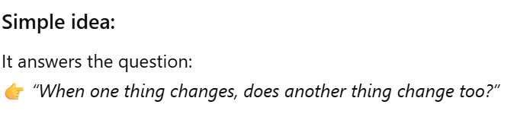
B)
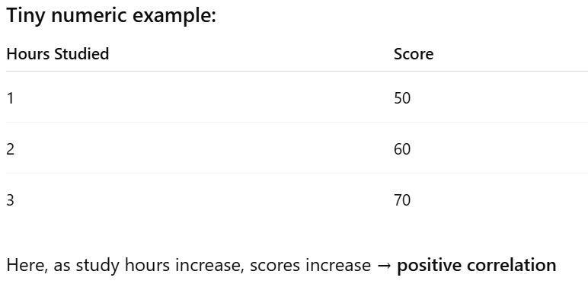
C)


The persistent instructions will continue to give me a simple explanation in accordance with the prompt criteria until I manually adjust it. As my skill increases, I can adjust the size of the numbers and complexity of the explanations. The value of an AI agent like this is that I can get consistent results without having to provide specific parameters in every prompt.

