Weak Prompts
- Explain regression.
- Help me understand SQL.
- Create a dataset.

Strong Prompts
- Explain regression analysis in simple terms suited for a novice
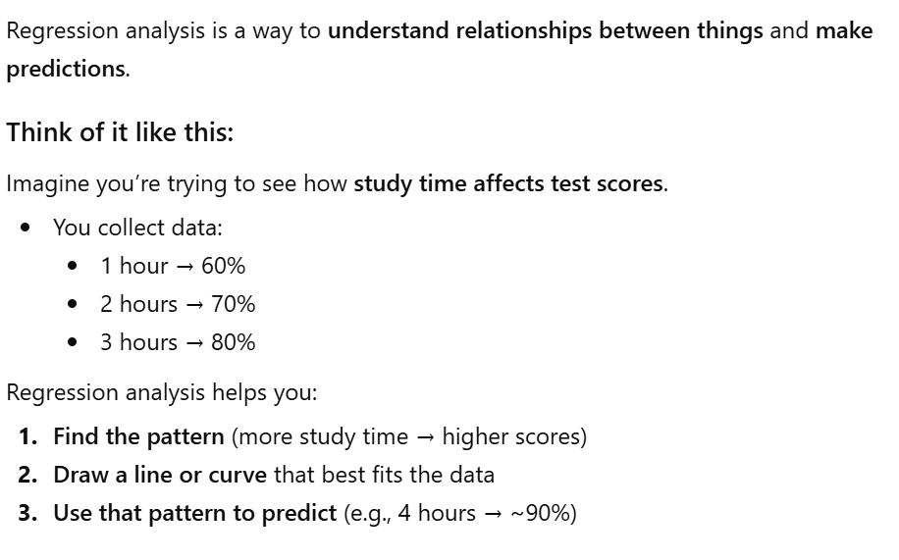

Clarification provides me with an easy-to-understand explanation of regression analysis. “Simple terms” is the secret to this prompt’s strength

- What is SQL and how can it be used to manipulate databases?
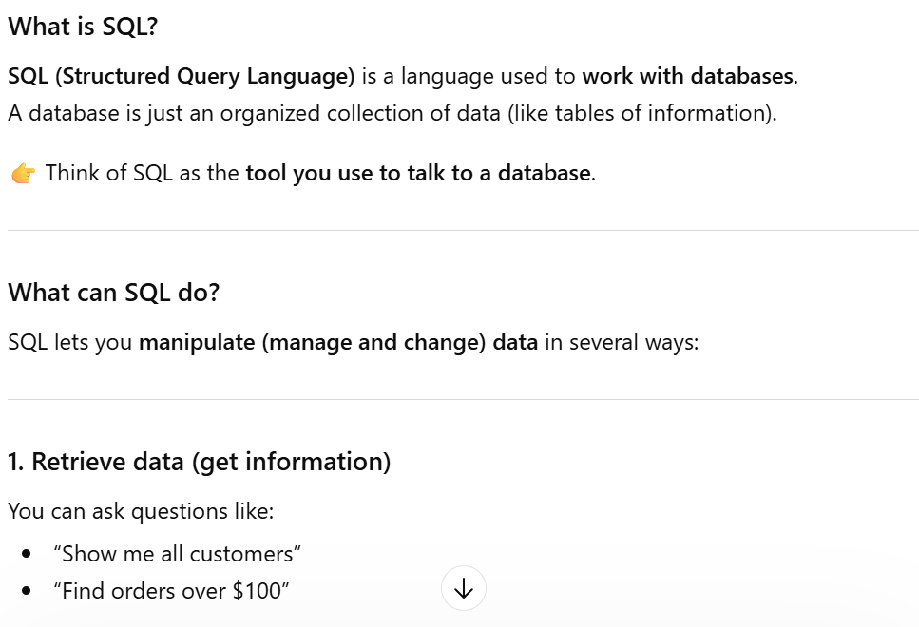

The revised prompt is more specific and yields a more adequate response. Including the use case for SQL makes this prompt stronger

- Create a 12-row data set containing fake NC weather information
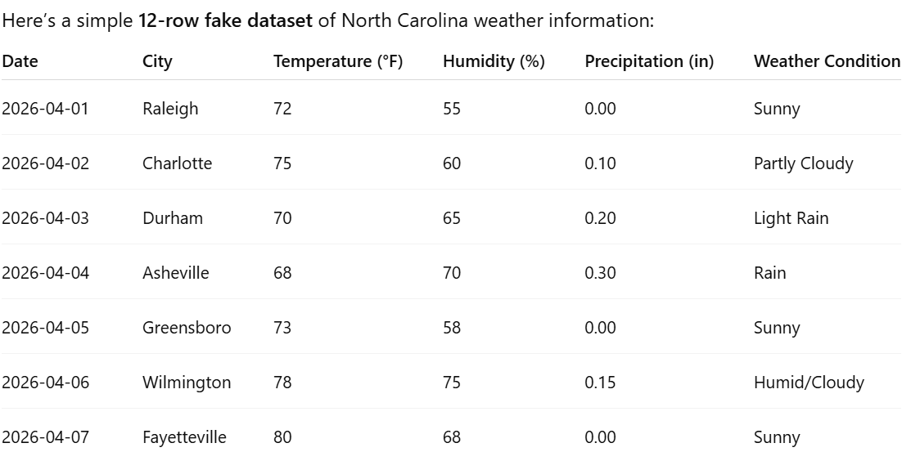

This prompt is strong because it has a set quantity of rows. If I didn’t make this distinction, I may have gotten a dataset with over 100 rows!

