DAY 2 (Installation)

Apache Tomcat:

1. Surf to apache.tomcat.org and look into binary distributions download Tomcat

Note: The Apache Tomcat® software is an open source implementation of the Java Servlet, JavaServer Pages, Java Expression Language and Java WebSocket technologies. The Java Servlet, JavaServer Pages, Java Expression Language and Java WebSocket specifications are developed under the java community process.

JAVA 10:

1. Navigate to oracle.com and download java 10 SE SDK and install into computer.
2. MAKE SURE to have java installed. Open a terminal and type java –version
3. If you see java version then you have it if not then you need to restart the computer and try again, if you still don’t have it, try downloading again and save the application on the desktop and re launch. If you still have problems then google “how to install java into max / windows .

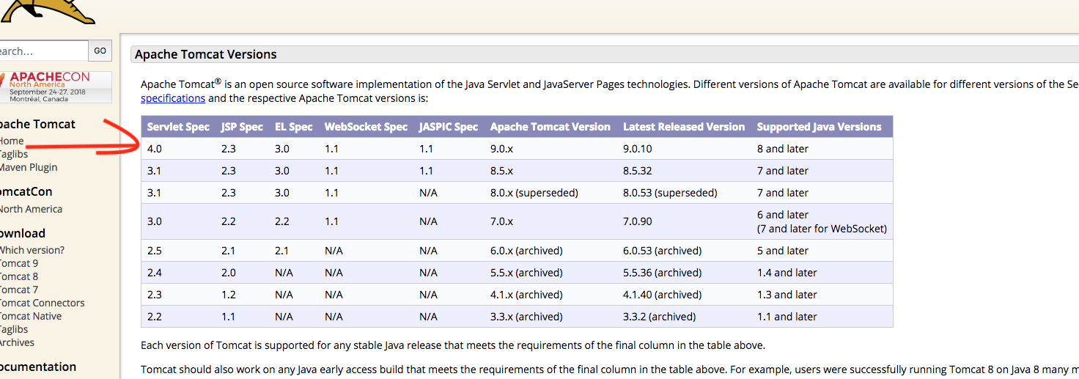

I have downloaded java 10 so I will choose Tomcat 9.0x. Tomcat is a servlet container.

1. Click on this link to see a video how to install tomcat on your machine and start and stop the servlet container, it is the best video I could find. JAVA MUST BE INSTALL BEFORE DOING THIS, AFTER INSTALLING JAVA COME BACK HERE AND CLICK ON THE LINK.

https://www.youtube.com/watch?v=h_qQOVDTxo8&t=460s

Eclipse:

1. Navigate to eclipse.org and download eclipse for java developers EE. And install into machine. NOTE THE EE.

IN ECLIPSE IDE

Configurations:

1. Enter / choose JAVA perspective and CLICK on server to install tomcat. >
2. Click on server , Then click on “browse file” and find the file where you downloaded “tomcat” (the unzipped file) , select it and press next.
3. Select the tomcat version (in my case it is tomcat 9.0) then press next,
4. On console verify you see a message “stopped Republish”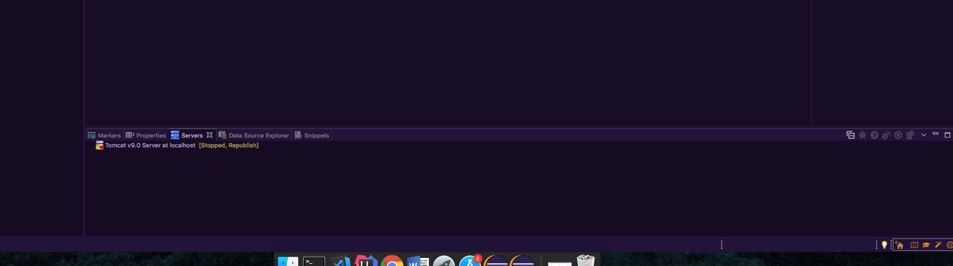
5. WE ARE READY TO DOWNLOAD SPRING JAR FILES NEXT .

NOTE: you might ask yourself why I have 2 different eclipse programs and the reason behind is that I rock Eclipse EE for java projects (purple) as it contains all the necessary technologies for spring, and I rock eclipse for developers (green) for automation and test cases. It all comes to self efficiency and available resources. You can also download spring STS suite but for me I find it too buggy and also I don’t like using plugins from the market place. BUT if your machine can handle the load then maybe Spring STS will work, you would have to try it. >:D

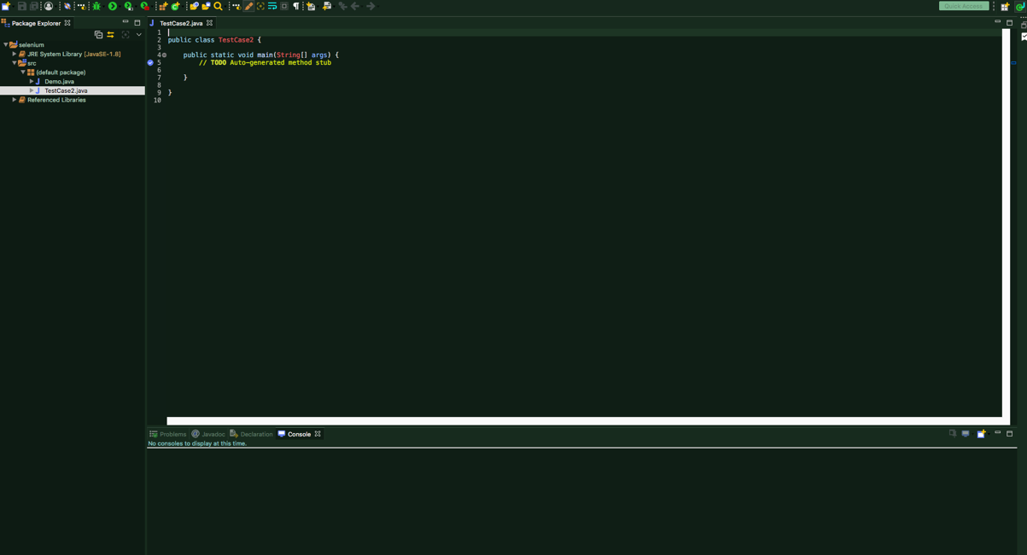

**SPRING JAR FILES**

For the sake of keeping everything organized, I like making To Do lists.

1. Download Spring JAR Files
2. Add Jar files to Eclipse Project …. Build Path

NOTE: You might be wondering why not use MAVEN, instead of manually downloading, if you are a Maven expert.. go ahead and get started XD. My main focus is Spring, but we can get fancy …later.

1. File / new Create a new project,
2. Name it spring-demo-one click finish (keep everything default) you might need to switch java version to 10. But java 8 will work too, java 9 is no longer supported as per oracle. Don’t use anything lower than 8 since we downloaded tomcat 9.0x