**STOCK PRICE PREDICTION**

RISHABH GUPTA(2014086)

KUSHAGRA MAHAJAN(2014055)

**INTRODUCTION**

In this project, machine learning algorithms were used to predict the closing price of stocks of companies across various sectors (IT, Pharmaceutical ,Banking Industry) and find out if same model gives best performance across stocks in different sectors.

Stock price prediction has always been one of the most challenging problems affecting the lives of millions of people around the world. Recently the problem has gained great popularity due to its unpredictable behaviour. This work is our attempt to explore the performance of some of the common techniques on stock datasets.

**DATASETS**

We explore three datasets taken from Quandl.com :- **HDFC Bank, TCS, CIPLA Pharmaceuticals Pvt. Ltd**.

The datasets provided stock values for the past 8 years(3000 samples).

* 80%(2400 samples) of the data was chosen for training.
* 10% of the training data(240 samples) were used for validation.
* 20% of the total data was used for testing.

**FEATURE EXTRACTION**

The original data had the following features: Opening, Highest, Lowest, Last, Closing prices, Total trade Quantity and Turnover.

The features used for Learning Model are given in Table-3 .

**EVALUATION METRICS**

Mean Squared Error was used as an Evaluation Metrics for our Models.

**PRE-PROCESSING**

|  |  |  |
| --- | --- | --- |
| **Technique** | **Applied** | **Remarks** |
| Normalization | YES | The Dataset was scaled between 0 and 1. |
| PCA | NO | The number of features were not large. |
| Missing Values Correction | YES | Taking average of surrounding values |

**TECHNIQUES APPLIED**

We have explored

* Simple and Regularized Linear Regression(LASSO and RIDGE).
  + Stochastic Gradient Descent
  + Batch Gradient Descent
* Polynomial Kernel Regression
* Gaussian Kernel Regression
* Support Vector Regression
  + Linear kernel
  + Polynomial kernel
  + Gaussian kernel

**METHODOLOGY**

* We have used **Grid Search** along with **Cross Validation** Technique in each model(wherever possible) to hyper-tune the parameters and come up with the ones which gives minimum MSE.
* Using the best parameters various techniques were applied and MSE was computed.
* Nifty feature was removed and all techniques were again applied against best parameters and the results were compared.

**CHALLENGES**

Finding out the appropriate features was a big challenge. Lot of papers were consulted and research was done to come up with relevant features in stock market prediction. Some of the relevant works explored were:

* Feature Investigation for Stock market Prediction by Hui Lin[[1].](http://cs229.stanford.edu/proj2013/Lin-Feature%20Investigation%20for%20Stock%20Market%20Prediction.pdf)
* FEATURE SELECTION FOR PRICE CHANGE PREDICTION by Zehra Çataltepe1 , Savaş Özer2 , Vahide Unutmaz Barın2[[2]](http://web.itu.edu.tr/~cataltepe/pdf/2011_ICMFECataltepe.pdf).

**OBSERVATIONS**

Note: All the values are normalized between 0 and 1.So MSE values are according to normalization.

* **Linear and Regularized Regression**

After hyper-tuning the parameters ( alpha and delta ) Linear ,LASSO and Ridge Regression was applied along with Stochastic and Batch Gradient Descent algorithm. The results corresponding to best parameters are as follows:

**Table-1** : MSE corresponding to best alpha and delta for Regularized Linear Regression.

|  |  |  |  |
| --- | --- | --- | --- |
| **Stock** | **Best Model** | **Best Parameters** | **MSE** |
| **CIPLA** | Simple Linear Regression | Alpha=0.05  Delta=0 | 0.001425 |
| **TCS** | LASSO Linear Regression | Alpha=0.1  Delta=0.1 | 0.001067 |
| **HDFC BANK** | LASSO Linear Regression | Alpha=0.00005  Delta=0.01 | 0.002279 |

* **Polynomial Kernel Regression**

Extracting the polynomial features and then applying Linear Regression across different degree gives the following results against each stock:

**Table-2** : MSE corresponding to best degree in Polynomial Kernel Regression.

|  |  |  |
| --- | --- | --- |
| **Stock** | **Best Degree** | **MSE** |
| **CIPLA** | 2 | 0.00006993 |
| **TCS** | 3 | 0.000884 |
| **HDFC** | 3 | 0.000149 |

* **Gaussian Kernel Regression**

Applying Gaussian Kernel Regression against best value of sigma across each stock gives the following results.

**Table-3** : MSE corresponding to best sigma in

Gaussian Kernel Regression.

|  |  |  |
| --- | --- | --- |
| **Stock** | **Best Sigma** | **MSE** |
| **CIPLA** | 0.0002 | 0.0210 |
| **TCS** | 0.2599* | 0.000127 |
| **HDFC** | 0.02 | 0.000553 |

* Standard deviation of Closing Prices of

training set

* **Support Vector Regression**

Applying Support Vector Regression using linear, polynomial and Gaussian Kernel across each stock gives the following results.

**Table-4** : MSE corresponding to best alpha and sigma in Support Vector Regression.

|  |  |  |
| --- | --- | --- |
| **Stock** | **Kernel** | **MSE** |
| **CIPLA** | Linear | 0.00036 |
| Polynomial | 0.015 |
| Gaussian | 0.00246 |
| **TCS** | Linear | 0.000155 |
| Polynomial | 0.00448 |
| Gaussian | 0.0003196 |
| **HDFC** | Linear | 0.00000355 |
| Polynomial | 0.010 |
| Gaussian | 0.000144 |

To explore and prove the importance of good feature selection we eliminated an important feature(NIFTY closing price) and recalculated the MSE.

The Best Accuracy is compared in both cases across all Models and stocks.

**Table-5** : Comparison of MSE when NIFTY feature was removed.

|  |  |  |  |
| --- | --- | --- | --- |
| **Stock** | **Technique** | **MSE**  **(With Nifty)** | **MSE**  **(Without Nifty)** |
| **CIPLA** | **Regularized** | 0.002279 | 0.00248 |
| **Polynomial** | **0.00006993** | 0.0000703 |
| **Gaussian** | 0.00045 | 0.020 |
| **Support Vector** | 0.000359 | 0.000341 |
| **TCS** | **Regularized** | 0.001067 | 0.001198 |
| **Polynomial** | 0.000884 | 0.001966 |
| **Gaussian** | **0.000127** | 0.0003548 |
| **Support Vector** | 0.000155 | 0.000155 |
| **HDFC** | **Regularized** | 0.001425 | 0.001465 |
| **Polynomial** | 0.000149 | 0.0009838 |
| **Gaussian** | 0.00045 | 0.0005535 |
| **Support Vector** | **0.00000355** | 0.00000379 |

**RESULTS**

The Best Model corresponding to each stock is as follows:

**Table-6** : Best Model of each Stock.

|  |  |  |
| --- | --- | --- |
| **STOCK** | **BEST MODEL** | **MSE** |
| **CIPLA** | Polynomial Kernel Regression | 0.00006993 |
| **TCS** | Gaussian Kernel Regression | 0.000127 |
| **HDFC BANK** | Support Vector Regression (Linear Kernel) | 0.00000355 |

* We observe that the same model does not give best results across different stocks. Hence stocks across different sectors (IT, Banking, Pharmaceutical) move differently with features and historical data.
* The complexity of the best models of different stocks(Polynomial, Gaussian, Support Vector Regression) shows that the closing price of stock are not merely linearly related to the features but are rather more complex.
* The closing Price of HDFC BANK is most predictable among the 3 stocks as it gives the least MSE.
* The MSE values were found to be mostly higher when NIFTY feature was removed. This shows that the choice of good features is an important determinant in good performance from the machine learning models.

**REFERENCES**

* <https://www.quandl.com/data/NSE?keyword>=
* <http://web.itu.edu.tr/~cataltepe/pdf/2011_ICMFECataltepe.pdf>
* <http://www.ntu.edu.sg/home/elpwang/PDF_web/13_ICONIP.pdf>
* <http://www.csie.ntu.edu.tw/~cjlin/libsvm/>

**Source Code**

* <https://github.com/git-rishabh/Stock-Price-Prediction>

**Additional Tables and Graph**

**Table-7** : Features used in our Learning Model.

|  |
| --- |
| Previous Day Closing Price |
| Same Day Opening Price |
| Previous Day Nifty Closing Price |
| 10 Days Moving averages |
| 15 Days Moving averages |
| 20 Days Moving averages |
| 40 Days Moving averages |
| 10 Days Momentum |
| 40 Days Momentum |
| Average Difference between Opening Price and Closing Price (5 Days ) |
| Average Difference between Opening Price and Closing Price (10 Days ) |
| Average Difference between Opening Price and Closing Price (40 Days ) |
| Average Difference between Highest Price and Lowest Price (5 Days ) |
| Average Difference between Highest Price and Lowest Price (10 Days ) |
| Average Difference between Highest Price and Lowest Price (40 Days ) |
| Volatility |
| Average Turnover for 10 Days |

**Table-8** : Best Value of Alpha and Delta by applying cross validation and grid search

|  |  |  |  |  |
| --- | --- | --- | --- | --- |
| **Stock** |  | **Alpha** | **Delta** | **MSE** |
| **CIPLA** | **LASSO** | 0.05 | 0 | 0.033688 |
| **RIDGE** | 0.05 | 0 | 0.3688 |
| **TCS** | **LASSO** | 0.1 | 0.1 | 0.00139 |
| **RIDGE** | 0.10 | 0 | 0.00144 |
| **HDFC** | **LASSO** | 0.00005 | 0.01 | 0.00146 |
| **RIDGE** | 0.00001 | 0 | 0.00188 |

**Table-9** : MSE corresponding to best alpha and delta for Regularized Linear Regression.

|  |  |  |  |
| --- | --- | --- | --- |
| **Stock** | **Parameters** | **Gradient Descent** | **MSE** |
| **CIPLA** | Alpha=0.05 | Stochastic | 0.002474 |
| Delta=0 | Batch | **0.002279** |
| **TCS** | Alpha=0.1 | Stochastic | **0.001067** |
| Delta=0.1 | Batch | 0.001116 |
| **HDFC** | Alpha=0.00005 | Stochastic | **0.001425** |
| Delta=0.01 | Batch | 0.001754 |

**Plots of Closing Price for 3000 days.**

Note: These plots does not tell anything about the best model in each stock and any model should not be evaluated against these plots.

**CIPLA DATASET**

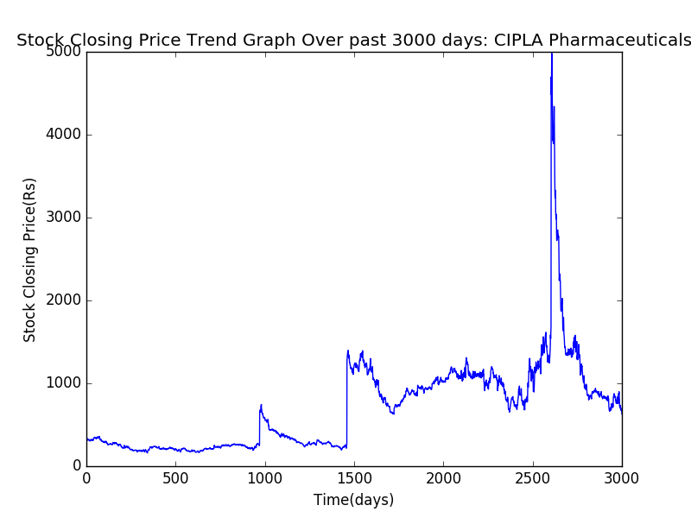

**HDFC DATASET**

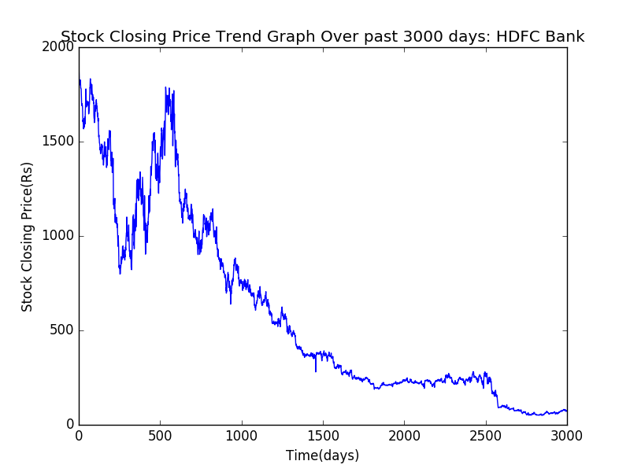

**TCS DATASET**

