ASG Airlines: Data Engineering Case Study
Documentation: architecture, data model, cleaning logic and assumptions

1. Overview
This document describes the end-to-end pipeline built for the ASG Airlines flight operations dataset: ingestion of 4 linked source tables (flights, bookings, passengers, payments), data quality remediation, PII protection, dimensional modelling, KPI calculation, and the Power BI reporting layer built on top.
Architecture used: Python (pandas) for ingestion, cleaning and modelling, loading into a local MySQL Server as the storage and serving layer, with Power BI Desktop as the reporting layer. This choice is discussed in Section 2.

2. Architecture and data flow
The diagram below shows the end-to-end architecture (source, ETL, storage, BI), the bronze/silver/gold layering inside the notebook, and the database-level separation used for access control.
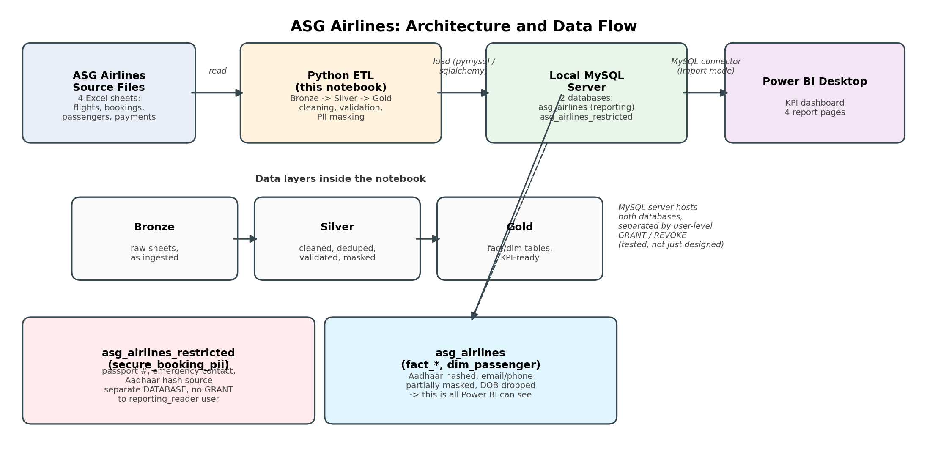

Why Python + local MySQL Server
Python (pandas) handles ingestion, cleaning and modelling, and a local MySQL Server holds the data in two databases: asg_airlines for reporting and asg_airlines_restricted for PII. This keeps the full pipeline runnable on a single machine with no cloud account or setup step required, and MySQL's user and privilege system gives a real, testable access boundary between the reporting data and the restricted PII, rather than a boundary enforced only by convention. Access control is enforced through MySQL users and GRANT/REVOKE: a dedicated reporting_reader user can query asg_airlines but has no grant at all on asg_airlines_restricted. The brief lists Azure Data Factory and Databricks as preferred for the transform layer; for a dataset this size (about 4,000 rows across 4 files), a scripted Python pipeline is faster to build and test, and keeps every transformation decision inspectable as code, while a local MySQL Server is an accepted alternative to a cloud database for storage.

3. Dataset structure
The source workbook contains four related sheets:
Table | Rows (raw) | Key columns | Notes
flights | 1,020 | flight_id, airline, source, destination, departure_time, arrival_time | Operational flight records
bookings | 1,000 | booking_id, passenger_id, flight_id, status | Links passengers to flights; contains PII (passport, emergency contact)
passengers | 1,039 | passenger_id, name, age, email, phone, aadhaar_id, DOB | Passenger master data; heavy PII
payments | 1,000 | payment_id, booking_id, amount, payment_method | Financial data linked to bookings

4. Data quality issues found and cleaning logic
Each issue below was identified through profiling before writing any cleaning code, and handled with an explicit, documented rule rather than a blanket drop-everything-unclean approach.
Issue | Rows | Decision and rationale
Exact duplicate flight rows | 15 | Dropped, kept first occurrence.
Same flight_id reused for two genuinely different flights (different times) | 2 IDs / 4 rows | Not deduped away. Given a synthetic surrogate key (flight_sk) so both real flights survive. This is the corrupted-identifier scenario the brief calls out directly.
airline missing or literally the string "UNKNOWN" | 69 | Imputed deterministically from the 2-letter flight_id prefix (SJ->SpiceJet, AI->Air India, UK->Vistara, 6F->IndiGo). Evidence-based, verified 1:1 against every non-missing row before applying.
Arrival before departure with no date rollover (logically impossible) | 1 | Flagged corrupted_timestamp; duration left null and excluded from duration KPIs, but counted in the anomaly log rather than silently repaired or dropped.
Normal overnight flights (arrival date = departure date + 1) | 124 | Duration computed directly from the timestamp difference. The date already rolls over correctly, so no special-case logic was needed once timestamps were parsed as full datetimes.
bookings.status missing (blank) vs. literal "INVALID" | 45 vs. 30 | Treated as two different things: blank relabelled UNKNOWN (truly not known); "INVALID" kept as its own status, since it may represent a real business state rather than a data entry error.
payments.amount literally the string "INVALID" | 30 | Coerced to null and tracked separately from genuinely missing amounts (48 rows). Confirms "INVALID" is a deliberate placeholder pattern used consistently across the source system, not a one-off in a single column.
Duplicate passenger_id with conflicting details (whitespace, different email/phone/Aadhaar/DOB) | 39 | Kept the most complete record per ID (fewest nulls); ties broken by keeping the last occurrence. Conflict count logged as its own data-quality metric rather than resolved silently.

5. Overnight flight and duration logic
Duration is computed as arrival_time minus departure_time using full datetime values, not just the time-of-day component, so a flight that lands the next calendar day naturally produces a positive duration without any special-case branching. A separate is_overnight flag (arrival date > departure date) is retained for reporting.
The single exception found (flight SJ192) had an arrival date one day before departure, not after, which is not a valid overnight pattern and cannot be corrected by simply adding a day. It is flagged as a data-quality anomaly rather than guessed at.

6. Delays and anomalies: assumption
The source data has no scheduled-time field, only actual departure and arrival timestamps. A true delay (actual vs. scheduled) is therefore not computable from this dataset, and no delay figure is reported, since inventing one would misrepresent the data.
As a check, flight duration was tested for statistical outliers per route (IQR method). It found zero outliers: duration is spread uniformly from 30 to 300 minutes on every route with no natural clustering, indicating this field was randomly generated for the exercise rather than modelling real scheduling behaviour. The detector stays in the pipeline since it would be valid on real-world data, and this result is reported as found.
"Anomalies" in the KPI dashboard refer to the data-quality anomalies actually present in this dataset: corrupted timestamps, reused flight identifiers, and bookings referencing an ambiguous flight ID.

7. Data model (star schema)
Table | Type | Grain / description
fact_flights | Fact | One row per operated flight; duration, route, overnight flag, data-quality flag
fact_bookings | Fact | One row per booking; status, passenger and flight references
fact_payments | Fact | One row per payment; amount, method, linked to a booking
dim_passenger | Dimension | One row per unique passenger, PII masked (see Section 8)
dim_airport | Dimension | Airport code to city name lookup, used to enrich route visuals
secure_booking_pii | Restricted | Passport number, emergency contact. Access-restricted, not exposed to reporting

8. PII masking, privacy and access control
Passenger and booking data contains genuine PII: Aadhaar ID, passport number, email, phone, date of birth, and emergency contact details. These are handled as follows:
- Aadhaar ID: one-way SHA-256 hash (with a static salt). Irreversible, but the same real value always hashes identically, so duplicate-person checks remain possible without ever storing the raw number in the analytics layer.
- Email / phone: partially masked (e.g. v***@gmail.com), kept recognisable for support scenarios without exposing the full value.
- Date of birth: dropped entirely from the analytics table and replaced with an age_band bucket (<18, 18-25, 26-40, 41-60, 60+), since exact DOB plus name is a re-identification risk even after other fields are masked.
- Passport number and emergency contact details: kept only in asg_airlines_restricted, a completely separate MySQL database, never joined into the reporting fact tables.
At the database level, asg_airlines_restricted is a physically separate MySQL database from asg_airlines (the reporting database). A dedicated reporting_reader MySQL user is granted SELECT on asg_airlines only; no GRANT of any kind is issued on asg_airlines_restricted, so the access boundary is enforced by MySQL's own privilege system rather than by convention. This was tested directly, not just designed: connecting as reporting_reader against asg_airlines_restricted returns "Access denied for user" (MySQL error 1044), while the same user can query asg_airlines normally. Net effect: Power BI, connected as reporting_reader, can only reach dim_passenger (already masked) and the fact tables, never secure_booking_pii or a plaintext Aadhaar/passport number.
Per-column privileges or masked views on top of asg_airlines_restricted would add a further layer of defense and can be added if time permits, but the core access boundary above already holds on its own.

9. Business KPIs
KPI | Definition
Average flight duration | Mean of duration_minutes across clean flights, overall / by airline / by route
Route-wise traffic | Flight count grouped by source-destination pair
Distribution of flights by airline | Flight count grouped by airline
Anomalies | Count of corrupted-timestamp flights, reused flight-ID conflicts, and ambiguous booking references (see Section 6 for why this replaces a literal delay figure)
Revenue by airline / route | Sum of payment amount for CONFIRMED bookings, joined bookings to payments to flights
Booking status funnel | Share of bookings by status: CONFIRMED / CANCELLED / PENDING / INVALID / UNKNOWN
Payment method mix | Share of payments by method: UPI / CARD / NETBANKING
Passenger age-band distribution | Passenger count by age_band, from the masked passenger dimension

10. Data quality summary (from pipeline run)
Metric | Count
Raw rows ingested (flights / bookings / passengers / payments) | 1,020 / 1,000 / 1,039 / 1,000
Exact duplicate flights removed | 15
Reused flight-ID conflicts resolved (kept, not dropped) | 2 IDs (4 rows)
Airline values imputed from flight_id prefix | 69
Corrupted flight timestamps flagged | 1
Booking status values imputed to UNKNOWN | 45
Bookings with ambiguous flight reference | 2
Passenger duplicate IDs resolved (conflicting data) | 39
Payments with missing amount | 48
Payments with amount = "INVALID" string | 30

11. Notebook and repository
The complete, executed pipeline is in ASG_Airlines_Pipeline.ipynb, with markdown explanations alongside every transformation step. Repository structure:
- /notebook/ASG_Airlines_Pipeline.ipynb: the pipeline, ingestion through KPI calculation
- /data/cleaned/: fact_flights.csv, fact_bookings.csv, fact_payments.csv, dim_passenger.csv, dim_airport.csv
- /dashboard/ASG_Airlines_Dashboard.pbix and a screenshot of each page
- /docs/ASG_Airlines_Documentation.docx: this document
- /docs/architecture_diagram.png
- README.md: setup instructions and a summary of the approach

