**BLOOD BANK AND**

**DONAR SYSTEM**

**INTRODUCTION**

Blood is a necessary element in the human body. Without blood, the human body is incomplete. Blood is about 7% to 8% of human weight, according to scientists. Blood is donated in the conventional way by blood donation services or blood bank. Blood bank is defined as an area where blood is obtained as a result of donor blood donation operation that is processed and preserved for subsequent transfusion (maximum twenty-eight days). Because of the enormous amount of donor data there must be an efficient and successful way of managing data that could make the online blood donation site a pavestone. It is a clear sign that blood donors rise with population growth. In addition to the blood handling issue, there is a possibility that data is obsolete and the process of data retrieval is also hindered by conventional manual operator’s data entry techniques.

OBJECTIVE

The main aim of this project will therefore be to find more effective ways of managing the database of blood banks and blood donors. This online website is built in order to get details as soon as required and we don’t have to visit the blood banks.

**REQUIREMENT**

#Languages

* HTML
* CSS
* PHP

USECASE

USER

ADMIN

**ERD**

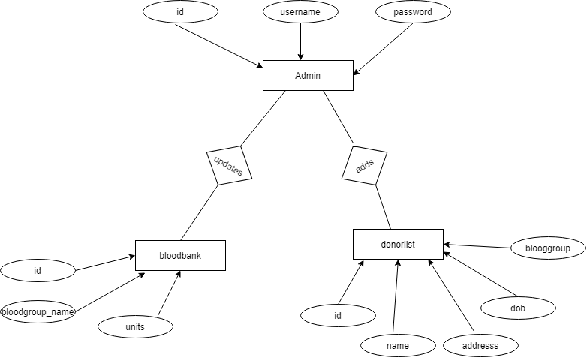

**SCREENSHORTS**

**Main page**

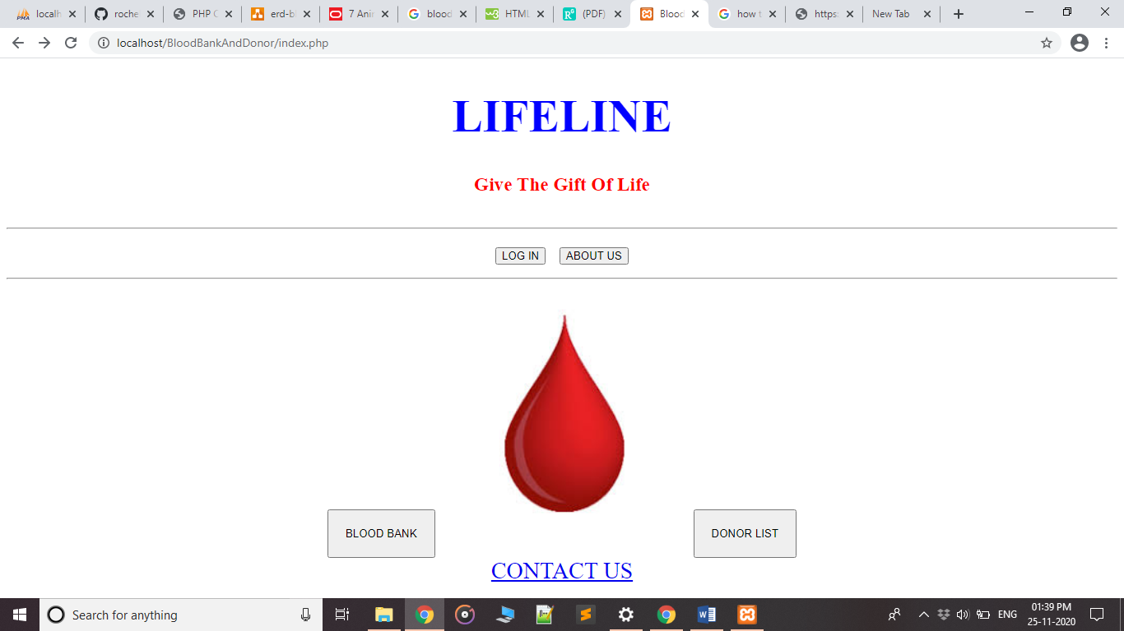

**Blood bank**

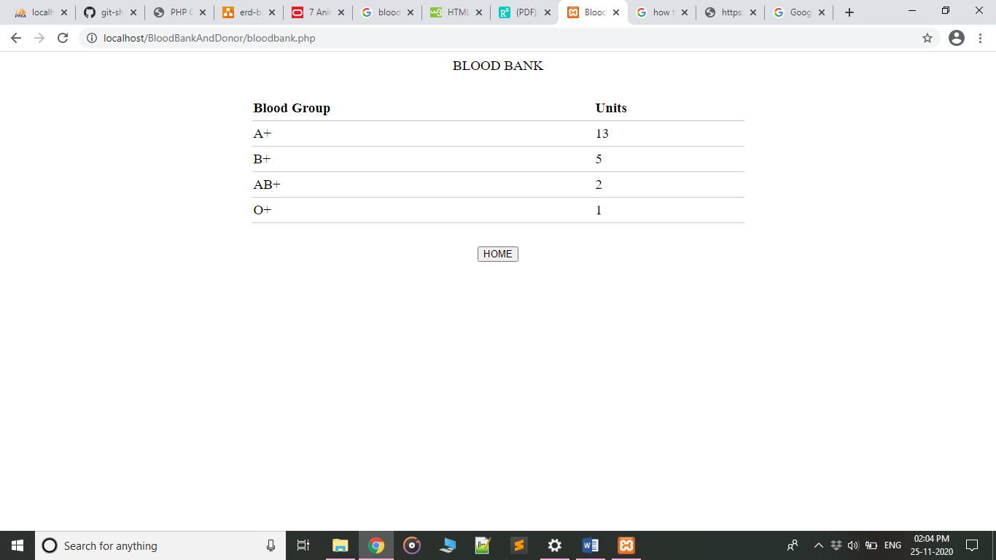

**DONOR LIST**

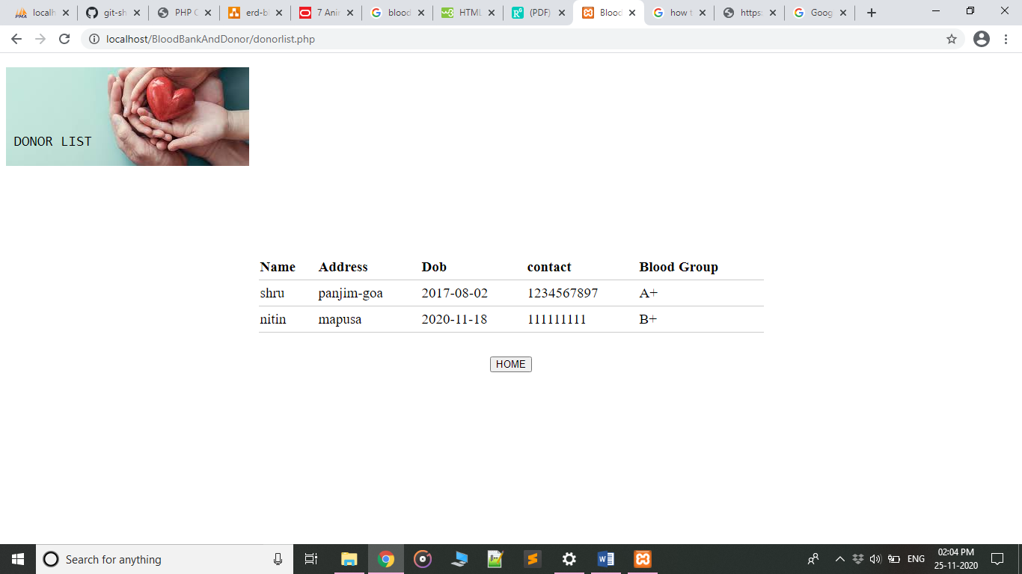

**ABOUT US PAGE**

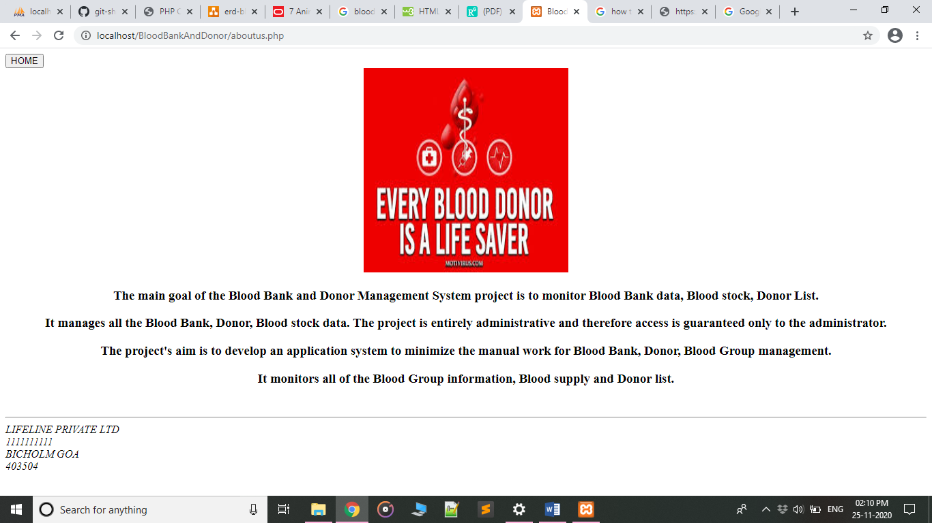

**LOGIN PAGE**

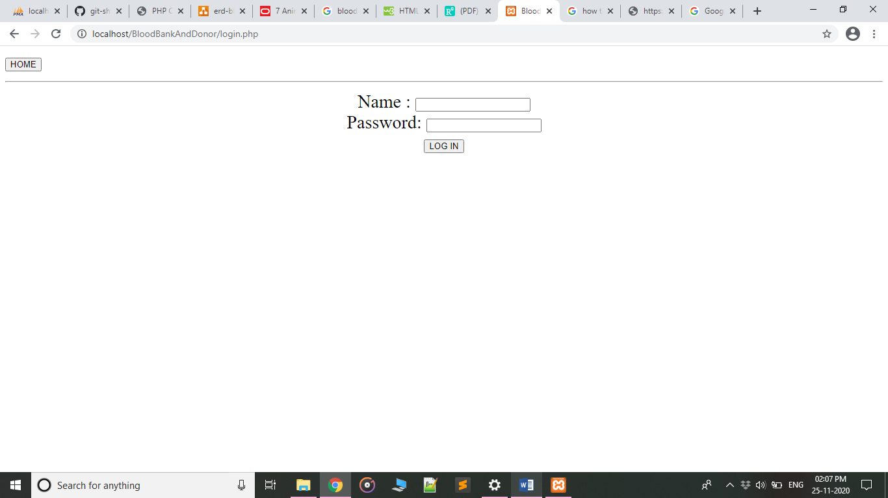

**ADMIN DONOR LIST PAGE**

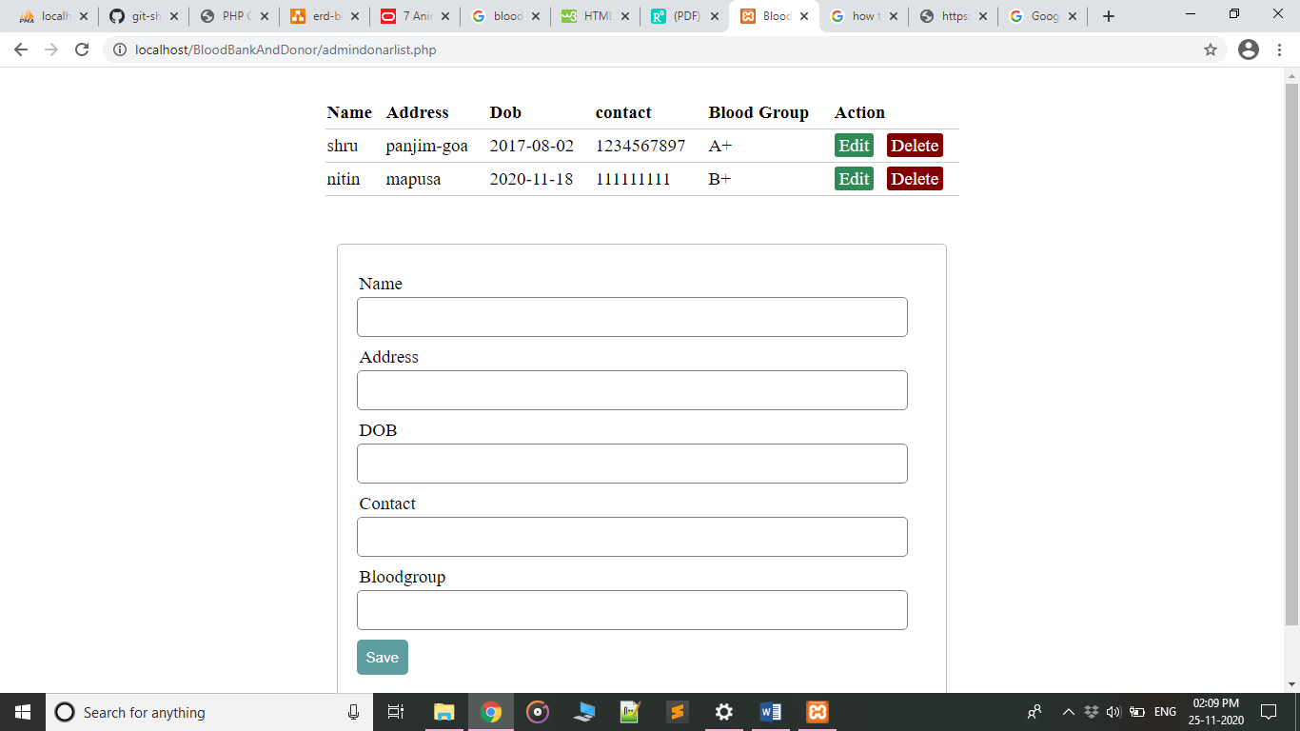

**ADMIN BLOOD BANK PAGE**

