**Auto Recorder**

**Purpose:**APP to convert Mobile Phone to DVR (Digital Video Recorder) and platform to see live and playback

**Mode:**Server Side and Mobile

**Function:   
*Server Side:****Server side is supposed to perform 3 main functions*

1. Push/Pull Settings from and to mobile phone  
{"schedule":[{"from":"08:24","to":"08:30"},{"from":"12:35","to":"12:38"}],"upload":0,"website":"http://live.021175.in/AutoRecordPHP/","camera_id":1,"video_quality":0,"orientation":1,"audio":1,"duration":30}

***Understanding settings***

*from and to time of record*{"schedule":[{"from":"08:24","to":"08:30"},{"from":"12:35","to":"12:38"}],

*Upload file when data is from Wifi=2, Mobile data=1, Wifi/Mobile data=0*"upload":0,

*Upload to server*"website":"http://live.021175.in/AutoRecordPHP/",

*Camera setting to front camera active=1 and rear camera active = 0*"camera_id":1,

*Set the resolution of the camera video quality*"video_quality":0,

*To set picture orientation say landscape=1 and portrait=0*"orientation":1,

*To record audio or not, say 0=audio off , 1=audio on*"audio":1,

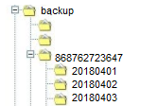*Duration of file in seconds*"duration":30,}

Backup days  
"backup":3,}

2. Capture and save time to time uploaded video files from mobile phone  
 So when save in folder mean   
 backup/358952061787677/20180208/082545_082615.mp4  
 main folder/imei_folder/date_folder/from_totime.mp4 [file]

3. Fetch list of files between said datetime from the particular phone on real-time basis  
 Say: **NOW:** 358952061787677_20180208_082545.mp4   
 ***SHOULD Be*** *amended and saved as*   
 358952061787677_20180208_082545_082615  
 imei date from to  
  
Purpose: When you fetch data from server between said datetime it should give the list of files in-between that datetime

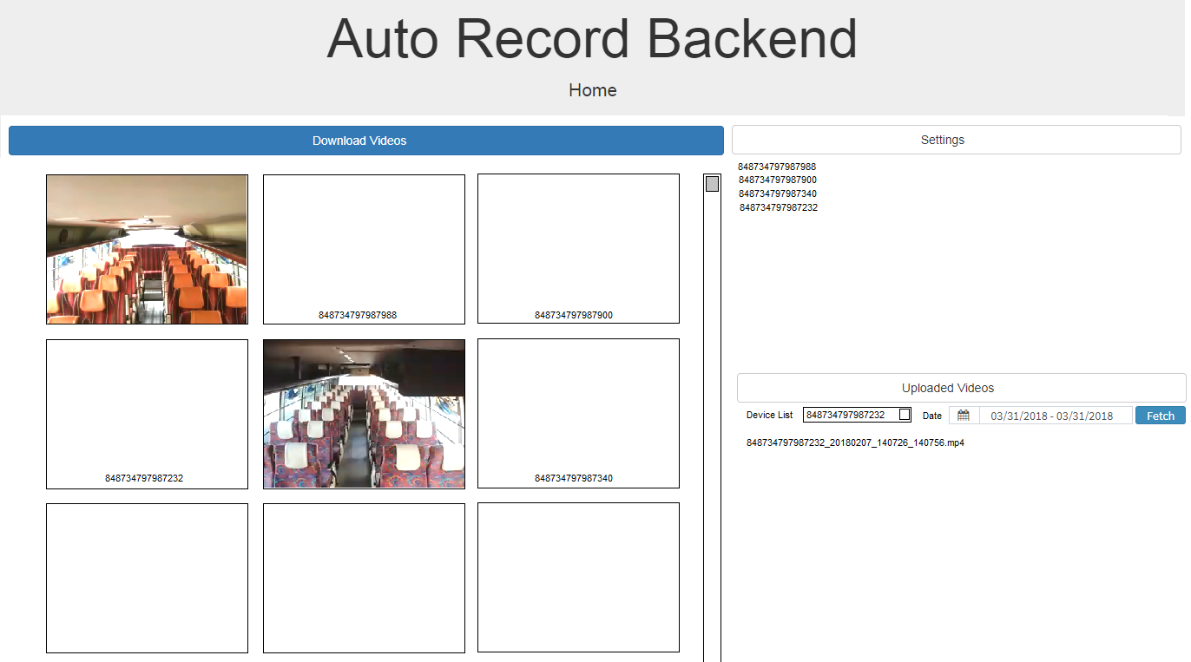

**Mobile Interface and its features**

1. Accepts settings from the server and update them, restart the app and work as per new settings

It will update which are the latest settings set in mobile app from time to time to server.

1. Make 2 folder

**Upload** and **Backup**

**Upload**/879879879879_20180401_011032_011532.mp4 --- This will keep files which have not been uploaded to server, due to any reason and will delete from there when successfully loaded, there should be log file which will keep track for the same and inform the server the number of files pending to be uploaded to be server when asked

Backup/20180401/filename.mp4 --- This folder will keep all recorded files and last 3 days (as defined in settings) backup will be stored and will delete 4th day folder say today is 20180401 then it should have

**Backup**/20180327 -- should be deleted on 20180330 (as it is 4th day)

**Backup**/20180328 -- should be deleted on 20180331 (as it is 4th day)

**Backup**/20180329 -- should be deleted on 20180401 (as it is 4th day)

**Backup**/20180330

**Backup**/20180331

**Backup**/20180401

1. Fetch date-wise data

When fetch query based on datetime is triggered, it should look data files from backup folder for that particular date and time and send the list to the server, and there should be process to fetch particular file if needed.

