**1.List :**

Example:-1

<!DOCTYPE html>

<html lang="en">

<head>

    <meta charset="UTF-8">

    <meta name="viewport" content="width=device-width, initial-scale=1.0">

    <title>Document</title>

</head>

<body>

    <ol type="1">

        <li>MCA</li>

        <li>BCA</li>

        <li>B.Tech</li>

        <li>BSC</li>

    </ol>

</body>

</html>

Output:

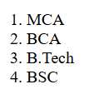

Example:-2

<!DOCTYPE html>

<html lang="en">

<head>

    <meta charset="UTF-8">

    <meta name="viewport" content="width=device-width, initial-scale=1.0">

    <title>Document</title>

</head>

<body>

    <ul type="circle">

        <li>Mango</li>

        <li>Banana</li>

        <li>Apple</li>

        <li>PineApple</li>

    </ul>

</body>

</html>

Output:

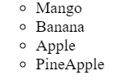

Example :-3

<!DOCTYPE html>

<html lang="en">

<head>

    <meta charset="UTF-8">

    <meta name="viewport" content="width=device-width, initial-scale=1.0">

    <title>Document</title>

</head>

<body>

    <h1>List of Fruits</h1>

    <ol type="1">

        <li>Apple</li>

        <li>Mango</li>

        <li>Banana</li>

        <li>Grapes</li>

        <li>Orange</li>

    </ol>

</body>

</html>

Output:

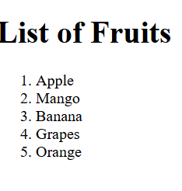

Example:-4

<!DOCTYPE html>

<html lang="en">

<head>

    <meta charset="UTF-8">

    <meta name="viewport" content="width=device-width, initial-scale=1.0">

    <title>Document</title>

</head>

<body>

    <ol type="1">

        <li>Ice-Cream</li>

        <li>Chocoba</li>

        <li>Cold-Coffee</li>

    </ol>

    <ol type="A">

        <li>Sugar</li>

        <li>Salt</li>

        <li>Sour</li>

    </ol>

    <ol type="a">

        <li>Car</li>

        <li>Bike</li>

        <li>Scooty</li>

    </ol>

    <ol type="I">

        <li>Aroplane</li>

        <li>Bus</li>

        <li>Ship</li>

    </ol>

    <ol type="i">

        <li>Air</li>

        <li>Water</li>

        <li>Fire</li>

    </ol>

</body>

</html>

Output:

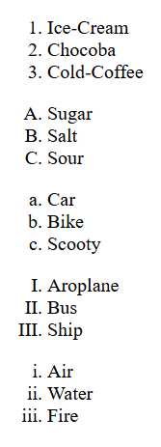

Example:-5

<!DOCTYPE html>

<html lang="en">

<head>

    <meta charset="UTF-8">

    <meta name="viewport" content="width=device-width, initial-scale=1.0">

    <title>Document</title>

</head>

<body>

    <ul type="Disc">

        <li>HTML</li>

        <li>CSS</li>

        <ul type="circle">

            <li>Introduction</li>

            <li>CSS Attributes</li>

            <ul type="square">

                <li>color</li>

                <li>font</li>

            </ul>

        </ul>

        </ul>

    </ul>

    <ul type="Disc">

        <li>Javascript</li>

    </ul>

</body>

</html>

Output:

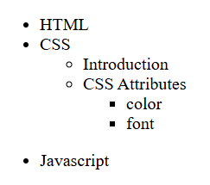

Example:-6

<!DOCTYPE html>

<html lang="en">

<head>

    <meta charset="UTF-8">

    <meta name="viewport" content="width=device-width, initial-scale=1.0">

    <title>Document</title>

</head>

<body>

    <h1>Description Lists:</h1>

    <dt>Tea</dt>

    <dd>-hot drink</dd>

    <dt>Juice</dt>

    <dd>-cold drink</dd>

</body>

</html>

Output:

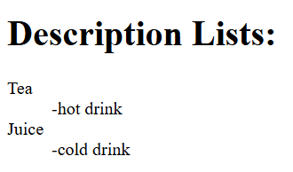

Example:-7

<!DOCTYPE html>

<html lang="en">

<head>

    <meta charset="UTF-8">

    <meta name="viewport" content="width=device-width, initial-scale=1.0">

    <title>Document</title>

</head>

<body>

    <dt>HTML</dt>

    <dd>Hyper-Text Markup Language</dd>

    <dt>CSS</dt>

    <dd>Cascading StyleSheets</dd>

    <dt>JS</dt>

    <dd>Javascript</dd>

</body>

</html>

Output:

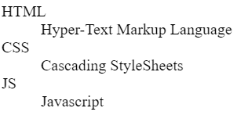

Example:-8

<!DOCTYPE html>

<html lang="en">

<head>

    <meta charset="UTF-8">

    <meta name="viewport" content="width=device-width, initial-scale=1.0">

    <title>Document</title>

</head>

<body>

    <h1>Frontend</h1>

    <ul type="circle">

        <li>HTML</li>

        <li>CSS</li>

        <ul type="square">

            <li>onsubmit Attribute</li>

            <li>onclick Attribute</li>

        </ul>

        <li>Javascript</li>

    </ul>

    <h2>Library/Framework</h2>

    <ul type="circle">

        <li>ReactJS</li>

        <ul type="square">

            <li>Hoisting</li>

            <li>Props</li>

        </ul>

    </ul>

</body>

</html>

Output:

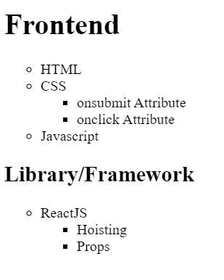

Example:-9

<!DOCTYPE html>

<html lang="en">

<head>

    <meta charset="UTF-8">

    <meta name="viewport" content="width=device-width, initial-scale=1.0">

    <title>Document</title>

</head>

<body>

    <h1>List Example</h1>

    <ol type="I">

        <li>List Item 1</li>

        <ol type="a">

            <li>Nested item 1.1</li>

            <li>Nested item 1.2</li>

        </ol>

        <li>List item 2</li>

        <ol type="1">

            <li>Nested item 2.1</li>

            <li>Nested item 2.2</li>

            <ul type="circle">

                <li>Nested item 2.2.1</li>

                <li>Nested item 2.2.2</li>

                <ul type="square">

                    <li>Nested item 2.2.2.1</li>

                    <li>Nested item 2.2.2.2</li>

                </ul>

                <li>Nested item 2.2.3</li>

            </ul>

            <li>Nested Item 2.3</li>

        </ol>

        <li>List Item 3</li>

        <ul type="Disc">

            <li>Nested item 3.1</li>

            <li>Nested item 3.1</li>

            <li>Nested item 3.1</li>

        </ul>

    </ol>

</body>

</html>

Output:

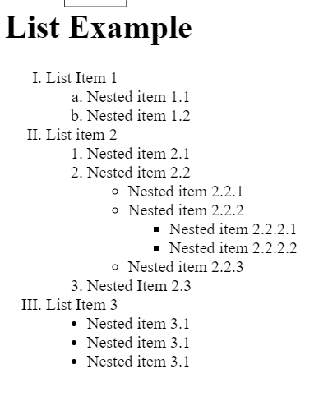

Example:10

<!DOCTYPE html>

<html lang="en">

<head>

    <meta charset="UTF-8">

    <meta name="viewport" content="width=device-width, initial-scale=1.0">

    <title>Document</title>

</head>

<body>

    <h1>Nested List</h1>

    <ol type="I">

        <li>Background Skills</li>

        <ol type="A">

            <li>Unix Commands</li>

            <li>Vim Test Editors</li>

        </ol>

        <li>HTML</li>

        <ol type="A">

            <li>Minimal Page</li>

            <li>Headings</li>

            <li>Elements</li>

            <li>Lists</li>

            <ol type="i">

                <li>Unordered</li>

                <li>Ordered</li>

                <li>Defination</li>

                <li>Nested</li>

            </ol>

            <li>Links</li>

            <ol type="i">

                <li>Absolute</li>

                <li>Relative</li>

            </ol>

            <li>Images</li>

        </ol>

        <li>CSS</li>

        <ol type="A">

            <li>Anatomy</li>

            <li>Basic Selectors</li>

            <ol type="i">

                <li>Element</li>

                <li>Class</li>

                <li>ID</li>

                <li>Group</li>

            </ol>

            <li>The DOM</li>

            <li>Advanced Selectors</li>

            <li>Box Model</li>

        </ol>

        <li>Programming</li>

        <ol type="A">

            <li>Python</li>

            <li>JavaScript</li>

        </ol>

        <li>Database</li>

        <ol type="A">

            <li>Flat File</li>

            <li>Relational</li>

        </ol>

    </ol>

</body>

</html>

Output:

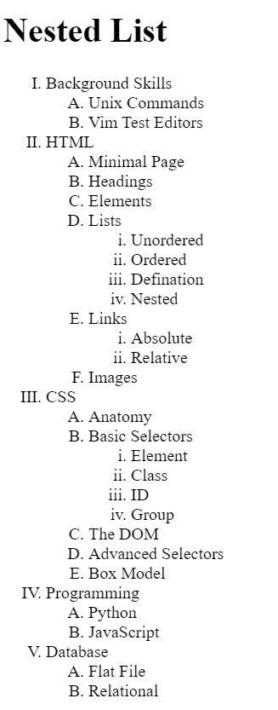

**2.Table :**

Example:-1

<!DOCTYPE html>

<html lang="en">

<head>

    <meta charset="UTF-8">

    <meta name="viewport" content="width=device-width, initial-scale=1.0">

    <title>Document</title>

</head>

<body>

    <table border="2">

        <tr>

            <th>sr.no</th>

            <th>roll.no</th>

            <th>name</th>

            <th>team</th>

        </tr>

        <tr>

            <td>1</td>

            <td>1001</td>

            <td>john</td>

            <td>red</td>

        </tr>

        <tr>

            <td>2</td>

            <td>1002</td>

            <td>peter</td>

            <td>blue</td>

        </tr>

        <tr>

            <td>3</td>

            <td>1003</td>

            <td>henry</td>

            <td>green</td>

        </tr>

    </table>

</body>

</html>

Output:

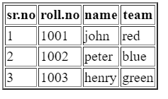

Example:-2

<!DOCTYPE html>

<html lang="en">

<head>

    <meta charset="UTF-8">

    <meta name="viewport" content="width=device-width, initial-scale=1.0">

    <title>Document</title>

    <h1>weather station</h1>

</head>

<body>

    <table border="1">

        <tr>

            <th rowspan="2">station</th>

            <th colspan="2">temprature</th>

            <th rowspan="2">humidity</th>

            <th rowspan="2">weather</th>

        </tr>

        <tr>

            <th>max</th>

            <th>min</th>

        </tr>

        <tr>

            <td>USA</td>

            <td>24</td>

            <td>19</td>

            <td>60%</td>

            <td>cloudy</td>

        </tr>

        <tr>

            <td>germany</td>

            <td>5</td>

            <td>-1</td>

            <td>70%</td>

            <td>rainy</td>

        </tr>

    </table>

</body>

</html>

Output:

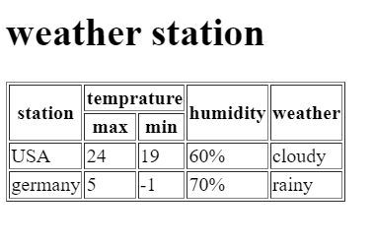

Example:-3

<!DOCTYPE html>

<html lang="en">

<head>

    <meta charset="UTF-8">

    <meta name="viewport" content="width=device-width, initial-scale=1.0">

    <title>Document</title>

</head>

<body>

    <table border="1" height="100" width="200">

        <tr align="center">

            <th>Name</th>

            <th>Age</th>

            <th>Country</th>

        </tr>

        <tr align="center">

            <td>Michel</td>

            <td>27</td>

            <td>Alaska</td>

        </tr>

        <tr align="center">

            <td>Evelyn</td>

            <td>32</td>

            <td>Ohio</td>

        </tr>

    </table>

</body>

</html>

Output:

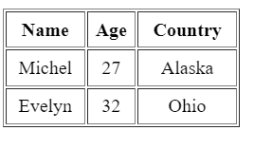

Example:-4

<!DOCTYPE html>

<html lang="en">

<head>

    <meta charset="UTF-8">

    <meta name="viewport" content="width=device-width, initial-scale=1.0">

    <title>Document</title>

</head>

<body>

    <table border="1">

        <tr>

            <th>Name</th>

            <th>Country</th>

            <th>Age</th>

        </tr>

        <tr>

            <td>Peter</td>

            <td>USA</td>

            <td>21</td>

        </tr>

        <tr>

            <td>Sam</td>

            <td>Mexico</td>

            <td>23</td>

        </tr>

        <tr>

            <td>John</td>

            <td>Spain</td>

            <td>25</td>

        </tr>

    </table>

</body>

</html>

Output:

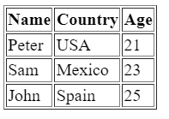

Example:-5

<!DOCTYPE html>

<html lang="en">

<head>

    <meta charset="UTF-8">

    <meta name="viewport" content="width=device-width, initial-scale=1.0">

    <title>Document</title>

</head>

<body>

    <table border="1">

        <tr align="center">

            <th>No.</th>

            <th>Full Name</th>

            <th>Position</th>

            <th>Salary</th>

        </tr>

        <tr align="center">

            <td>1</td>

            <td>Bill Gates</td>

            <td>Founder Microsoft</td>

            <td>$1000</td>

        </tr>

        <tr align="center">

            <td>2</td>

            <td>Steve Jobs</td>

            <td>Founder Apple</td>

            <td>$1200</td>

        </tr>

        <tr align="center">

            <td>3</td>

            <td>Larry Page</td>

            <td>Founder Google</td>

            <td>$1100</td>

        </tr>

        <tr align="center">

            <td>4</td>

            <td>Bill Google</td>

            <td>Founder Facebook</td>

            <td>$1300</td>

        </tr>

    </table>

</body>

</html>

Output:

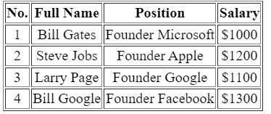

Example:-6

<!DOCTYPE html>

<html lang="en">

<head>

    <meta charset="UTF-8">

    <meta name="viewport" content="width=device-width, initial-scale=1.0">

    <title>Document</title>

</head>

<body>

    <table border="1" height="100" width="400">

        <tr align="center">

            <th></th>

            <th colspan="2" bgcolor="lightgreen">2 By 3 Map</th>

            <th bgcolor="lightgreen">3 By 4 Map</th>

        </tr>

        <tr align="center">

            <td rowspan="2">Method 1</td>

            <td>60 ms</td>

            <td>940 ms</td>

            <td>60530 ms(1 minute)</td>

        </tr>

        <tr align="center">

            <td>0 ms</td>

            <td>0 ms</td>

            <td>0 ms</td>

        </tr>

        <tr align="center">

            <td>Total</td>

            <td>1 ms</td>

            <td>1 ms</td>

            <td>1 ms</td>

        </tr>

    </table>

</body>

</html>

Output:

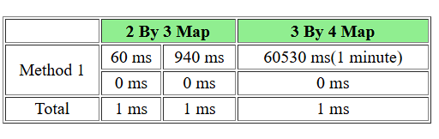

Example:-7

<!DOCTYPE html>

<html lang="en">

<head>

    <meta charset="UTF-8">

    <meta name="viewport" content="width=device-width, initial-scale=1.0">

    <title>Document</title>

</head>

<body>

    <table border="1">

        <tr align="center">

            <th colspan="2">Name</th>

            <th>Age</th>

            <th colspan="2">Course</th>

        </tr>

        <tr align="center">

            <td>Ninja</td>

            <td>1</td>

            <td>20</td>

            <td>C++</td>

            <td>Python</td>

        </tr>

        <tr align="center">

            <td>Ninja</td>

            <td>2</td>

            <td>31</td>

            <td colspan="2">Java</td>

        </tr>

        <tr align="center">

            <td>Ninja</td>

            <td>3</td>

            <td>29</td>

            <td>JavaScript</td>

            <td>R</td>

        </tr>

    </table>

</body>

</html>

Output:

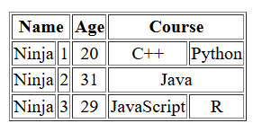

Example:-8

<!DOCTYPE html>

<html lang="en">

<head>

    <meta charset="UTF-8">

    <meta name="viewport" content="width=device-width, initial-scale=1.0">

    <title>Document</title>

</head>

<body>

    <table border="1" height="100" width="400">

    <tr align="center">

    <td>Column 1</td>

    <td>Column 2</td>

    <td>Column 3</td>

    </tr>

    <tr align="center">

        <td rowspan="2">Row 1 Cell 1</td>

        <td>Row 1 Cell 2</td>

        <td>Row 1 Cell 3</td>

    </tr>

    <tr align="center">

        <td>Row 2 Cell 2</td>

        <td>Row 2 Cell 3</td>

    </tr>

    <tr>

        <td colspan="3">Row 3 Cell 1</td>

    </tr>

    </table>

</body>

</html>

Output:

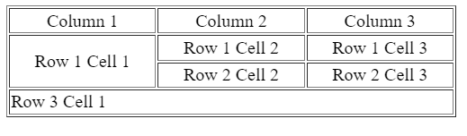

Example:-9

<!DOCTYPE html>

<html lang="en">

<head>

    <meta charset="UTF-8">

    <meta name="viewport" content="width=device-width, initial-scale=1.0">

    <title>Document</title>

</head>

<body>

    <table border="1" bordercolor="green" height="100" width="400">

        <tr align="center">

            <th bgcolor="orange">Sr.No</th>

            <th bgcolor="orange">Roll No</th>

            <th bgcolor="orange">Name</th>

            <th bgcolor="orange">Team</th>

        </tr>

        <tr align="center">

            <th bgcolor="orange">1</th>

            <td>1001</td>

            <td>John</td>

            <td>Red</td>

        </tr>

        <tr align="center">

            <th bgcolor="orange">2</th>

            <td>1002</td>

            <td>Peter</td>

            <td>Blue</td>

        </tr>

        <tr align="center">

            <th bgcolor="orange">3</th>

            <td>1003</td>

            <td>Henry</td>

            <td>Green</td>

        </tr>

    </table>

</body>

</html>

Output:

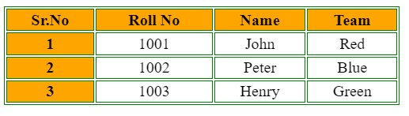

**3.Form :**

Example:-1

<!DOCTYPE html>

<html lang="en">

<head>

    <meta charset="UTF-8">

    <meta name="viewport" content="width=device-width, initial-scale=1.0">

    <title>Document</title>

</head>

<body>

    <label for="text">First Name:</label>

    <input type="text" id="text" name="name"><br>

    <label for="text">Last Name:</label>

    <input type="text" id="text" name="name" required><br>

    <label for="number">Date of birth:</label>

    <input type="date" id="number" name="age"><br>

    <label for="Age">Age:</label>

    <input type="number" id="number" name="Age" required><br>

    <label for="Gender">Gender</label>

    <input type="radio" name="Gender" value="male">Male

    <input type="radio" name="Gender" value="female">female

    <input type="radio" name="Gender" value="other">other <br>

    <label for="email">Enter Email:</label>

    <input type="email" id="email" name="email" required> <br>

    <label for="Positions">Positions Available</label>

    <input type="radio" name="Positions" value="Junior Developer">Junior Developer

    <input type="radio" name="Positions" value="Mid level Developer">Mid level Developer

    <input type="radio" name="Positions" value="Senior Developer">Senior Developer <br>

    <label for="language">Programming language</label>

    <input type="checkbox" name="Select value" value="Python">Python

    <input type="checkbox" name="Select value" value="Java">Java

    <input type="checkbox" name="Select value" value="C++">C++ <br>

    <label for="Password">Password:</label>

    <input type="Password" id="Password" name="Password" required><br>

    <label for="Confirm Password">Confirm Password:</label>

    <input type="Password" id="Confirm Password" name="Password" required><br>

    <button>Reset</button>

    <button>Submit</button>

    </body>

</html>

Output:



Example:-2

<!DOCTYPE html>

<html lang="en">

<head>

    <meta charset="UTF-8">

    <meta name="viewport" content="width=device-width, initial-scale=1.0">

    <title>Document</title>

</head>

<body>

    <input type="text" id="text" name="name" placeholder="Enter Name"><br>

    <input type="text" id="text" name="name" placeholder="Last Name"><br>

    <input type="email" id="email" placeholder="email"><br>

    <input type="password" id="password" placeholder="password"><br>

    <input type="number" id="age" name="age" placeholder="age"><br>

    <input type="file" id="file" name="file"><br>

    <input type="color"><br>

    <input type="date" id="date" name="date"><br>

    <textarea name="" id=""></textarea><br>

    <select>

    <option value="">java</option>

    <option value="">c++</option>

    </select><br>

    <button>submit</button>

</body>

</html>

Output:

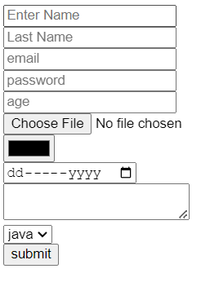

Example:-3

<!DOCTYPE html>

<html lang="en">

<head>

    <meta charset="UTF-8">

    <meta name="viewport" content="width=device-width, initial-scale=1.0">

    <title>Document</title>

</head>

<body>

    <input type="text" id="text" name="name" placeholder="Enter First Name"><br>

    <input type="text" id="text" name="name" placeholder="Enter Last Name"><br>

    <input type="email" id="email" placeholder="Enter your Email"><br>

    <label for="Password">Password</label>

    <input type="Password" id="Password" name="Password" required><br>

    <label for="Gender">Gender</label>

    <input type="radio" name="Gender" value="male">Male

    <input type="radio" name="Gender" value="female">female

    <input type="radio" name="Gender" value="other">other <br>

    <input type="number" id="age" name="age" placeholder="Age"><br>

    <select>

    <option value="">Student</option>

    <option value="">Shruti</option>

    </select><br>

    <textarea placeholder="Share few lines about yourself"></textarea><br>

    Agree and Continue<input type="checkbox" name="selct value" value="Agree and Continue"><br>

    <button>Submit</button>

    <button>Reset</button>

</body>

</html>

Output:

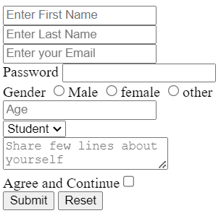

Example:-4

<!DOCTYPE html>

<html lang="en">

<head>

    <meta charset="UTF-8">

    <meta name="viewport" content="width=device-width, initial-scale=1.0">

    <title>Document</title>

</head>

<body>

    <h2>Student Admission Form:</h2>

   <p>Your Admission Information Below:</p>

  <form>

    <label for="firstName">First Name:</label>

    <input type="text" id="firstName" name="firstName" placeholder="Enter First name"><br><br>

    <label for="middleName">Middle Name:</label>

    <input type="text" id="middleName" name="middleName" placeholder="Enter Middle name"><br><br>

    <label for="lastName">Last Name:</label>

    <input type="text" id="lastName" name="lastName" placeholder="Enter Last name"><br><br>

    <label for="dob">Date Of Birth:</label>

    <input type="date" id="dob" name="dob" placeholder="dd-mm-yyyy"><br><br>

    <label>Gender:</label>

    <input type="radio" id="male" name="gender" value="male">

    <label for="male">Male</label>

    <input type="radio" id="female" name="gender" value="female">

    <label for="female">Female</label>

    <input type="radio" id="other" name="gender" value="other">

    <label for="other">Other</label><br><br>

    <label for="phone">Phone No:</label>

    <input type="tel" id="phone" name="phone"><br>

    <label for="email">Email:</label>

    <input type="email" id="email" name="email"><br>

    <label for="currentAddress">Current Address:</label>

    <textarea id="currentAddress" name="currentAddress"></textarea><br>

    <label for="permanentAddress">Permanent Address:</label>

    <textarea id="permanentAddress" name="permanentAddress"></textarea><br>

    <input type="submit" value="Submit">

    <input type="reset" value="Reset">

  </form>

</body>

</html>

Output:

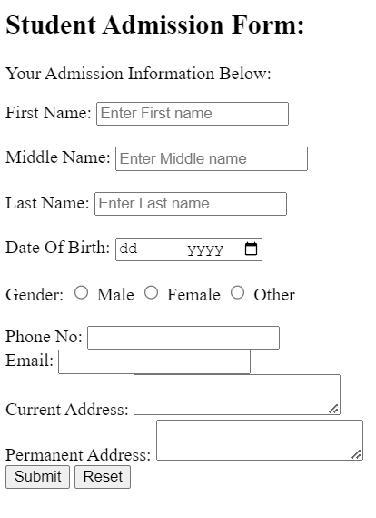

**4.Signal Lights :**

.HTML

<!DOCTYPE html>

<html lang="en">

<head>

    <meta charset="UTF-8">

    <meta name="viewport" content="width=device-width, initial-scale=1.0">

    <title>Document</title>

    <link rel="stylesheet" href="style7.css">

</head>

<body>

    <div class="box" align="center">

        <div class="box1"></div>

        <div class="box2"></div>

        <div class="box3"></div>

    </div>

</body>

</html>

.CSS

*{

    margin: 0;

    padding: 0;

    box-sizing: border-box;

}

html,body{

    height: 100px;

    width: 100px;

}

.box{

    height: 350px;

    width: 200px;

    border:4px solid black;

    background-color: black;

    margin: 20px;

    border-radius: 20px;

    outline-offset: 5px solid black;

    box-shadow: 5px 5px 5px 10px black;

    outline: 4px solid black;

}

.box1{

    height: 100px;

    width: 100px;

    background-color: red;

    border-radius: 50%;

    margin-top: 10px;

    margin-left: 20px;

}

.box2{

    height: 100px;

    width: 100px;

    background-color: yellow;

    border-radius: 50%;

    margin-top: 10px;

    margin-left: 20px;

}

.box3{

    height: 100px;

    width: 100px;

    background-color: green;

    border-radius: 50%;

    margin-top: 10px;

    margin-left: 20px;

}

Output:

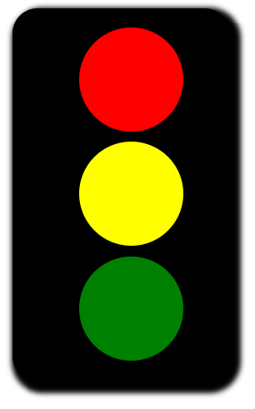

**5.Smile Output:**

.HTML

<!DOCTYPE html>

<html lang="en">

<head>

    <meta charset="UTF-8">

    <meta name="viewport" content="width=device-width, initial-scale=1.0">

    <title>Document</title>

    <link rel="stylesheet" href="style19.css">

</head>

<body>

    <main>

        <div class="circle">

            <div class="circle1" id="c1">

            <div class="circle1-sub"></div>

        </div>

        <div class="circle2" id="c2">

            <div class="circle2-sub"></div>

        </div>

    <div class="circle3" id="c3">

    </div>

</div>

        </main>

</body>

</html>

.CSS

*{

    margin: 0;

    padding: 0;

    box-sizing: border-box;

}

html,

body{

    height: 100%;

    width: 100%;

}

.circle{

    height: 550px;

    width: 550px;

    border: 2px solid black;

    border-radius: 100%;

    background-color: rgba(239, 239, 11, 0.882);

    border-radius: 50%;

    margin-left: 10px;

    box-shadow:  0px 0px 50px black;

}

.circle1{

    height: 150px;

    width: 100px;

    border: 2px solid rgb(34, 17, 17);

    margin-top: 150px;

    margin-left: 110px;

    background-color: black;

    border-radius: 100%;

}

.circle1-sub {

    height: 100px;

    width: 50px;

    border: 2px solid rgb(34, 17, 17);

    margin-top: 48px ;

    margin-left: 24px;

    background-color: rgb(253, 250, 250);

    border-radius: 100%;

}

.circle2-sub {

    height: 100px;

    width: 50px;

    border: 2px solid rgb(34, 17, 17);

    margin-top: 48px ;

    margin-left: 24px;

    background-color: rgb(253, 250, 250);

    border-radius: 100%;

}

.circle2{

    height: 150px;

    width: 100px;

    border: 2px solid black;

    border-radius: 100%;

    margin-top: 100px;

    margin-left: 350px;

    top: 50px;

    position: absolute;

    background-color: black;

}

.circle3{

    height: 280px;

    width: 285px;

    border-bottom: 35px solid;

    border-radius: 140px;

    margin-top: 155px;

    margin-left: 155px;

    top: 38px;

    position: absolute;

}

Output:



**6.Indian Flag:-**

.HTML

<!DOCTYPE html>

<html lang="en">

<head>

    <meta charset="UTF-8">

    <meta name="viewport" content="width=device-width, initial-scale=1.0">

    <title>Document</title>

    <link rel="stylesheet" href="style22.css">

</head>

<body>

    <h1></h1>

    <div class="parent1">

    <div class="parent">

        <div class="box1">

            <div class="ashoka-chakra">

                <img src="/HTML/CSS/WhatsApp Image 2025-02-25 at 1.14.57 PM.jpeg" alt="" class="img">

            </div>

        </div>

        <div class="box2"></div>

        <div class="box3"></div>

    </div>

    </div>

</body>

</html>

.CSS

*{

    margin: 0px;

    padding: 0px;

    box-sizing: border-box;

}

html,body{

    height: 100%;

    width: 100%;

}

.parent{

    margin-top: 40px;

    margin-left: 30px;

    border-radius: 50px;

}

.box1{

    height: 100px;

    width: 450px;

    background-color: orangered;

    border: 4px solid;

}

.box2{

    height: 95px;

    width: 450px;

    background-color: white;

    border: 4px solid;

}

.box3{

    height: 100px;

    width: 450px;

    background-color: green;

    border: 4px solid;

}

.img{

    height: 86px;

    width: 86px;

    margin-top: 100px;

    margin-left: 175px;

    border-radius:  200px;

}

h1::before{

        margin-left: 200px;

        content: "INDIA";

        background: linear-gradient(orangered,white,green);

}

Output:

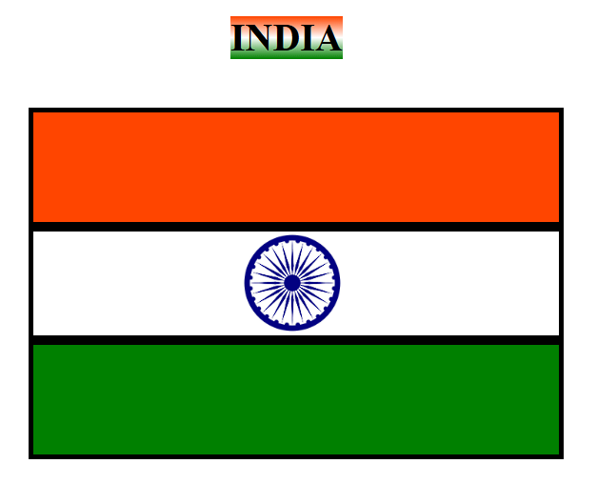

**7.Indian Flag(circle):**

.HTML

<!DOCTYPE html>

<html lang="en">

<head>

    <meta charset="UTF-8">

    <meta name="viewport" content="width=device-width, initial-scale=1.0">

    <title>Indian Flag Circle</title>

    <link rel="stylesheet" href="style24.css">

</head>

<body>

    <div class="circle">

        <div class="box1">

        </div>

        <div class="box2">

            <img src="./HTML/CSS/WhatsApp Image 2025-02-25 at 1.14.57 PM.jpeg" alt="" class="img">

        </div>

        <div class="box3"></div>

    </div>

</body>

</html>

.CSS

*{

    margin: 0px;

    padding: 0px;

    box-sizing: border-box;

}

html,body {

    height: 100%;

    width: 100%;

}

.circle {

    width: 400px;

    height: 400px;

    border-radius: 50%;

    overflow: hidden;

    position: relative;

    border: 3px solid black;

    top: 30px;

    left: 30px;

}

.box1 {

    background-color: orangered;

    height: 33.3%;

    width: 100%;

    position: absolute;

    top: 0;

}

.box2 {

    background-color: white;

    height: 33.3%;

    width: 100%;

    position: absolute;

    top: 33.3%;

    display: flex;

    justify-content: center;

    align-items: center;

}

.box3 {

    background-color: green;

    height: 33.3%;

    width: 100%;

    position: absolute;

    bottom: 0;

}

.img{

    height: 120px;

    width: 120px;

}

Output:



8)Grid Output :

1).HTML

<!DOCTYPE html>

<html lang="en">

  <head>

    <meta charset="UTF-8" />

    <meta name="viewport" content="width=device-width, initial-scale=1.0" />

    <title>Document</title>

    <link rel="stylesheet" href="style36.css" />

  </head>

  <body>

    <div class="container">

      <div class=" item item1">content1</div>

      <div class=" item item2">content2</div>

      <div class=" item item3">content3</div>

      <div class=" item item4">content4</div>

      <div class=" item item5">content5</div>

      <div class=" item item6">content6</div>

      <div class=" item item7">content7</div>

      <div class=" item item8">content8</div>

      <div class=" item item9">content9</div>

    </div>

  </body>

</html>

.css

*{

    margin: 0;

    padding: 0;

    box-sizing: border-box;

}

html,body{

    height: 100%;

    width:100%;

}

.container{

    border:2px solid;

    background-color: azure;

    height:100%;

    display:grid;

    grid-template-areas: "item1 item2 item2 item2 item2"

    "item1 item3 item4 item4 item4"

    "item1 item3 item5 item6 item6"

    "item1 item3 item5 item7 item8"

    "item1 item3 item5 item7 item9"

;

}

.item{

    border:2px solid black;

    display: flex;

    align-items: center;

    justify-content: center;

}

.item1{

    background-color: green;

    grid-area: item1;

}

.item2{

    background-color: red;

    grid-area: item2;

}

.item3{

    background-color: yellowgreen;

    grid-area: item3;

}

.item4{

    background-color: orange;

    grid-area: item4;

}

.item5{

    background-color: aquamarine;

    grid-area: item5;

}

.item6{

    background-color: yellow;

    grid-area: item6;

}

.item7{

    background-color: rgb(157, 222, 26);

    grid-area: item7;

}

.item7{

    background-color: skyblue;

    grid-area: item7;

}

.item8{

    background-color: violet;

    grid-area: item8;

}

.item9{

    background-color: palevioletred;

    grid-area: item9;

}

Output:

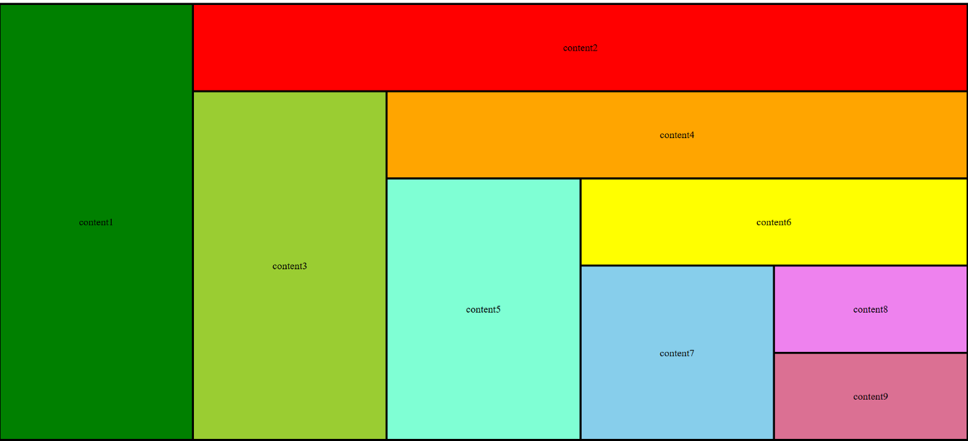

2).HTML

<!DOCTYPE html>

<html lang="en">

<head>

    <meta charset="UTF-8">

    <meta name="viewport" content="width=device-width, initial-scale=1.0">

    <title>Document</title>

    <link rel="stylesheet" href="style34.css">

</head>

<body>

    <div class="container">

        <div class="item item1"> Header</div>

        <div class="item item2">Navigation</div>

        <div class="item item3">Content</div>

        <div class="item item4">Section</div>

        <div class="item item5">footer</div>

        <div class="item item6">aside</div>

    </div>

</body>

</html>

.css

*{

    margin: 0;

    padding: 0;

    box-sizing: border-box;

}

html,body{

    height:100%;

    width:100%;

}

.container{

    border:2px soild;

    background-color: azure;

    height:100%;

    display:grid;

    grid-template-areas: "header header header header"

    "nav nav nav nav"

     "aside aside content content"

    "aside aside section section"

     "footer footer footer footer";

     gap:10px;

}

.item{

    border: 2px solid black;

    display:flex;

    justify-content: center;

    align-items: center;

}

.item1{

    background-color: aqua;

    grid-area: header;

}

.item2{

    background-color: green;

    grid-area: nav;

}

.item3{

    background-color:violet;

    grid-area: content;

}

.item4{

    background-color:blue ;

    grid-area: section;

}

.item5{

    background-color: rgb(51, 171, 51);

    grid-area: footer;

}

.item6{

    background-color: red;

    grid-area: aside;

}

Output:

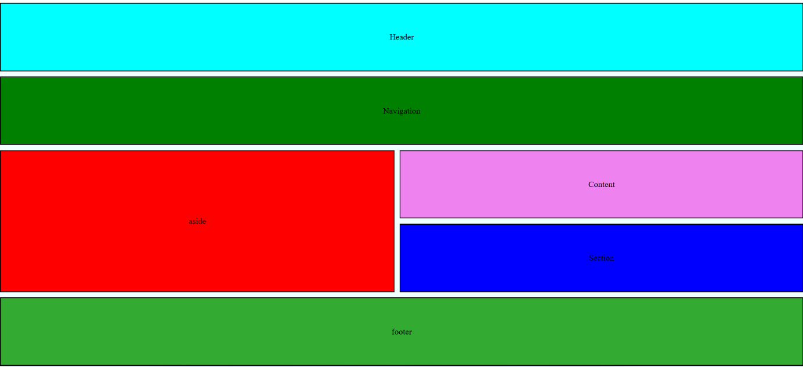

9)Login Form:

.HTML

<!DOCTYPE html>

<html lang="en">

<head>

    <meta charset="UTF-8">

    <meta name="viewport" content="width=device-width, initial-scale=1.0">

    <title>Document</title>

    <link rel="stylesheet" href="styl.css">

</head>

<body>

    <h1>Login Page</h1>

    <div class="maincon">

       <form>

        <input type="text" name="username" placeholder="Enter User Name" />

        <input type="password" name="username" placeholder="Enter Password">

        <button>Login</button>

        <div><input type="checkbox" name="" id="" />Remember Me</div>

        <a href="">Forget Password</a>

       </form>

    </div>

</body>

</html>

.css

*{

    margin: 0;

    padding: 0;

    box-sizing: border-box;

}

html,body{

    height: 100%;

    width: 100%;

    background-color: teal;

}

h1{

    text-align: center;

    color: palevioletred;

    font-weight: 900;

    margin-bottom: 40px;

}

.maincon{

    width: 50%;

    min-height: 50vh;

    background-color: aqua;

    border: 2px solid;

    margin: auto;

    filter: drop-shadow(0px 0px 2px red);

    border: none;

    border-radius: 10px;

}

form{

    display: flex;

    justify-content: center;

    flex-direction: column;

    width: 45%;

    margin: auto;

    gap: 10px;

    position: relative;

    top: 10px;

}

input::placeholder{

    color: purple;

    padding: 5px;

    border-radius: 20px;

    background-color: white;

}

button{

    background-color: red;

    border: none;

    border-radius: 20px;

    padding: 3px;

}

Output:

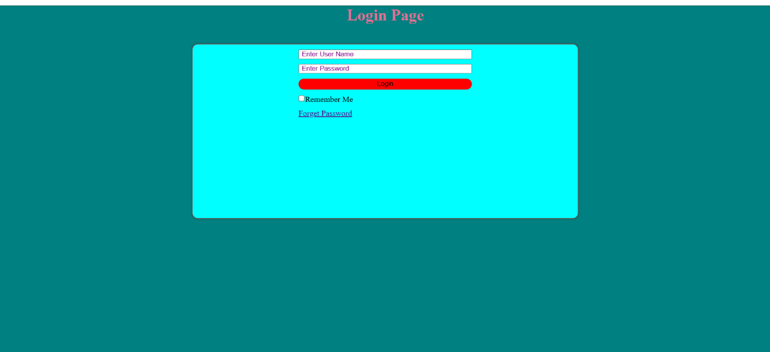

10)Transition Output:

.HTML

<!DOCTYPE html>

<html lang="en">

<head>

    <meta charset="UTF-8">

    <meta name="viewport" content="width=device-width, initial-scale=1.0">

    <title>Simple Layout</title>

    <link rel="stylesheet" href="style40.css">

</head>

<body>

    <div class="container">

        <div class="sidebar">

            <div class="icon"></div>

            <div class="icon"></div>

            <div class="icon"></div>

            <div class="icon"></div>

        </div>

        <div class="main-content"></div>

    </div>

</body>

</html>

.css

*{

    margin: 0;

    padding: 0;

    box-sizing: border-box;

}

html,body {

    background-color: #a9a9a9;

    display: flex;

    justify-content: center;

    align-items: center;

}

.container {

    width: 600px;

    height: 500px;

    background-color: #8b806f;

    border: 2px solid black;

    position: relative;

}

.sidebar {

    position: absolute;

    top: 20px;

    left: 20px;

    display: flex;

    flex-direction: column;

    gap: 10px;

}

.icon {

    width: 60px;

    height: 60px;

    background-color: purple;

    display: flex;

    justify-content: center;

    align-items: center;

    border: 2px solid;

}

.icon::before {

    content: "👈";

    color: gold;

    font-size: 20px;

}

Output:

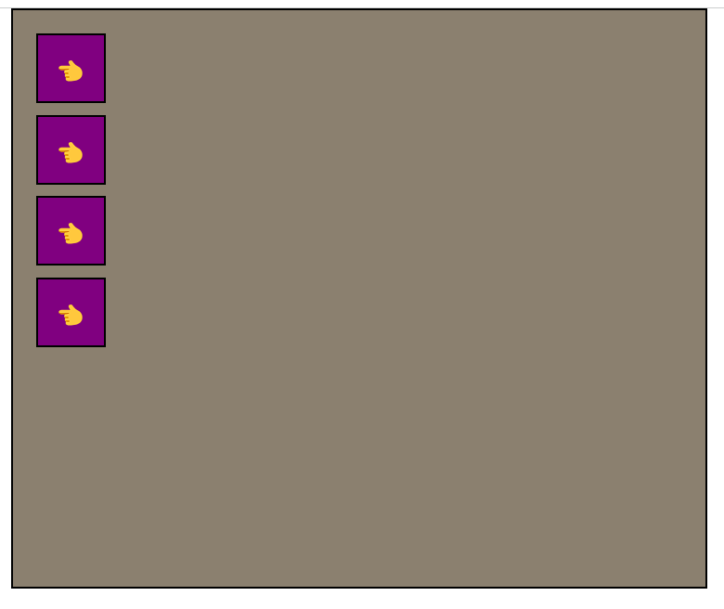

11)Animation Output:

.HTML

<!DOCTYPE html>

<html lang="en">

<head>

    <meta charset="UTF-8">

    <meta name="viewport" content="width=device-width, initial-scale=1.0">

    <title>Document</title>

    <link rel="stylesheet" href="style30.css">

</head>

<body>

    <div class="ball"></div>

    <div class="box"></div>

</body>

</html>

.css

*{

    margin: 0px;

    padding: 0;

    box-sizing: border-box;

}

html,body{

    height: 100%;

    width: 100%;

    background-color: yellow;

}

.ball{

    height: 40px;

    width: 40px;

    border: 1px solid;

    background-color: red;

    border-radius: 100px;

    top: 0;

    left: 0;

    position: absolute;

    animation: movex 6s infinite linear, movey 2s infinite alternate-reverse;

}

@keyframes movex{

    from{

        left: 0;

    }

    to {

        left: 100%;

 }

}

@keyframes movey{

    from{

        top: 0;

    }

    to{

        top: 100%;

    }

}

.box{

    height: 40px;

    width: 40px;

    border: 1px solid;

    background-color: green;

    border-radius: 100px;

    position: absolute;

    right: 0;

    animation: movex1 6s infinite linear,movey2 2s infinite alternate-reverse;

}

@keyframes movex1{

    from{

        right: 100%;

    }

    to{

        right: 0;

    }

}

@keyframes movey2{

    from{

        top: 100%;

    }

    to{

        top: 0;

    }

}

Output:



12)Card Output:

1).HTML

<!DOCTYPE html>

<html lang="en">

<head>

    <meta charset="UTF-8">

    <meta name="viewport" content="width=device-width, initial-scale=1.0">

    <title>Blog Posts</title>

    <link rel="stylesheet" href="style41.css">

</head>

<body>

    <div class="container">

        <div class="card">

            <img src="https://t3.ftcdn.net/jpg/03/17/76/14/360_F_317761488_lUO7Enkcskj6wppf9Ycf5zck5Jm2Y2b9.jpg" alt="Mountain">

            <p class="date">4 Days ago</p>

            <h2>Post One</h2>

            <p>Lorem ipsum dolor, sit amet consectetur adipisicing elit. Itaque, labore.</p>

            <div class="info">

                <span>4m READ</span>

                <span>5123 VIEWS</span>

                <span>32 COMMENTS</span>

            </div>

        </div>

        <div class="card">

            <img src="https://rukminim2.flixcart.com/image/850/1000/jh80ia80/poster/x/g/a/medium-azohp7308-azohp7308-sunset-nature-full-hd-poster-original-imaf59zjfscwzuy5.jpeg?q=90&crop=false" alt="Sunset">

            <p class="date">1 week ago</p>

            <h2>Post Two</h2>

            <p>Adipisicing elit. Omnis quos ad perspiciatis, facere doloribus hic praesentium.</p>

            <div class="info">

                <span>7m READ</span>

                <span>7152 VIEWS</span>

                <span>21 COMMENTS</span>

            </div>

        </div>

        <div class="card">

            <img src="https://www.travelmalnad.com/Blog/wp-content/uploads/2018/11/Green-Hills-Landscape-1440x900.jpg" alt="Green Hills">

            <p class="date">3 week ago</p>

            <h2>Post Three</h2>

            <p>Cum enim quis sint dolor nimus adipisci barum, vel quisquam nobis.</p>

            <div class="info">

                <span>5m READ</span>

                <span>3021 VIEWS</span>

                <span>15 COMMENTS</span>

            </div>

        </div>

    </div>

</body>

</html>

.CSS

*{

    margin: 0;

    padding: 0;

    box-sizing: border-box;

}

html,body {

    font-family: Arial, sans-serif;

    display: block;

    justify-content: center;

    align-items: center;

    height: 100vh;

    background: url('https://th-thumbnailer.cdn-si-edu.com/h-bun2rAGQCTzVJvCy-fJPZB-wE=/fit-in/1600x0/https://tf-cmsv2-smithsonianmag-media.s3.amazonaws.com/filer/f2/94/f294516b-db3d-4f7b-9a60-ca3cd5f3d9b2/fbby1h_1.jpg') no-repeat center center/cover;

}

.container {

    display: flex;

    gap: 20px;

    justify-content: center;

    align-items: center;

    height: 100vh;

    flex-wrap: wrap;

}

.card {

    background: white;

    width: 250px;

    border-radius: 10px;

    overflow: hidden;

    text-align: center;

    box-shadow: 0px 4px 10px black;

    border: 2px solid;

}

.card img {

    width: 100%;

    height: 150px;

}

.date {

    color: red;

    font-size: 14px;

    margin: 10px 0;

}

.card h2 {

    margin: 5px 0;

}

.card p {

    padding: 0 15px;

    font-size: 14px;

}

.info {

    display: flex;

    justify-content: space-around;

    padding: 10px;

    background: orange;

    color: white;

    font-weight: bold;

}

@media screen and (min-width: 576px) and (max-width: 768px) {

    .container {

      flex-direction: column;

      align-items: center;

    }

    .card {

      width: 80%;

    }

  }

  @media screen and (max-width: 600px) {

    .card {

      width: 100%;

    }

  }

Output:

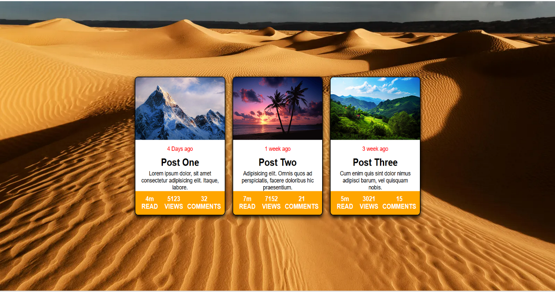

2).HTML

<!DOCTYPE html>

<html lang="en">

<head>

    <meta charset="UTF-8">

    <meta name="viewport" content="width=device-width, initial-scale=1.0">

    <title>Pricing Table</title>

    <link rel="stylesheet" href="style42.css">

</head>

<body>

    <div class="pricing-container">

        <div class="pricing-card">

            <h2>Basic</h2>

            <p class="price">₹ 99 /month</p>

            <ul>

                <li>✔ 1 Website</li>

                <li>✔ 2 GB storage</li>

                <li>✔ 1 Database</li>

                <li>✖ Free Domain</li>

                <li>✖ Professional Email</li>

                <li>✖ 24/7 Support</li>

            </ul>

            <button>Buy Now</button>

        </div>

        <div class="pricing-card">

            <h2>Standard</h2>

            <p class="price">₹ 199 /month</p>

            <ul>

                <li>✔ 10 Websites</li>

                <li>✔ 25 GB storage</li>

                <li>✔ 10 Databases</li>

                <li>✔ Free Domain</li>

                <li>✔ Professional Email</li>

                <li>✔ 24/7 Support</li>

            </ul>

            <button>Buy Now</button>

        </div>

        <div class="pricing-card">

            <h2>Premium</h2>

            <p class="price">₹ 299 /month</p>

            <ul>

                <li>✔ Unlimited Websites</li>

                <li>✔ 96 GB storage</li>

                <li>✔ Unlimited Databases</li>

                <li>✔ Free Domain</li>

                <li>✔ Professional Email</li>

                <li>✔ 24/7 Support</li>

            </ul>

            <button>Buy Now</button>

        </div>

    </div>

</body>

</html>

.css

*{

    margin: 0;

    padding: 0;

    box-sizing: border-box;

}

html,body {

    font-family: Arial, sans-serif;

    background-color: #e0e0e0;

    display: flex;

    justify-content: center;

    align-items: center;

    height: 100vh;

    margin: 0;

}

.pricing-container {

    display: flex;

    gap: 20px;

    justify-content: center;

    flex-wrap: wrap;

}

.pricing-card {

    background: linear-gradient(135deg, #4a0072, #800080);

    color: white;

    padding: 20px;

    border-radius: 10px;

    text-align: center;

    width: 250px;

    border: 2px solid black;

    box-shadow: 0px 0px 10px black;

}

.pricing-card h2 {

    font-size: 22px;

}

.price {

    font-size: 24px;

    font-weight: bold;

    margin: 10px 0;

}

ul {

    list-style: none;

    padding: 0;

}

li {

    margin: 5px 0;

}

button {

    background-color: white;

    border: none;

    padding: 10px;

    width: 100%;

    border-radius: 5px;

    font-size: 16px;

    border-radius: 40px;

}

button:hover {

    background-color: #b8860b;

}

h2{

    color: yellow;

}

@media (max-width: 768px) {

    .pricing-plans {

        flex-direction: column;

        align-items: center;

    }

    .plan {

        width: 80%;

    }

}

@media (max-width: 480px) {

    .plan {

        width: 100%;

        padding: 15px;

    }

}

Output:



3).HTML

<!DOCTYPE html>

<html lang="en">

<head>

    <meta charset="UTF-8">

    <meta name="viewport" content="width=device-width, initial-scale=1.0">

    <title>Document</title>

    <link rel="stylesheet" href="style39.css">

</head>

<body>

    <div class="container">

        <div class="item item1">

            <div class="box1">

                <img  class="i1"src=" https://es2i77y8bys.exactdn.com/wp-content/uploads/sites/5/2020/11/Mads-Munk-M2__SH-3-1366x2048.jpeg?strip=all&lossy=1&ssl=1" height="200px">

            </div>

            <h1 align="center">Json watson</h1><br>

            <h4 align="center"> CEO & Founder</h4><br>

            <h5 align="center">Oxford University</h5>

            <svg xmlns="http://www.w3.org/2000/svg" viewBox="0 0 24 24" fill="currentColor"><path d="M12.001 9C10.3436 9 9.00098 10.3431 9.00098 12C9.00098 13.6573 10.3441 15 12.001 15C13.6583 15 15.001 13.6569 15.001 12C15.001 10.3427 13.6579 9 12.001 9ZM12.001 7C14.7614 7 17.001 9.2371 17.001 12C17.001 14.7605 14.7639 17 12.001 17C9.24051 17 7.00098 14.7629 7.00098 12C7.00098 9.23953 9.23808 7 12.001 7ZM18.501 6.74915C18.501 7.43926 17.9402 7.99917 17.251 7.99917C16.5609 7.99917 16.001 7.4384 16.001 6.74915C16.001 6.0599 16.5617 5.5 17.251 5.5C17.9393 5.49913 18.501 6.0599 18.501 6.74915ZM12.001 4C9.5265 4 9.12318 4.00655 7.97227 4.0578C7.18815 4.09461 6.66253 4.20007 6.17416 4.38967C5.74016 4.55799 5.42709 4.75898 5.09352 5.09255C4.75867 5.4274 4.55804 5.73963 4.3904 6.17383C4.20036 6.66332 4.09493 7.18811 4.05878 7.97115C4.00703 9.0752 4.00098 9.46105 4.00098 12C4.00098 14.4745 4.00753 14.8778 4.05877 16.0286C4.0956 16.8124 4.2012 17.3388 4.39034 17.826C4.5591 18.2606 4.7605 18.5744 5.09246 18.9064C5.42863 19.2421 5.74179 19.4434 6.17187 19.6094C6.66619 19.8005 7.19148 19.9061 7.97212 19.9422C9.07618 19.9939 9.46203 20 12.001 20C14.4755 20 14.8788 19.9934 16.0296 19.9422C16.8117 19.9055 17.3385 19.7996 17.827 19.6106C18.2604 19.4423 18.5752 19.2402 18.9074 18.9085C19.2436 18.5718 19.4445 18.2594 19.6107 17.8283C19.8013 17.3358 19.9071 16.8098 19.9432 16.0289C19.9949 14.9248 20.001 14.5389 20.001 12C20.001 9.52552 19.9944 9.12221 19.9432 7.97137C19.9064 7.18906 19.8005 6.66149 19.6113 6.17318C19.4434 5.74038 19.2417 5.42635 18.9084 5.09255C18.573 4.75715 18.2616 4.55693 17.8271 4.38942C17.338 4.19954 16.8124 4.09396 16.0298 4.05781C14.9258 4.00605 14.5399 4 12.001 4ZM12.001 2C14.7176 2 15.0568 2.01 16.1235 2.06C17.1876 2.10917 17.9135 2.2775 18.551 2.525C19.2101 2.77917 19.7668 3.1225 20.3226 3.67833C20.8776 4.23417 21.221 4.7925 21.476 5.45C21.7226 6.08667 21.891 6.81333 21.941 7.8775C21.9885 8.94417 22.001 9.28333 22.001 12C22.001 14.7167 21.991 15.0558 21.941 16.1225C21.8918 17.1867 21.7226 17.9125 21.476 18.55C21.2218 19.2092 20.8776 19.7658 20.3226 20.3217C19.7668 20.8767 19.2076 21.22 18.551 21.475C17.9135 21.7217 17.1876 21.89 16.1235 21.94C15.0568 21.9875 14.7176 22 12.001 22C9.28431 22 8.94514 21.99 7.87848 21.94C6.81431 21.8908 6.08931 21.7217 5.45098 21.475C4.79264 21.2208 4.23514 20.8767 3.67931 20.3217C3.12348 19.7658 2.78098 19.2067 2.52598 18.55C2.27848 17.9125 2.11098 17.1867 2.06098 16.1225C2.01348 15.0558 2.00098 14.7167 2.00098 12C2.00098 9.28333 2.01098 8.94417 2.06098 7.8775C2.11014 6.8125 2.27848 6.0875 2.52598 5.45C2.78014 4.79167 3.12348 4.23417 3.67931 3.67833C4.23514 3.1225 4.79348 2.78 5.45098 2.525C6.08848 2.2775 6.81348 2.11 7.87848 2.06C8.94514 2.0125 9.28431 2 12.001 2Z"></path></svg>

            <svg class="s1" xmlns="http://www.w3.org/2000/svg" viewBox="0 0 24 24" fill="currentColor"><path d="M22.2125 5.65605C21.4491 5.99375 20.6395 6.21555 19.8106 6.31411C20.6839 5.79132 21.3374 4.9689 21.6493 4.00005C20.8287 4.48761 19.9305 4.83077 18.9938 5.01461C18.2031 4.17106 17.098 3.69303 15.9418 3.69434C13.6326 3.69434 11.7597 5.56661 11.7597 7.87683C11.7597 8.20458 11.7973 8.52242 11.8676 8.82909C8.39047 8.65404 5.31007 6.99005 3.24678 4.45941C2.87529 5.09767 2.68005 5.82318 2.68104 6.56167C2.68104 8.01259 3.4196 9.29324 4.54149 10.043C3.87737 10.022 3.22788 9.84264 2.64718 9.51973C2.64654 9.5373 2.64654 9.55487 2.64654 9.57148C2.64654 11.5984 4.08819 13.2892 6.00199 13.6731C5.6428 13.7703 5.27232 13.8194 4.90022 13.8191C4.62997 13.8191 4.36771 13.7942 4.11279 13.7453C4.64531 15.4065 6.18886 16.6159 8.0196 16.6491C6.53813 17.8118 4.70869 18.4426 2.82543 18.4399C2.49212 18.4402 2.15909 18.4205 1.82812 18.3811C3.74004 19.6102 5.96552 20.2625 8.23842 20.2601C15.9316 20.2601 20.138 13.8875 20.138 8.36111C20.138 8.1803 20.1336 7.99886 20.1256 7.81997C20.9443 7.22845 21.651 6.49567 22.2125 5.65605Z"></path></svg>

            <svg  class="s2"xmlns="http://www.w3.org/2000/svg" viewBox="0 0 24 24" fill="currentColor"><path d="M14 13.5H16.5L17.5 9.5H14V7.5C14 6.47062 14 5.5 16 5.5H17.5V2.1401C17.1743 2.09685 15.943 2 14.6429 2C11.9284 2 10 3.65686 10 6.69971V9.5H7V13.5H10V22H14V13.5Z"></path></svg>

            <svg class="s3" xmlns="http://www.w3.org/2000/svg" viewBox="0 0 24 24" fill="currentColor"><path d="M10.3645 19.8327L12.2941 16.4905C12.1969 16.4968 12.0988 16.5 12 16.5C10.3037 16.5 8.82656 15.5614 8.0597 14.1752L4.79459 8.51986C4.28545 9.57206 4 10.7527 4 12C4 15.8578 6.73064 19.0778 10.3645 19.8327ZM12.5897 19.9786C16.7326 19.6767 20 16.2199 20 12C20 11.1269 19.8601 10.2865 19.6016 9.5H15.7422C16.2209 10.215 16.5 11.0749 16.5 12C16.5 12.8477 16.2656 13.6406 15.8581 14.3175L12.5897 19.9786ZM14.1434 13.2875L14.1651 13.25C14.3782 12.8824 14.5 12.4554 14.5 12C14.5 10.6193 13.3807 9.5 12 9.5C10.6193 9.5 9.5 10.6193 9.5 12C9.5 12.4383 9.6128 12.8503 9.81094 13.2084L9.83494 13.25C10.2669 13.9973 11.0747 14.5 12 14.5C12.9098 14.5 13.7061 14.014 14.1434 13.2875ZM6.03522 6.66871L7.9635 10.0086C8.69821 8.52222 10.2297 7.5 12 7.5H18.6153C17.1753 5.38723 14.7497 4 12 4C9.62968 4 7.50014 5.03086 6.03522 6.66871ZM12 22C6.47715 22 2 17.5228 2 12C2 6.47715 6.47715 2 12 2C17.5228 2 22 6.47715 22 12C22 17.5228 17.5228 22 12 22Z"></path></svg>

            <button type="submit">Contact</button>

        </div>

        <div class="item item2">

            <div class="box2">

                <img class="i2" src="https://encrypted-tbn0.gstatic.com/images?q=tbn:ANd9GcTaxVVJU-sLO9g_7_bjpHcQYjwfRyTwGubNPw&s">

            </div>

            <h1 align="center">Jon watson</h1><br>

            <h4 align="center"> CEO & Founder</h4><br>

            <h5 align="center">Oxford University</h5>

            <svg xmlns="http://www.w3.org/2000/svg" viewBox="0 0 24 24" fill="currentColor"><path d="M12.001 9C10.3436 9 9.00098 10.3431 9.00098 12C9.00098 13.6573 10.3441 15 12.001 15C13.6583 15 15.001 13.6569 15.001 12C15.001 10.3427 13.6579 9 12.001 9ZM12.001 7C14.7614 7 17.001 9.2371 17.001 12C17.001 14.7605 14.7639 17 12.001 17C9.24051 17 7.00098 14.7629 7.00098 12C7.00098 9.23953 9.23808 7 12.001 7ZM18.501 6.74915C18.501 7.43926 17.9402 7.99917 17.251 7.99917C16.5609 7.99917 16.001 7.4384 16.001 6.74915C16.001 6.0599 16.5617 5.5 17.251 5.5C17.9393 5.49913 18.501 6.0599 18.501 6.74915ZM12.001 4C9.5265 4 9.12318 4.00655 7.97227 4.0578C7.18815 4.09461 6.66253 4.20007 6.17416 4.38967C5.74016 4.55799 5.42709 4.75898 5.09352 5.09255C4.75867 5.4274 4.55804 5.73963 4.3904 6.17383C4.20036 6.66332 4.09493 7.18811 4.05878 7.97115C4.00703 9.0752 4.00098 9.46105 4.00098 12C4.00098 14.4745 4.00753 14.8778 4.05877 16.0286C4.0956 16.8124 4.2012 17.3388 4.39034 17.826C4.5591 18.2606 4.7605 18.5744 5.09246 18.9064C5.42863 19.2421 5.74179 19.4434 6.17187 19.6094C6.66619 19.8005 7.19148 19.9061 7.97212 19.9422C9.07618 19.9939 9.46203 20 12.001 20C14.4755 20 14.8788 19.9934 16.0296 19.9422C16.8117 19.9055 17.3385 19.7996 17.827 19.6106C18.2604 19.4423 18.5752 19.2402 18.9074 18.9085C19.2436 18.5718 19.4445 18.2594 19.6107 17.8283C19.8013 17.3358 19.9071 16.8098 19.9432 16.0289C19.9949 14.9248 20.001 14.5389 20.001 12C20.001 9.52552 19.9944 9.12221 19.9432 7.97137C19.9064 7.18906 19.8005 6.66149 19.6113 6.17318C19.4434 5.74038 19.2417 5.42635 18.9084 5.09255C18.573 4.75715 18.2616 4.55693 17.8271 4.38942C17.338 4.19954 16.8124 4.09396 16.0298 4.05781C14.9258 4.00605 14.5399 4 12.001 4ZM12.001 2C14.7176 2 15.0568 2.01 16.1235 2.06C17.1876 2.10917 17.9135 2.2775 18.551 2.525C19.2101 2.77917 19.7668 3.1225 20.3226 3.67833C20.8776 4.23417 21.221 4.7925 21.476 5.45C21.7226 6.08667 21.891 6.81333 21.941 7.8775C21.9885 8.94417 22.001 9.28333 22.001 12C22.001 14.7167 21.991 15.0558 21.941 16.1225C21.8918 17.1867 21.7226 17.9125 21.476 18.55C21.2218 19.2092 20.8776 19.7658 20.3226 20.3217C19.7668 20.8767 19.2076 21.22 18.551 21.475C17.9135 21.7217 17.1876 21.89 16.1235 21.94C15.0568 21.9875 14.7176 22 12.001 22C9.28431 22 8.94514 21.99 7.87848 21.94C6.81431 21.8908 6.08931 21.7217 5.45098 21.475C4.79264 21.2208 4.23514 20.8767 3.67931 20.3217C3.12348 19.7658 2.78098 19.2067 2.52598 18.55C2.27848 17.9125 2.11098 17.1867 2.06098 16.1225C2.01348 15.0558 2.00098 14.7167 2.00098 12C2.00098 9.28333 2.01098 8.94417 2.06098 7.8775C2.11014 6.8125 2.27848 6.0875 2.52598 5.45C2.78014 4.79167 3.12348 4.23417 3.67931 3.67833C4.23514 3.1225 4.79348 2.78 5.45098 2.525C6.08848 2.2775 6.81348 2.11 7.87848 2.06C8.94514 2.0125 9.28431 2 12.001 2Z"></path></svg>

            <svg class="s1" xmlns="http://www.w3.org/2000/svg" viewBox="0 0 24 24" fill="currentColor"><path d="M22.2125 5.65605C21.4491 5.99375 20.6395 6.21555 19.8106 6.31411C20.6839 5.79132 21.3374 4.9689 21.6493 4.00005C20.8287 4.48761 19.9305 4.83077 18.9938 5.01461C18.2031 4.17106 17.098 3.69303 15.9418 3.69434C13.6326 3.69434 11.7597 5.56661 11.7597 7.87683C11.7597 8.20458 11.7973 8.52242 11.8676 8.82909C8.39047 8.65404 5.31007 6.99005 3.24678 4.45941C2.87529 5.09767 2.68005 5.82318 2.68104 6.56167C2.68104 8.01259 3.4196 9.29324 4.54149 10.043C3.87737 10.022 3.22788 9.84264 2.64718 9.51973C2.64654 9.5373 2.64654 9.55487 2.64654 9.57148C2.64654 11.5984 4.08819 13.2892 6.00199 13.6731C5.6428 13.7703 5.27232 13.8194 4.90022 13.8191C4.62997 13.8191 4.36771 13.7942 4.11279 13.7453C4.64531 15.4065 6.18886 16.6159 8.0196 16.6491C6.53813 17.8118 4.70869 18.4426 2.82543 18.4399C2.49212 18.4402 2.15909 18.4205 1.82812 18.3811C3.74004 19.6102 5.96552 20.2625 8.23842 20.2601C15.9316 20.2601 20.138 13.8875 20.138 8.36111C20.138 8.1803 20.1336 7.99886 20.1256 7.81997C20.9443 7.22845 21.651 6.49567 22.2125 5.65605Z"></path></svg>

            <svg  class="s2"xmlns="http://www.w3.org/2000/svg" viewBox="0 0 24 24" fill="currentColor"><path d="M14 13.5H16.5L17.5 9.5H14V7.5C14 6.47062 14 5.5 16 5.5H17.5V2.1401C17.1743 2.09685 15.943 2 14.6429 2C11.9284 2 10 3.65686 10 6.69971V9.5H7V13.5H10V22H14V13.5Z"></path></svg>

            <svg class="s3" xmlns="http://www.w3.org/2000/svg" viewBox="0 0 24 24" fill="currentColor"><path d="M10.3645 19.8327L12.2941 16.4905C12.1969 16.4968 12.0988 16.5 12 16.5C10.3037 16.5 8.82656 15.5614 8.0597 14.1752L4.79459 8.51986C4.28545 9.57206 4 10.7527 4 12C4 15.8578 6.73064 19.0778 10.3645 19.8327ZM12.5897 19.9786C16.7326 19.6767 20 16.2199 20 12C20 11.1269 19.8601 10.2865 19.6016 9.5H15.7422C16.2209 10.215 16.5 11.0749 16.5 12C16.5 12.8477 16.2656 13.6406 15.8581 14.3175L12.5897 19.9786ZM14.1434 13.2875L14.1651 13.25C14.3782 12.8824 14.5 12.4554 14.5 12C14.5 10.6193 13.3807 9.5 12 9.5C10.6193 9.5 9.5 10.6193 9.5 12C9.5 12.4383 9.6128 12.8503 9.81094 13.2084L9.83494 13.25C10.2669 13.9973 11.0747 14.5 12 14.5C12.9098 14.5 13.7061 14.014 14.1434 13.2875ZM6.03522 6.66871L7.9635 10.0086C8.69821 8.52222 10.2297 7.5 12 7.5H18.6153C17.1753 5.38723 14.7497 4 12 4C9.62968 4 7.50014 5.03086 6.03522 6.66871ZM12 22C6.47715 22 2 17.5228 2 12C2 6.47715 6.47715 2 12 2C17.5228 2 22 6.47715 22 12C22 17.5228 17.5228 22 12 22Z"></path></svg>

            <button type="submit">Contact</button>

        </div>

        <div class="item item3">

            <div class="box3">

                <img class="i3" src="https://c8.alamy.com/comp/PD25N9/frank-koster-chief-executive-officer-at-axa-belgium-belgium-20042016-PD25N9.jpg">

            </div>

            <h1 align="center">Nick watson</h1><br>

            <h4 align="center"> CEO & Founder</h4><br>

            <h5 align="center">Oxford University</h5>

            <svg xmlns="http://www.w3.org/2000/svg" viewBox="0 0 24 24" fill="currentColor"><path d="M12.001 9C10.3436 9 9.00098 10.3431 9.00098 12C9.00098 13.6573 10.3441 15 12.001 15C13.6583 15 15.001 13.6569 15.001 12C15.001 10.3427 13.6579 9 12.001 9ZM12.001 7C14.7614 7 17.001 9.2371 17.001 12C17.001 14.7605 14.7639 17 12.001 17C9.24051 17 7.00098 14.7629 7.00098 12C7.00098 9.23953 9.23808 7 12.001 7ZM18.501 6.74915C18.501 7.43926 17.9402 7.99917 17.251 7.99917C16.5609 7.99917 16.001 7.4384 16.001 6.74915C16.001 6.0599 16.5617 5.5 17.251 5.5C17.9393 5.49913 18.501 6.0599 18.501 6.74915ZM12.001 4C9.5265 4 9.12318 4.00655 7.97227 4.0578C7.18815 4.09461 6.66253 4.20007 6.17416 4.38967C5.74016 4.55799 5.42709 4.75898 5.09352 5.09255C4.75867 5.4274 4.55804 5.73963 4.3904 6.17383C4.20036 6.66332 4.09493 7.18811 4.05878 7.97115C4.00703 9.0752 4.00098 9.46105 4.00098 12C4.00098 14.4745 4.00753 14.8778 4.05877 16.0286C4.0956 16.8124 4.2012 17.3388 4.39034 17.826C4.5591 18.2606 4.7605 18.5744 5.09246 18.9064C5.42863 19.2421 5.74179 19.4434 6.17187 19.6094C6.66619 19.8005 7.19148 19.9061 7.97212 19.9422C9.07618 19.9939 9.46203 20 12.001 20C14.4755 20 14.8788 19.9934 16.0296 19.9422C16.8117 19.9055 17.3385 19.7996 17.827 19.6106C18.2604 19.4423 18.5752 19.2402 18.9074 18.9085C19.2436 18.5718 19.4445 18.2594 19.6107 17.8283C19.8013 17.3358 19.9071 16.8098 19.9432 16.0289C19.9949 14.9248 20.001 14.5389 20.001 12C20.001 9.52552 19.9944 9.12221 19.9432 7.97137C19.9064 7.18906 19.8005 6.66149 19.6113 6.17318C19.4434 5.74038 19.2417 5.42635 18.9084 5.09255C18.573 4.75715 18.2616 4.55693 17.8271 4.38942C17.338 4.19954 16.8124 4.09396 16.0298 4.05781C14.9258 4.00605 14.5399 4 12.001 4ZM12.001 2C14.7176 2 15.0568 2.01 16.1235 2.06C17.1876 2.10917 17.9135 2.2775 18.551 2.525C19.2101 2.77917 19.7668 3.1225 20.3226 3.67833C20.8776 4.23417 21.221 4.7925 21.476 5.45C21.7226 6.08667 21.891 6.81333 21.941 7.8775C21.9885 8.94417 22.001 9.28333 22.001 12C22.001 14.7167 21.991 15.0558 21.941 16.1225C21.8918 17.1867 21.7226 17.9125 21.476 18.55C21.2218 19.2092 20.8776 19.7658 20.3226 20.3217C19.7668 20.8767 19.2076 21.22 18.551 21.475C17.9135 21.7217 17.1876 21.89 16.1235 21.94C15.0568 21.9875 14.7176 22 12.001 22C9.28431 22 8.94514 21.99 7.87848 21.94C6.81431 21.8908 6.08931 21.7217 5.45098 21.475C4.79264 21.2208 4.23514 20.8767 3.67931 20.3217C3.12348 19.7658 2.78098 19.2067 2.52598 18.55C2.27848 17.9125 2.11098 17.1867 2.06098 16.1225C2.01348 15.0558 2.00098 14.7167 2.00098 12C2.00098 9.28333 2.01098 8.94417 2.06098 7.8775C2.11014 6.8125 2.27848 6.0875 2.52598 5.45C2.78014 4.79167 3.12348 4.23417 3.67931 3.67833C4.23514 3.1225 4.79348 2.78 5.45098 2.525C6.08848 2.2775 6.81348 2.11 7.87848 2.06C8.94514 2.0125 9.28431 2 12.001 2Z"></path></svg>

            <svg class="s1" xmlns="http://www.w3.org/2000/svg" viewBox="0 0 24 24" fill="currentColor"><path d="M22.2125 5.65605C21.4491 5.99375 20.6395 6.21555 19.8106 6.31411C20.6839 5.79132 21.3374 4.9689 21.6493 4.00005C20.8287 4.48761 19.9305 4.83077 18.9938 5.01461C18.2031 4.17106 17.098 3.69303 15.9418 3.69434C13.6326 3.69434 11.7597 5.56661 11.7597 7.87683C11.7597 8.20458 11.7973 8.52242 11.8676 8.82909C8.39047 8.65404 5.31007 6.99005 3.24678 4.45941C2.87529 5.09767 2.68005 5.82318 2.68104 6.56167C2.68104 8.01259 3.4196 9.29324 4.54149 10.043C3.87737 10.022 3.22788 9.84264 2.64718 9.51973C2.64654 9.5373 2.64654 9.55487 2.64654 9.57148C2.64654 11.5984 4.08819 13.2892 6.00199 13.6731C5.6428 13.7703 5.27232 13.8194 4.90022 13.8191C4.62997 13.8191 4.36771 13.7942 4.11279 13.7453C4.64531 15.4065 6.18886 16.6159 8.0196 16.6491C6.53813 17.8118 4.70869 18.4426 2.82543 18.4399C2.49212 18.4402 2.15909 18.4205 1.82812 18.3811C3.74004 19.6102 5.96552 20.2625 8.23842 20.2601C15.9316 20.2601 20.138 13.8875 20.138 8.36111C20.138 8.1803 20.1336 7.99886 20.1256 7.81997C20.9443 7.22845 21.651 6.49567 22.2125 5.65605Z"></path></svg>

            <svg  class="s2"xmlns="http://www.w3.org/2000/svg" viewBox="0 0 24 24" fill="currentColor"><path d="M14 13.5H16.5L17.5 9.5H14V7.5C14 6.47062 14 5.5 16 5.5H17.5V2.1401C17.1743 2.09685 15.943 2 14.6429 2C11.9284 2 10 3.65686 10 6.69971V9.5H7V13.5H10V22H14V13.5Z"></path></svg>

            <svg class="s3" xmlns="http://www.w3.org/2000/svg" viewBox="0 0 24 24" fill="currentColor"><path d="M10.3645 19.8327L12.2941 16.4905C12.1969 16.4968 12.0988 16.5 12 16.5C10.3037 16.5 8.82656 15.5614 8.0597 14.1752L4.79459 8.51986C4.28545 9.57206 4 10.7527 4 12C4 15.8578 6.73064 19.0778 10.3645 19.8327ZM12.5897 19.9786C16.7326 19.6767 20 16.2199 20 12C20 11.1269 19.8601 10.2865 19.6016 9.5H15.7422C16.2209 10.215 16.5 11.0749 16.5 12C16.5 12.8477 16.2656 13.6406 15.8581 14.3175L12.5897 19.9786ZM14.1434 13.2875L14.1651 13.25C14.3782 12.8824 14.5 12.4554 14.5 12C14.5 10.6193 13.3807 9.5 12 9.5C10.6193 9.5 9.5 10.6193 9.5 12C9.5 12.4383 9.6128 12.8503 9.81094 13.2084L9.83494 13.25C10.2669 13.9973 11.0747 14.5 12 14.5C12.9098 14.5 13.7061 14.014 14.1434 13.2875ZM6.03522 6.66871L7.9635 10.0086C8.69821 8.52222 10.2297 7.5 12 7.5H18.6153C17.1753 5.38723 14.7497 4 12 4C9.62968 4 7.50014 5.03086 6.03522 6.66871ZM12 22C6.47715 22 2 17.5228 2 12C2 6.47715 6.47715 2 12 2C17.5228 2 22 6.47715 22 12C22 17.5228 17.5228 22 12 22Z"></path></svg>

            <button type="submit">Contact</button>

        </div>

        <div class="item item4">

            <div class="box4">

                <img class="i4" src="https://www.dragos.com/wp-content/uploads/2018/12/rob-lee-800x633.jpg" height="200px">

            </div>

            <h1 align="center">Joy watson</h1><br>

            <h4 align="center"> CEO & Founder</h4><br>

            <h5 align="center">Oxford University</h5>

            <svg xmlns="http://www.w3.org/2000/svg" viewBox="0 0 24 24" fill="currentColor"><path d="M12.001 9C10.3436 9 9.00098 10.3431 9.00098 12C9.00098 13.6573 10.3441 15 12.001 15C13.6583 15 15.001 13.6569 15.001 12C15.001 10.3427 13.6579 9 12.001 9ZM12.001 7C14.7614 7 17.001 9.2371 17.001 12C17.001 14.7605 14.7639 17 12.001 17C9.24051 17 7.00098 14.7629 7.00098 12C7.00098 9.23953 9.23808 7 12.001 7ZM18.501 6.74915C18.501 7.43926 17.9402 7.99917 17.251 7.99917C16.5609 7.99917 16.001 7.4384 16.001 6.74915C16.001 6.0599 16.5617 5.5 17.251 5.5C17.9393 5.49913 18.501 6.0599 18.501 6.74915ZM12.001 4C9.5265 4 9.12318 4.00655 7.97227 4.0578C7.18815 4.09461 6.66253 4.20007 6.17416 4.38967C5.74016 4.55799 5.42709 4.75898 5.09352 5.09255C4.75867 5.4274 4.55804 5.73963 4.3904 6.17383C4.20036 6.66332 4.09493 7.18811 4.05878 7.97115C4.00703 9.0752 4.00098 9.46105 4.00098 12C4.00098 14.4745 4.00753 14.8778 4.05877 16.0286C4.0956 16.8124 4.2012 17.3388 4.39034 17.826C4.5591 18.2606 4.7605 18.5744 5.09246 18.9064C5.42863 19.2421 5.74179 19.4434 6.17187 19.6094C6.66619 19.8005 7.19148 19.9061 7.97212 19.9422C9.07618 19.9939 9.46203 20 12.001 20C14.4755 20 14.8788 19.9934 16.0296 19.9422C16.8117 19.9055 17.3385 19.7996 17.827 19.6106C18.2604 19.4423 18.5752 19.2402 18.9074 18.9085C19.2436 18.5718 19.4445 18.2594 19.6107 17.8283C19.8013 17.3358 19.9071 16.8098 19.9432 16.0289C19.9949 14.9248 20.001 14.5389 20.001 12C20.001 9.52552 19.9944 9.12221 19.9432 7.97137C19.9064 7.18906 19.8005 6.66149 19.6113 6.17318C19.4434 5.74038 19.2417 5.42635 18.9084 5.09255C18.573 4.75715 18.2616 4.55693 17.8271 4.38942C17.338 4.19954 16.8124 4.09396 16.0298 4.05781C14.9258 4.00605 14.5399 4 12.001 4ZM12.001 2C14.7176 2 15.0568 2.01 16.1235 2.06C17.1876 2.10917 17.9135 2.2775 18.551 2.525C19.2101 2.77917 19.7668 3.1225 20.3226 3.67833C20.8776 4.23417 21.221 4.7925 21.476 5.45C21.7226 6.08667 21.891 6.81333 21.941 7.8775C21.9885 8.94417 22.001 9.28333 22.001 12C22.001 14.7167 21.991 15.0558 21.941 16.1225C21.8918 17.1867 21.7226 17.9125 21.476 18.55C21.2218 19.2092 20.8776 19.7658 20.3226 20.3217C19.7668 20.8767 19.2076 21.22 18.551 21.475C17.9135 21.7217 17.1876 21.89 16.1235 21.94C15.0568 21.9875 14.7176 22 12.001 22C9.28431 22 8.94514 21.99 7.87848 21.94C6.81431 21.8908 6.08931 21.7217 5.45098 21.475C4.79264 21.2208 4.23514 20.8767 3.67931 20.3217C3.12348 19.7658 2.78098 19.2067 2.52598 18.55C2.27848 17.9125 2.11098 17.1867 2.06098 16.1225C2.01348 15.0558 2.00098 14.7167 2.00098 12C2.00098 9.28333 2.01098 8.94417 2.06098 7.8775C2.11014 6.8125 2.27848 6.0875 2.52598 5.45C2.78014 4.79167 3.12348 4.23417 3.67931 3.67833C4.23514 3.1225 4.79348 2.78 5.45098 2.525C6.08848 2.2775 6.81348 2.11 7.87848 2.06C8.94514 2.0125 9.28431 2 12.001 2Z"></path></svg>

            <svg class="s1" xmlns="http://www.w3.org/2000/svg" viewBox="0 0 24 24" fill="currentColor"><path d="M22.2125 5.65605C21.4491 5.99375 20.6395 6.21555 19.8106 6.31411C20.6839 5.79132 21.3374 4.9689 21.6493 4.00005C20.8287 4.48761 19.9305 4.83077 18.9938 5.01461C18.2031 4.17106 17.098 3.69303 15.9418 3.69434C13.6326 3.69434 11.7597 5.56661 11.7597 7.87683C11.7597 8.20458 11.7973 8.52242 11.8676 8.82909C8.39047 8.65404 5.31007 6.99005 3.24678 4.45941C2.87529 5.09767 2.68005 5.82318 2.68104 6.56167C2.68104 8.01259 3.4196 9.29324 4.54149 10.043C3.87737 10.022 3.22788 9.84264 2.64718 9.51973C2.64654 9.5373 2.64654 9.55487 2.64654 9.57148C2.64654 11.5984 4.08819 13.2892 6.00199 13.6731C5.6428 13.7703 5.27232 13.8194 4.90022 13.8191C4.62997 13.8191 4.36771 13.7942 4.11279 13.7453C4.64531 15.4065 6.18886 16.6159 8.0196 16.6491C6.53813 17.8118 4.70869 18.4426 2.82543 18.4399C2.49212 18.4402 2.15909 18.4205 1.82812 18.3811C3.74004 19.6102 5.96552 20.2625 8.23842 20.2601C15.9316 20.2601 20.138 13.8875 20.138 8.36111C20.138 8.1803 20.1336 7.99886 20.1256 7.81997C20.9443 7.22845 21.651 6.49567 22.2125 5.65605Z"></path></svg>

            <svg  class="s2"xmlns="http://www.w3.org/2000/svg" viewBox="0 0 24 24" fill="currentColor"><path d="M14 13.5H16.5L17.5 9.5H14V7.5C14 6.47062 14 5.5 16 5.5H17.5V2.1401C17.1743 2.09685 15.943 2 14.6429 2C11.9284 2 10 3.65686 10 6.69971V9.5H7V13.5H10V22H14V13.5Z"></path></svg>

            <svg class="s3" xmlns="http://www.w3.org/2000/svg" viewBox="0 0 24 24" fill="currentColor"><path d="M10.3645 19.8327L12.2941 16.4905C12.1969 16.4968 12.0988 16.5 12 16.5C10.3037 16.5 8.82656 15.5614 8.0597 14.1752L4.79459 8.51986C4.28545 9.57206 4 10.7527 4 12C4 15.8578 6.73064 19.0778 10.3645 19.8327ZM12.5897 19.9786C16.7326 19.6767 20 16.2199 20 12C20 11.1269 19.8601 10.2865 19.6016 9.5H15.7422C16.2209 10.215 16.5 11.0749 16.5 12C16.5 12.8477 16.2656 13.6406 15.8581 14.3175L12.5897 19.9786ZM14.1434 13.2875L14.1651 13.25C14.3782 12.8824 14.5 12.4554 14.5 12C14.5 10.6193 13.3807 9.5 12 9.5C10.6193 9.5 9.5 10.6193 9.5 12C9.5 12.4383 9.6128 12.8503 9.81094 13.2084L9.83494 13.25C10.2669 13.9973 11.0747 14.5 12 14.5C12.9098 14.5 13.7061 14.014 14.1434 13.2875ZM6.03522 6.66871L7.9635 10.0086C8.69821 8.52222 10.2297 7.5 12 7.5H18.6153C17.1753 5.38723 14.7497 4 12 4C9.62968 4 7.50014 5.03086 6.03522 6.66871ZM12 22C6.47715 22 2 17.5228 2 12C2 6.47715 6.47715 2 12 2C17.5228 2 22 6.47715 22 12C22 17.5228 17.5228 22 12 22Z"></path></svg>

            <button type="submit">Contact</button>

        </div>

    </div>

</body>

</html>

.css

*{

    margin: 0;

    padding: 0;box-sizing: border-box;

}

html,body{

    height: 100%;

    width: 100%;

}

.container{

    height:600px;

    width:1400px;

    border: 2px solid black;

    margin-left: 20px;

    margin-top: 20px;

    display: flex;

    flex-direction: row;

    background-color: gray;

}

.item{

    border-radius: 20px;

}

.item1{

    height:500px;

    width:300px;

    border: 2px solid black;

    margin-left: 90px;

    margin-top: 20px;

    background-color: aliceblue;

    filter: drop-shadow(0px 0px 3px green);

    outline: 5px solid aquamarine;

}

svg{

    height:30px;

    width:30px;

    margin-left: 80px;

    margin-top: 40px;

}

.s1{

    height:30px;

    width:30px;

    margin-left: 0px;

}

.s2{

    height:30px;

    width:30px;

    margin-left: 0px;

}

.s3{

    height:30px;

    width:30px;

    margin-left: 0px;;

}

.item2{

    height:500px;

    width:300px;

    border: 2px solid black;

    margin-left: 20px;

    margin-top:20px;

    background-color: aliceblue;

    filter: drop-shadow(0px 0px 3px green);

    outline: 5px solid aquamarine;

}

.item3{

    height:500px;

    width:300px;

    border: 2px solid black;

    margin-left: 20px;

    margin-top:20px;

    background-color: aliceblue;

    filter: drop-shadow(0px 0px 3px green);

    outline: 5px solid aquamarine;

}

.box1{

    height:200px;

    width:160px;

    /* border: 2px solid black; */

    border-radius: 50%;

    margin-left: 25%;

    margin-top: 5%;

}

.box2{

    height:200px;

    width:160px;

    /* border: 2px solid black; */

    border-radius: 50%;

    margin-left: 25%;

    margin-top: 5%;

}

.box3{

    height:200px;

    width:160px;

    /* border: 2px solid black; */

    border-radius: 50%;

    margin-left: 25%;

    margin-top: 5%;

}

button{

    height:30px;

    width:250px;

    margin-top: 20px;

    margin-left: 25px;

    background-color:black;

    color: aliceblue;

   border-radius: 50px;

}

.i1{

    height:200px;

    width:160px;

    border-radius: 49%;

}

.i2{

    height:200px;

    width:160px;

    border-radius: 49%;

}

.i3{

    height:200px;

    width:160px;

    border-radius: 49%;

}

.i4{

    height:200px;

    width:160px;

    border-radius: 49%;

}

.item4{

    height:500px;

    width:300px;

    border: 2px solid black;

    margin-left: 20px;

    margin-top:20px;

    background-color: aliceblue;

    filter: drop-shadow(0px 0px 3px green);

    outline: 5px solid aquamarine;

}

.box4{

    height:200px;

    width:160px;

    /* border: 2px solid black; */

    border-radius: 50%;

    margin-left: 25%;

    margin-top: 5%;

}

Output:

