Table of Contents

Software Requirements Specification

MSBON Fraud-Sensitive Transcript Verification System

Version 1.0 | Team Nexus | University of Southern Mississippi | CSC 424 Capstone

Revision History
Version | Date | Author | Description
0.1 | 2026-05-12 | Team Nexus | Initial draft of capstone SRS
1.0 | 2026-05-12 | Team Nexus | Baseline SRS — PoC scope, IEEE 830 structure

Table of Contents
- Introduction
- Overall Description
- External Interface Requirements
- Functional Requirements
- Non-Functional Requirements
- Use Cases
- Data Requirements
- System Constraints and Compliance
- Acceptance Criteria and Traceability Matrix
- Appendix

1. Introduction

1.1 Purpose
This Software Requirements Specification (SRS) defines the complete functional, non-functional, interface, and data requirements for the MSBON Fraud-Sensitive Transcript Verification System — a Proof of Concept (PoC) developed by Team Nexus for the Mississippi State Board of Nursing (MSBON) under the CSC 424 Senior Capstone at The University of Southern Mississippi. This document is the binding contract between the development team and the customer (MSBON). It tells the customer exactly what the delivered system will do; the companion Software Design Document (SDD) explains how the system implements these requirements.
This SRS conforms to IEEE Std 830-1998 in spirit, adapted for an academic capstone deliverable and a single-cycle PoC release. It is the authoritative input to test plans, acceptance review, and the end-of-semester demonstration.

1.2 Scope

1.2.1 Product Identification
The product is named MSBON Transcript Verification System, version 1.0.0-poc. It is delivered as a self-contained web application consisting of a FastAPI HTTP backend (Python 3.11+) and a React 18 single-page frontend (TypeScript + Vite + Tailwind CSS), backed by SQLite for the PoC.

1.2.2 What the Product Does
The system automates the first-pass review of nursing school transcripts submitted to MSBON for licensure applications. Specifically it shall:
- Ingest transcript documents (PDF or scanned image) uploaded by authorized MSBON staff.
- Extract structured data from each document using a two-stage pipeline: deterministic OCR/text extraction (pdfplumber + Tesseract) followed by a Large Language Model (Google Gemini gemini-2.0-flash) that produces normalized JSON.
- Verify the extracted data against twelve transparent, rule-based fraud and compliance checks across five categories: Graduation, Accreditation, Course Completion, Fraud Indicators, and Formatting.
- Surface every flag with a human-readable explanation, source excerpt, and severity to the reviewing staff member.
- Capture the staff member’s decision — Confirmed, Overridden, or Needs More Information — along with a free-text justification when required.
- Persist every state change in a tamper-evident audit log that is exportable as CSV or JSON for compliance review.

1.2.3 What the Product Does NOT Do (Out of Scope)
# | Out of Scope | Rationale
1 | Issue, deny, or revoke a nursing license | All licensure decisions remain with human MSBON staff per board statute.
2 | Process foreign (non-U.S.) transcripts | Foreign credential evaluation is delegated to CGFNS in the production process.
3 | Communicate with applicants | The system has no applicant-facing surface in this PoC.
4 | Long-term storage of original transcript files | Source files are deleted after configurable retention (default 24 h).
5 | Integrate with MSBON’s production licensing database | PoC is air-gapped from production data.
6 | Provide HIPAA/PHI-grade encryption-at-rest | Field-level encryption planned for Phase D infrastructure work.

1.2.4 Benefits and Objectives
Benefit | Measurable Objective
Reduce manual transcript review time | First-pass triage in ≤ 30 s per transcript at 95th percentile
Increase fraud detection sensitivity | ≥ 90 % flag accuracy against the synthetic test transcript set
Provide complete audit trail | 100 % of state changes produce an audit entry; 0 audit gaps
Preserve human authority | 100 % of OVERRIDDEN decisions store a justification
Make decisions explainable | Every flag carries rule ID + source excerpt + plain-language explanation

1.3 Definitions, Acronyms, and Abbreviations
Term | Definition
MSBON / MSBN | Mississippi State Board of Nursing — the customer
PoC | Proof of Concept — capstone deliverable, not production
OCR | Optical Character Recognition (Tesseract via pytesseract)
LLM | Large Language Model (Google Gemini gemini-2.0-flash)
SRS / SRD | Software Requirements Specification / Software Requirements Document
SDD | Software Design Document — companion document
ACEN | Accreditation Commission for Education in Nursing
CCNE | Commission on Collegiate Nursing Education
ADN / BSN / MSN | Associate / Bachelor / Master of Science in Nursing
API | Application Programming Interface
REST | Representational State Transfer
RBAC | Role-Based Access Control
JWT | JSON Web Token (RFC 7519)
ORM | Object-Relational Mapper
SPA | Single Page Application
FERPA | Family Educational Rights and Privacy Act
WCAG | Web Content Accessibility Guidelines
Operation Nightingale | 2023 federal investigation into fraudulent nursing diplomas
Flag | A finding produced by a verification rule (rule_id, severity, message, source excerpt)
Rule | A deterministic predicate evaluating extracted transcript data
Reviewer | An MSBON staff member with the reviewer role
Decision | One of CONFIRMED, OVERRIDDEN, or NEEDS_MORE_INFO

1.4 References
# | Reference
R-1 | MSBON PoC Scope Document, January 7 2026
R-2 | MSBON Project Concept, Team Nexus, February 27 2026
R-3 | Software Design Document (SDD), Team Nexus, v1.0 — Software_Design_Document.md
R-4 | Phase 1 Audit Report, 2026-03-29 — msbon-app/docs/PHASE1_AUDIT_REPORT.md
R-5 | Phase 2 Implementation Blueprint, 2026-03-29 — msbon-app/docs/PHASE2_BLUEPRINT.md
R-6 | IEEE Std 830-1998, Recommended Practice for Software Requirements Specifications
R-7 | OWASP Top 10 (2021)
R-8 | NIST SP 800-63B (digital identity guidelines)
R-9 | WCAG 2.1 Level AA
R-10 | ACEN and CCNE accreditation standards (publicly published)
R-11 | FastAPI documentation, https://fastapi.tiangolo.com/
R-12 | Google Gemini API documentation, https://ai.google.dev/
R-13 | Operation Nightingale federal indictment, U.S. Attorney for the Southern District of Florida, 2023

1.5 Document Overview
Section 2 paints the system in broad strokes: where it sits in the MSBON workflow, who uses it, and what constraints it operates under. Section 3 enumerates every interface the system presents — to users, to other software, and to the network. Section 4 contains the catalog of functional requirements (REQ-FR-***), each numbered, prioritized, and traceable to a use case. Section 5 covers the non-functional requirements (performance, security, reliability, usability). Section 6 captures the primary use cases as actor flows. Section 7 specifies the data model. Section 8 lists external constraints and compliance obligations. Section 9 defines the acceptance criteria and a traceability matrix linking every requirement to a test or demo step. Section 10 holds the appendices.

2. Overall Description

2.1 Product Perspective
The MSBON Transcript Verification System is a new, self-contained product with no dependency on existing MSBON information systems. It is intended to be operated on a workstation or private server inside the MSBON network. The system consumes one external service (the Google Gemini API over HTTPS) and produces output that is exclusively read by human MSBON staff. It is not a component of a larger system in this PoC; integration with the production licensing database is explicitly deferred to a follow-on engagement.

2.1.1 System Context Diagram
The diagram below shows the system boundary, the external actors, and the external services. Anything inside the dashed box is delivered by Team Nexus; everything outside is supplied or operated by another party.
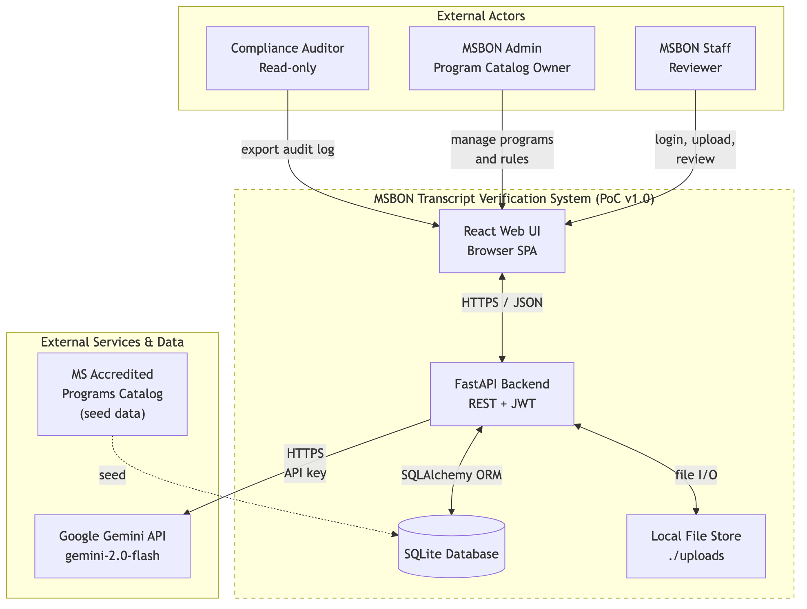
Srd Context Diagram

2.2 Product Functions
The system implements seven top-level capabilities. Each is broken down into specific functional requirements in Section 4.
# | Capability | Primary Actor | FR Range
F1 | Authenticate and authorize staff members (RBAC) | Reviewer / Admin | FR-001 – FR-010
F2 | Upload nursing transcripts (PDF or image) | Reviewer / Admin | FR-020 – FR-029
F3 | Extract structured data via OCR + LLM | System (background task) | FR-030 – FR-039
F4 | Apply 12 transparent verification rules | System | FR-040 – FR-052
F5 | Review, annotate, and decide on flagged transcripts | Reviewer | FR-060 – FR-074
F6 | Maintain tamper-evident audit log | System (write-only) | FR-080 – FR-089
F7 | Manage accredited program catalog | Admin | FR-090 – FR-099

2.3 User Classes and Characteristics
User Class | Count | Frequency | Technical Skill | Privileges (RBAC)
Reviewer (MSBON licensure staff) | ~5–15 | Daily | Comfortable with web apps; not technical | Upload, list, review, annotate; cannot manage rules or programs
Admin (MSBON IT / program catalog owner) | 1–2 | Weekly | Technically literate | All Reviewer rights + manage programs, rules, view system status
Viewer (Compliance auditor) | 1–3 | Quarterly | Audit-focused | Read-only access to transcripts and audit log; no upload, no review
Developer (Team Nexus, capstone team) | 5 | During development only | Full-stack | Direct DB / filesystem access in dev environment only
The Reviewer is the primary user — interface design (font size, contrast, button placement, plain-language flag explanations) is optimized for this class first.

2.4 Operating Environment
Element | Specification
Server OS | macOS 13+, Ubuntu 22.04 LTS, or Windows 11 (PoC supports any platform with Python 3.11)
Server Runtime | Python 3.11+, Node.js 18+ (build only)
Server Hardware | 4 GB RAM minimum, 10 GB free disk for uploads + DB; no GPU required
Database | SQLite 3.39+ (PoC); upgrade path to PostgreSQL 15+ documented in SDD §11.2
Client | Any evergreen browser supporting ES2022 (Chrome 110+, Firefox 110+, Safari 16+, Edge 110+)
Client Hardware | Standard office workstation; 1366×768 minimum display
Network | Local or private network; outbound HTTPS to generativelanguage.googleapis.com for LLM calls
External Service | Google Gemini API (active API key required)

2.5 Design and Implementation Constraints
# | Constraint | Origin
C-1 | Backend language must be Python (FastAPI) | Course tooling alignment + team skill
C-2 | Frontend must be React + TypeScript | Course tooling alignment
C-3 | LLM provider must be Google Gemini for the PoC | Customer-supplied API access
C-4 | All AI outputs are advisory; no automated licensure decisions | MSBON board policy
C-5 | Only synthetic or de-identified transcript data may be used during development | FERPA / privacy
C-6 | All source code, scripts, and documents under git version control | CSC 424 capstone tooling requirement
C-7 | Mermaid is the canonical diagramming notation for both SRS and SDD | Team standard; CI-renderable
C-8 | The product must be demonstrable end-to-end in a recorded video at semester end | CSC 424 presentation deliverable
C-9 | No long-term retention of raw transcript files | Privacy + storage cost

2.6 Assumptions and Dependencies
# | Assumption / Dependency | If Violated
A-1 | A valid Google Gemini API key is provisioned in GEMINI_API_KEY | Extraction fails with LLM_UNAVAILABLE; uploads queue but never process
A-2 | Tesseract OCR is installed on the host (brew install tesseract / apt install tesseract-ocr) | Image-based transcripts cannot be extracted
A-3 | libmagic is installed for MIME validation (brew install libmagic) | File-type detection falls back to extension only — security regression
A-4 | The MSBON-approved accredited program list is seeded into the database | ACCR-001 / ACCR-002 rules over-flag every transcript
A-5 | Reviewers are trained on what each flag category means | Decision quality degrades; OVERRIDDEN rate spikes
A-6 | Network access to generativelanguage.googleapis.com is permitted | Same as A-1

3. External Interface Requirements

3.1 User Interfaces
The system provides a single web-based UI served at http://<host>:5173 in development (and a static-asset bundle for deployment). The information architecture is summarized below.
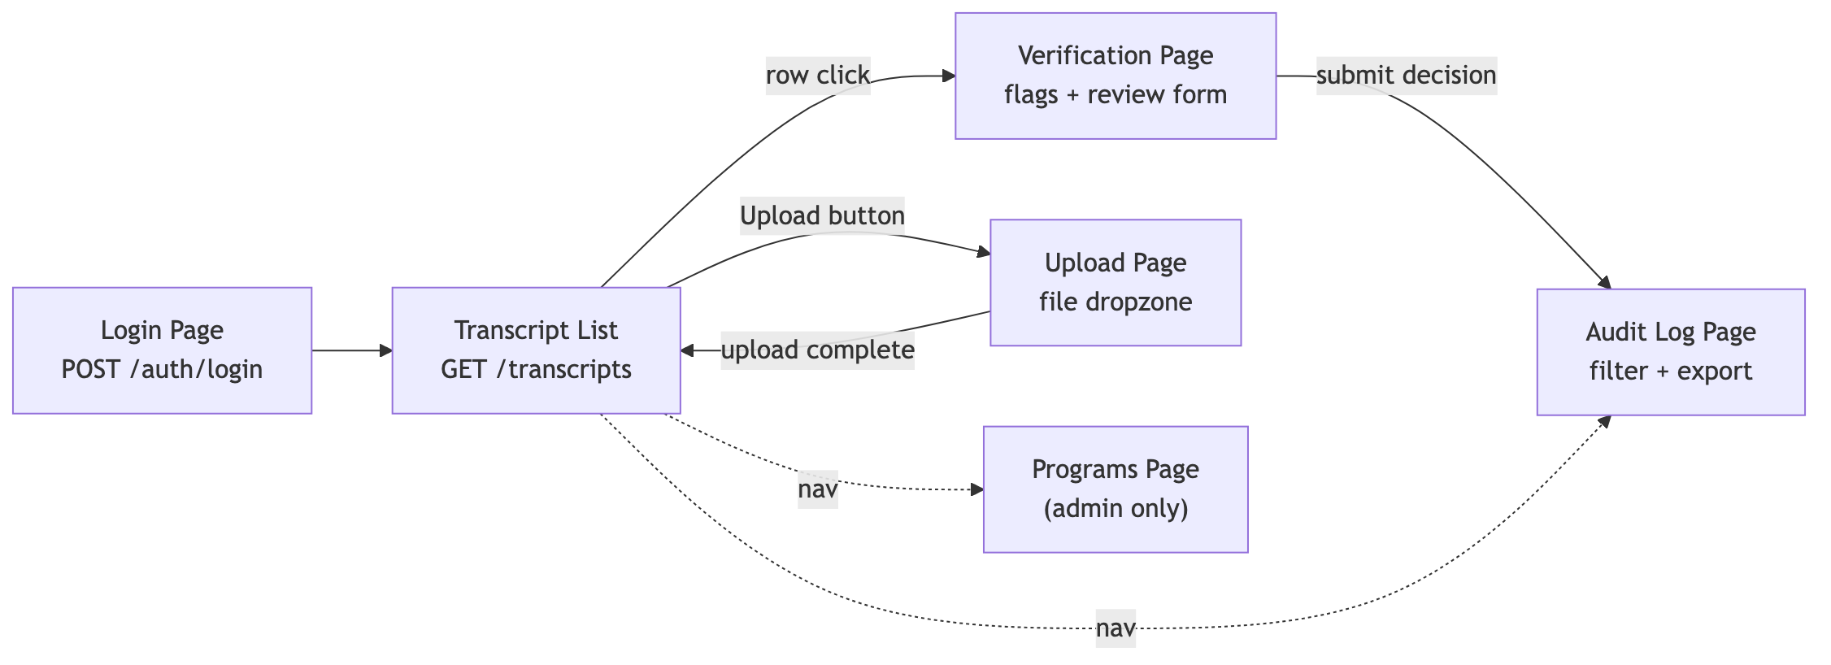
Srd Information Architecture
UI requirements:
ID | Requirement
UI-001 | The UI shall present a top-level navigation with links: Transcripts, Upload, Programs (admin-only), Audit Log, and a session indicator (logged-in user, role, log-out).
UI-002 | The UI shall be operable on viewports 1366×768 and larger; mobile responsiveness is not required for the PoC.
UI-003 | The UI shall conform to WCAG 2.1 Level AA contrast ratios for all text on background.
UI-004 | All actionable controls shall be reachable by keyboard navigation (Tab / Shift-Tab / Enter / Space).
UI-005 | Status indicators (transcript status, flag severity) shall convey meaning by both color and text/icon — never color alone.
UI-006 | All asynchronous operations (upload, processing, submit) shall display either a deterministic progress indicator or a textual “in progress” state within 200 ms of trigger.
UI-007 | Server-side errors shall be surfaced to the user with the human-readable error.message field; raw stack traces shall never be displayed.
UI-008 | The UI shall obey the design tokens defined in frontend/docs/DESIGN_TOKENS.md (no hardcoded colors).

3.2 Hardware Interfaces
The system imposes no special hardware requirements beyond the operating environment in §2.4. There is no integration with scanners, ID readers, biometric devices, or printers in the PoC scope.

3.3 Software Interfaces
Interface | Direction | Protocol | Auth | Notes
Browser → Backend REST API | Bidirectional | HTTPS, JSON | JWT bearer (header Authorization: Bearer <token>) | All endpoints under /api/v1/
Backend → Google Gemini | Outbound | HTTPS | API key (env var GEMINI_API_KEY) | Endpoint generativelanguage.googleapis.com; gemini-2.0-flash model
Backend → SQLite | Local | SQLAlchemy ORM | Filesystem permissions | DSN sqlite:///./data/msbon.db; Alembic-managed schema
Backend → Local file store | Local | POSIX file I/O | Filesystem permissions | Files written as {uuid}.{ext} under ./uploads, MIME-validated via libmagic
Backend → Tesseract | Subprocess | pytesseract shell-out | none | Used by DocumentExtractor for image transcripts

3.4 Communications Interfaces
ID | Requirement
COM-001 | All HTTP traffic in production deployment shall use TLS 1.2 or higher. (PoC dev mode permits plain HTTP on 127.0.0.1.)
COM-002 | The backend shall accept CORS pre-flight requests only from origins listed in CORS_ORIGINS (default http://localhost:5173).
COM-003 | The backend shall expose its OpenAPI 3.1 schema at /openapi.json and an interactive Swagger UI at /docs.
COM-004 | All error responses shall conform to a uniform envelope {"error": {"code", "message", "detail", "timestamp"}}.
COM-005 | The backend shall propagate or generate an X-Correlation-ID header on every request and include it in every log line for that request.

4. Functional Requirements
Each requirement is identified REQ-FR-NNN, has a Priority (Must / Should / May per MoSCoW), and traces to one or more use cases in §6.
Must = required for capstone demo and acceptance. Should = scheduled for the PoC but acceptable to defer with justification. May = stretch goal; included only if time permits.

4.1 Authentication and Authorization (F1)
ID | Requirement | Priority | Trace
FR-001 | The system shall authenticate users via a POST /api/v1/auth/login endpoint accepting staff_id and password, returning a signed JWT with payload {sub, role, exp}. | Must | UC-01
FR-002 | The system shall reject login attempts with invalid credentials with HTTP 401 and the error envelope from COM-004. | Must | UC-01
FR-003 | Issued JWTs shall expire after a configurable interval (default 480 minutes = 8-hour shift). | Must | UC-01
FR-004 | Every protected endpoint shall require a valid JWT in the Authorization: Bearer header. | Must | All UCs
FR-005 | The system shall implement role-based access control with three roles: admin, reviewer, viewer. | Must | UC-01–UC-07
FR-006 | The system shall enforce permissions per role as defined in app/auth/permissions.py (Admin: all; Reviewer: upload + review; Viewer: read-only). | Must | UC-01–UC-07
FR-007 | The system shall reject requests carrying expired or tampered tokens with HTTP 401. | Must | All UCs
FR-008 | Client-supplied identity headers (X-Staff-ID, X-Staff-Role) shall never be used for authorization decisions. | Must | UC-01
FR-009 | The system shall log every successful login and every authorization failure to the audit log (AUTH_LOGIN, AUTH_DENIED). | Must | UC-06
FR-010 | The system should redirect a user to the login page upon receiving an HTTP 401 from any API call. | Should | UC-01

4.2 Transcript Upload (F2)
ID | Requirement | Priority | Trace
FR-020 | The system shall accept transcript uploads via POST /api/v1/transcripts as multipart/form-data with a single file part. | Must | UC-02
FR-021 | Accepted file types shall be: application/pdf, image/png, image/jpeg, image/tiff. | Must | UC-02
FR-022 | File type shall be validated by inspecting magic bytes (via python-magic), not by trusting the filename extension. | Must | UC-02
FR-023 | Maximum accepted file size shall be configurable (MAX_FILE_SIZE_MB, default 10 MB); larger files shall be rejected with HTTP 413. | Must | UC-02
FR-024 | Uploaded files shall be stored under UPLOAD_DIR with a randomized name {uuid}.{ext}; the original filename shall be preserved as metadata only. | Must | UC-02
FR-025 | A successful upload shall return HTTP 202 with a JSON body containing {transcript_id, status: "QUEUED"} and trigger an asynchronous extraction task. | Must | UC-02
FR-026 | The system shall create an audit entry (TRANSCRIPT_UPLOADED) for every successful upload, recording transcript_id, staff_id, filename, file_size, and timestamp. | Must | UC-06
FR-027 | If validation fails, no file shall be persisted to disk and no DB row shall be created. | Must | UC-02
FR-028 | The system should delete uploaded files after FILE_RETENTION_HOURS (default 24 h) once processing is complete. | Should | UC-02
FR-029 | The UI should display a deterministic upload progress bar driven by the XHR onprogress event. | Should | UC-02

4.3 Document Extraction (F3)
ID | Requirement | Priority | Trace
FR-030 | The system shall extract raw text from PDF transcripts using pdfplumber. | Must | UC-02
FR-031 | The system shall extract raw text from image transcripts using Tesseract via pytesseract. | Must | UC-02
FR-032 | Image inputs shall be preprocessed (grayscale conversion, contrast enhancement) before OCR. | Should | UC-02
FR-033 | The extracted raw text shall be passed to the Google Gemini LLM with a deterministic prompt template that returns JSON conforming to the schema in §7.2. | Must | UC-02
FR-034 | The LLM adapter shall validate the response against the JSON schema; non-conforming responses shall be retried (≤ 3 attempts) with exponential back-off (1 s, 2 s, 4 s). | Must | UC-02
FR-035 | If all retries fail, the transcript status shall be set to FAILED and an audit entry EXTRACTION_FAILED shall be created with the underlying error code. | Must | UC-02, UC-06
FR-036 | The system shall persist extracted data as a ExtractedData row linked one-to-one with Transcript. | Must | UC-02
FR-037 | Upon successful extraction, the transcript status shall transition QUEUED → PROCESSING → EXTRACTED. | Must | UC-02
FR-038 | The Gemini API key shall be read from environment variables only; it shall never appear in logs, error messages, or HTTP responses. | Must | NFR-SEC
FR-039 | The system may support pluggable LLM providers via an LLMAdapter interface for future replacement. | May | —

4.4 Verification (Rule Engine) (F4)
ID | Requirement | Priority | Trace
FR-040 | After successful extraction, the system shall automatically invoke the Rule Engine over the extracted JSON. | Must | UC-02
FR-041 | The Rule Engine shall load the active rule set from the flagging_rules table (only rows with is_active=true). | Must | UC-02
FR-042 | The system shall implement and ship the following twelve rules — see §10.2 for the canonical reference: GRAD-001, GRAD-002, ACCR-001, ACCR-002, COUR-001, COUR-002, FRAU-001, FRAU-002, FRAU-003, FORM-001, FORM-002, FORM-003. | Must | UC-02, UC-03
FR-043 | Every emitted flag shall include rule_id, severity (HIGH / MEDIUM / LOW), message, source_excerpt (verbatim text from the transcript), and explanation (≥ 1 plain-language sentence). | Must | UC-03
FR-044 | Verification results shall be persisted as VerificationFlag rows linked to the parent transcript. | Must | UC-02
FR-045 | Upon completion, the transcript status shall transition EXTRACTED → AWAITING_REVIEW if any flags exist, or EXTRACTED → CLEARED if zero flags. | Must | UC-02
FR-046 | An audit entry VERIFICATION_COMPLETED shall be written with the flag count and rule IDs that fired. | Must | UC-06
FR-047 | The system shall allow the active rule set to be modified by an admin user via PATCH /api/v1/rules/{rule_id} (toggle is_active). | Should | UC-07
FR-048 | Rule evaluation shall be deterministic: identical extracted JSON + identical active rule set shall always yield identical flags. | Must | NFR-REL
FR-049 | A failure inside any single rule shall not prevent other rules from running; the failed rule shall produce a flag of severity HIGH with rule_id="RULE_INTERNAL_ERROR". | Should | NFR-REL
FR-050 | The system should allow admins to add custom rules via configuration without code changes (post-PoC). | May | —
FR-051 | The Rule Engine shall complete evaluation of a single transcript within 2 s on PoC reference hardware (M1 MacBook). | Must | NFR-PERF
FR-052 | Accreditation rules shall consult the accredited_programs catalog (institution name, body, is_active); rules shall not hardcode program names. | Must | UC-07

4.5 Staff Review and Decision (F5)
ID | Requirement | Priority | Trace
FR-060 | The system shall provide GET /api/v1/transcripts returning a paginated list filterable by status. | Must | UC-04
FR-061 | The system shall provide GET /api/v1/transcripts/{id} returning the transcript, its extracted data, and all flags. | Must | UC-03
FR-062 | The Verification page shall display flags grouped by severity (HIGH first, then MEDIUM, then LOW). | Must | UC-03
FR-063 | Each flag shall be expandable to show the source_excerpt and explanation inline. | Must | UC-03
FR-064 | The Review form shall provide three exclusive decision controls — CONFIRMED, OVERRIDDEN, NEEDS_MORE_INFO — selectable by mouse or keyboard. | Must | UC-03
FR-065 | If OVERRIDDEN is selected, the user shall be required to enter an override_reason of at least 10 characters before submission. | Must | UC-03
FR-066 | Submission shall be a single POST /api/v1/transcripts/{id}/reviews carrying {decision, override_reason?, annotation?}. | Must | UC-03
FR-067 | Upon successful submission, the transcript status shall transition to REVIEWED and an audit entry REVIEW_SUBMITTED shall be written. | Must | UC-03, UC-06
FR-068 | A transcript may be reviewed multiple times; each review shall be persisted as a separate StaffReview row. The most recent decision is the operative one. | Should | UC-03
FR-069 | The system shall reject review submissions on transcripts whose status is not in {AWAITING_REVIEW, REVIEWED} with HTTP 409. | Must | UC-03
FR-070 | A reviewer with the viewer role shall be able to read flags but shall be denied submission with HTTP 403. | Must | UC-03
FR-071 | The system shall record reviewer_id from the JWT sub claim — never from a request body field. | Must | NFR-SEC
FR-072 | The UI shall provide a confirmation prompt (modal or inline) before a OVERRIDDEN submission is sent. | Should | UC-03
FR-073 | The system shall allow free-text reviewer annotations of up to 2,000 characters per review. | Should | UC-03
FR-074 | The system may allow attaching supporting documents to a review (post-PoC). | May | —

4.6 Audit Log (F6)
ID | Requirement | Priority | Trace
FR-080 | The system shall create an AuditLog entry for every state-changing operation (upload, extraction success/failure, verification, review, login, role change). | Must | UC-06
FR-081 | Each AuditLog entry shall capture id, timestamp (UTC), actor_id, actor_role, action_type, transcript_id (nullable), action_detail (JSON), ip_address, correlation_id. | Must | UC-06
FR-082 | The AuditRepository shall be write-only: update() and delete() shall raise OperationNotPermittedError. | Must | NFR-SEC
FR-083 | The system shall provide GET /api/v1/audit returning paginated audit entries filterable by transcript_id, actor_id, action_type, and date range. | Must | UC-06
FR-084 | The system shall provide GET /api/v1/audit/export?format={csv\|json} returning the full filtered audit set as a downloadable file. | Must | UC-06
FR-085 | Audit entries shall never be edited or deleted by any code path; corrections must be issued as new compensating audit entries. | Must | NFR-SEC
FR-086 | The action_detail field shall not contain raw transcript text or PII; it shall reference the transcript_id for joinable lookups. | Must | NFR-PRIV
FR-087 | Audit entries shall be ordered by timestamp DESC by default in list responses. | Must | UC-06
FR-088 | The audit list shall be paginated with default page size 50 and maximum 500. | Must | UC-06
FR-089 | The CSV export shall include a header row and shall be quoted per RFC 4180. | Must | UC-06

4.7 Program Catalog Management (F7)
ID | Requirement | Priority | Trace
FR-090 | The system shall provide GET /api/v1/programs returning all accredited nursing programs. | Must | UC-07
FR-091 | The system shall provide POST /api/v1/programs (admin only) creating a new accredited program. | Must | UC-07
FR-092 | The system shall provide PATCH /api/v1/programs/{id} (admin only) updating fields including is_active. | Must | UC-07
FR-093 | Each program record shall capture institution_name, program_name, accreditation_body (ACEN | CCNE), accreditation_type (ADN | Baccalaureate | Master | Doctoral), state (2-letter), is_active, accreditation_expires (nullable date). | Must | UC-07
FR-094 | The system shall seed the database on first start with the canonical Mississippi accredited program list (see SDD §11.5). | Must | UC-07
FR-095 | Program changes shall be captured in the audit log (PROGRAM_CREATED, PROGRAM_UPDATED, PROGRAM_DEACTIVATED). | Must | UC-06, UC-07
FR-096 | The system shall validate that accreditation_body ∈ {ACEN, CCNE} and reject other values with HTTP 422. | Must | UC-07
FR-097 | The Programs page shall present an inline editor with role-based visibility (Reviewers see read-only; Admins see editable). | Must | UC-07
FR-098 | The system should provide a bulk-import endpoint for CSV upload of programs (admin only). | May | —
FR-099 | The system should warn at upload time if accreditation_expires is within 90 days. | Should | UC-07

5. Non-Functional Requirements

5.1 Performance (NFR-PERF)
ID | Requirement | Target | Measurement
NFR-PERF-01 | A single transcript upload (≤ 10 MB) shall return HTTP 202 within | ≤ 1 s @ p95 | Manual stopwatch + browser DevTools
NFR-PERF-02 | End-to-end processing (upload → AWAITING_REVIEW) shall complete within | ≤ 30 s @ p95 | Background task instrumentation
NFR-PERF-03 | The Verification page shall load and render flags within | ≤ 1.5 s @ p95 on broadband | Lighthouse / browser perf
NFR-PERF-04 | The system shall sustain | ≥ 5 concurrent reviewers without degradation | Manual concurrent test
NFR-PERF-05 | Audit log queries with date range ≤ 30 days shall return within | ≤ 800 ms | Server timing header

5.2 Security (NFR-SEC)
ID | Requirement
NFR-SEC-01 | All authentication shall use stateless JWT (HMAC-SHA256) signed with a server-side secret of ≥ 32 bytes.
NFR-SEC-02 | The JWT secret (JWT_SECRET) shall be supplied via environment variable; the system shall refuse to start if it is missing or shorter than 32 bytes.
NFR-SEC-03 | All external API keys (GEMINI_API_KEY) shall be supplied via environment variable; they shall not be persisted, logged, or returned in responses.
NFR-SEC-04 | Passwords (when implemented in Phase B) shall be hashed with bcrypt cost ≥ 12.
NFR-SEC-05 | The system shall mitigate the OWASP Top 10 (2021): Broken Access Control (RBAC), Cryptographic Failures (TLS + secret hygiene), Injection (parameterized SQL via ORM), Insecure Design (threat model in SDD §7.1), Security Misconfiguration (env validation), Vulnerable Components (pip-audit in CI), ID&Auth Failures (JWT expiry), SSRF (no user-supplied URLs reach the LLM call).
NFR-SEC-06 | File uploads shall be rejected if the detected MIME type does not match the claimed extension.
NFR-SEC-07 | The system shall set X-Content-Type-Options: nosniff, X-Frame-Options: DENY, and Strict-Transport-Security headers on every response in production.
NFR-SEC-08 | All authorization decisions shall come from the JWT payload — never from request bodies, query parameters, or non-Authorization headers.
NFR-SEC-09 | The audit log shall be append-only at the application layer (AuditRepository.update/delete raise OperationNotPermittedError).
NFR-SEC-10 | Error responses shall not include stack traces, file paths, or framework internals in production.

5.3 Reliability and Availability (NFR-REL)
ID | Requirement
NFR-REL-01 | The Gemini LLM adapter shall retry on transient errors (5xx, 429, network timeouts) up to 3 times with exponential back-off; non-transient errors (401, 400) shall fail fast.
NFR-REL-02 | A failure in the extraction pipeline shall leave the database in a consistent state — either the full (Transcript, ExtractedData, AuditLog) triple is committed or none of it is.
NFR-REL-03 | The system shall recover automatically from a process restart: queued / processing transcripts shall be retried by the next start.
NFR-REL-04 | The system shall expose /api/v1/health returning {status, database, version, timestamp} for readiness probes.
NFR-REL-05 | Target availability for a hosted deployment: ≥ 99 % over a calendar month.

5.4 Usability (NFR-USE)
ID | Requirement
NFR-USE-01 | A new reviewer shall be able to complete their first transcript review within 10 minutes given only the in-app text and tooltips.
NFR-USE-02 | Every flag explanation shall be readable at a Flesch-Kincaid grade level ≤ 10.
NFR-USE-03 | The system shall comply with WCAG 2.1 Level AA.
NFR-USE-04 | All form fields shall have visible labels (no placeholder-only inputs).
NFR-USE-05 | All destructive or irreversible actions (e.g., OVERRIDDEN decision submission) shall require explicit confirmation.

5.5 Maintainability (NFR-MAINT)
ID | Requirement
NFR-MAINT-01 | All code shall be formatted with black (Python) and prettier (TS/React).
NFR-MAINT-02 | All Python code shall pass ruff check with the project ruleset.
NFR-MAINT-03 | Backend test coverage shall reach ≥ 60 % line coverage by end of PoC (Phase C target: 80 %).
NFR-MAINT-04 | All schema changes shall be expressed as Alembic migrations under backend/migrations/versions/.
NFR-MAINT-05 | Service classes shall depend on repository / adapter interfaces, not concrete implementations, to enable mocking.
NFR-MAINT-06 | The OpenAPI schema at /openapi.json shall be the single source of truth for the HTTP contract.

5.6 Portability (NFR-PORT)
ID | Requirement
NFR-PORT-01 | The backend shall run on macOS 13+, Ubuntu 22.04 LTS, and Windows 11 with no source changes.
NFR-PORT-02 | The application shall be deployable as a Docker container (docker-compose up).
NFR-PORT-03 | The database adapter shall be SQLAlchemy-backed so the SQLite → PostgreSQL upgrade requires only a connection-string change.

5.7 Privacy (NFR-PRIV)
ID | Requirement
NFR-PRIV-01 | Only synthetic / de-identified transcripts shall be used during development and demonstration.
NFR-PRIV-02 | Original uploaded files shall be deleted after the configurable retention window (FILE_RETENTION_HOURS, default 24 h).
NFR-PRIV-03 | Audit log entries shall not contain raw transcript text — only transcript_id references.
NFR-PRIV-04 | The system shall not transmit transcript content to any third party other than the configured LLM provider.
NFR-PRIV-05 | The system shall provide an admin operation to permanently purge a transcript and all dependent records (cascades) in support of right-to-erasure requests. (Phase B)

6. Use Cases

6.1 Use Case Diagram
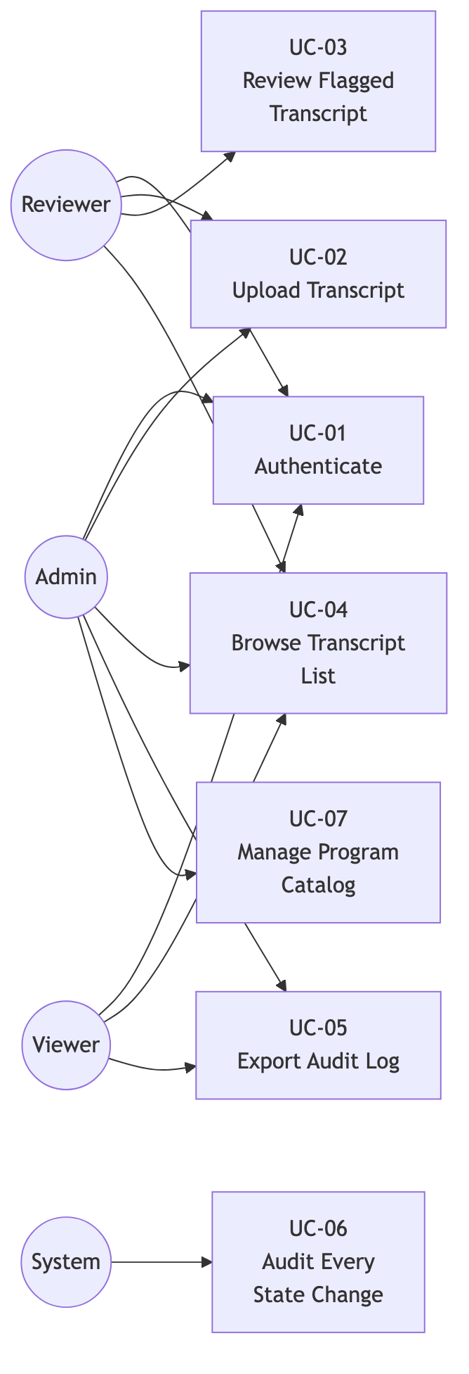
Srd Use Case Diagram

6.2 UC-01 — Authenticate
Primary Actor: Reviewer / Admin / Viewer. Preconditions: User has valid credentials provisioned by an Admin. Trigger: User opens the application URL.
Main Success Scenario: 1. The system displays the Login page. 2. The user enters staff_id and password and clicks Sign In. 3. The system validates credentials against the user store. 4. The system issues a JWT with payload {sub, role, exp} and returns it to the client. 5. The client stores the token in memory and redirects to the Transcript List. 6. The system writes an AUTH_LOGIN audit entry.
Extensions: - 3a. Credentials invalid → return HTTP 401, display “Invalid credentials,” write AUTH_DENIED audit entry. - 4a. Token signing fails → return HTTP 500, display generic error.

6.3 UC-02 — Upload Transcript
Primary Actor: Reviewer / Admin. Preconditions: User authenticated; Gemini API key configured; Tesseract installed. Trigger: User clicks Upload on the Transcript List page.
Main Success Scenario: 1. The system displays the Upload page with a drag-and-drop area. 2. The user drops or selects a .pdf / .png / .jpg / .tiff file ≤ 10 MB. 3. The client posts the file to POST /api/v1/transcripts. 4. The system validates type (magic bytes) and size; persists the file as {uuid}.{ext}; creates a Transcript row with status QUEUED; returns HTTP 202 with transcript_id. 5. A background task picks up the row, calls DocumentExtractor then LLMAdapter; persists ExtractedData; transitions status QUEUED → PROCESSING → EXTRACTED. 6. The Rule Engine runs over the extracted JSON and persists VerificationFlag rows; status transitions EXTRACTED → AWAITING_REVIEW (or → CLEARED if no flags). 7. The UI polls or websockets-into status updates and surfaces the row in Awaiting Review. 8. Each step writes an audit entry per FR-026 / FR-035 / FR-046.
Extensions: - 4a. Invalid file → HTTP 422, no DB row, no file persisted. - 4b. File too large → HTTP 413. - 5a. OCR/extraction fails → status FAILED, EXTRACTION_FAILED audit entry, surfaced as red row in UI. - 5b. LLM unavailable → 3 retries with back-off; if all fail, same as 5a but error code LLM_UNAVAILABLE.

6.4 UC-03 — Review Flagged Transcript
Primary Actor: Reviewer. Preconditions: Transcript is in status AWAITING_REVIEW or REVIEWED. Trigger: Reviewer clicks the transcript row.
Main Success Scenario: 1. The system loads GET /api/v1/transcripts/{id} returning extracted data + flags. 2. The Verification page renders the transcript summary, then the flag list grouped by severity. 3. The reviewer expands each flag to read source_excerpt + explanation. 4. The reviewer chooses a decision (CONFIRMED / OVERRIDDEN / NEEDS_MORE_INFO). 5. If OVERRIDDEN, the reviewer enters a justification ≥ 10 chars. 6. Optional annotation up to 2 000 chars. 7. The reviewer submits → POST /api/v1/transcripts/{id}/reviews. 8. The system persists the StaffReview, transitions status to REVIEWED, writes REVIEW_SUBMITTED audit entry. 9. UI shows confirmation toast and returns to the list.
Extensions: - 7a. Submission rejected because status was already CLEARED → HTTP 409, no state change. - 7b. Viewer role attempts submission → HTTP 403, no state change.

6.5 UC-04 — Browse Transcript List
Primary Actor: Reviewer / Admin / Viewer. Trigger: User opens the Transcript List page.
Main Success Scenario: 1. System loads GET /api/v1/transcripts?status=…&page=…. 2. The page renders a paginated table with columns: filename, uploaded_at, status, flag count, last action. 3. Filter chips allow narrowing by status; sort by uploaded_at. 4. Clicking a row navigates to the Verification page (UC-03).

6.6 UC-05 — Export Audit Log
Primary Actor: Admin / Viewer (compliance auditor). Trigger: User clicks Export CSV on the Audit Log page.
Main Success Scenario: 1. User opens Audit Log; sets filters (date range, action type, transcript ID, actor). 2. User clicks Export CSV (or JSON). 3. System queries the matching audit rows and streams a text/csv (or application/json) response with Content-Disposition: attachment. 4. Browser saves the file audit_export_{timestamp}.csv.

6.7 UC-06 — Audit Every State Change (System)
Primary Actor: System (no human trigger). Trigger: Any state-changing handler in the API or services layer.
Main Success Scenario: Each handler calls AuditService.log(action_type, transcript_id?, actor, detail) inside the same database transaction as the state change, ensuring atomicity. The audit row is uneditable thereafter (NFR-SEC-09).

6.8 UC-07 — Manage Program Catalog
Primary Actor: Admin. Trigger: Admin opens the Programs page.
Main Success Scenario: 1. System loads GET /api/v1/programs. 2. Admin clicks Add Program; fills the form (institution, program, body, type, state, expires); submits. 3. System validates body ∈ {ACEN, CCNE} and persists. 4. System writes PROGRAM_CREATED audit entry. 5. New program is immediately consulted by ACCR-001 / ACCR-002 on subsequent verifications.

6.9 Sequence Diagram — End-to-End Verification
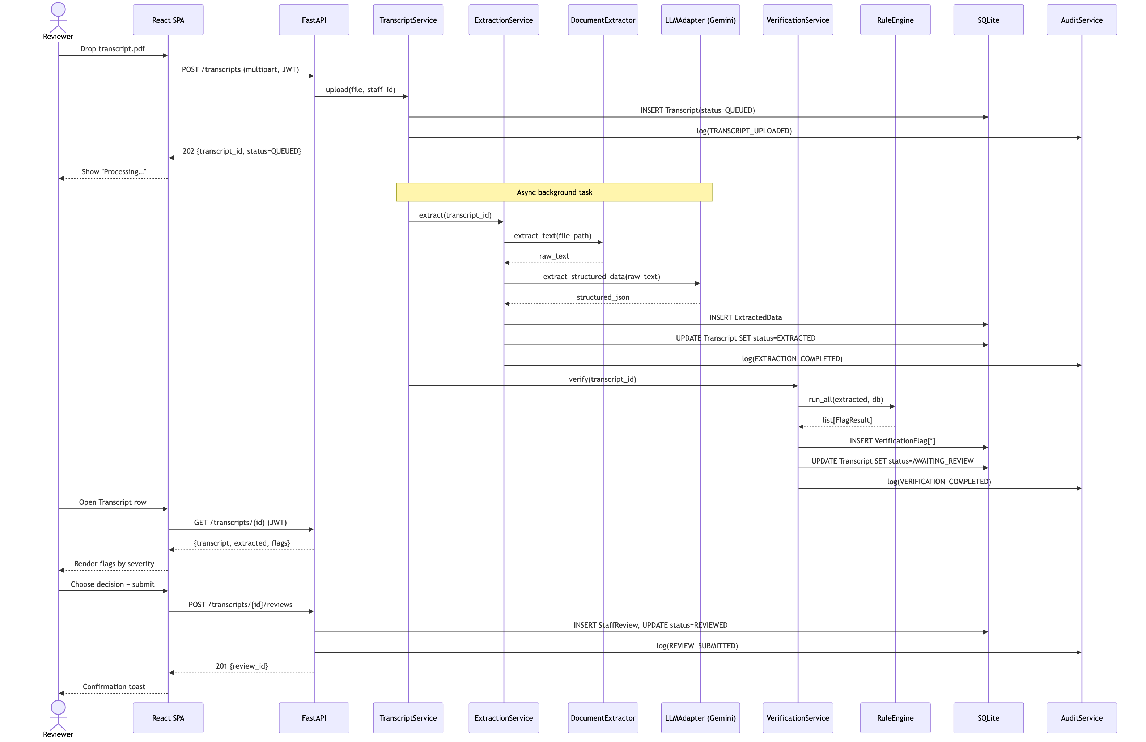
Srd Sequence E2E

7. Data Requirements

7.1 Logical Data Model (Entity-Relationship)
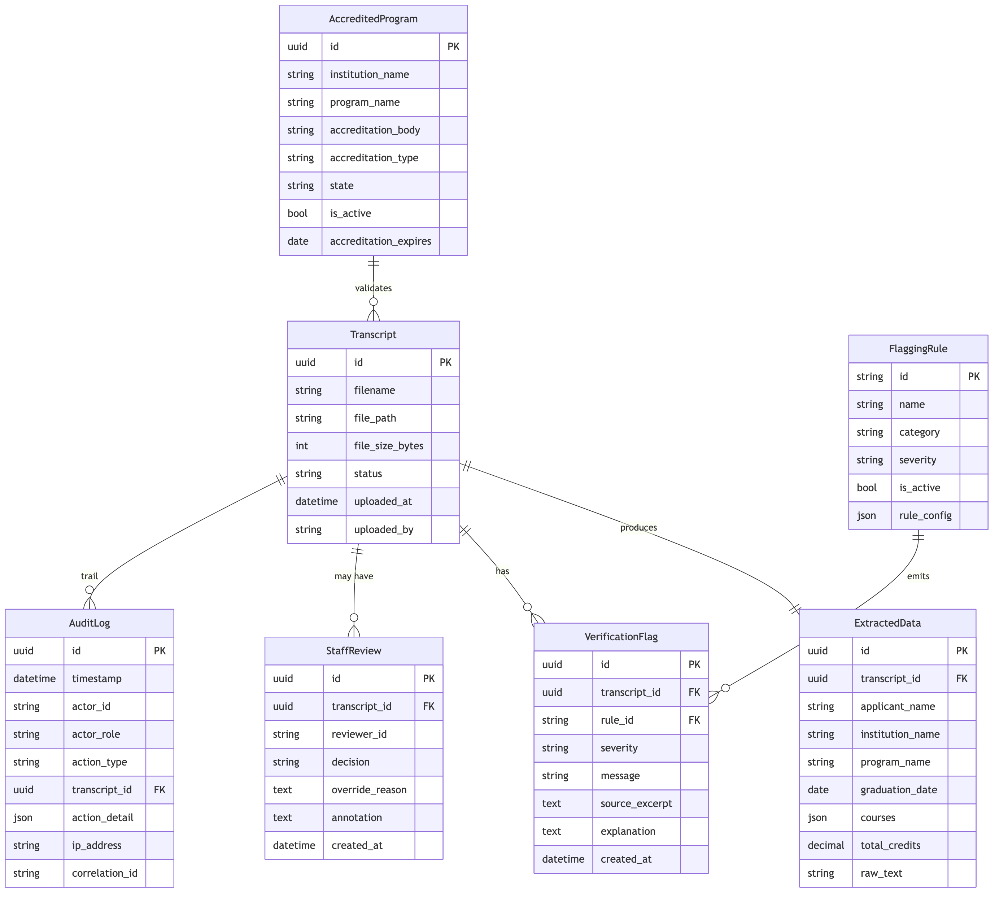
Srd Er Diagram

7.2 LLM-Returned JSON Schema (Extracted Data)
{
"applicant_name": "string",
"institution_name": "string",
"program_name": "string",
"graduation_date": "YYYY-MM-DD | null",
"enrollment_date": "YYYY-MM-DD | null",
"total_credits": "number | null",
"courses": [
{
"code": "string",
"title": "string",
"credits": "number",
"grade": "string"
}
],
"accreditation_body": "string | null",
"raw_text_preview": "string (≤ 500 chars)"
}

7.3 Transcript State Machine
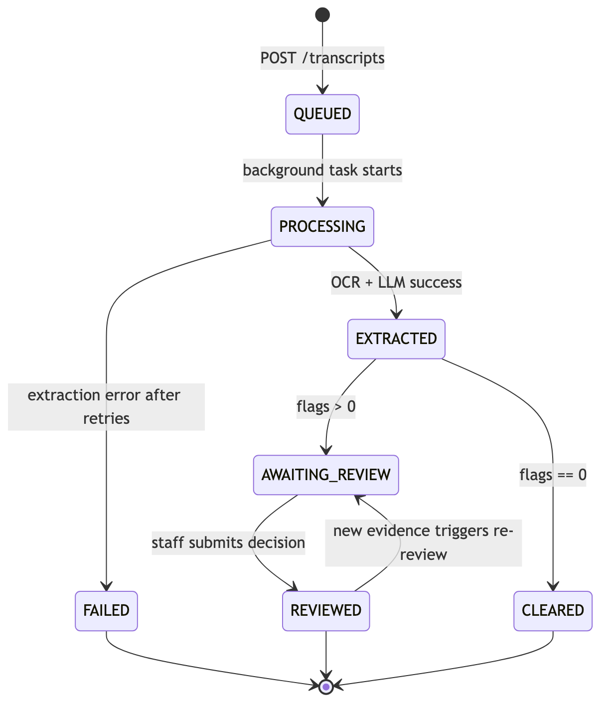
Srd State Machine

7.4 Data Retention
Entity | Retention | Notes
Original uploaded file | FILE_RETENTION_HOURS (default 24 h) after status reaches REVIEWED or CLEARED | Deleted by scheduled cleanup task
Transcript row + ExtractedData | Indefinite for the PoC | Phase B: configurable
VerificationFlag | Indefinite | Joined to transcript
StaffReview | Indefinite | Required for compliance
AuditLog | Indefinite, append-only | Required for audit per FR-082

8. System Constraints and Compliance
ID | Constraint / Compliance Item | Source
CMP-01 | No automated licensure decisions | MSBON board policy
CMP-02 | Synthetic / de-identified data only during development | FERPA
CMP-03 | All data minimization principles followed (raw text not exported in audit) | NIST Privacy Framework
CMP-04 | OWASP Top 10 (2021) addressed in design and implementation | NFR-SEC-05
CMP-05 | WCAG 2.1 Level AA conformance | UI-003
CMP-06 | LLM responses are advisory; staff retain decision authority | CMP-01
CMP-07 | All deliverables under git version control with branch protection on main | CSC 424 tool requirement
CMP-08 | Project teams shall record and submit meeting minutes | CSC 424 grading rubric
CMP-09 | Final demonstration shall be a recorded video walkthrough | CSC 424 oral component

9. Acceptance Criteria and Traceability Matrix

9.1 Acceptance Criteria (Customer-Facing)
# | Acceptance Criterion | Target | Measurement Method
AC-01 | Flag detection accuracy on the synthetic test set | ≥ 90 % | Confusion matrix from tests/synthetic/
AC-02 | Every flag includes rule ID + source excerpt + explanation | 100 % | Schema-validated assertion
AC-03 | Every state change produces an audit entry | 100 % | pytest integration test
AC-04 | Every OVERRIDDEN decision stores override_reason | 100 % | DB constraint + service-layer check
AC-05 | No endpoint approves or denies licensure | 100 % | Code review + endpoint audit
AC-06 | The end-to-end happy path is demonstrable in a recorded video | Pass / fail | Final presentation

9.2 Functional Requirement → Use Case → Test Traceability
Legend: ✓ = covered by automated test, △ = covered by manual demo step, — = pending Phase B/C.
Requirement | Use Case | Test Type | Status
FR-001..010 (Auth) | UC-01 | Integration (tests/test_auth.py) | △
FR-020..029 (Upload) | UC-02 | Integration + manual | △
FR-030..039 (Extraction) | UC-02 | Integration + mocked LLM | —
FR-040..052 (Rules) | UC-02, UC-03 | Unit (per rule) | △
FR-060..074 (Review) | UC-03 | Integration | △
FR-080..089 (Audit) | UC-06 | Integration | △
FR-090..099 (Programs) | UC-07 | Integration | △
NFR-PERF-01..05 | All | Manual stopwatch | △
NFR-SEC-01..10 | All | Code review + pip-audit | △
NFR-USE-01..05 | All | UAT | —

9.3 Demo Script (recorded presentation)
The capstone demonstration shall execute the following flow on screen (timing approximate, full script in §10.4):
- Login as admin / demo (UC-01) → land on Transcript List.
- Walk through Programs page; show seeded MS programs (UC-07).
- Upload synthetic transcript A (clean BSN graduate) → watch status QUEUED → AWAITING_REVIEW; open it → 0–1 flags → CONFIRMED (UC-02, UC-03).
- Upload synthetic transcript B (fraud indicators: 8-month BSN duration) → review flags → OVERRIDDEN with justification (UC-02, UC-03).
- Open Audit Log → filter by transcript_id → demonstrate every action recorded (UC-06).
- Click Export CSV → open the file in Numbers/Excel showing the audit trail (UC-05).

10. Appendix

10.1 Mapping to CSC 424 Capstone Deliverables
Capstone Deliverable | Where Addressed
Concept Document (10 %) | Original MSBON Fraud-Sensitive Transcript Verification_Concept_CSC424_02.pdf
Software Requirements Document (15 %) | This document
High Level Design Document (10 %) | Software_Design_Document.md (companion SDD)
High-Fidelity Mockup (10 %) | Live-rendered React UI on localhost:5173; screenshots in §10.3
Meeting Minutes (5 %) | docs/meeting-minutes/ directory
Documentation Quality (5 %) | This document + SDD + READMEs
Project Presentation (20 %) | Recorded walkthrough per §9.3

10.2 Flagging Rules Reference (canonical list — same as SDD §5.4)
Rule ID | Name | Category | Severity | Trigger
GRAD-001 | Missing graduation confirmation | GRADUATION | HIGH | No explicit degree conferral text in raw transcript
GRAD-002 | Graduation date absent | GRADUATION | MEDIUM | graduation_date field empty in extracted JSON
ACCR-001 | Institution not in MS accredited list | ACCREDITATION | HIGH | institution_name not found in accredited_programs
ACCR-002 | Accreditation body not recognized | ACCREDITATION | MEDIUM | accreditation_body ∉ {ACEN, CCNE}
COUR-001 | Required nursing courses not present | COURSE | HIGH | One or more mandatory course codes missing
COUR-002 | Insufficient credit hours | COURSE | MEDIUM | total_credits below minimum threshold (configurable)
FRAU-001 | Program completion time below minimum | FRAUD | HIGH | (graduation_date − enrollment_date) < program minimum
FRAU-002 | Suspicious grade distribution | FRAUD | MEDIUM | All-A pattern with no grade variance across ≥ 8 courses
FRAU-003 | Institution on fraud watch list | FRAUD | HIGH | institution_name matches a known-fraud entry
FORM-001 | Required transcript fields missing | FORMAT | LOW | One or more of {applicant, institution, program} could not be extracted
FORM-002 | Inconsistent date formatting | FORMAT | LOW | Multiple date formats appear in raw text
FORM-003 | Inconsistent grade formatting | FORMAT | LOW | Mixed letter / numeric / pass-fail grades

10.3 Glossary of Status Codes
Status | Meaning
QUEUED | Uploaded; awaiting background extraction
PROCESSING | Extraction in progress
EXTRACTED | LLM JSON persisted; rule engine pending
AWAITING_REVIEW | One or more flags raised; needs staff decision
CLEARED | Zero flags after verification
REVIEWED | Staff has submitted a decision
FAILED | Unrecoverable error during processing

10.4 Demo Script Detailed Steps
The full keystroke-level demo script is maintained in docs/DEMO_SCRIPT.md (created during Step 5 of the capstone implementation plan). It includes the synthetic transcript fixtures, expected flag set per fixture, and a 6-minute recording outline aligned with §9.3.

10.5 Open Issues / Future Work
# | Issue | Disposition
OI-1 | Real user store (replace hardcoded demo users) | Phase B
OI-2 | Field-level encryption for PII | Phase B (DB-010)
OI-3 | Configurable rule authoring UI | Post-PoC
OI-4 | PostgreSQL migration | Phase D (infrastructure decision required)
OI-5 | Integration with MSBON production licensing DB | Out of capstone scope
OI-6 | Mobile-responsive UI | Phase C
OI-7 | E2E browser test suite (Playwright) | Phase C+

End of Software Requirements Specification — MSBON Transcript Verification System v1.0 PoC.

