Table of Contents

Software Design Document

MSBON Fraud-Sensitive Transcript Verification System

Version 1.0 | Team Nexus | University of Southern Mississippi

Revision History
Version | Date | Author | Description
0.1 | 2026-03-28 | Team Nexus | Initial draft
1.0 | 2026-03-28 | Team Nexus | Baseline SDD — PoC scope

Table of Contents
- Introduction
- System Overview
- Architectural Design
- Data Design
- Component Design
- Interface Design
- Security Design
- Error Handling & Resilience
- Testing Strategy
- Non-Functional Requirements
- Appendix

1. Introduction

1.1 Purpose
This Software Design Document (SDD) provides the complete technical specification for the MSBON Fraud-Sensitive Transcript Verification System — a Proof of Concept (PoC) developed for the Mississippi State Board of Nursing (MSBON) by Team Nexus at The University of Southern Mississippi. It describes the system’s architecture, data models, component interactions, API contracts, security posture, and testing strategy, and serves as the authoritative reference for development and stakeholder review.

1.2 Scope
The system automates the extraction and rule-based verification of nursing school transcripts submitted to MSBON for licensure applications. It flags potential anomalies — missing graduation confirmation, accreditation mismatches, course deficiencies, fraud indicators, and formatting inconsistencies — for human staff review. All staff decisions and system actions are captured in tamper-evident audit logs. No automated licensure decisions are ever made by this system.

1.3 Definitions, Acronyms, and Abbreviations
Term | Definition
MSBON / MSBN | Mississippi State Board of Nursing
PoC | Proof of Concept
OCR | Optical Character Recognition
LLM | Large Language Model
SDD | Software Design Document
ACEN | Accreditation Commission for Education in Nursing
CCNE | Commission on Collegiate Nursing Education
API | Application Programming Interface
REST | Representational State Transfer
ORM | Object-Relational Mapper
SPA | Single Page Application
SOP | Standard Operating Procedure
ER | Entity-Relationship
UML | Unified Modeling Language
FERPA | Family Educational Rights and Privacy Act
ADN | Associate Degree in Nursing
BSN | Bachelor of Science in Nursing
MSN | Master of Science in Nursing
ASGI | Asynchronous Server Gateway Interface

1.4 References
- MSBON PoC Scope Document (January 7, 2025)
- MSBON Project Proposal, Team Nexus (February 27, 2026)
- Operation Nightingale Federal Investigation
- ACEN and CCNE Accreditation Standards
- FastAPI Official Documentation
- Google Gemini API Documentation
- OWASP Top 10 Security Guidelines (2021)
- PEP 8 — Python Style Guide

1.5 Document Overview
Section 2 provides a system overview and stakeholder context. Section 3 covers layered architecture with C4 container and component diagrams. Section 4 details the data design including ER diagram, database schema, and state machine. Section 5 defines class diagrams for every layer. Section 6 specifies REST API contracts and sequence diagrams. Section 7 addresses security. Section 8 covers error handling. Section 9 defines the testing strategy. Section 10 lists non-functional requirements. Section 11 provides the directory structure, environment variables, and dependency manifest.

2. System Overview

2.1 Background and Problem Statement
The Mississippi State Board of Nursing currently reviews nursing school transcripts manually to confirm that applicants have completed an approved nursing education program. This process is time-consuming, inconsistent across institutions, and vulnerable to human error. Federal investigations such as Operation Nightingale demonstrated that bad actors can exploit gaps in manual review processes to fraudulently obtain nursing licenses — a direct threat to public safety.

2.2 System Purpose
The MSBON Transcript Verification System is an AI-assisted tool that:
- Ingests nursing transcripts (PDF or scanned image)
- Extracts structured data using OCR and a Large Language Model (Google Gemini)
- Applies transparent, rule-based verification logic against MSBON-defined licensure requirements
- Flags anomalies with full explanations for staff review
- Provides a staff workflow for confirming, overriding, and annotating findings
- Generates audit-ready logs documenting every action
All AI outputs are advisory only. Human staff retain full decision-making authority.

2.3 Stakeholders
Role | Person(s) | Interaction with System
Business Decision Maker | Shantannar Montgomery | Product direction, acceptance
Data Validators | Dr. Burks, Dr. Smith, Talisha Greenlaw | Rule accuracy validation
Primary Users | MSBON Staff | Upload, review, annotate
Development Team | Team Nexus (Sandesh, Nishit, Kiran, Chance, Suvi) | Build and test

2.4 System Context Diagram (C4 Level 1)
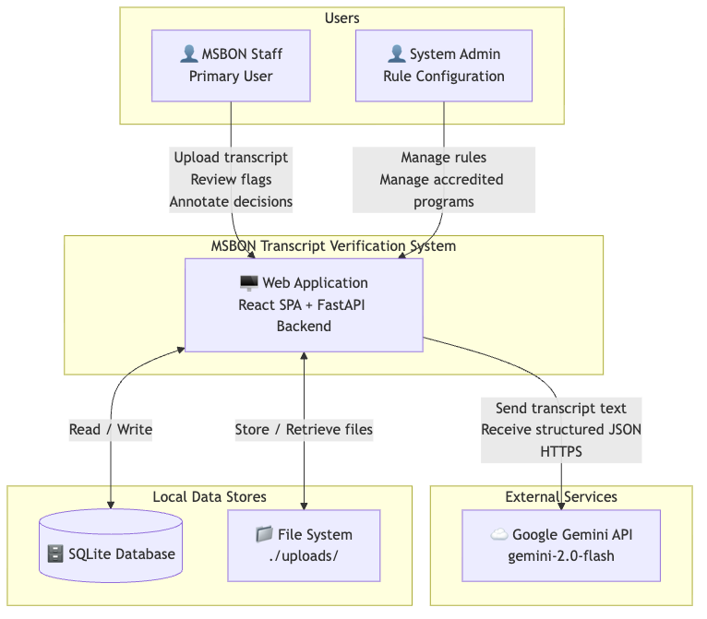
Graph 1

2.5 Assumptions and Constraints
Constraint | Detail
Scope | PoC only — not for production deployment or public access
Transcript origin | Only domestic (U.S.) transcripts in scope
Data | Only synthetic or de-identified sample transcripts during development
Storage | No permanent retention of real transcript content
Network | Operates on local or private network
AI authority | All AI outputs advisory — no automated licensure decisions
Runtime | Python 3.11+, Node.js 18+

3. Architectural Design

3.1 Architectural Style
The system follows a Layered Architecture pattern with strict separation of concerns across five layers.
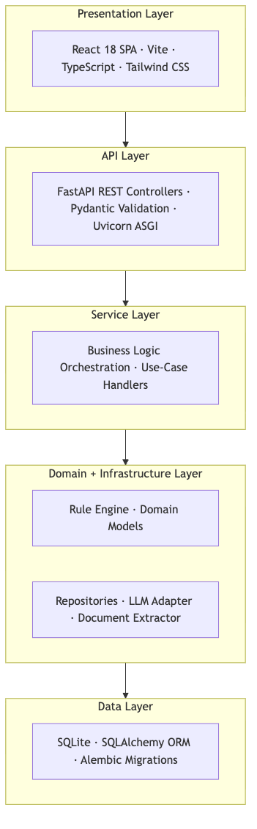
Graph 2
Why layered architecture:
Benefit | How it applies
Testability | Each layer tested independently with mocks at boundaries
Auditability | All business logic isolated — every flag traceable to a rule class
Maintainability | Rule engine evolves without touching API or UI
Explainability | Transparent rule logic required by scope; no black-box processing

3.2 Container Diagram (C4 Level 2)
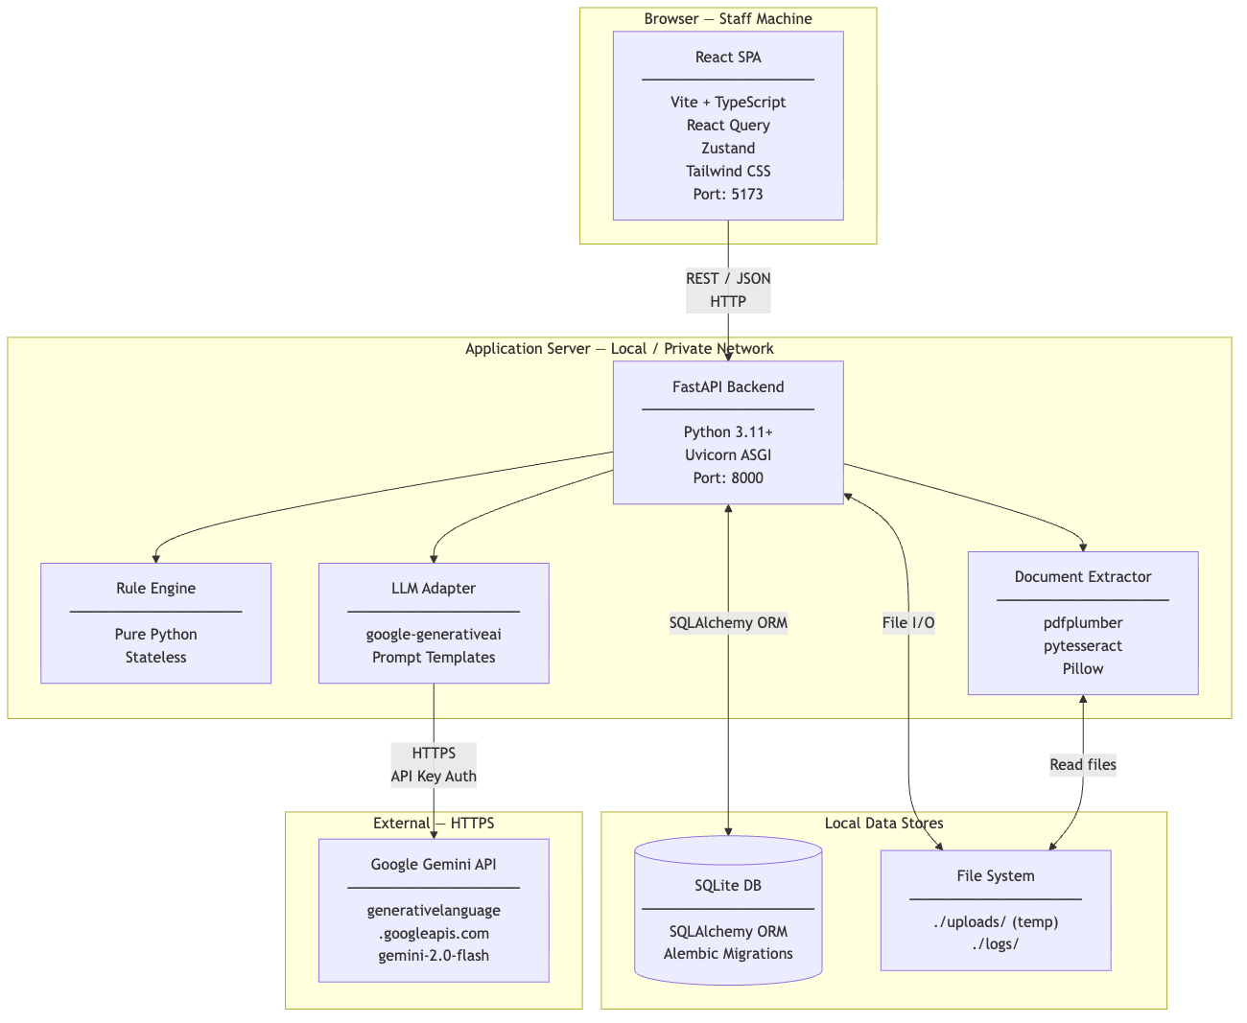
Graph 3

3.3 Backend Component Diagram (C4 Level 3)
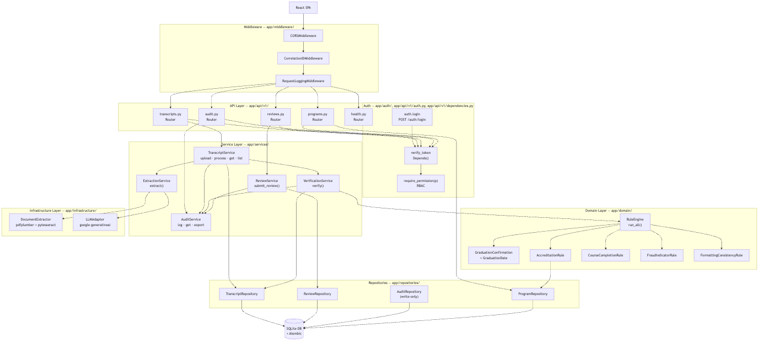
Graph 4

3.4 Frontend Component Hierarchy
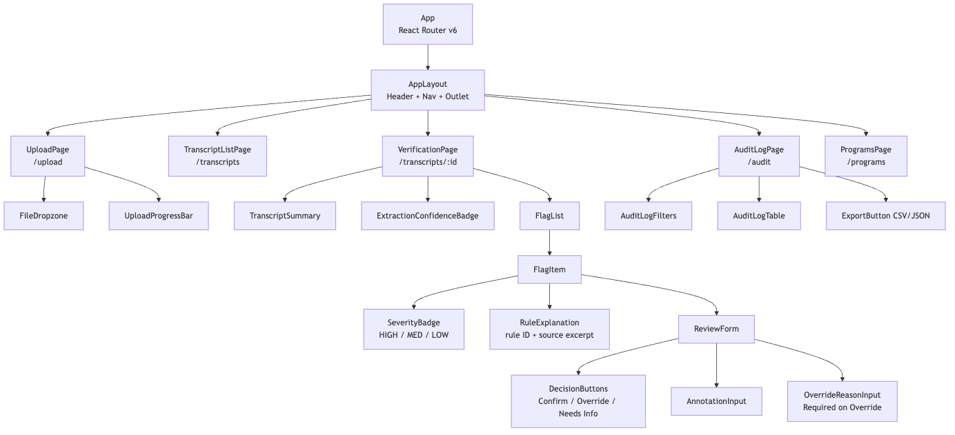
Graph 5

3.5 Deployment Diagram (PoC)
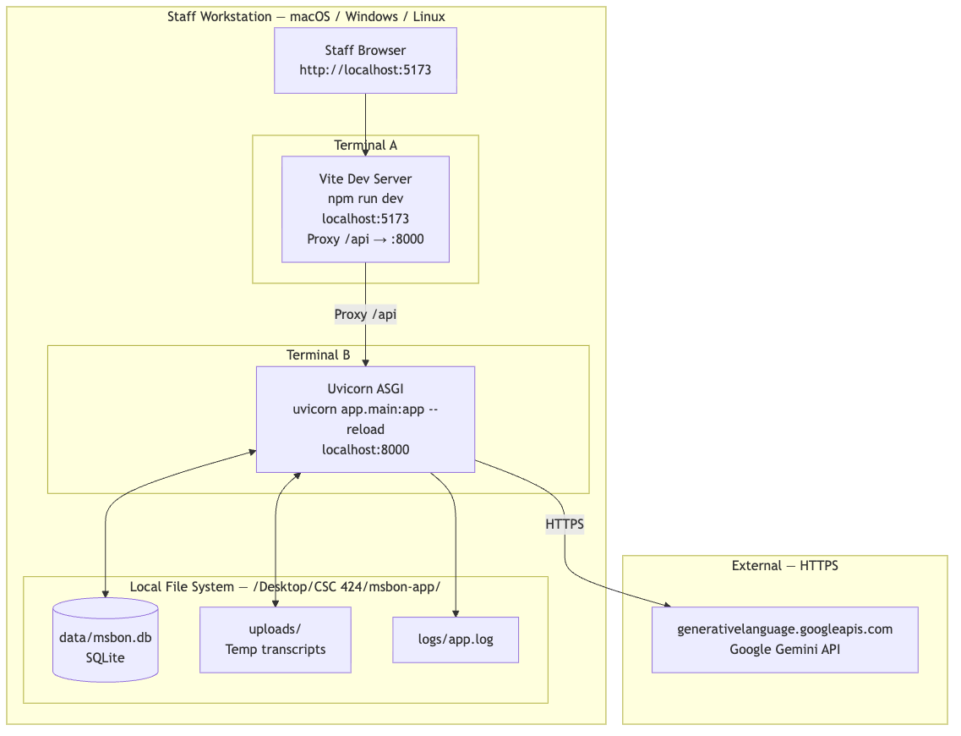
Graph 6

4. Data Design

4.1 Entity-Relationship Diagram
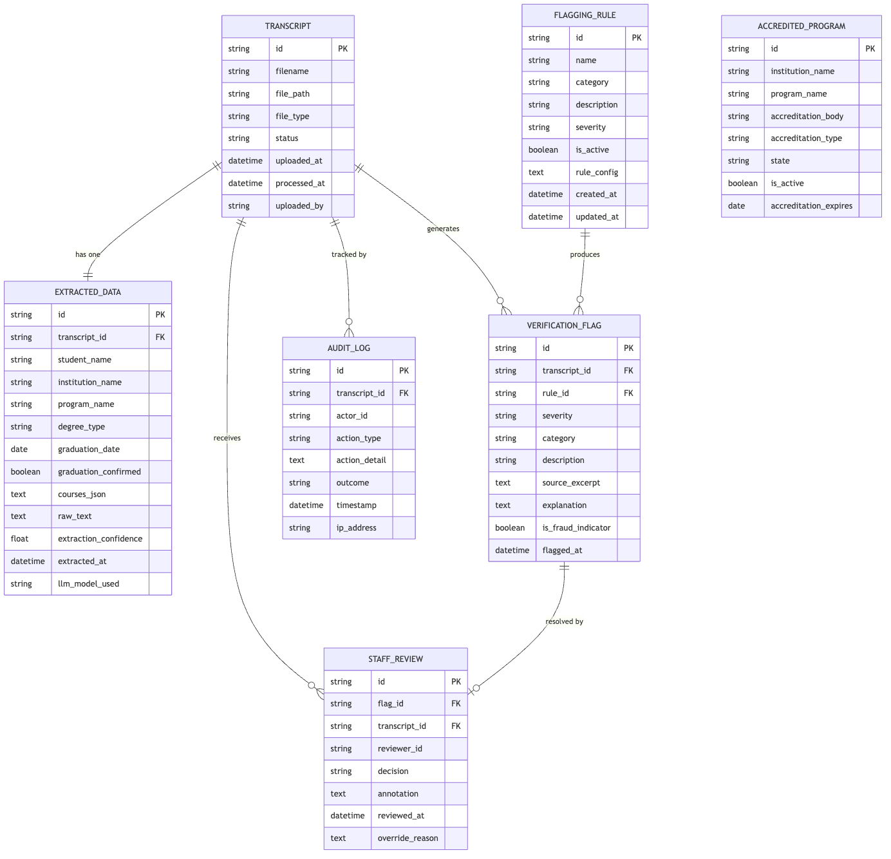
Er Diagram 1

4.2 Database Schema

Table: transcripts
Column | Type | Constraints | Description
id | VARCHAR(36) | PK, NOT NULL | UUID v4
filename | VARCHAR(255) | NOT NULL | Original filename (sanitized for display only)
file_path | VARCHAR(512) | NOT NULL | Relative path under ./uploads/
file_type | VARCHAR(10) | NOT NULL, CHECK IN (‘pdf’,‘image’) | File category
status | VARCHAR(20) | NOT NULL | See §4.3 state machine
uploaded_at | DATETIME | NOT NULL | UTC timestamp
processed_at | DATETIME | NULLABLE | UTC — set when verification completes
uploaded_by | VARCHAR(100) | NOT NULL | Staff identifier from X-Staff-ID header

Table: extracted_data
Column | Type | Constraints | Description
id | VARCHAR(36) | PK | UUID v4
transcript_id | VARCHAR(36) | FK → transcripts.id, UNIQUE | One-to-one with transcript
student_name | VARCHAR(255) | NULLABLE | Full name as extracted
institution_name | VARCHAR(255) | NULLABLE | School name as extracted
program_name | VARCHAR(255) | NULLABLE | Nursing program name
degree_type | VARCHAR(20) | NULLABLE | ADN / BSN / MSN / DNP / LPN / OTHER
graduation_date | DATE | NULLABLE | ISO 8601
graduation_confirmed | BOOLEAN | NOT NULL DEFAULT FALSE | True only when explicit conferral statement present
courses_json | TEXT | NULLABLE | JSON array of course objects
raw_text | TEXT | NULLABLE | Full text from OCR / PDF extraction
extraction_confidence | REAL | NULLABLE | 0.0–1.0 model confidence
extracted_at | DATETIME | NOT NULL | UTC
llm_model_used | VARCHAR(100) | NOT NULL | e.g., gemini-2.0-flash

Table: verification_flags
Column | Type | Constraints | Description
id | VARCHAR(36) | PK | UUID v4
transcript_id | VARCHAR(36) | FK → transcripts.id
rule_id | VARCHAR(36) | FK → flagging_rules.id | Rule that produced this flag
severity | VARCHAR(10) | NOT NULL | HIGH / MEDIUM / LOW
category | VARCHAR(20) | NOT NULL | GRADUATION / ACCREDITATION / COURSE / FRAUD / FORMAT
description | VARCHAR(500) | NOT NULL | One-line human-readable description
source_excerpt | TEXT | NULLABLE | Verbatim text from transcript that triggered flag
explanation | TEXT | NOT NULL | Full rule rationale with rule ID
is_fraud_indicator | BOOLEAN | NOT NULL
flagged_at | DATETIME | NOT NULL | UTC

Table: staff_reviews
Column | Type | Constraints | Description
id | VARCHAR(36) | PK | UUID v4
flag_id | VARCHAR(36) | FK → verification_flags.id, UNIQUE | One review per flag
transcript_id | VARCHAR(36) | FK → transcripts.id | Denormalized for query convenience
reviewer_id | VARCHAR(100) | NOT NULL | Staff identifier
decision | VARCHAR(20) | NOT NULL | CONFIRMED / OVERRIDDEN / NEEDS_MORE_INFO
annotation | TEXT | NULLABLE | Staff notes
reviewed_at | DATETIME | NOT NULL | UTC
override_reason | TEXT | NULLABLE | Required when decision = OVERRIDDEN

Table: audit_logs
Column | Type | Constraints | Description
id | VARCHAR(36) | PK | UUID v4
transcript_id | VARCHAR(36) | FK NULLABLE | Null for system-level events
actor_id | VARCHAR(100) | NOT NULL | Staff or system identifier
action_type | VARCHAR(50) | NOT NULL | UPLOAD / EXTRACT / VERIFY / REVIEW_FLAG / OVERRIDE_FLAG / EXPORT / VIEW
action_detail | TEXT | NOT NULL | JSON blob with full context
outcome | VARCHAR(20) | NOT NULL | SUCCESS / FAILURE / PARTIAL
timestamp | DATETIME | NOT NULL | UTC
ip_address | VARCHAR(45) | NULLABLE | IPv4 or IPv6
Immutability constraint: No UPDATE or DELETE operations are permitted on audit_logs. Enforced at the AuditRepository layer — save() is the only allowed write operation.

Table: flagging_rules
Column | Type | Constraints | Description
id | VARCHAR(36) | PK | UUID v4
name | VARCHAR(100) | NOT NULL, UNIQUE | Rule short name (e.g., GRAD-001)
category | VARCHAR(20) | NOT NULL | GRADUATION / ACCREDITATION / COURSE / FRAUD / FORMAT
description | TEXT | NOT NULL | Full description of what this rule checks
severity | VARCHAR(10) | NOT NULL | HIGH / MEDIUM / LOW
is_active | BOOLEAN | NOT NULL DEFAULT TRUE | Disabled rules are skipped by RuleEngine
rule_config | TEXT | NULLABLE | JSON for configurable thresholds (e.g., min program months)
created_at | DATETIME | NOT NULL | UTC
updated_at | DATETIME | NOT NULL | UTC

Table: accredited_programs
Column | Type | Constraints | Description
id | VARCHAR(36) | PK | UUID v4
institution_name | VARCHAR(255) | NOT NULL | Full institution name
program_name | VARCHAR(255) | NOT NULL | Nursing program name
accreditation_body | VARCHAR(20) | NOT NULL | ACEN / CCNE / STATE / OTHER
accreditation_type | VARCHAR(50) | NOT NULL
state | VARCHAR(2) | NOT NULL | Two-letter state code
is_active | BOOLEAN | NOT NULL DEFAULT TRUE
accreditation_expires | DATE | NULLABLE

4.3 Transcript State Machine
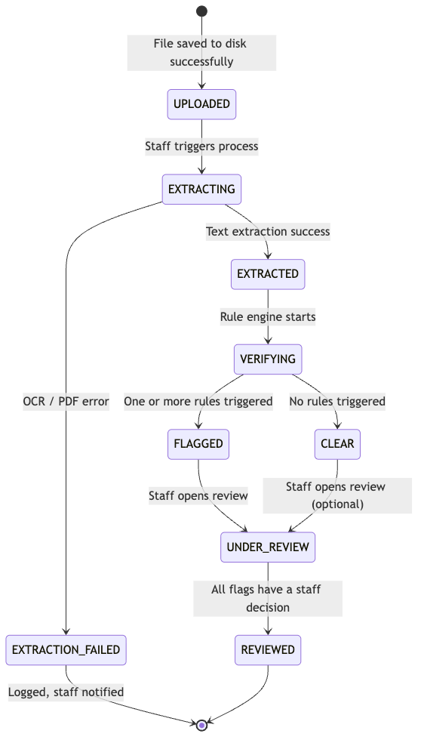
State Diagram 1

4.4 Data Flow Diagram
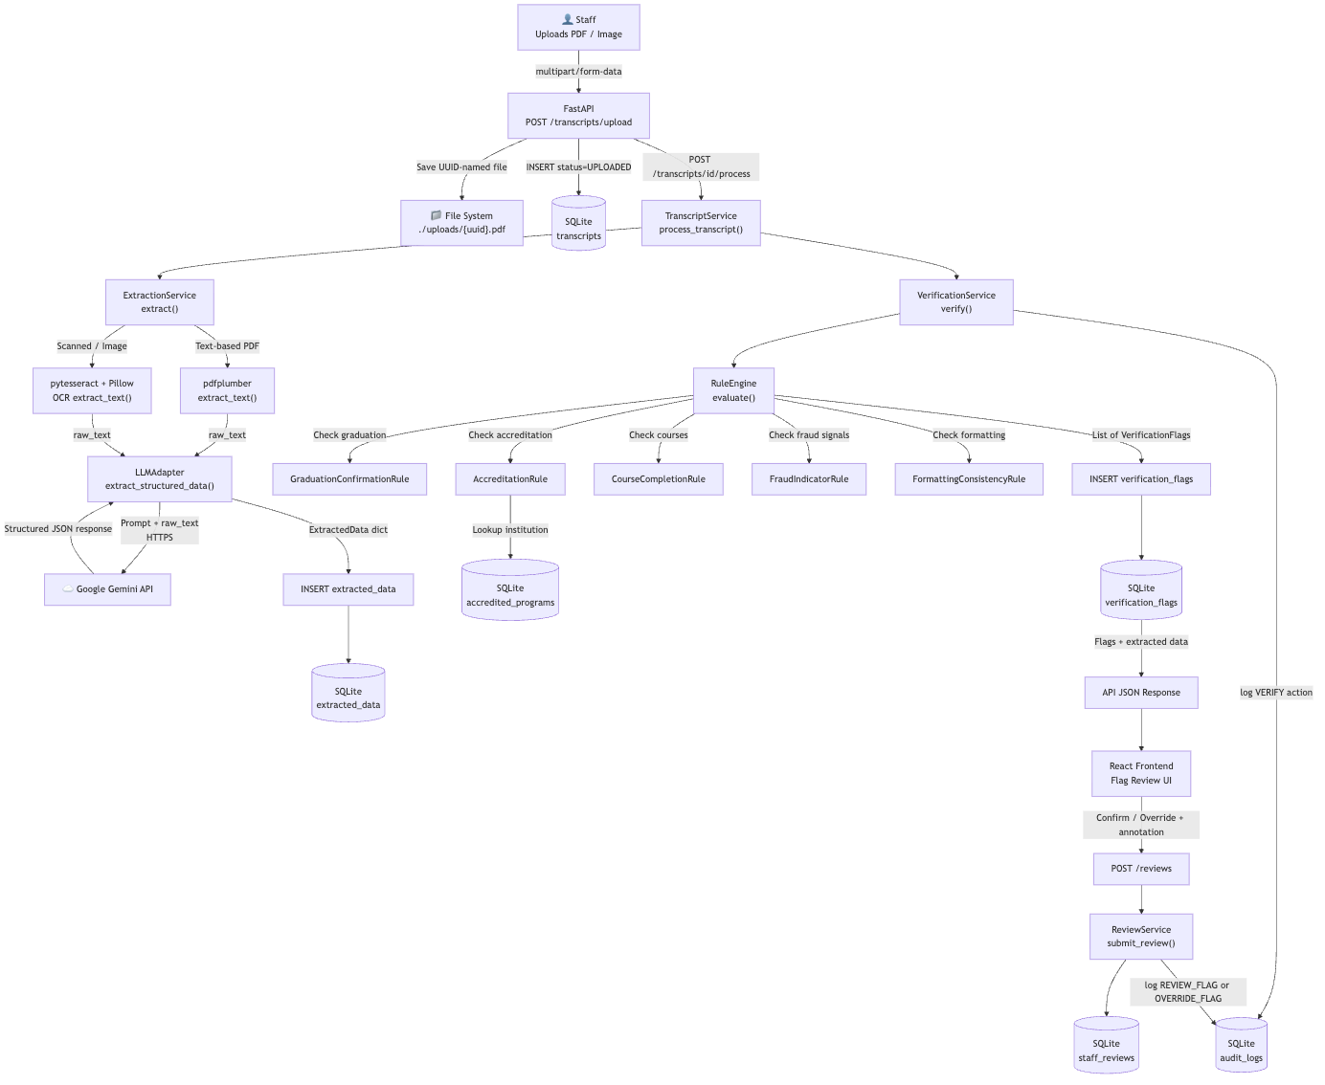
Flowchart 1

5. Component Design

5.1 Class Diagram — Domain Models
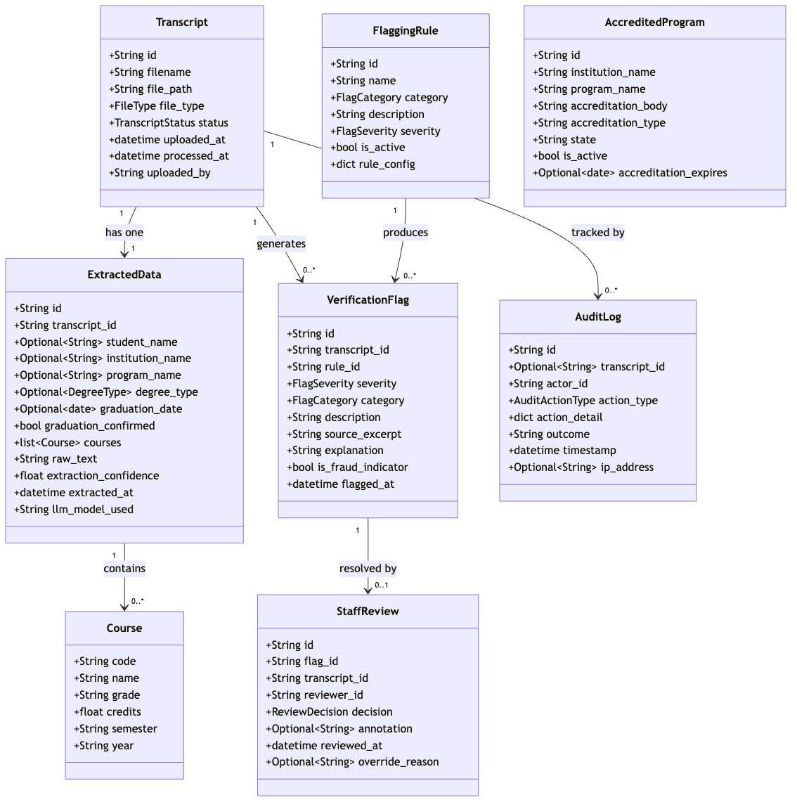
Class Diagram 1

5.2 Class Diagram — Service Layer
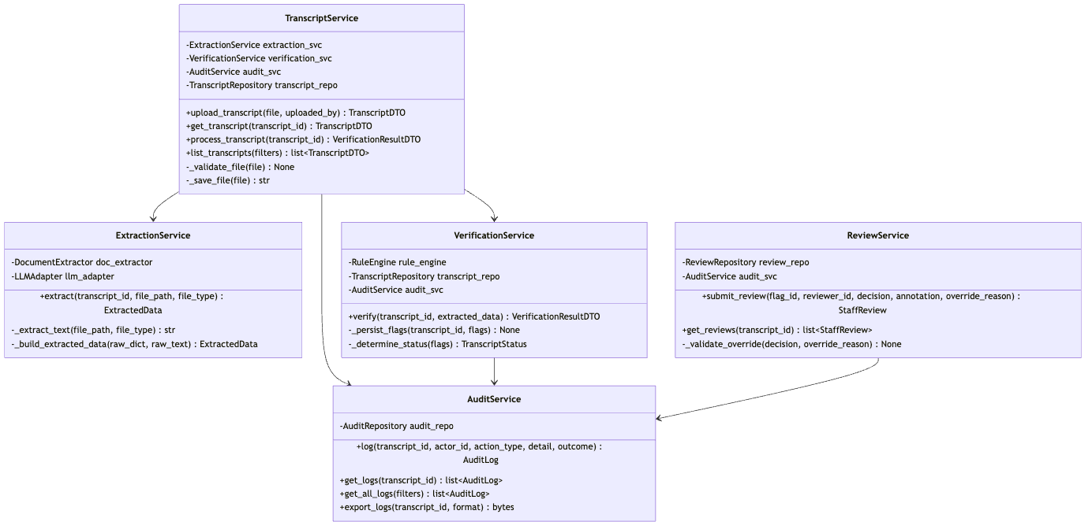
Class Diagram 2

5.3 Class Diagram — Rule Engine
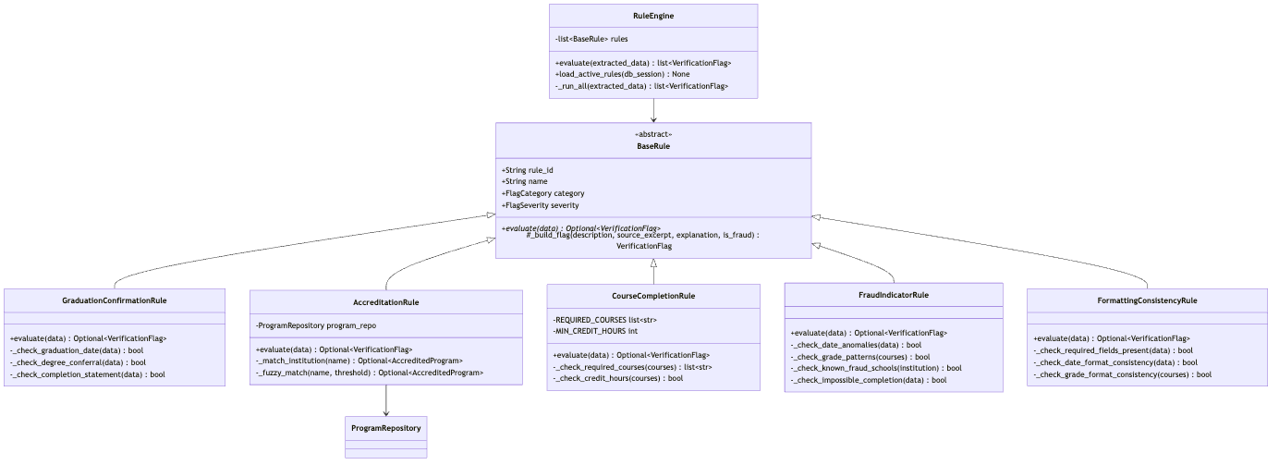
Class Diagram 3

5.4 Flagging Rules Reference
Rule ID | Name | Category | Severity | Description
GRAD-001 | Missing graduation confirmation | GRADUATION | HIGH | No explicit degree conferral statement found
GRAD-002 | Graduation date absent | GRADUATION | MEDIUM | Graduation date field not present
ACCR-001 | Institution not in MS accredited list | ACCREDITATION | HIGH | School not found in accredited_programs table
ACCR-002 | Accreditation body not recognized | ACCREDITATION | MEDIUM | Body is not ACEN or CCNE
COUR-001 | Required nursing courses not present | COURSE | HIGH | One or more mandatory courses missing from course list
COUR-002 | Insufficient credit hours | COURSE | MEDIUM | Total nursing credits below minimum threshold
FRAU-001 | Program completion time below minimum | FRAUD | HIGH | Duration from enrollment to graduation is physically impossible
FRAU-002 | Suspicious grade distribution | FRAUD | MEDIUM | Abnormal pattern suggesting grade fabrication
FRAU-003 | Institution on fraud watch list | FRAUD | HIGH | School name matches known fraudulent program
FORM-001 | Required transcript fields missing | FORMAT | LOW | Key fields (name, school, program) could not be extracted
FORM-002 | Inconsistent date formatting | FORMAT | LOW | Dates appear in multiple conflicting formats
FORM-003 | Inconsistent grade formatting | FORMAT | LOW | Grade notation changes mid-transcript

5.5 Class Diagram — Infrastructure Layer
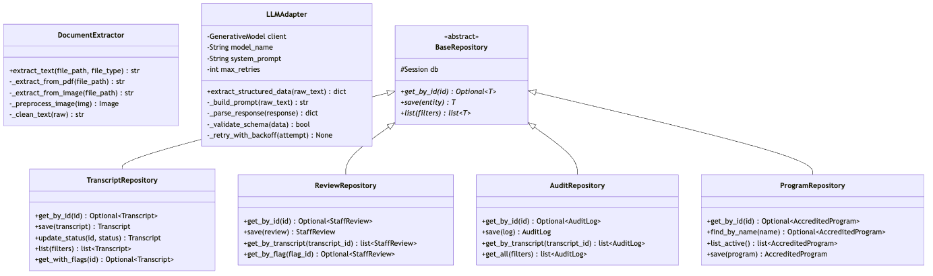
Class Diagram 4
AuditRepository immutability note: The AuditRepository deliberately omits update() and delete() methods. Any attempt to modify audit log records raises OperationNotPermittedError at the repository boundary.

6. Interface Design

6.1 REST API Overview
Base URL: http://localhost:8000/api/v1
Method | Endpoint | Description
POST | /transcripts/upload | Upload a transcript file
POST | /transcripts/{id}/process | Trigger extraction + verification
GET | /transcripts/{id} | Get transcript with extracted data + flags
GET | /transcripts | List all transcripts (paginated, filterable)
POST | /reviews | Submit a staff review decision
GET | /reviews/{transcript_id} | Get all reviews for a transcript
GET | /audit-logs | Get all audit logs (filterable)
GET | /audit-logs/{transcript_id} | Get audit trail for one transcript
GET | /audit-logs/{transcript_id}/export | Export audit trail (CSV or JSON)
GET | /programs | List accredited nursing programs
POST | /programs | Add an accredited program (admin)
GET | /health | System health check
Standard Request Headers:
Header | Required On | Value
X-Staff-ID | All write operations | Staff identifier string
X-Staff-Role | Admin-only endpoints | admin
Content-Type | JSON body requests | application/json
Standard Error Response Shape:
{
"error": {
"code": "ERROR_CODE",
"message": "Human-readable message",
"detail": "Optional technical detail",
"transcript_id": "optional-uuid",
"timestamp": "2026-03-28T14:00:00Z"
}
}

6.2 Endpoint Contracts

POST /transcripts/upload
Upload a transcript file for processing.
Request: multipart/form-data
Field | Type | Required | Description
file | binary | Yes | PDF, PNG, JPEG, or TIFF — max 10MB
uploaded_by | string | Yes | Staff identifier
Response 201 Created:
{
"id": "3fa85f64-5717-4562-b3fc-2c963f66afa6",
"filename": "transcript_jane_doe.pdf",
"status": "UPLOADED",
"uploaded_at": "2026-03-28T14:00:00Z",
"uploaded_by": "staff_dr_burks"
}
Error responses:
Status | Code | Condition
400 | INVALID_FILE_TYPE | File is not PDF / PNG / JPEG / TIFF
413 | FILE_TOO_LARGE | File exceeds 10MB

POST /transcripts/{id}/process
Trigger the extraction and verification pipeline.
Response 202 Accepted:
{
"transcript_id": "3fa85f64-...",
"status": "EXTRACTING",
"message": "Processing pipeline started"
}

GET /transcripts/{id}
Retrieve a transcript with extracted data and all flags.
Response 200 OK:
{
"id": "3fa85f64-...",
"filename": "transcript_jane_doe.pdf",
"status": "FLAGGED",
"uploaded_at": "2026-03-28T14:00:00Z",
"processed_at": "2026-03-28T14:01:32Z",
"extracted_data": {
"student_name": "Jane Doe",
"institution_name": "University of Southern Mississippi",
"program_name": "Bachelor of Science in Nursing",
"degree_type": "BSN",
"graduation_date": "2024-05-15",
"graduation_confirmed": true,
"courses": [
{
"code": "NUR 301",
"name": "Fundamentals of Nursing",
"grade": "A",
"credits": 3.0,
"semester": "Fall",
"year": "2022"
}
],
"extraction_confidence": 0.94,
"extracted_at": "2026-03-28T14:01:05Z"
},
"flags": [
{
"id": "flag-uuid",
"severity": "HIGH",
"category": "FRAUD",
"description": "Program completion time below minimum threshold",
"source_excerpt": "Enrollment: January 2024 | Graduation: May 2024",
"explanation": "Rule FRAU-001: BSN program requires minimum 24 months. Detected completion in approximately 4 months.",
"is_fraud_indicator": true,
"flagged_at": "2026-03-28T14:01:30Z",
"review": null
}
]
}

POST /reviews
Submit a staff review decision on a specific flag.
Request body:
{
"flag_id": "flag-uuid",
"transcript_id": "transcript-uuid",
"reviewer_id": "staff_dr_burks",
"decision": "OVERRIDDEN",
"annotation": "Applicant was in an accelerated BSN bridge program.",
"override_reason": "Accelerated program documentation verified separately."
}
Decision values:
Value | Meaning | override_reason required?
CONFIRMED | Staff agrees with the flag | No
OVERRIDDEN | Staff dismisses the flag | Yes
NEEDS_MORE_INFO | Additional documentation required | No
Response 201 Created:
{
"id": "review-uuid",
"flag_id": "flag-uuid",
"decision": "OVERRIDDEN",
"annotation": "Applicant was in an accelerated BSN bridge program.",
"reviewed_at": "2026-03-28T14:30:00Z"
}
Error responses:
Status | Code | Condition
404 | TRANSCRIPT_NOT_FOUND | Transcript ID doesn’t exist
409 | TRANSCRIPT_NOT_PROCESSED | Transcript not yet verified
409 | FLAG_ALREADY_REVIEWED | Flag already has a staff review
422 | OVERRIDE_REASON_REQUIRED | Decision is OVERRIDDEN but reason is missing

GET /audit-logs/{transcript_id}/export
Query params:
Param | Values | Default
format | csv | json | json
Response: Binary file download — Content-Disposition: attachment; filename="audit_{transcript_id}.{format}"

GET /health
Response 200 OK:
{
"status": "healthy",
"database": "connected",
"llm_api": "reachable",
"version": "1.0.0-poc",
"timestamp": "2026-03-28T14:00:00Z"
}

6.3 Sequence Diagram — Full Transcript Verification Flow
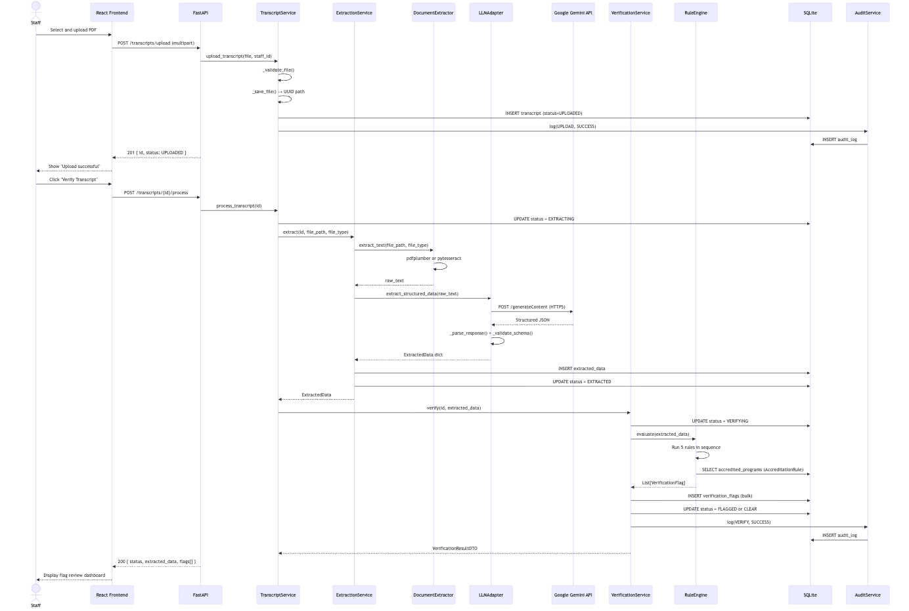
Sequence Diagram 1

6.4 Sequence Diagram — Staff Review Decision
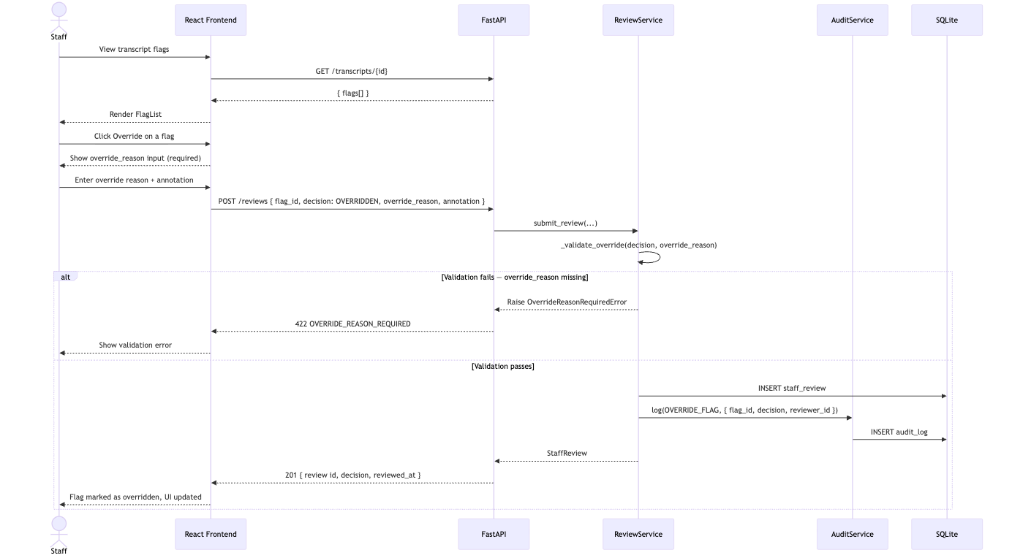
Sequence Diagram 2

6.5 LLM Prompt Design (Google Gemini)
System Instruction:
You are a transcript verification assistant for the Mississippi State Board of Nursing (MSBON).
Your only task is to extract structured information from nursing school transcripts.
Do not infer, guess, or fabricate any information.
If a field cannot be determined from the document, return null for that field.
Return ONLY a valid JSON object — no explanation, no markdown, no code fences.
User Prompt Template:
Extract the following information from this nursing school transcript and return it as JSON.
Required output schema:
{
"student_name": string | null,
"institution_name": string | null,
"program_name": string | null,
"degree_type": "ADN" | "BSN" | "MSN" | "DNP" | "LPN" | "OTHER" | null,
"graduation_date": "YYYY-MM-DD" | null,
"graduation_confirmed": boolean,
"enrollment_date": "YYYY-MM-DD" | null,
"courses": [
{
"code": string | null,
"name": string,
"grade": string,
"credits": number | null,
"semester": string | null,
"year": string | null
}
],
"extraction_notes": string | null
}
Rules:
- graduation_confirmed = true ONLY when an explicit degree conferral or graduation statement is present
- Return dates strictly in ISO 8601 format (YYYY-MM-DD)
- Do not populate courses array with non-nursing courses if easily distinguishable
TRANSCRIPT TEXT:
---
{raw_text}
---

7. Security Design
Phase A note: Authentication and authorization in this section reflect the JWT-based implementation that landed in Phase A of the remediation plan (backend/app/auth/permissions.py, backend/app/api/v1/auth.py, backend/app/api/v1/dependencies.py). The earlier X-Staff-ID / X-Staff-Role header pattern is removed and must not be reintroduced.

7.1 Threat Model (STRIDE)
Category | Threat | Risk Level | Mitigation
Spoofing | Impersonating MSBON staff | HIGH | Stateless JWT (HS256) with server-side secret ≥ 32 bytes; client-supplied identity headers ignored
Tampering | Modifying audit logs after creation | HIGH | AuditRepository.update() and delete() raise OperationNotPermittedError; write-only at repository layer
Repudiation | Staff denying a review action | HIGH | Every review stores reviewer_id (sourced from JWT sub claim, not request body), decision, annotation, override_reason, reviewed_at, and a correlation ID
Info Disclosure | Transcript PII leaked via API response | HIGH | File paths never exposed; no PII in log messages; uploads stored outside web root; audit action_detail references transcript_id only
Info Disclosure | Transcript content sent externally via LLM | MEDIUM | Only synthetic/de-identified data in PoC; all LLM calls over HTTPS to a single allow-listed host
Info Disclosure | API key leak via logs / responses | HIGH | GEMINI_API_KEY and JWT_SECRET read from env only; never logged or returned; redacted in any structured log scrubber
Denial of Service | Upload request flooding | LOW | 10 MB hard size limit at FastAPI; rate limiting deferred to Phase B
Elevation of Privilege | Non-admin accessing program / rule management | MEDIUM | require_permission(Permission.MANAGE_PROGRAMS) dependency on every admin route; permission set sourced exclusively from JWT role claim
Elevation of Privilege | Identity impersonation via request body | MEDIUM | reviewer_id is never read from the request body — always taken from the verified JWT sub claim

7.2 File Upload Security Controls
Control | Implementation
MIME type validation | python-magic reads file magic bytes — not file extension
Cross-validation | Detected MIME must match the claimed extension; mismatch → 422
Filename sanitization | Files saved as {uuid}.{ext} — original filename used for display only
Path traversal prevention | Upload directory is a fixed absolute path; filenames never concatenated raw
Size limit | Enforced at FastAPI middleware before file is written to disk
Storage isolation | ./uploads/ is outside the static file serving root
Retention | Files deleted after FILE_RETENTION_HOURS (default 24 h) via background task

7.3 Authentication and Authorization

7.3.1 JWT Issuance and Verification
Authentication is stateless and JWT-based, implemented with python-jose and HMAC-SHA256.
Element | Value
Algorithm | HS256 (configurable via JWT_ALGORITHM)
Secret | JWT_SECRET env var, minimum 32 bytes; system refuses to start otherwise
Token lifetime | 480 minutes (8-hour shift), configurable via JWT_EXPIRE_MINUTES
Payload | {"sub": "<staff_id>", "role": "admin\|reviewer\|viewer", "exp": <unix-ts>}
Issued by | POST /api/v1/auth/login
Verified by | verify_token dependency in app/api/v1/dependencies.py — applied to every protected route

7.3.2 Role-Based Access Control
# app/auth/permissions.py
ROLE_PERMISSIONS = {
"admin": {MANAGE_PROGRAMS, SUBMIT_REVIEW, VIEW_TRANSCRIPTS,
EXPORT_AUDIT, UPLOAD_TRANSCRIPT},
"reviewer": {SUBMIT_REVIEW, VIEW_TRANSCRIPTS},
"viewer": {VIEW_TRANSCRIPTS},
}
def require_permission(p: Permission) -> Callable:
async def _check(token: dict = Depends(verify_token)) -> None:
if p not in ROLE_PERMISSIONS.get(token.get("role", ""), set()):
raise HTTPException(status_code=403, detail={"error": {...}})
return _check
Routes declare their required permission as a FastAPI dependency, e.g.:
@router.post("/transcripts", dependencies=[Depends(require_permission(Permission.UPLOAD_TRANSCRIPT))])

7.3.3 Login + Authenticated Request Flow
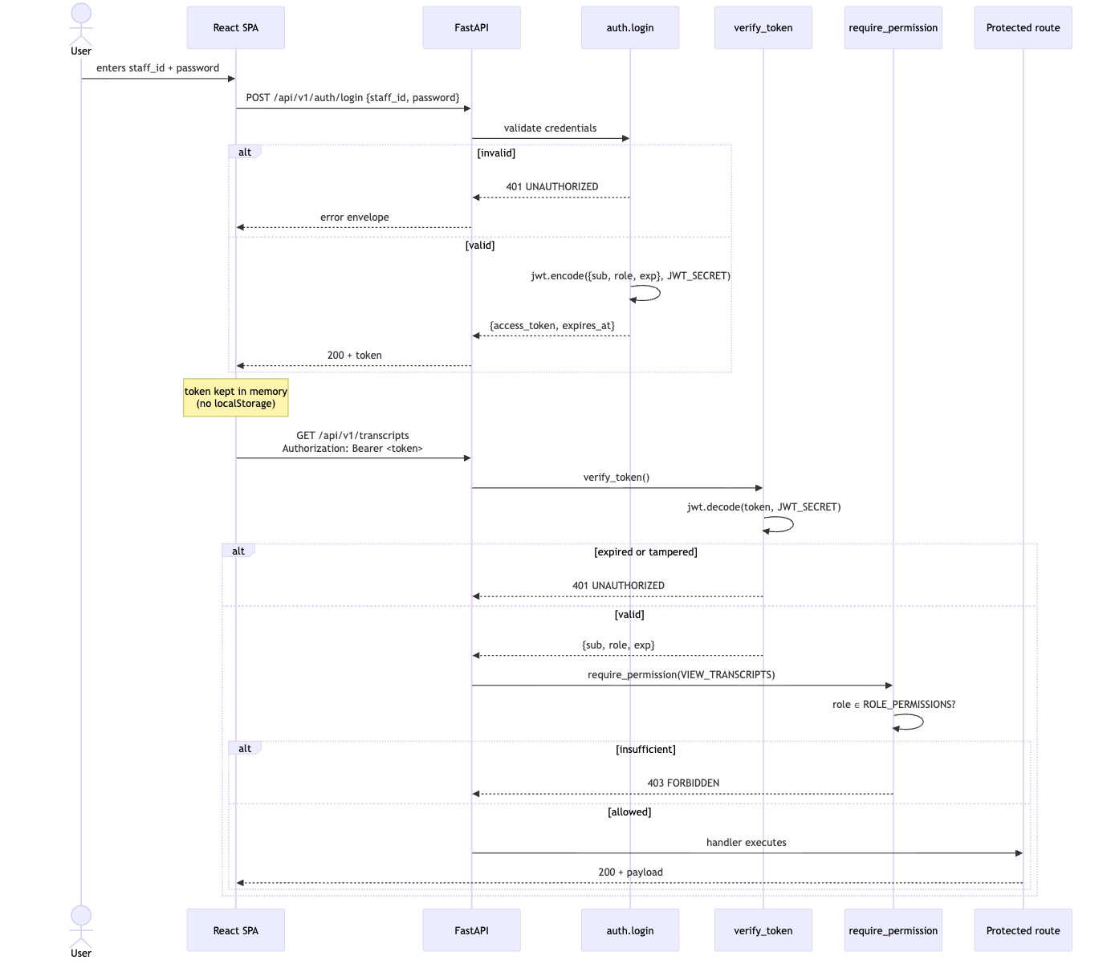
Sequence Diagram 3

7.4 CORS Configuration
# app/main.py — current implementation
app.add_middleware(
CORSMiddleware,
allow_origins=settings.cors_origins_list, # env: CORS_ORIGINS, comma-separated
allow_methods=["GET", "POST"],
allow_headers=["Authorization", "Content-Type"],
)
X-Staff-ID and X-Staff-Role are intentionally not in allow_headers — they are no longer trusted inputs.

7.5 Observability and Audit Hardening
Control | Detail
Correlation ID | CorrelationIDMiddleware sets/propagates X-Correlation-ID; included in every log line and audit row
Structured logging | app/logging_config.py configures python-json-logger; all logs are JSON Lines for ingestion by SIEM
Request log | RequestLoggingMiddleware records method, path, status, duration, correlation_id, actor_id (if auth’d) — no body, no headers
Audit append-only | AuditRepository.update() / .delete() raise OperationNotPermittedError
Sentry | Optional SENTRY_DSN; PII scrubbing rules deny Authorization, Cookie, password keys

7.6 Data Privacy Controls
Control | Detail
No live data | Only synthetic / de-identified transcripts used during PoC
Log sanitization | Log messages reference transcript_id only — never student name or PII
LLM transmission | Transcript text sent to Google Gemini over HTTPS only; outbound host allow-listed
Audit detail scrubbing | AuditLog.action_detail JSON omits raw transcript text; references transcript_id for joins
Temp file cleanup | Uploaded files deleted after FILE_RETENTION_HOURS (default 24 h) via background task
Field-level encryption | Reserved for Phase B (DB-010) — not in PoC scope

8. Error Handling & Resilience

8.1 Error Code Reference
Code | HTTP Status | Trigger Condition
INVALID_FILE_TYPE | 400 | File is not PDF / PNG / JPEG / TIFF
FILE_TOO_LARGE | 413 | File exceeds 10MB
TRANSCRIPT_NOT_FOUND | 404 | Transcript ID does not exist
TRANSCRIPT_NOT_PROCESSED | 409 | Attempting to review a transcript not yet verified
FLAG_ALREADY_REVIEWED | 409 | A review already exists for this flag
EXTRACTION_FAILED | 500 | OCR / pdfplumber returned empty text after all attempts
LLM_UNAVAILABLE | 503 | Gemini API unreachable after 3 retries
LLM_PARSE_ERROR | 500 | Gemini returned non-JSON or schema-invalid response
OVERRIDE_REASON_REQUIRED | 422 | Decision is OVERRIDDEN but override_reason is missing
VALIDATION_ERROR | 422 | Pydantic request body validation failure

8.2 LLM Retry and Resilience Strategy
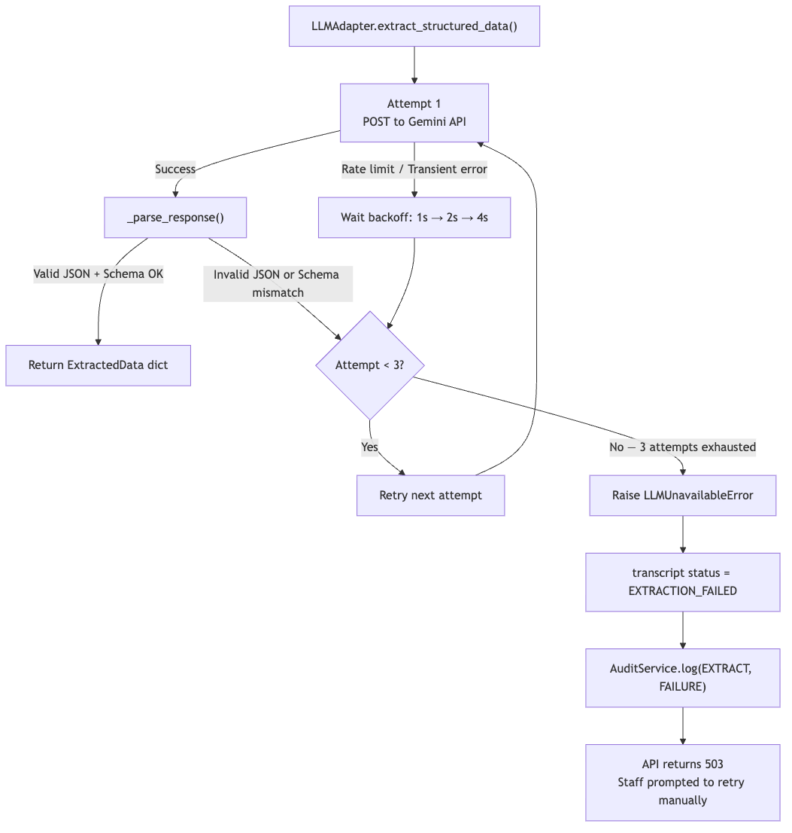
Flowchart 2

8.3 Global Exception Handler
@app.exception_handler(MSBONBaseException)
async def msbon_exception_handler(request: Request, exc: MSBONBaseException):
return JSONResponse(
status_code=exc.http_status,
content={
"error": {
"code": exc.code,
"message": exc.message,
"detail": exc.detail,
"timestamp": datetime.utcnow().isoformat() + "Z",
}
},
)
All custom exceptions (InvalidFileTypeError, ExtractionFailedError, LLMUnavailableError, etc.) inherit from MSBONBaseException and declare their own http_status, code, and default message.

9. Testing Strategy

9.1 Test Pyramid
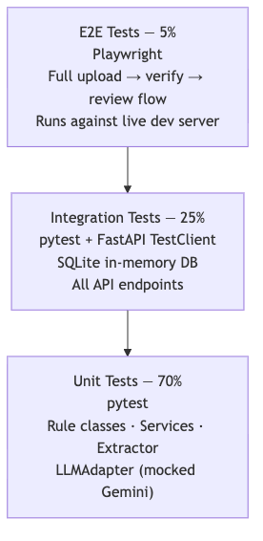
Graph 7

9.2 Unit Test Coverage Targets
Module | Key Test Cases
GraduationConfirmationRule | graduation_confirmed=True (pass), False (flag), graduation_date=null (flag)
AccreditationRule | Exact name match, fuzzy match within threshold, no match, inactive program
CourseCompletionRule | All required courses present, one missing, credit hours below threshold
FraudIndicatorRule | BSN completed in 2 months (flag), normal timeline (pass), known fraud school (flag)
FormattingConsistencyRule | All fields present (pass), student_name null (flag), mixed date formats (flag)
DocumentExtractor | Valid text PDF, valid image (mocked tesseract), empty PDF (raises)
LLMAdapter | Success on attempt 1, success on attempt 2 (retry), all 3 fail, bad JSON
ReviewService | Valid CONFIRMED, valid OVERRIDDEN with reason, OVERRIDDEN without reason (422)
AuditService | Log creates entry, get_by_transcript returns all entries, no update allowed

9.3 Integration Test Scenarios
Test Scenario | Expected Outcome
Upload valid PDF → process → all rules pass | status=CLEAR, flags=[]
Upload transcript, missing graduation confirmation | status=FLAGGED, GRAD-001 present
Upload transcript from unaccredited school | status=FLAGGED, ACCR-001 present
Submit OVERRIDDEN review without override_reason | 422 OVERRIDE_REASON_REQUIRED
Submit valid review → check audit log | Audit entry with action_type=REVIEW_FLAG
Upload file > 10MB | 413 FILE_TOO_LARGE
Upload .exe disguised as .pdf | 400 INVALID_FILE_TYPE
GET /audit-logs/{id}/export?format=csv | Returns valid CSV binary
GET /health when DB connected | { "status": "healthy", "database": "connected" }

9.4 Synthetic Test Transcript Inventory
Transcript ID | Description | Expected Flags
TEST-CLEAN-BSN | Valid BSN — all fields complete, ACEN-accredited school | None
TEST-CLEAN-ADN | Valid ADN — all fields complete, CCNE-accredited school | None
TEST-NO-GRAD | Transcript without graduation/degree conferral statement | GRAD-001
TEST-NO-DATE | Graduation date field absent | GRAD-002
TEST-PARTIAL | Incomplete program, missing required nursing courses | COUR-001
TEST-FAST-COMPLETE | BSN granted 3 months after enrollment | FRAU-001
TEST-UNKNOWN-SCHOOL | Institution not in accredited_programs table | ACCR-001
TEST-FRAUD-SCHOOL | Institution matches known fraudulent program name | FRAU-003
TEST-SCANNED | Low-quality scanned image transcript | Depends on OCR quality
TEST-FORMAT-BAD | Mixed date formats, missing credit hour fields | FORM-001, FORM-002

9.5 Acceptance Criteria (from Scope Document)
Criterion | Target | How Measured
Flag detection accuracy | ≥ 90% | Against synthetic test set
Flag explainability | 100% | Every flag has: rule ID + source excerpt + explanation
Audit completeness | 100% | Every state change produces an audit_log entry
Override traceability | 100% | Every OVERRIDDEN decision has a stored override_reason
No automated decisions | 100% | No endpoint approves or denies licensure
Staff usability | Positive feedback | Qualitative review with Dr. Burks, Dr. Smith, Talisha Greenlaw

10. Non-Functional Requirements
Category | Requirement | Target | Notes
Performance | Upload response time | < 2 seconds | File save + DB insert
Performance | End-to-end verification | < 30 seconds | OCR + LLM + rules
Performance | Review submit response | < 1 second | DB insert only
Accuracy | Flag detection rate | ≥ 90% | Against synthetic test set
Explainability | Flags with full explanation | 100% | Scope requirement
Auditability | Actions logged | 100% | Zero unlogged state changes
Security | File size limit | 10 MB | Enforced at API middleware
Security | Accepted file types | PDF, PNG, JPEG, TIFF | Validated by magic bytes
Privacy | Temp file retention | ≤ 24 hours | Configurable via FILE_RETENTION_HOURS
Compatibility | Browser support | Chrome 120+, Firefox 120+, Edge 120+
Runtime | Python version | 3.11+
Runtime | Node.js version | 18+

11. Appendix

11.1 Project Directory Structure
msbon-app/
├── backend/
│ ├── app/
│ │ ├── __init__.py
│ │ ├── main.py # FastAPI app factory, CORS, routers
│ │ ├── config.py # pydantic-settings — loads .env
│ │ ├── database.py # SQLAlchemy engine + session dependency
│ │ │
│ │ ├── api/
│ │ │ └── v1/
│ │ │ ├── __init__.py
│ │ │ ├── transcripts.py
│ │ │ ├── reviews.py
│ │ │ ├── audit.py
│ │ │ ├── programs.py
│ │ │ └── health.py
│ │ │
│ │ ├── services/
│ │ │ ├── transcript_service.py
│ │ │ ├── extraction_service.py
│ │ │ ├── verification_service.py
│ │ │ ├── review_service.py
│ │ │ └── audit_service.py
│ │ │
│ │ ├── domain/
│ │ │ ├── rule_engine.py
│ │ │ └── rules/
│ │ │ ├── __init__.py
│ │ │ ├── base_rule.py
│ │ │ ├── graduation_rule.py
│ │ │ ├── accreditation_rule.py
│ │ │ ├── course_completion_rule.py
│ │ │ ├── fraud_indicator_rule.py
│ │ │ └── formatting_rule.py
│ │ │
│ │ ├── infrastructure/
│ │ │ ├── document_extractor.py
│ │ │ └── llm_adapter.py
│ │ │
│ │ ├── models/
│ │ │ ├── orm/
│ │ │ │ ├── __init__.py
│ │ │ │ ├── transcript.py
│ │ │ │ ├── extracted_data.py
│ │ │ │ ├── verification_flag.py
│ │ │ │ ├── staff_review.py
│ │ │ │ ├── audit_log.py
│ │ │ │ ├── flagging_rule.py
│ │ │ │ └── accredited_program.py
│ │ │ └── schemas/
│ │ │ ├── transcript.py
│ │ │ ├── review.py
│ │ │ ├── audit.py
│ │ │ └── program.py
│ │ │
│ │ └── repositories/
│ │ ├── base_repository.py
│ │ ├── transcript_repository.py
│ │ ├── review_repository.py
│ │ ├── audit_repository.py
│ │ └── program_repository.py
│ │
│ ├── migrations/
│ │ ├── env.py
│ │ └── versions/
│ │
│ ├── tests/
│ │ ├── unit/
│ │ │ ├── test_rules.py
│ │ │ ├── test_services.py
│ │ │ ├── test_extractor.py
│ │ │ └── test_llm_adapter.py
│ │ ├── integration/
│ │ │ ├── test_transcripts_api.py
│ │ │ ├── test_reviews_api.py
│ │ │ └── test_audit_api.py
│ │ └── fixtures/
│ │ ├── synthetic_transcripts/
│ │ └── conftest.py
│ │
│ ├── data/ # gitignored — SQLite DB file
│ ├── uploads/ # gitignored — temp transcript storage
│ ├── logs/ # gitignored — app log files
│ ├── requirements.txt
│ ├── requirements-dev.txt
│ ├── alembic.ini
│ └── .env.example
│
├── frontend/
│ ├── src/
│ │ ├── pages/
│ │ │ ├── UploadPage.tsx
│ │ │ ├── TranscriptListPage.tsx
│ │ │ ├── VerificationPage.tsx
│ │ │ ├── AuditLogPage.tsx
│ │ │ └── ProgramsPage.tsx
│ │ ├── components/
│ │ │ ├── upload/
│ │ │ │ ├── FileDropzone.tsx
│ │ │ │ └── UploadProgressBar.tsx
│ │ │ ├── verification/
│ │ │ │ ├── TranscriptSummary.tsx
│ │ │ │ ├── FlagList.tsx
│ │ │ │ ├── FlagItem.tsx
│ │ │ │ └── RuleExplanation.tsx
│ │ │ ├── review/
│ │ │ │ ├── ReviewForm.tsx
│ │ │ │ ├── DecisionButtons.tsx
│ │ │ │ └── AnnotationInput.tsx
│ │ │ └── audit/
│ │ │ ├── AuditLogTable.tsx
│ │ │ ├── AuditLogFilters.tsx
│ │ │ └── ExportButton.tsx
│ │ ├── services/
│ │ │ ├── transcriptClient.ts
│ │ │ ├── reviewClient.ts
│ │ │ └── auditClient.ts
│ │ ├── store/
│ │ │ └── uiStore.ts
│ │ ├── types/
│ │ │ └── index.ts
│ │ ├── App.tsx
│ │ └── main.tsx
│ ├── package.json
│ ├── vite.config.ts # Proxy /api → localhost:8000
│ └── tsconfig.json
│
├── docs/
│ └── Software_Design_Document.md
└── README.md

11.2 Environment Variables
backend/.env:
# Google Gemini
GEMINI_API_KEY=AIza...
GEMINI_MODEL=gemini-2.0-flash
# Database
DATABASE_URL=sqlite:///./data/msbon.db
# File storage
UPLOAD_DIR=./uploads
MAX_FILE_SIZE_MB=10
FILE_RETENTION_HOURS=24
# App
LOG_LEVEL=INFO
CORS_ORIGINS=http://localhost:5173
APP_VERSION=1.0.0-poc
frontend/.env:
VITE_API_BASE_URL=http://localhost:8000/api/v1

11.3 Backend Dependency Manifest
requirements.txt:
fastapi==0.110.0
uvicorn[standard]==0.27.0
sqlalchemy==2.0.29
alembic==1.13.1
pydantic==2.6.4
pydantic-settings==2.2.1
google-generativeai==0.5.0
pdfplumber==0.11.0
pytesseract==0.3.10
Pillow==10.3.0
python-multipart==0.0.9
python-magic==0.4.27
requirements-dev.txt:
pytest==8.1.1
httpx==0.27.0
pytest-asyncio==0.23.6
faker==24.3.0

11.4 Frontend Dependency Manifest
Package | Version | Purpose
react | ^18.3.0 | UI framework
react-dom | ^18.3.0 | DOM rendering
react-router-dom | ^6.22.3 | SPA routing
@tanstack/react-query | ^5.28.0 | Server state management + caching
zustand | ^4.5.2 | Client UI state
axios | ^1.6.8 | HTTP client for API calls
tailwindcss | ^3.4.0 | Utility-first CSS
typescript | ^5.4.0 | Type safety
vite | ^5.2.0 | Build tool + dev server
@vitejs/plugin-react | ^4.2.0 | React Fast Refresh

11.5 Flagging Rules Seed Data
The following 12 records are inserted into flagging_rules at database initialization:
rule_id | name | category | severity | is_active
GRAD-001 | Missing graduation confirmation | GRADUATION | HIGH | true
GRAD-002 | Graduation date absent | GRADUATION | MEDIUM | true
ACCR-001 | Institution not in MS accredited list | ACCREDITATION | HIGH | true
ACCR-002 | Accreditation body not recognized | ACCREDITATION | MEDIUM | true
COUR-001 | Required nursing courses not present | COURSE | HIGH | true
COUR-002 | Insufficient credit hours | COURSE | MEDIUM | true
FRAU-001 | Program completion time below minimum | FRAUD | HIGH | true
FRAU-002 | Suspicious grade distribution | FRAUD | MEDIUM | true
FRAU-003 | Institution on fraud watch list | FRAUD | HIGH | true
FORM-001 | Required transcript fields missing | FORMAT | LOW | true
FORM-002 | Inconsistent date formatting | FORMAT | LOW | true
FORM-003 | Inconsistent grade formatting | FORMAT | LOW | true

