Лабораторная работа №1.
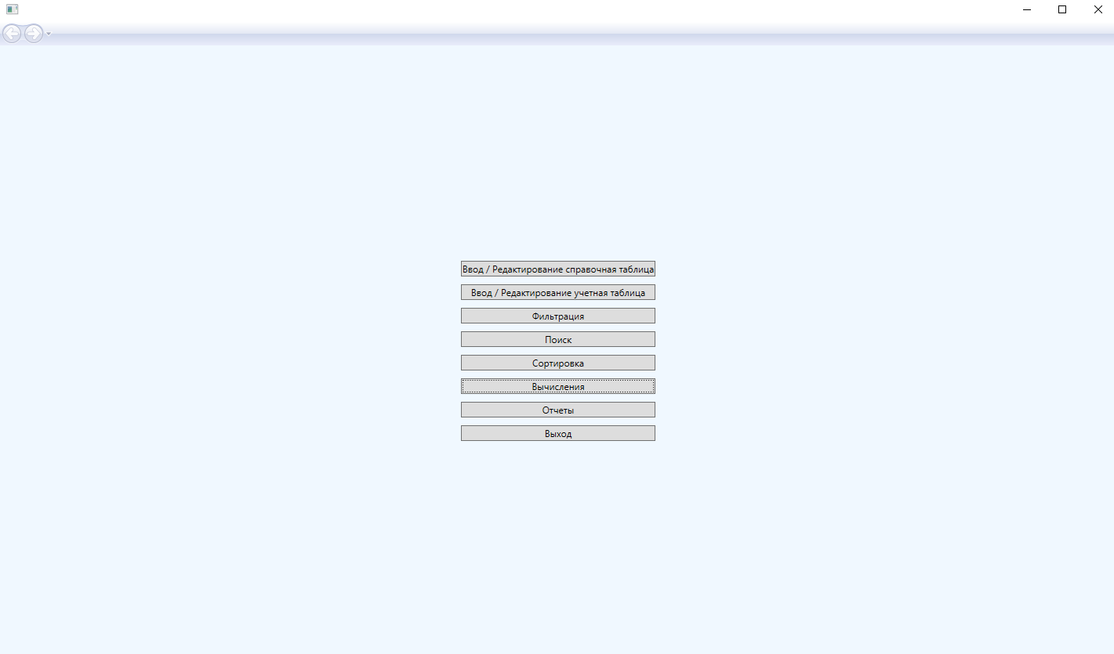
<Page x:Class="lb1Kon.Pages.MainPage"
xmlns="http://schemas.microsoft.com/winfx/2006/xaml/presentation"
xmlns:x="http://schemas.microsoft.com/winfx/2006/xaml"
xmlns:mc="http://schemas.openxmlformats.org/markup-compatibility/2006"
xmlns:d="http://schemas.microsoft.com/expression/blend/2008"
xmlns:local="clr-namespace:lb1Kon.Pages"
mc:Ignorable="d"
d:DesignHeight="450" d:DesignWidth="800"
Title="MainPage"
Background="AliceBlue">

<Grid>
<StackPanel HorizontalAlignment="Center" VerticalAlignment="Center">
<Button Content="Ввод / Редактирование справочная таблица" Margin="5"/>
<Button Content="Ввод / Редактирование учетная таблица" Margin="5"/>
<Button Content="Фильтрация" Margin="5"/>
<Button Content="Поиск" Margin="5"/>
<Button Content="Сортировка" Margin="5"/>
<Button Content="Вычисления" Margin="5"/>
<Button Content="Отчеты" Margin="5"/>
<Button Content="Выход" Margin="5"/>
</StackPanel>

</Grid>
</Page>

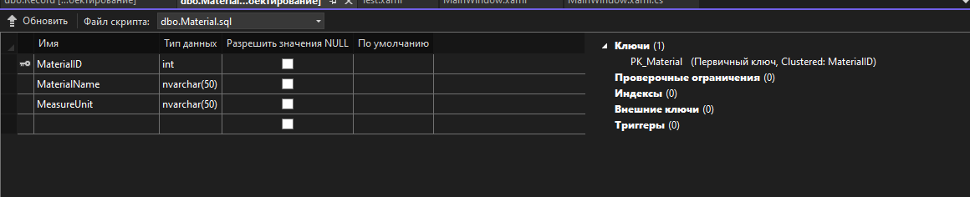
CREATE TABLE [dbo].[Material] (
[MaterialID] INT IDENTITY (1, 1) NOT NULL,
[MaterialName] NVARCHAR (50) NOT NULL,
[MeasureUnit] NVARCHAR (50) NOT NULL,
CONSTRAINT [PK_Material] PRIMARY KEY CLUSTERED ([MaterialID] ASC)
);

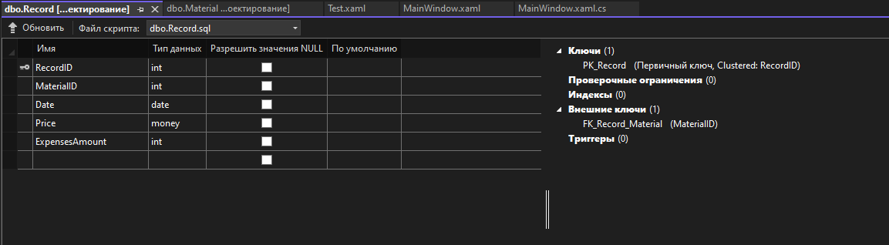
CREATE TABLE [dbo].[Record] (
[RecordID] INT IDENTITY (1, 1) NOT NULL,
[MaterialID] INT NOT NULL,
[Date] DATE NOT NULL,
[Price] MONEY NOT NULL,
[ExpensesAmount] INT NOT NULL,
CONSTRAINT [PK_Record] PRIMARY KEY CLUSTERED ([RecordID] ASC),
CONSTRAINT [FK_Record_Material] FOREIGN KEY ([MaterialID]) REFERENCES [dbo].[Material] ([MaterialID])
);

