KshetraAI
Field Intelligence
AI-Guided Field Force Intelligence System
Track 2, Syngenta x IITM Hackathon 2026
Complete Technical Documentation
Right Rep. Right Retailer. Right Time.

Contents
1. Project Summary
2. Problem Statement
3. Data Foundation
4. System Architecture
5. Feature Engineering
6. Machine Learning Pipeline
7. Route Optimiser
8. Anomaly Detection: CHETAVANI
9. Feedback Loop: SEEKHO
10. Results and Validation
11. Engineering Changes in This Version
12. Limitations
13. Deployment Roadmap
14. File Reference

1. Project Summary
KshetraAI is an AI co-pilot for the Syngenta India field sales force. It tells each field representative which retailers to visit, in what order, what product to pitch, and the reasoning behind every recommendation. The name comes from the Sanskrit word for field.
The system covers 500 field representatives, 4,000 retail outlets, and the full Rabi 2025-26 season across 10 states and 33 districts. The core problem it addresses is the gap between a representative's limited working hours and the constantly shifting agronomic reality of a large territory. A static beat plan cannot respond to inventory depletion, pest pressure, weather change, or shifting grower demand. KshetraAI ranks retailers daily on nine real data signals so the representative spends the day where a productive conversation is most likely.

2. Problem Statement
Syngenta field operations face four structural inefficiencies that this system targets directly.
- Static routing. Representatives follow habitual beat plans that do not change with inventory, crop stage, or weather.
- No inventory visibility. Representatives visit fully stocked retailers while outlets short on critical SKUs go unserviced, and the 10-day spray window closes.
- Reactive pest response. Field response arrives after the spray window has passed, and a faster competitor captures the sale.
- No learning loop. Visit logs are filed as compliance records, with no mechanism connecting field activity to actual sell-out outcomes.

3. Data Foundation
All data covers the Rabi 2025-26 season, from October 2025 to April 2026.

3.1 Internal Dataset
File | Rows | Description
retailers.csv | 4,000 | Outlet locations across 500 territories
reps_territory.csv | 500 | Representative to territory assignments
retailer_visit_log.csv | 30,000 | Historical visits with products promoted
retailer_inventory_weekly.csv | 310,544 | Weekly SKU stock snapshots per retailer
retailer_pos.csv | 235,042 | Point of sale transactions with product and price
growers.csv | 6,000 | Grower profiles with crop calendars
digital_funnel_weekly.csv | 104 | Campaign digital performance metrics
whatsapp_campaign.csv | 4,479 | WhatsApp delivery, open and click data per grower

3.2 External Data Sources
Open-Meteo API supplies historical weather for all 33 districts: temperature, humidity, and rainfall. It is free and needs no key. The fetch now retries with backoff and caches to disk so the pipeline runs even when the network is down.
The NDVI signal is a proxy, stated plainly. Satellite imagery from MODIS or Sentinel was attempted and was not reliably available in this environment, so crop health is estimated from crop stage and humidity. It is labelled a proxy everywhere it appears and carries the smallest weight in the scorer.
The crop calendar combines public government Rabi stage timings with the calendar JSON embedded in growers.csv, covering wheat, mustard, chickpea, potato, barley, and lentil.

3.3 Data Quality
Seven of the eight files have zero missing values. The eighth, growers.csv, carries 13,020 missing values across three fields. The product name field is empty for growers who did not scan a product, which is expected and not an error. Farm size is missing for 12.4 percent of rows and is imputed with the median, with a companion flag kept so the model can tell. The crop calendar is empty for 450 growers, and the JSON parser now logs exactly how many rows fail rather than silently returning an empty value. All 500 territories and 4,000 retailers join cleanly with no orphan records.

4. System Architecture
The system runs as a single pipeline with clearly separated modules rather than five monolithic notebooks. The five layers, and the modules within each, are shown in the diagram below.
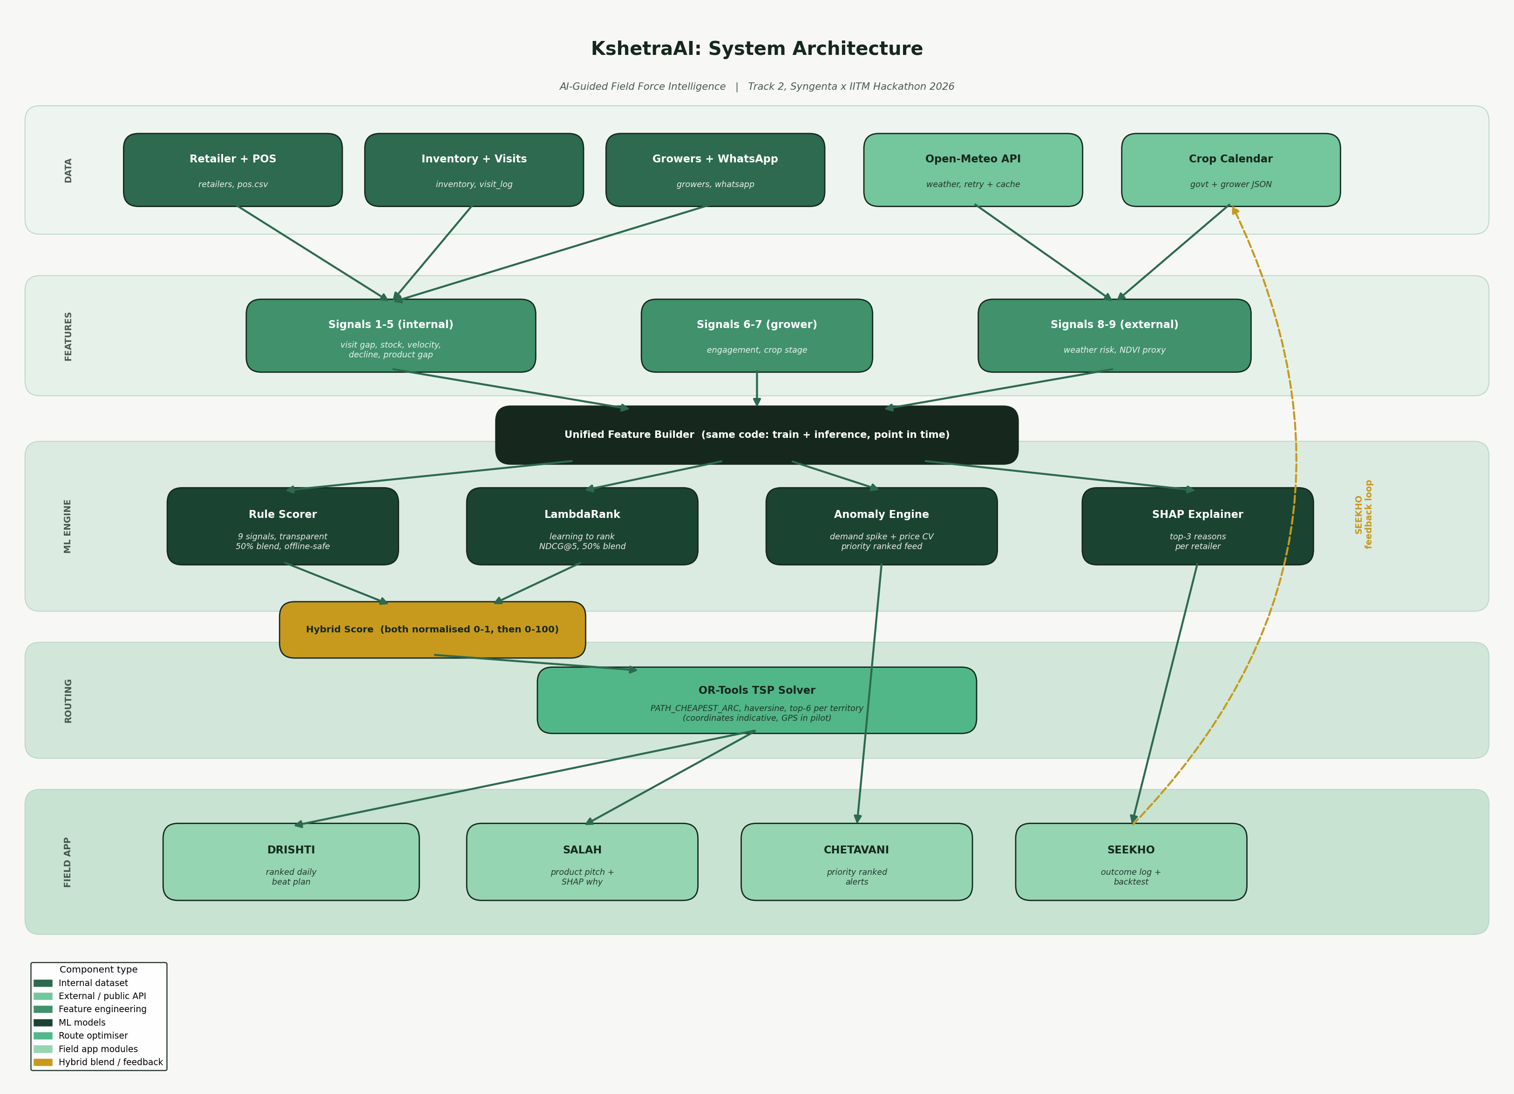
Figure 1. KshetraAI five-layer architecture with the SEEKHO feedback loop.
The data layer joins internal CSVs with the weather API and the crop calendar. The feature layer builds nine signals through one shared builder used by both training and inference. The ML engine runs the rule scorer, the LambdaRank ranker, the anomaly engine, and the SHAP explainer. The route optimiser sequences the top retailers per territory. The field app surfaces the beat plan, the pitch advice, the alerts, and the outcome loop.

5. Feature Engineering
Nine signals are engineered per retailer, each scaled to a 0 to 1 range. Every signal takes an as-of date and reads only data on or before it, which keeps the features point in time and prevents leakage from the future. The same signal functions serve both training and inference, so there is no drift between how the model was trained and how it scores in production.
On granularity, stated honestly: the visit log records activity at territory and tehsil level, not per retailer. The days-since-visit and product-gap signals are therefore tehsil level and shared by retailers in a tehsil. The stock, sales, and decline signals are genuinely per retailer.
Signal | Weight | Basis
Days since last visit | 0.20 | Tehsil level recency from the visit log
Stock urgency | 0.20 | Low stock plus stockout rate, latest snapshot
Sales velocity | 0.15 | Recent four week sales per retailer
Stock decline | 0.15 | Drop in total stock over four weeks
Weather risk | 0.10 | Humidity, rainfall, heat from Open-Meteo
Product gap | 0.10 | Campaign products not yet pitched in the tehsil
Crop stage | 0.05 | Closeness to a sensitive crop stage
Grower engagement | 0.03 | WhatsApp delivery, open, click rates
NDVI proxy | 0.02 | Crop stage and humidity composite (proxy)

The weights are defined in config.py and a runtime check asserts they sum to exactly 1.0. The earlier version shipped weights that summed to 1.05, which quietly inflated every score before it was caught.

6. Machine Learning Pipeline

6.1 Label Construction
No explicit successful-visit label exists in the data, so labels are built from implicit feedback. A visit is labelled successful only if the specific product recommended sells at that retailer within 14 days. This is a deliberate choice. A generic check for any sale within 14 days produced a 95.8 percent success rate, which gave the model almost nothing to learn. Product specific matching reduces this to a realistic 19.1 percent, so the model genuinely measures whether the pitch was acted on.

6.2 Learning to Rank, not Binary Classification
The problem is fundamentally a ranking problem: order the retailers in a representative's day so the ones most likely to convert sit at the top. The model is therefore a LightGBM LambdaRank ranker, grouped by representative and day, evaluated with NDCG at 5. This matches the metric the project reports against. The earlier version trained a binary classifier and then reported it against an NDCG target it never actually computed.

6.3 Honest Evaluation
Three guards are built into every training run. A baseline ranker that orders retailers by recent sales velocity is computed alongside the model, so the headline NDCG always has something honest to beat. Light L1 and L2 regularisation and a higher minimum child sample count reduce the overfitting that a single season of data invites. An expanding window time series cross validation runs across four test months so variance is visible rather than hidden behind a single fold.

6.4 Hybrid Score
The final retailer priority blends the rule score and the model score. Both are scaled to a common 0 to 1 range before blending, so the stated 50-50 split actually holds. In the earlier code the rule score sat on a 0 to 0.6 range while the model score was a 0 to 1 probability, so the blend was dominated by the model without anyone intending it. The rule score is also no longer fed into the model as a feature and then added again at blend time, which removes a circular double counting. The blended score is then spread across the full 0 to 100 range so the urgent, important, and monitor tiers separate clearly.

6.5 Explainability
SHAP values are computed for every retailer through a single reusable function. Each recommendation carries its top three contributing signals translated into plain language, and one signal that is holding the score back. The representative never sees a black box.

7. Route Optimiser
The top six retailers per territory, ranked by final score, are passed to the Google OR-Tools travelling salesman solver to find the shortest visiting sequence. Distance is the haversine great circle distance in kilometres, and the solver uses the path cheapest arc strategy with a five second time limit.
The honest caveat, stated here and in the code, is that retailer coordinates are approximated from the district centre plus a small systematic offset per tehsil. They are not GPS readings, so the distances are indicative. Real retailer coordinates from the field CRM would replace these in a pilot, after which the same solver runs unchanged.

8. Anomaly Detection: CHETAVANI
CHETAVANI flags two kinds of anomaly and returns them as a single priority ordered feed rather than a flat list of hundreds.
Demand spikes compare a recent weekly sales rate against the trailing weekly rate. Both sides are weekly rates, so a 3x flag means the recent weekly rate is three times the baseline weekly rate. This corrects a real bug in the earlier version, which compared a monthly sales total against a per-day historical average. That was a units mismatch, a month against a day, and it flagged nearly 90 percent of all retailers. Raising the threshold from 2x to 3x would not have fixed it, because the ratio itself was malformed. The fix is matching units on both sides.
Price anomalies flag retailer and SKU combinations whose price varies more than 50 percent around its own mean, measured by coefficient of variation. A real example from the data is retailer RTL_03909 selling Vertimec 1.8 EC across a range from about 382 to 2,136 rupees, a coefficient of variation near 0.70.

9. Feedback Loop: SEEKHO
SEEKHO was described in the earlier architecture but had no implementation. It is now real. Each time a representative closes a visit, the outcome is appended to a log with a fixed schema: timestamp, representative, retailer, product pitched, recommended rank, whether a sale was made, and notes. The schema is the contract that lets a later retraining job attach outcomes to the features that were shown at recommendation time and refresh the ranker. An acceptance rate function reads this log to report how often representatives act on the recommendation, one of the pilot success metrics.

10. Results and Validation
The pipeline produces a ranked score with SHAP reasons for every retailer, an optimised route per territory, a priority ordered anomaly feed, and a backtest number. The backtest is the figure the project rests on: of the retailers that actually converted in a representative-day, how many the ranking would have placed in the top six. This is the direct measure of whether the system beats habitual routing.
Metric | Definition | Target
NDCG at 5 | Top five ranking accuracy | above 0.80
Recall at 6 | Converters captured in top six (backtest) | report vs BAU
Hit rate | Recommended visit to sale within 14 days | above 70 percent
Revenue per field day | Revenue per representative per day | plus 15 to 20 percent
Acceptance rate | Representative followed the recommendation | above 65 percent
Stockout reduction | Campaign SKU stockouts per month | minus 30 percent

Validation runs in three phases: backtesting on October to January data against February to April actuals, a four week shadow mode pilot in two territories, and an eight week A/B test across 20 AI guided territories versus 20 run as usual.

11. Engineering Changes in This Version
This version addresses the issues found in a full engineering review of the original notebooks. The substantive corrections are listed below.
- Demand spike unit mismatch fixed by comparing weekly rate against weekly rate.
- Train and inference now use one shared feature builder, removing feature drift.
- Circular leakage removed: the rule score is no longer both a model feature and a blend term.
- Both scores normalised to a common scale before blending, so the split is real.
- Model changed from binary classifier to LambdaRank, so NDCG at 5 is actually computed.
- Baseline ranker, regularisation, and time series cross validation added for honest evaluation.
- Reference date moved to mid-January so the crop stage signal reflects peak season.
- Serving functions added so a live beat plan can be produced on demand.
- SEEKHO outcome loop and a backtest against actual representative behaviour implemented.
- Magic numbers centralised in config.py; weather fetch given retry and cache; JSON parsing given failure logging; requirements pinned.

12. Limitations
These are stated honestly because they affect production and need planning for in the pilot.
- Single season of data. The model has seen one Rabi season and may overfit patterns specific to it. Two to three seasons are needed for reliable generalisation.
- Territory level signals. Visit gap, product gap, engagement, and crop stage are aggregated at tehsil level because the source data does not allow per retailer attribution.
- NDVI proxy. True plot level satellite NDVI would replace the weather based proxy, which carries the lowest weight for that reason.
- Coordinate accuracy. Tehsil coordinates are approximations, so route distances are indicative until GPS data is available.
- WhatsApp coverage. About a quarter of growers use feature phones and have no engagement data, which lowers their tehsil engagement score by default.
- No competitor data. Spikes driven by competitor stockouts are detected but cannot be attributed to their cause without field investigation.
- Uplift is a proxy. A true causal uplift estimate needs a control group, which this single season data does not contain.

13. Deployment Roadmap
Phase | Timeline | Work
Pipeline | Week 1 to 2 | Automate ingestion, validate all nine signals, add unit tests
Rule baseline | Week 3 to 4 | Rule scorer live on daily data, full backtest complete
ML integration | Week 5 to 6 | LambdaRank and anomaly engine integrated, SHAP validated
Frontend MVP | Week 7 to 8 | Dashboard and offline first mobile, morning sync
Shadow mode | Month 3 | Two territory pilot, recommendations generated not shown
A/B test | Month 6 | Twenty AI territories versus twenty run as usual

14. File Reference
src/config.py all paths, weights, thresholds, district coordinates
requirements.txt pinned dependency versions
run_pipeline.py end to end pipeline entry point
src/data_io.py loading, cleaning, JSON parse with failure logging
src/signals.py nine point in time signal definitions
src/features.py shared train and inference feature builders
src/labels.py product specific labels and experimental uplift proxy
src/scoring.py rule scorer and hybrid blend
src/ranker.py LambdaRank, baseline, cross validation
src/anomaly.py demand spike and price anomaly, priority feed
src/route.py OR-Tools TSP route optimiser
src/explain.py SHAP explanations in plain language
src/feedback.py SEEKHO outcome logging
src/backtest.py recall at k against representative behaviour
src/weather.py Open-Meteo fetch with retry and cache
src/predict.py serving: score retailer, build beat plan
docs/ this document and the architecture diagram
KshetraAI. Right Rep. Right Retailer. Right Time.

