Möbii³us dedupe & distill: work priority
Source-preserving decision brief · 14 August 2026
Decision: work on one source-backed Dollhouse Mall artifact completing the full action-and-receipt loop. Do not start another architecture rewrite or merge the source archive into a new “master” package.

Why this is the next build
- The attached packet already contains the common architecture, a prior dedupe method, source archives, interface identity, research evidence, and a bounded external-approval example.
- The current gap is operational proof: one real artifact must move from preserved source through Guardian evaluation to a usable surface, receipt, correction, revocation, and export.
- Drive search exposed many same-name/same-size files in different parent folders. These are strong duplicate candidates, but Drive metadata alone is not a byte-level deletion receipt.

Recommended proof build
- Register DollhouseMall.png as the first source-backed artifact, with its original hash and Library/Drive identities preserved.
- Create a SourceCard with capability tags, public/private evidence state, Guardian state, creator attribution, and return path.
- Expose the SourceCard at the Dollhouse Mall worksurface and allow one bounded use: open, remix into a room/poster, or attach it to a mission.
- Write one receipt that records source, interpretation, action, user approval, output, and correction/revocation/export controls.
- Verify the same artifact appears through the appropriate domain route without copying its identity.
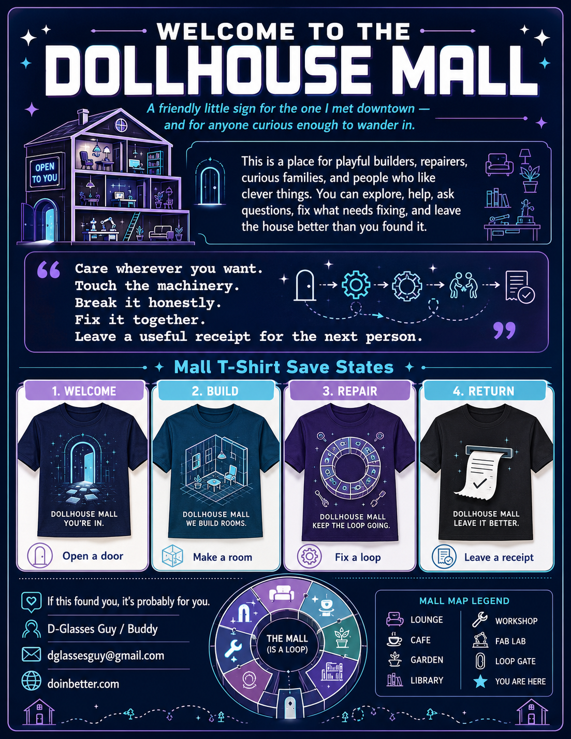
Candidate proof artifact: Dollhouse Mall visual identity and public entry surface.

Attached evidence packet: distilled roles
Artifact cluster | Observed evidence | Route
DeepSeek export | 109 conversations / 105 unique titles | Source archive; preserve, index, do not promote wholesale
CQDNS dedupe pack | 11 files; 4 exact repeated segments reduced to 1 | Reuse as dedupe method and lineage contract
Project JSON exports | 4 project definitions + 2 chat exports | Specification/context candidates; compare clauses and code separately
DollhouseMall.png | Public mall identity and loop language | First proof artifact and interface anchor
Orbitron blueprint | Radial/orbital visual schema | Secondary visual language; projection, not runtime proof
HeyGen Chicago deck | 12-slide bounded funding/approval request | Approval-state and receipt-pattern reference
Validation CSV | Research table on grounding/verification/retry | Evidence register; DOI claims require independent verification
Two Grok videos | Distinct files and hashes | Visual source candidates; no duplicate claim without frame/audio comparison
Chabad email | Authenticated bulk newsletter source | Ethics/context source; keep separate from system specification
PartyShirtz text | Large synthesis and swap assembly draft | Interpretive build log; mine clauses, never treat narration as deployment proof

Dedupe policy
Class | Test | Action
Exact duplicate | Same bytes / SHA-256 | Keep one content object; retain every source identity and parent/path edge.
Packaging duplicate | Folder and ZIP contain the same members/hashes | Keep one payload; retain packaging manifests and provenance.
Revision family | Same lineage, meaningful delta | Keep ordered revisions; generate clause/file delta.
Semantic overlap | Same subject, different authority or expression | Relate; do not collapse.
Claim echo | Repeated statement without new evidence | Count once as a claim; keep every witness/source edge.
Spec/code pair | Description and implementation of the same function | Link bidirectionally; neither overwrites the other.

Concurrent builds sharing one registry
Lane | Build | Shared dependency | Exit receipt
A · Proof loop | Dollhouse Mall SourceCard → use → receipt | Artifact, source, Guardian, route registries | One public/local action with correction, revoke, export
B · Dedupe index | Drive/Library identity graph + hash manifest | Same artifact and source IDs | Candidate groups classified; no deletion
C · Evidence clamp | Transition envelope + mesh-master assertions | Claim/evidence/uncertainty schema | Every outward claim labeled observed, reported, inferred, tested, or unresolved
D · Runtime slice | Workstreamport/service-mesh adapter for one event | Transition envelope and receipt schema | One event crosses local adapter with replayable receipt

What not to work on yet
- Another “complete,” “master,” “assembled,” “production,” or “all repos” bundle.
- Kubernetes, Gaussian-splat substrate, universal authentication, payment/CRED distribution, or ESP32 mesh before the single-artifact proof closes.
- Deleting Drive candidates based only on duplicate-looking names, timestamps, or sizes.
- Promoting random/demo coherence values, CRED totals, node counts, or validation percentages to measured facts.

Acceptance test
Pass only when: a visitor enters doinbetter.com, opens Dollhouse Mall, chooses one source-backed artifact, performs one bounded action, receives a Guardian-linked receipt, sees the artifact at its routed domain, and can correct, revoke, or export it.

Evidence boundary and lineage
- Local SHA-256 was computed for all 16 attached files; no two attached files are byte-identical.
- The DeepSeek ZIP contains user.json and conversations.json; the latter contains 109 conversations, 105 unique titles, and four duplicate-title groups.
- The notebook dedupe receipt reports four captured exact-repeat segments, three redundant copies removed in the derived export, and no remote notebook mutations.
- Drive search revealed repeated same-name/same-size objects across different parent folders, including multiple historical text/Markdown families. This is candidate evidence, not authorization to delete.
- All originals remain untouched. This brief is an interpretation and routing artifact, not a replacement source.

