Technologies:

Backend : Spring Boot, Jpa, H2 ,Junit(added junits)

Create Enrollees using post request

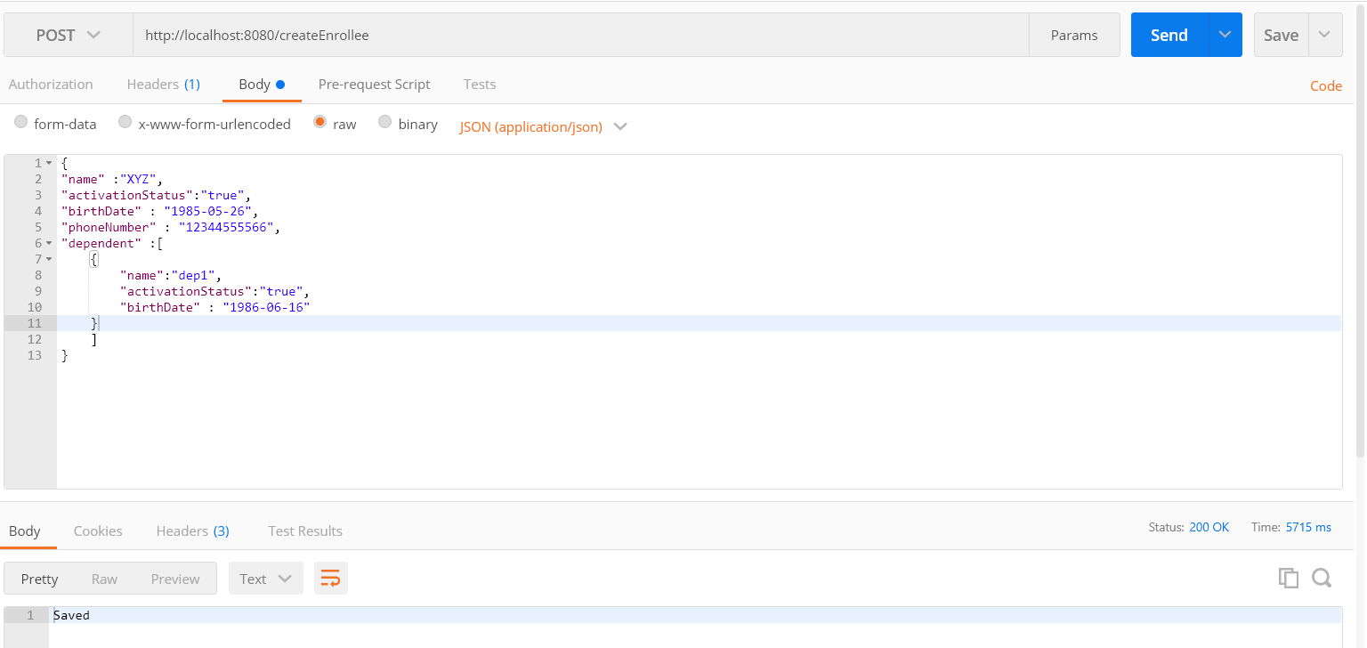

Get the Enrollees details

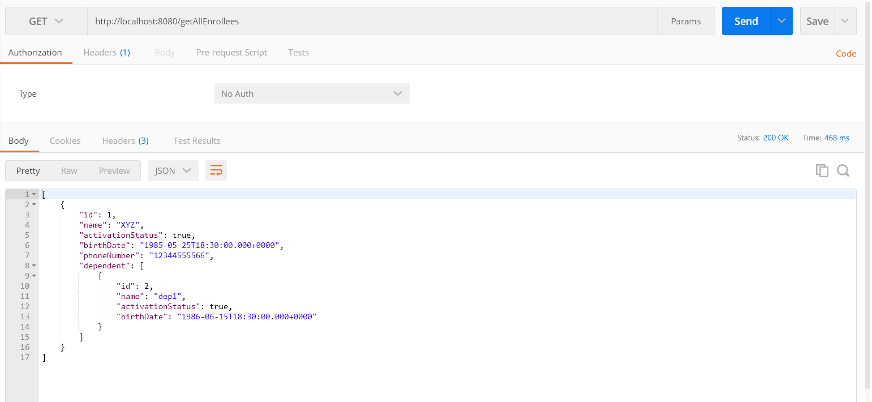

Get the details based on id

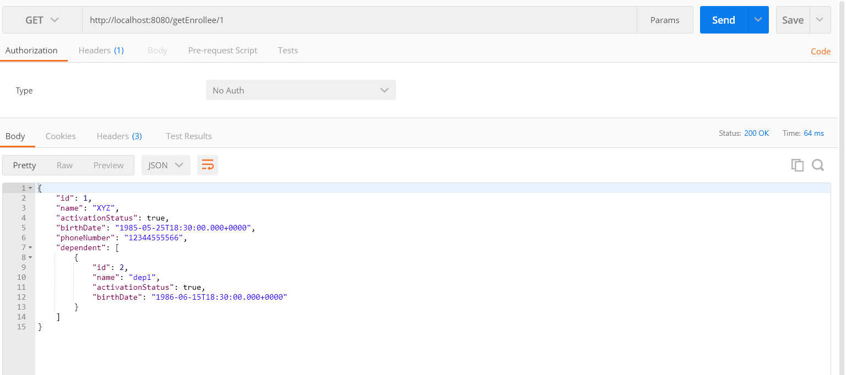

Delete the data based on id

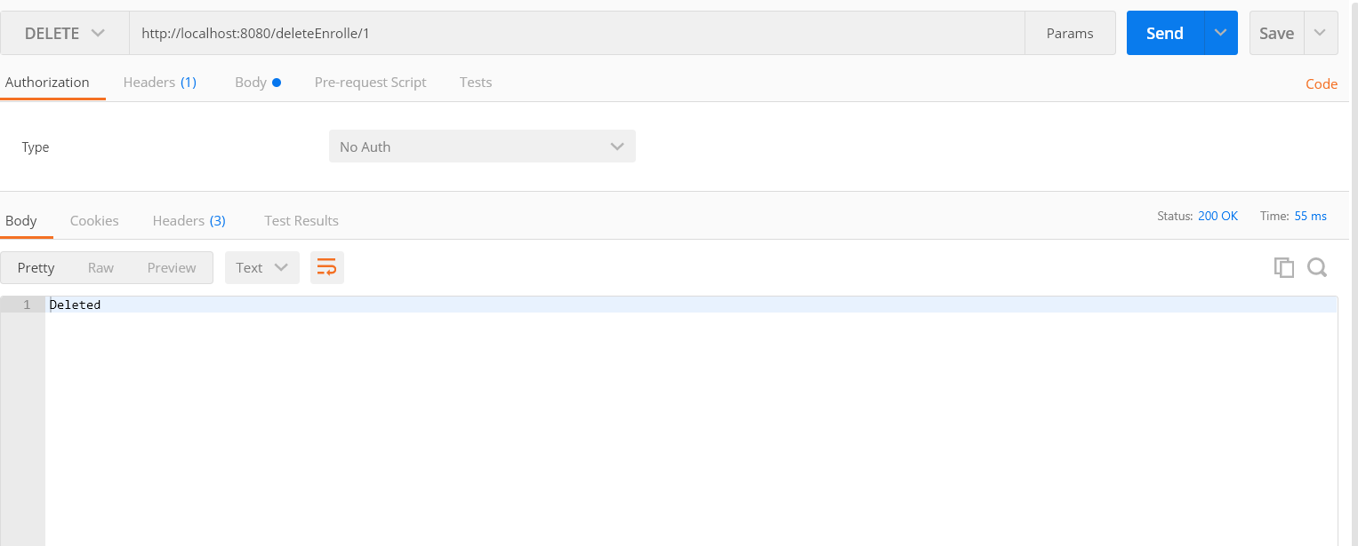

Similarliy we can use postman for create , update, retrieve, delete dependent rest url’s