SafeSquid Assignment Task

Dear Sir,

I am **Chaitanya Manchekar**, pleased to share the comprehensive documentation for the assignment developed utilizing cutting-edge technologies.

**Overview:** The Photographer Portfolio is designed to showcase a photographer's work in an elegant and user-friendly manner. It includes multiple pages to feature different aspects of the photographer's portfolio. For this project I used NodeJS as a framework. The frontend is crafted with HTML5, Bootstrap 5, CSS, JavaScript and jQuery, providing a seamless and responsive user interface. Also used grid layout on pages to make them device friendly (responsive). Implemented animation through CSS by utilising transform property. Used jQuery’s load and getJson methods to load content dynamically.

**Key Technologies Used:**

1**. Node.js**: Using as a framework for a project.

2. **HTML5**: Using HTML5's semantic elements to structure the content of the pages.

3. **Bootstrap5**: Using for a consistent look and feel across various devices and pages.

4. **Grid Layout & Media Queries**: Using to make page device friendly (responsive).

5**. CSS Animations**: Engaging animations by using CSS on various pages. –

6. **AOS Library**: Adding a few animation effects on the portfolio page by using AOS Library.

7. **jQuery**: Using jQuery’s accordion component on the "About Us" page, also using load and getJson methods to load content dynamically.

8. **JavaScript**: Using to fire methods during page load. Also using JavaScript to bind various click events.

9. **JSON**: Using to store data.

**Folder Structure:**

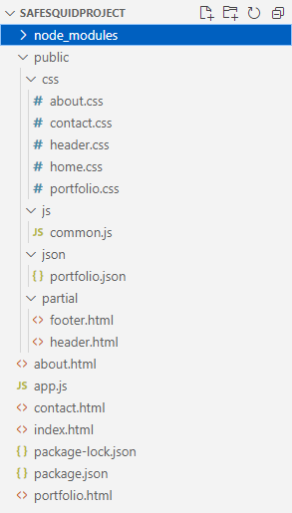

**Screenshots:**

**Home Page:**

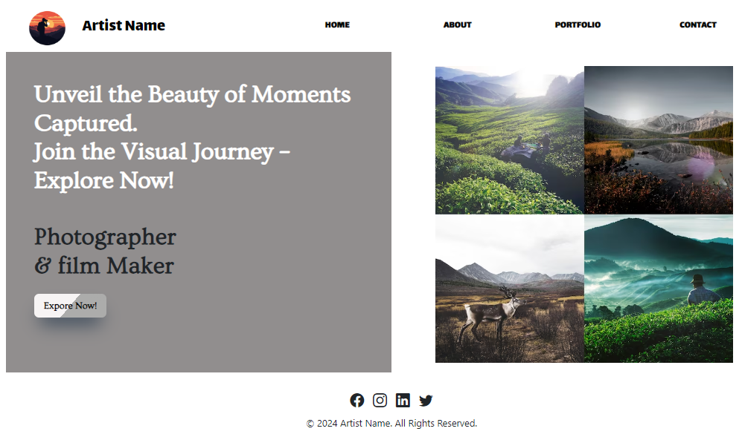

**Mobile View**

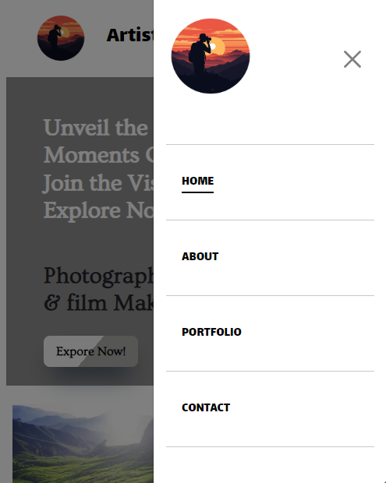

**About Page:**

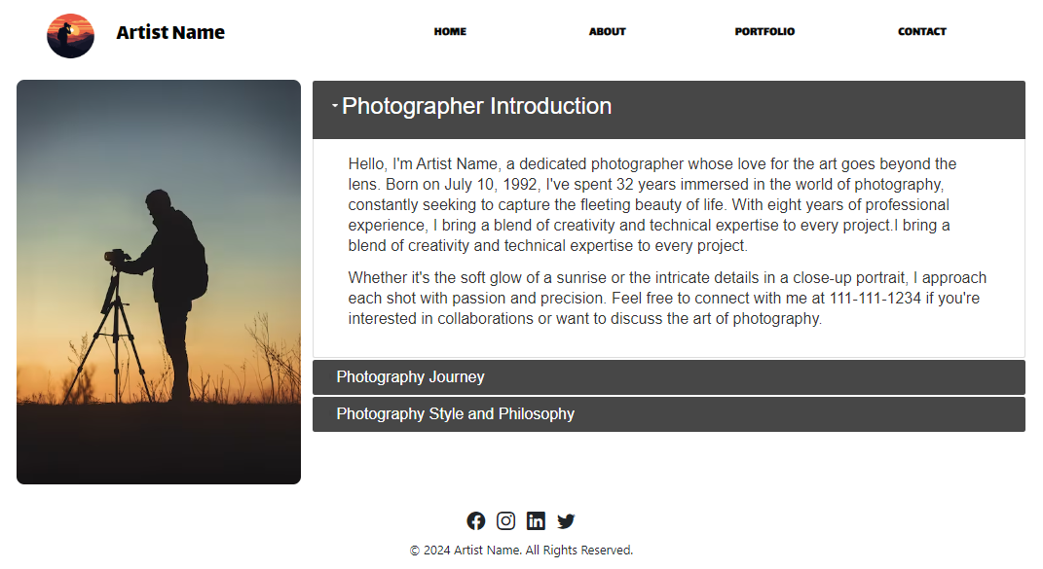

**Mobile View:**

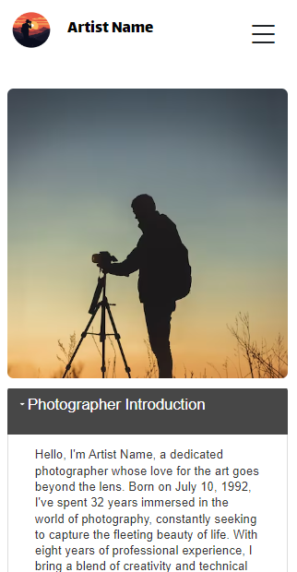

**Portfolio Page:**

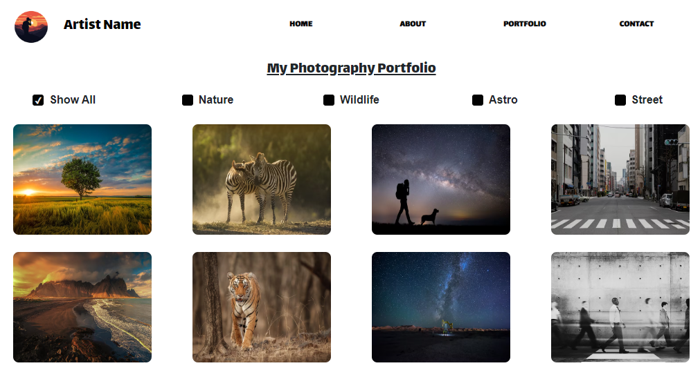

**Mobile View:**

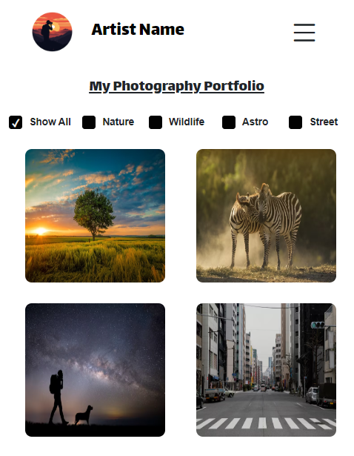

**Tab View**

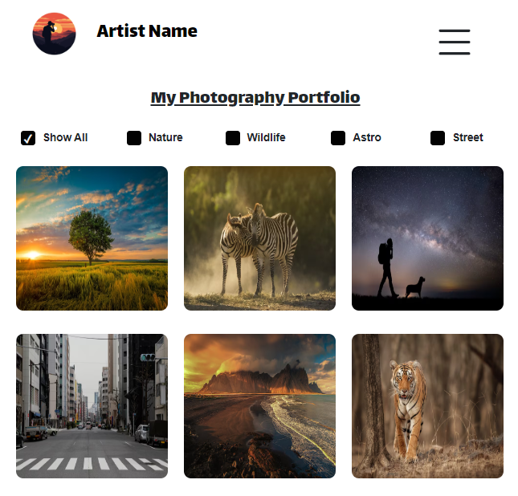

**Contact Page:**

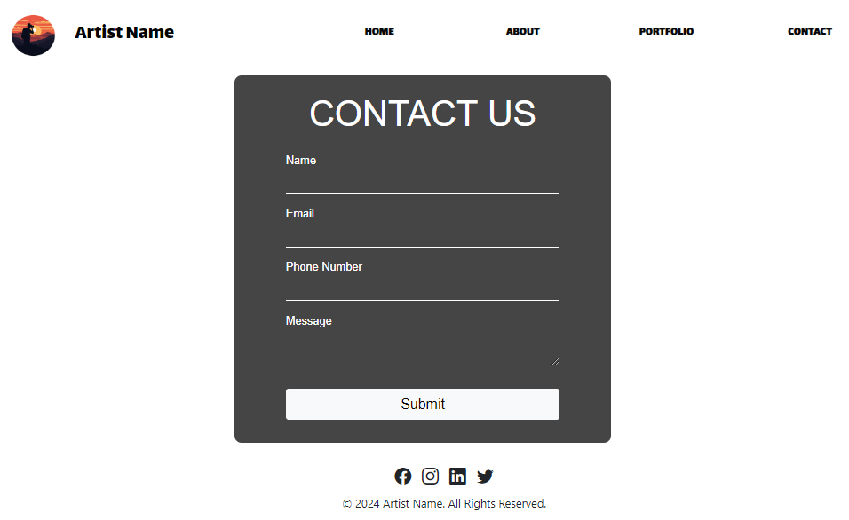

**Thank You**