

GNUspool Release 1
Web Browser Interface Manual
This manual is for GNUspool (Web Browser Interface Manual).
Copyright 2008 Free Software Foundation, Inc.
Permission is granted to copy, distribute and/or modify this document under the terms of the GNU Free Documentation License, Version 1.2 or any later version published by the Free Software Foundation; with no Invariant Sections, with no Front-Cover Texts, and with no Back-Cover Texts. A copy of the license is included in the GNUSpool reference manual in the section entitled ``GNU Free Documentation License''.
Table of Contents
1 GNUspool Web Browser 1
1.1 Overview 1
1.2 Varieties of interface 2
2 Login and Screen selection 3
2.1 Switching between job and printer list 4
2.2 List formats 5
2.3 Display option setting 9
2.3.1 Job Options 9
2.3.1.1 Display column headers 10
2.3.1.2 Display jobs for printer(s) 10
2.3.1.3 If no job destination printer 10
2.3.1.4 Printed/unprinted jobs 10
2.3.1.5 Restrict display to jobs local to server 11
2.3.1.6 Don't try to display page counts 11
2.3.2 Printer Options 11
2.3.2.1 Display column headers 11
2.3.2.2 Display printers 11
2.3.2.3 Restrict display to printers local to server 11
2.3.2.4 Sort printers into order 11
3 Job Operations 12
3.1 Create job 12
3.1.1 Job Title 13
3.1.2 Form type 13
3.1.3 Destination Printer 13
3.1.4 Copies 14
3.1.5 Priority 14
3.1.6 File 14
3.2 Create job copy 15
3.3 View job(s) 15
3.4 Abort or delete jobs 17
3.5 Form, priority, copies, title and printer 18
3.6 Pages 19
3.7 Job retention 20
3.7.1 Printed timeout 21
3.7.2 Unprinted timeout 21
3.7.3 Retain on queue after printing 21
3.7.4 Printed (or pretend it has been) 21
3.7.5 Hold times 21
3.8 Set Class Codes 22
4 Printer Operations 23
4.1 Single operations 23
4.1.1 Start 24
4.1.2 Halt at EOJ 24
4.1.3 Halt now 24
4.1.4 Abort 24
4.1.5 Restart 24
4.1.6 Interrupt 24
4.1.7 Alignment OK 24
4.1.8 Alignment not OK 24
4.2 Set form type 24
4.3 Printer Class Codes 25
5 Installation 27
5.1 General 27
5.2 HTML Files in Web Directory 27
5.2.1 gnuspool.html 27
5.2.2 gsjobbutts.html 27
5.2.3 gsptrbutts.html 28
5.2.4 gsjsfunc.js 28
5.3 CGI Binaries 28
5.3.1 Ownership of CGI files 28
5.4 Parameter File 28
5.5 HTML Template files 29
5.6 Message File 29
5.7 Host file 29
6 Parameters 30
6.1 Location of file 30
6.2 Format of file 30
6.3 Control parameters 31
6.3.1 userfile 31
6.3.2 defltuser 31
6.3.3 deflthost 31
6.3.4 usertimeout 31
6.3.5 userrefresh 31
6.4 Initialising default formats 31

GNUspool Web Browser
This document describes the GNUspool Web Browser interfaces. Knowledge of the base product is everywhere assumed. Please see the relevant manuals for more details.

Overview
The GNUspool web browser provides most of the facilities of the queue viewers gspl-pq and gspl-xpq via a web-browser interface. Local and remote jobs and printers may be accessed, attributes changed, printers started and halted.
The display is similar to the following:
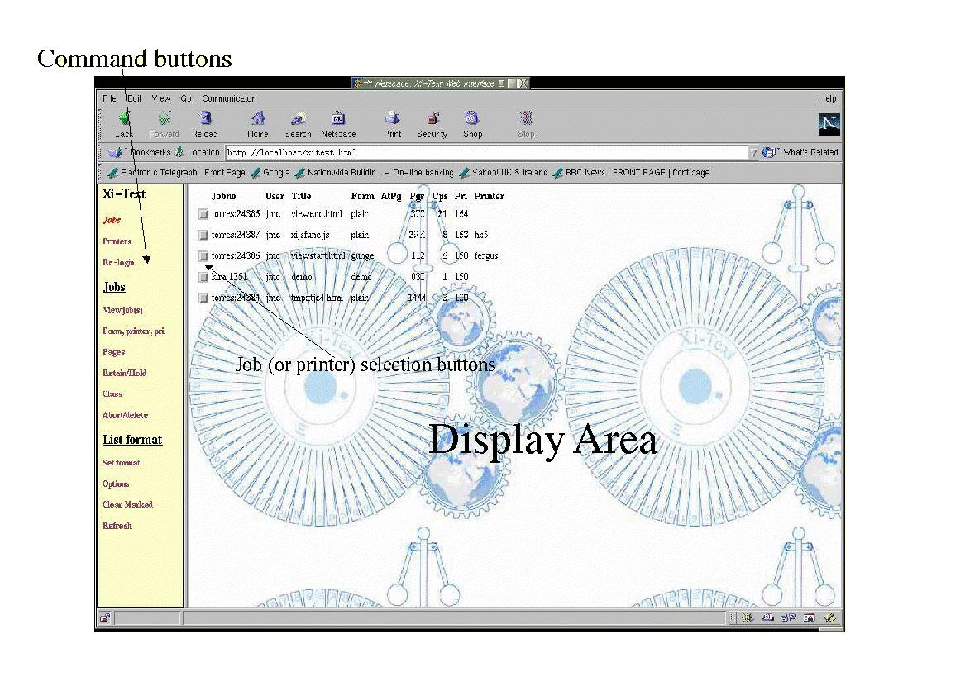
The interface consists of a series of HTML files, a JavaScript function library and a series of CGI binaries. The HTML and JavaScript files are all supplied in source form, so the background display, colours, styles and some of the functionality may all be adjusted as required.
Most of the job or printer operations may be effected by clicking one or more of the
checkboxes displayed beside the relevant job or printer and the desired operation on the command list on the left.
Prior to access, the user is invited to log in with his or her username and password, or a default user may be specified for the interface. The user may "re-log-in" with a different user name and password to access facilities available to the new user if required.

Varieties of interface
There are two versions of the browser interface:
- A local version, for where the web server and GNUspool are running on the same host. (The version of GNUspool does not have to be networked).
- A remote version, for where the web server and GNUspool are running on different hosts (in fact this is implemented as API programs).
The interface is virtually identical in each case, except that the initial login screen requests a host name in addition to the user name and password and some errors, particularly "no permission" errors, are detected slightly differently.

Login and Screen selection
The first time the GNUspool web interface is accessed, the following is usually displayed:
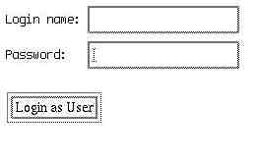
Log in with your usual Unix user name and password (this may be set up to be a different password from your Unix password) and press the "Login as User" button.
If you are using the remote interface (supporting GNUspool on a different host from the web server) the login screen will look like this:
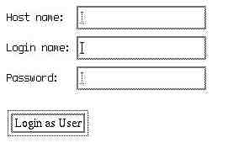
In this case you should specify the host name on which GNUspool is being run as well (you can put localhost if it is in fact the same host as the server).
It may be that the interface is set up with a default user name (and possibly host name), in which case this step will be omitted, but the permissions on the default user name are likely to be limited.
At any stage you may select a new user name (and/or host name) by pressing the Re-login link on the button bar. Note that a "cookie" is saved by your browser to record a code which is passed with each request to identify you. It is important to enable cookies on your browser for this reason. Certain options are also saved as cookies also.
After a certain time, which may be configured by the administrator (and may be just a few minutes or several days), the login record will time out and become stale. You will then have to re-login.
After a successful login, the main display of jobs will appear on the right half of the screen.

Switching between job and printer list
After successfully logging-in, the initial display will be of the job list. The top two entries in the button bar on the left allow the user to toggle between the display of jobs and printers. Note that the button bar is updated as well as the display.
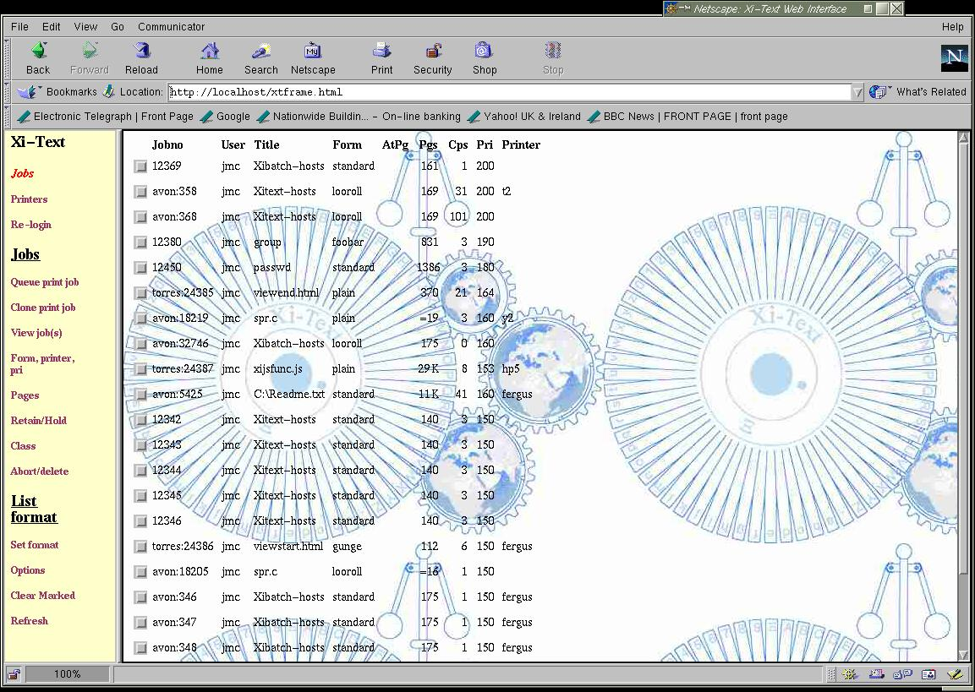
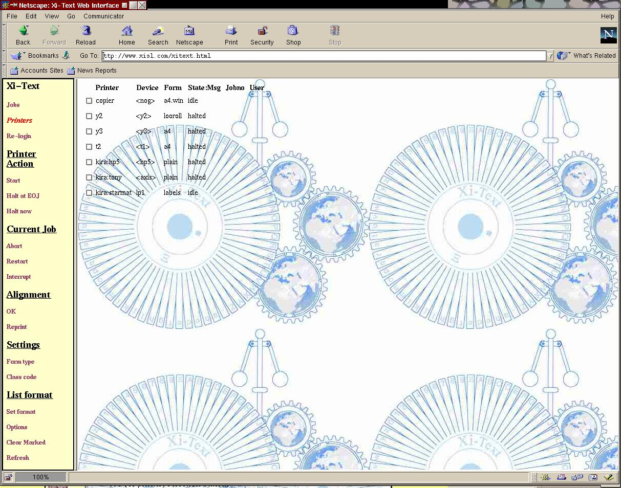

Nothing in either display implies that the user has any right to access anything in the displayed list. Appropriate error messages will be displayed if the user attempts access to facilities which he or she does not have permission.

List formats
The displayed attributes of the job or printer lists may be adjusted to suit the user's preferences. The selected formats are saved as a "cookie" in the web browser and will be re-selected each time the user returns to the display.
To change the format of the displayed list (either job or printer), click on the Set Format button on the button bar.
The main display will change to a screen of the form:
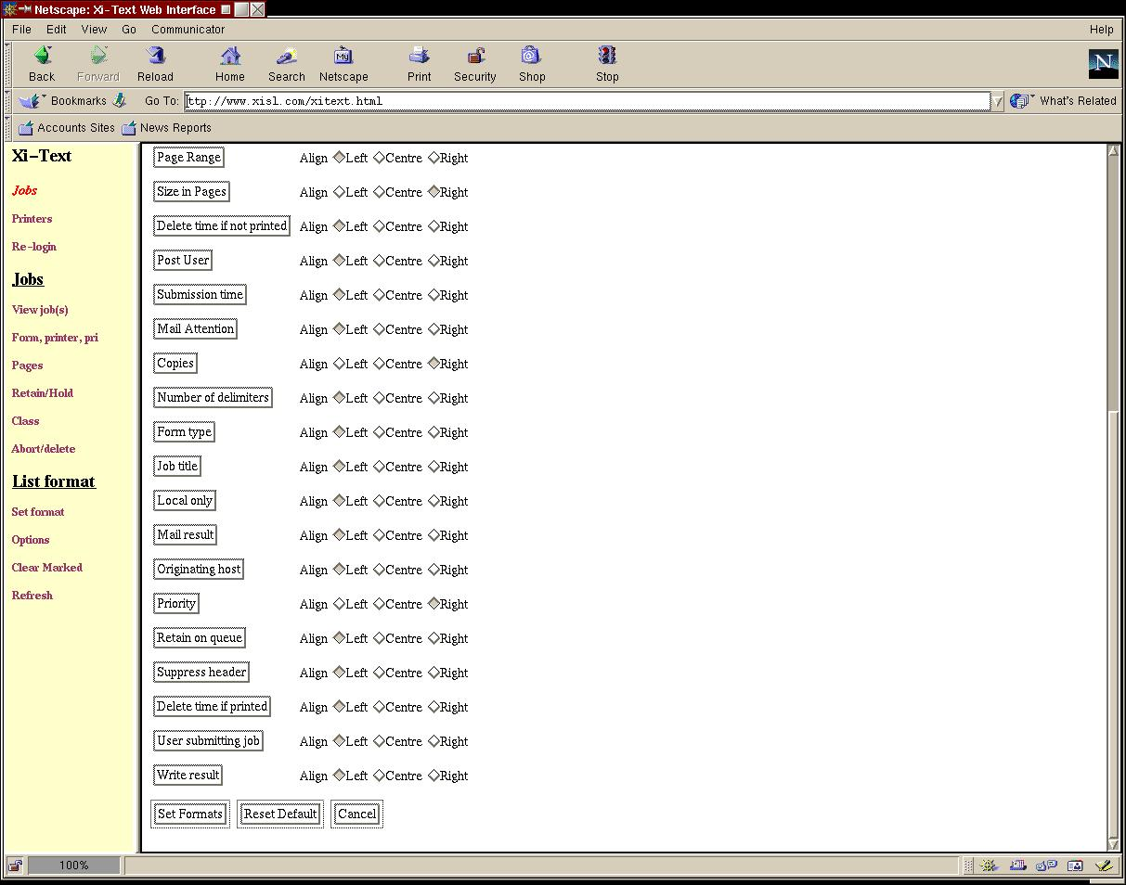

Each row corresponds to a column of the job or printer list (according to whichever was being displayed at the time).
To build up the required format, start with the attribute to be displayed in the leftmost column of the result, and work across to the right. To select a field, decide whether you wish the field to be displayed left or right-aligned or centred (the individual fields have common defaults set), and click the button on the left to insert the field.
This will cause a "pop-up" window to be displayed as follows:
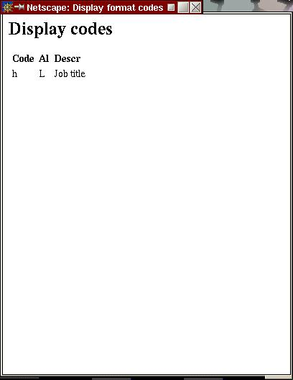

The "code" is for reference and is used internally. The other two fields give the alignment selected and the description of the field.
As you continue to work through the fields required, the result window will be updated, for example:
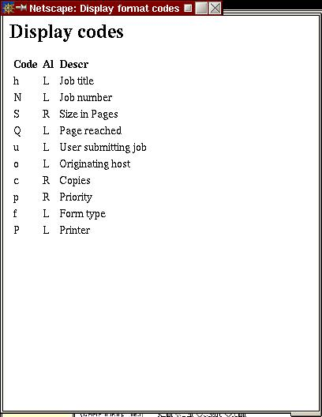

When you have finished doing this, press Set Formats to change the format display, in this instance to
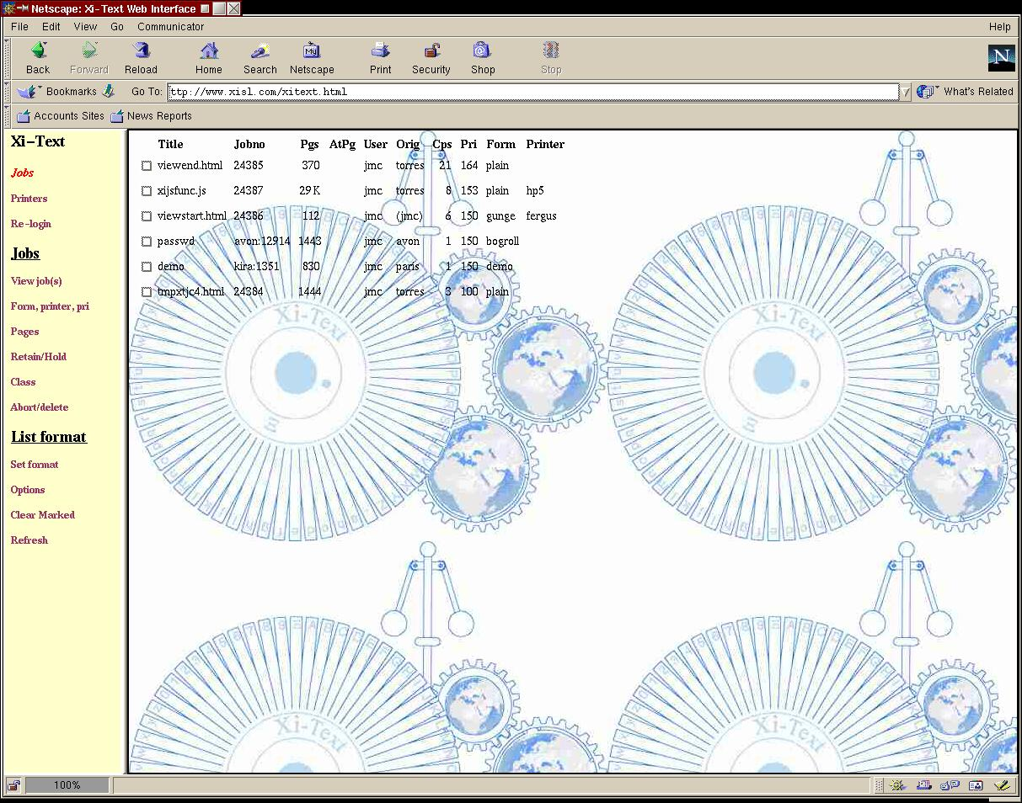

You can also press Cancel to abort the operation, or Reset Default to revert to the standard format and reset the "cookie".
The standard format may be defined as required for each installation by editing the parameters file.

Display option setting
You can arrange control which jobs or printers are displayed by clicking on the Options button. The selected options are saved as a "cookie" and retained for future invokations of the job or printer list display.

Job Options
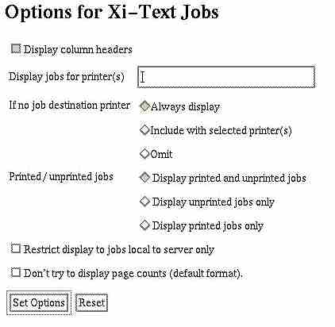
If jobs are being displayed, the following form will appear:

The initial selections are the default, and are the most inclusive. To revert to the default format, just click on Set Options without alterning anything.

Display column headers
Check or uncheck this to determine whether the first row of the job display is preceded by column titles.

Display jobs for printer(s)
You can put a printer name in here to cause the display to be limited to jobs for that printer. You can also put a comma-separated list of printers, and you can use a shell-style "wildcard", for example: pr*,*[1-6] would select jobs with printer destinations starting with pr or ending with 1 to 6.

If no job destination printer
Is applicable only if a printer name is given. In this case it determines whether or not a job is displayed if it has destination printer.

Printed/unprinted jobs
You can use this to limit the display to jobs which have or have not been printed.

Restrict display to jobs local to server
This will limit the display only to jobs on the server (i.e. The server on which GNUspool is being run as opposed to the server on which the web browser is run).

Don't try to display page counts
This only applies to the default job display format. Jobs are given as sizes in bytes rather than page counts.

Printer Options
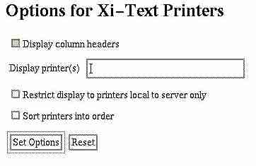
Again the initial selections are the default.

Display column headers
Selects or deselects the title at the top of each column.

Display printers
Here you can name the printers to be displayed, using wildcards and comma alternatives as with the printer destination display.

Restrict display to printers local to server
Here you can limit the display to printers on the server (i.e. The server on which GNUspool is being run as opposed to the server on which the web browser is run).

Sort printers into order
This will cause the printers to be sorted into alphabetical order. The default is the order in which the printers have been added to the printer list.

Job Operations
The jobs to be worked on are selected by clicking on the check box to the extreme left of the corresponding row. Then click on the required operation on the button bar.
Some operations, such as "view job" and "abort/delete" allow the selection and action on several jobs, whereas others should only be done on one job at a time.
Note that you can clear all the boxes on the job or printer list by pressing Clear Marked.
Most operations return a completion message to indicate successful completion or an error.
Options available are:
- Create job
- Create job with copied parameters
- View Jobs
- Abort and/or delete jobs
- Set Form type, priority, title, copies
- Set Pages
- Set Retention
- Set Class Codes

Create job
This option allows the user to create print jobs from files located on the browser client.
The following window is displayed:
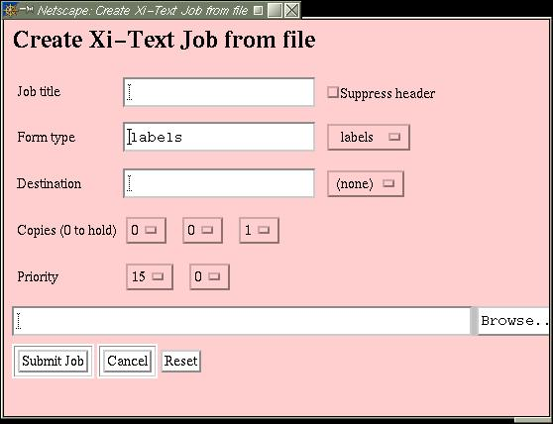

Only the most frequently-selected job parameters are displayed here. To set other parameters, queue the job with zero copies, or a non-existent printer, and change the required parameters.
The priority, form type and destination printer displayed initially are the defaults for the user.
Of the various fields:

Job Title
Insert any required title here. If it is not specified, the file name will be used.

Form type
Either type in the required form type, or select one of the existing form types taken from all visible jobs and printers using the selection button.
This field is initialised to the default form for the user.

Destination Printer
Again, either type in the required printer name (or pattern), or select one of the existing printer names taken from all visible jobs and printers using the selection button.
This field is initialised to the default printer for the user.

Copies
The three selection buttons (there may be less than three if the user is restricted to a lower number of copies) give hundreds, tens and units of the number of copies.
This is initialised to 1 copy.

Priority
There may be between one and three buttons here depending upon the range of priorities which the user may specify. The displayed values give the required priority, in the above example, 150. This is initialised to the default for the user.

File
Either type in a file name, or click the Browse button to find the required file.
Finally press Submit Job to queue the job. If all goes well, you should receive the message:
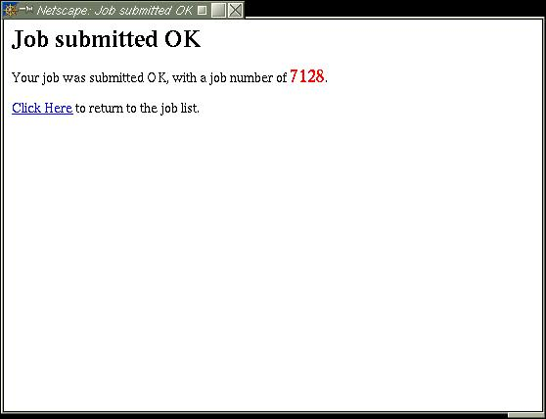
Click at the indicated place to close the window and return to the job list.

Create job copy
This option is similar to the previous one. However all parameters apart from the actual text of the job are copied or initialised from a job selected by clicking on the button in the job list.

View job(s)
Click on the check boxes on the left of the relevant job rows and click the view jobs button, to display windows such as the following:
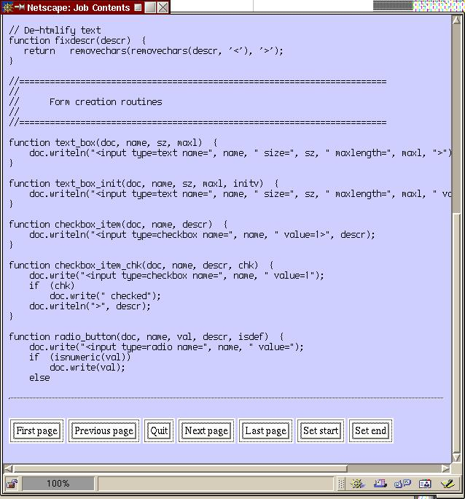

This is an example of a small job. Note that currently only text-format jobs are displayed sensibly. Press the Quit button, or close the window to cease viewing the job.
If the job has pages, then it will be displayed one page at a time as with this. (This job is a version of the JavaScript code used in the browser). Note the header at the start of the page and the indication that it is the "Start Page".
The indication may be "Start Page" or "End Page" if a range of pages has been selected. If the job was halted during printing, then the relevant page may be marked "Halted At Page".
At the bottom of each page is a selection of buttons. Some of the buttons may be omitted if they duplicate functions, for example if Next Page would in fact be the Last Page it is omitted.
Use the First Page, Previous Page, Next Page and Last Page buttons to move around the document, and Quit to finish. Set Start and Set end set the current page to be the first or last in the page range respectively. If the job was halted during printing, there will be two further buttons to change the Halted At page and to reset the halted at page.

Abort or delete jobs
To delete one or more jobs, including ones which may be currently printing, select them using the boxes and press Abort/Delete
If any of the jobs have not been deleted, the following confirmation is requested, listing all the relevant jobs:
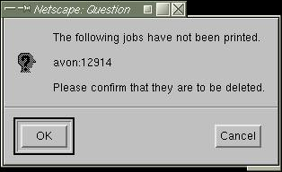
If you decide not to delete the unprinted job or jobs, the others will still be deleted.
If all goes well, the following message will be generated:
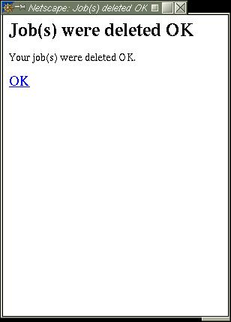

Click OK to accept and the job list will be refreshed.
If the user does not have permission, this will be detected before the operation is attempted in the local browser and during the operation in the remote browser.

Form, priority, copies, title and printer
To set these parameters for a job, select it and press the Form, Printer, Pributton to receive the following window.
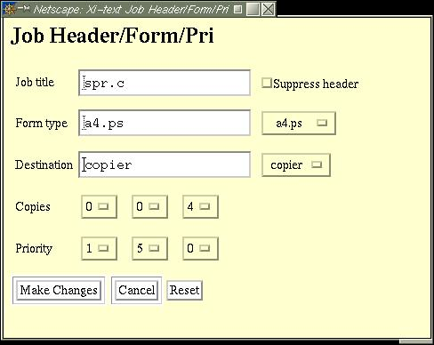

The fields are all initialised to those of the selected job. To set a new value, just enter the desired fields and click on Make Changes.
Form type and Destination may be entered either by typing in a required value or by clicking on the selection boxes to copy one of the range of available form types and printers into the field.
Copies and Priority can be selected using the selection boxes to give hundreds, tens and units. (There may be less than three boxes in each case if the user is limited to a smaller number of copies or range of priority).
Reset will clear and forget any changes which have been made.
If all goes well, a confirmation message will be displayed similar to that for delete and the job list will be refreshed after this has been dismissed.

Pages
Page ranges are selected from the view jobs screen, however odd and even page prints may be selected using the Pages option, thus:
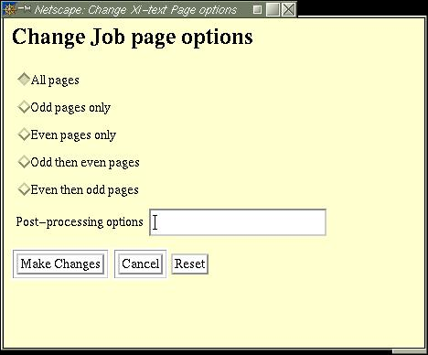

In addition the "post-processing option" string, passed as SPOOLFLAGS to any post-processing filter may be set. As with form etc setting, the default options are displayed and to actually set the default options you should select a different one and then switch back before pressing Make Changes.
If all goes well, a confirmation message will be displayed similar to that for delete and the job list will be refreshed after this has been dismissed.

Job retention
With this selection of options, you can set how long a selected job should be retained on the queue after printing, or if not printing and a start time for the job.
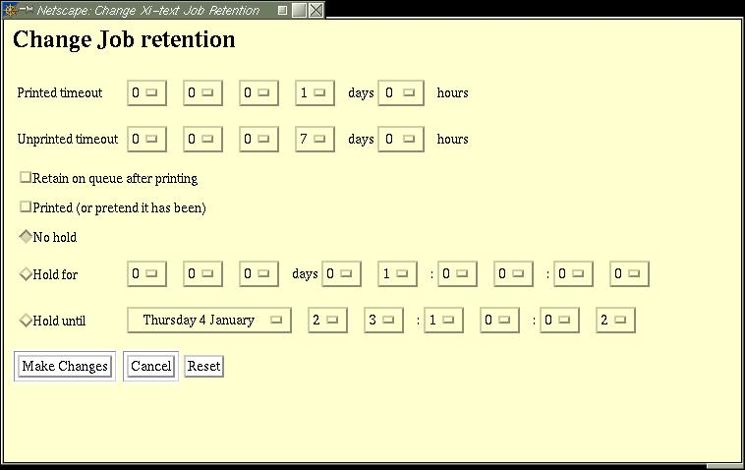

Printed timeout
This gives how long the job should remain on the queue after printing before being automatically deleted.

Unprinted timeout
This gives how long the job should remain on the queue if it is never printed.

Retain on queue after printing
This suppresses the automatic deletion of a printed job.

Printed (or pretend it has been)
You can pretend the job has or hasn't been printed by setting or clearing this.

Hold times
You can set an earliest time and date or a delay before the job starts printing. Hold for gives a delay from the current time, Hold Until gives a specified date and time.
If all goes well, a confirmation message will be displayed similar to that for delete and the job list will be refreshed after this has been dismissed.

Set Class Codes
These options set user options for the job and also the class codes, restricting the view of the job to a subset of users.
The following window is displayed.
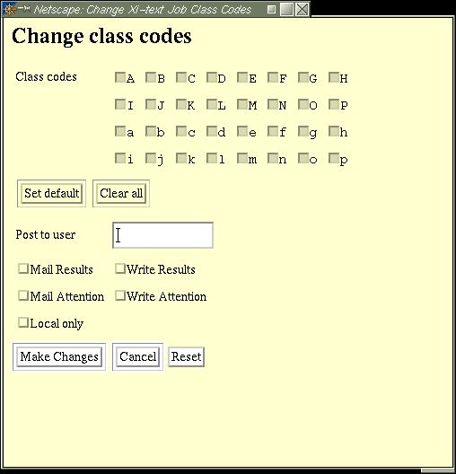
Class codes inaccessible to the user are disabled. The Set all and Clear all buttons may be used to clear the class code bits which the user can access.
Finally the mail and prompt notification flags may be set and the "post to" user.
If all goes well, a confirmation message will be displayed similar to that for delete and the job list will be refreshed after this has been dismissed.

Printer Operations
As with jobs, printers to be worked on are selected by clicking on the check box to the extreme left of the corresponding row. Then click on the required operation on the button bar.
Most operations allow the selection and action on several printers, whereas setting form type should only be done on one printer at a time.
Note that you can clear all the boxes on the job or printer list by pressing Clear Marked.

Single operations
All these operations may be performed on several printers at once. In most cases the printer should be in the appropriate state (running, or not running in the case of Start).
If all goes well (but that is not to say, for example, that after starting, some error occurred), you will receive the message:
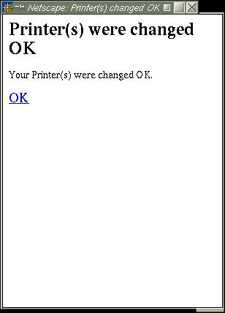

Start
This attempts to start the selected printers

Halt at EOJ
This halts the selected printers at the end of the current jobs, or immediately if not printing

Halt now
This halts the selected printers at once.

Abort
This aborts the job currently being printed on the selected printers.

Restart
This restarts the jobs at the currently-selected printers from the beginning.

Interrupt
This interrupts the printers, by halting at the current page and rescheduling the jobs for that printer. This may let a small high priority job in the middle of a large.

Alignment OK
If the printer(s) are in "Awaiting Operator" state after printing an alignment page, this will approve the alignment page and starting printing.

Alignment not OK
If the printer(s) are in "Awaiting Operator" state after printing an alignment page, this will disapprove the alignment page and print a new one.

Set form type
This is only intended to operate with one printer at a time. Additionally a new device and description can be specified, and the "network device" flag toggled.
The following window is displayed:
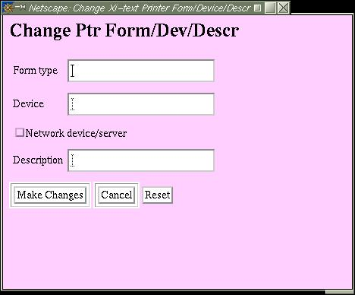

When Make Changes is pressed, only fields which have been changed are applied to the printer. This may make a slight problem where you want to set the Network device/server to unset, or Description to blank. However you do this by setting and then unsetting the field and then pressing Make Changes. Press Reset to "forget" all the changes made to date and start again.
If all goes well, you will get the printer changed OK message.

Printer Class Codes
Class codes for the printer may be set by selecting the printer and clicking the Class Codes button to give the following window:
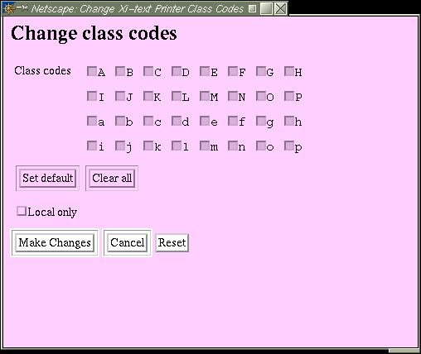

Class codes unavailable to the user are disabled. The Local only box may be used to set the printer to server jobs local to the server only.
Press Make Changes as before to complete the change. If all goes well, you will get the printer changed OK message.

Installation
This section provides some guidelines for installation. Most of the experience we have had has been with Apache, hence the advice is heavily oriented towards this.

General
Installation of the Web Interface may depend upon the Web Server in use and the locations of the CGI directories. As distributed, the installation puts the various files in the internal program directory for GNUspool, by default /usr/local/libexec/gnuspool, and in two subdirectories for HTML files and CGI binaries.
Currently we also provide a Perl script Apacheinst.pl to install the relevant components under the web directories specified for Apache.
Most of the HTML files are "template" files used by the CGI binaries and currently only 3 HTML files and the JavaScript routine file need to be placed in the web directories. However the CGI binaries will need to be copied to the CGI binary directory in most cases, as Apache normally will refuse to follow symbolic links.
Some of the files may need adjusting if some or all components are to be placed other than in the top-level directory of the web site.
The local version of the browser assumes that various of the component files of GNUspool are already installed. The remote version of the browser needs a small set of files and possibly the shared version of the API library.

HTML Files in Web Directory
The following files are located in the web directory. Note that if they are put in a subdirectory, cross-references to them in other files may need to be updated. These are installed by Apacheinst.pl as symbolic links.
These files may be edited and adjusted as required for individual requirements.

gnuspool.html
This is the basic frameset for the browser interface, invoking gsjobbutts.html for the button bar and a CGI binary for the list display. This is a symbolic link to gsframe.html for the local browser and gsrframe.html for the remote browser in the HTML files directory, by default /usr/local/share/gshtml. Currently the only difference between the two is that the local browser uses the CGI program sqcgi and the remote uses rsqcgi.

gsjobbutts.html
This provides the buttons down the left of the screen when displaying jobs. This is a symbolic link to a file of the same name in the HTML files directory, by default /usr/local/share/gshtml.

gsptrbutts.html
This provides the buttons down the left of the screen when displaying printers. This is a symbolic link to a file of the same name in the HTML files directory, by default /usr/local/share/gshtml.

gsjsfunc.js
This provides a library of JavaScript functions used by the interface. This is a symbolic link to a file of the same name in the HTML files directory, by default /usr/local/share/gshtml.

CGI Binaries
The following CGI binaries are provided by the local browser. The remote version has the names prefixed by "r", thus sqcgi becomes rsqcgi in the remote browser.
CGI Program | Function
sqcgi | List jobs and parameters
sqccgi | Make changes to jobs
sqdcgi | Delete jobs
sqvcgi | View jobs
spcgi | List printers and parameters
spccgi | Change printers
Under Apache, they usually have to be installed directly into the cgi-bin directory, as symbolic links on CGI programs are forbidden unless authorised using the FollowSymLinks directive in the Apache configuration file.

Ownership of CGI files
The CGI files are owned by and set-user to user spooler for the local interface (in order to access the job and printer shared memory segments) and by and set-user to user root for the remote interface (in order to masquerade as the appropriate user).
The user data is saved with a system group ownership, the CGI files are therefore all group-owned by and set-group id to a system group id such as daemon.
The standard permissions on the CGI files is therefore (octal) 6755 or rwsr-sr-x as displayed by ls.

Parameter File
A parameter file gshtml.ini is placed in the data directory, by default /usr/local/share to provide parameters for the browser interface. This is described in more detail in the following chapter.

HTML Template files
A series of "HTML template files" are used by the CGI programs to generate HTML. Certain parameters, represented by $Y and $Z, are substituted into the files as the HTML is generated, containing details of job numbers etc. These are usually located in /usr/local/share/gshtml but may be relocated.
An "indirect" means of reference is used to ease tuning of the web browser. The CGI programs name a file such as list_postamble which is searched for in the parameter file gshtml.ini, giving a file location possibly relative to the location of the parameter file.

Message File
Messages (error messages in particular) are extracted from the "shell command message file" for GNUspool, rest.help, stored by default in /usr/local/share/gnuspoolhelp. For the remote browser, this could be cut down to just the messages relevant to the browser, but it hardly seems worth it.

Host file
Host names may be specified in the /usr/local/etc/gnuspool.hosts file for the remote browser, if required, but this need not be included, and if not the gethostname routine is used.

Parameters
This chapter describes the parameter file gshtml.ini in a little more detail.
The file format is based on the types of .ini file which used to be found with Windows etc.

Location of file
The file is located in the data directory, which is by default /usr/local/share, however this may be relocated using the master configuration file /usr/local/etc/gnuspool.conf using the keyword SDATADIR (this applies even to the remote browser, for consistency). Please see the GNUspool reference manual for more information on this.
Files referred to in the parameter file are taken as being relative to the directory in which this file is found if they do not start with a "/", otherwise they are taken literally. For example if the file hgshtml.ini is in /usr/local/share, then a file name of htmllistpost.html will be taken to be /usr/local/share/gshtml/listpost.html. This applies after any environment variable expansions have taken place.

Format of file
The following is a series of extracts from the file. Note that comments start with # and continue to the end of the line.
# Files and parameters to control login
# First user key file

userfile=/var/spool/gnuspool/html_ufile

# Comment out the following if you do not want a default user
defltuser=guest

# Days after which timeout occurs
# This may be hh:mm or dd:hh:mm
usertimeout=7

error_preamble=html/error_pre.html
error_postamble=html/error_post.html

[sqcgi]
headers=y
list_preamble=html/sqcgilist_pre.html
The first part of the file, before any [xyz] sections, applies globally to all programs. Sections headed by a program name in [] apply only to that program, overriding the assignments in the global section. In this section, userfile, defltuser, usertimeout, error_preamble and error_postamble are set globally and headers and list_preamble are set only for sqcgi.
Parameters are numbers (as in usertimeout=7), strings (as in defluser=guest) or file names (as in error_preamble=html/error_pre.html).
Environment variables prefixed with $ (including ones set in /etc/gnuspool.conf) and ~username constructs are expanded in file names only. Environment variables whose values contain further environment variable names are recursively expanded up to 10 times.
Note that the CGI programs never ask for a complete file name, they ask for the parameter named, and this is expanded as required.

Control parameters
The following parameters have particular importance in configuring the Browser Interface. They should be placed in the global section of the file.

userfile
This locates the file in which user names and host names are encoded to a 32-bit keyword which is used to refer to users (for both GNUspool ).

defltuser
If specified, this gives the name of a default username to access the system unless the user changes identity using "re-login".

deflthost
If specified, this gives the name of a default host to access the system unless the user changes identity using "re-login". This is only relevant for the remote browser, in which case defltuser should also be specified.

usertimeout
This gives a "timeout" after which the login record of a user becomes "stale" and the user has to log in again with the correct password. This may be given in three formats:
- A number, indicating a number of days
- A time in the format hh:mm giving a time in hours (which may exceed 24) and minutes.
- A period in the format dd:hh:mm giving a time in days, hours and minutes.

userrefresh
If set, this indicates that each access to the system should "refresh" the user record, putting off the time after which the user has to log in again.

Initialising default formats
The initial format of the jobs and printers lists which will be displayed unless the user changes them, or if he/she clicks "reset default" may be defined here. This is done by inserting a parameter of the form format=string in the sections for sqcgi (job listing) or spcgi (printer listing) or their equivalents rsqcgi and rspcgi for the remote browser.
The string argument in the parameter consists of a sequence of letter pairs. The first letter in each pair is L, R or C, giving the required alignment. The second letter in each pair selects the required field, using the same format codes as are used in the -F options to sqlist and splist but without the % signs.
For example the following would specify the default format for job display in sqcgi, as being the standard, but with an initial column of the job submission time.
[sqcgi]
......
format=LsLNLuLhLfLLRKRcRpLP

