

GNUspool Release 1
MS Windows Interface
This manual is for GNUspool (MS Windows Interface Manual).
Copyright 2008 Free Software Foundation, Inc.
Permission is granted to copy, distribute and/or modify this document under the terms of the GNU Free Documentation License, Version 1.2 or any later version published by the Free Software Foundation; with no Invariant Sections, with no Front-Cover Texts, and with no Back-Cover Texts. A copy of the license is included in the GNUSpool reference manual in the section entitled ``GNU Free Documentation License''.
Table of Contents
1 Introduction 1
2 Installation 2
2.1 Configuring the PC host table 2
3 How files are printed via GNUspool 5
3.1 Windows system entry files 5
4 Windows Programs 8
5 Sprsetw 9
5.1 Program Menu 9
5.1.1 Login and logout 9
5.1.2 Port Settings 10
5.2 Network Menu 11
5.3 Options menu 12
5.3.1 Program Options dialog 12
5.4 View and Help Menus 13
6 Sprserv 14
6.1 File lists 14
6.2 File Menu 14
6.3 List Menu 15
6.4 Options menu 15
6.4.1 Form header copies 16
6.4.2 User and mail 16
6.4.3 Page options 17
6.4.4 Job size 18
6.4.5 Retain options 18
6.4.6 Security options 19
6.5 View and Help Menus 20
7 Spqw 21
7.1 Menu and toolbar options and commands 21
7.2 File Menu 22
7.2.1 Program Options 22
7.2.2 Display Options 23
7.2.3 Network Stats 24
7.2.4 User permissions 26
7.3 Windows menu 27
7.3.1 Window options 27
7.3.2 Set job list format 28
7.3.3 7.3.3 Set Printer list format 30
7.3.4 Printer colours 31
7.3.5 Save width settings 32
7.4 Action Menu 32
7.5 Jobs Menu 33
7.5.1 Viewing jobs 34
7.5.2 Title, form, printer, copies, priority 35
7.5.3 Pages 35
7.5.4 User and mail 36
7.5.5 Retain 36
7.5.6 Security 37
7.5.7 Unqueue job 38
7.5.8 Copy job 38
7.5.9 Copy options in job 38
7.6 Printer Menu 38
7.6.1 Printer form type 38
7.6.2 Printer class codes 39
7.7 Search menu 39
7.7.1 Search for jobs 40
7.8 Right-click menus 41
7.9 View and Help Menus 41

Introduction
The GNUspool Windows Interface provides a Windows User interface via a TCP/IP network to GNUspool running on one or more Unix hosts.
Jobs may be submitted from Windows automatically with a variety of appropriate options. They, and other jobs on various Unix hosts, may then be managed using a Windows front end program whose main screen looks like this.
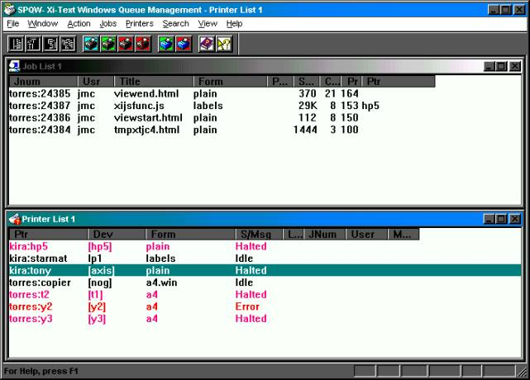
Note that this manual describes the Windows Interface Option to GNUspool and assumes knowledge of the basic Unix product. Please see the System Reference and Administration Manuals for more details of the various options on jobs and printers which this interface accesses.

Installation
Before installing this interface on one or more PCs, you should set up each of the Unix hosts to be accessed by the Interface.
Please see the section on "Configuring Network Hosts" in the Administration manual for details of this, including the setting-up of the /etc/gnuspool.hosts file on each host for Windows clients, possibly using the hostedit program. Also please note that you should choose the host file entries depending on whether the PCs have fixed IP addresses or whether they obtain the IP addresses using DHCP and should be identified by the user.
Once this has been done, you should be ready to install the Windows Interface on each PC. The installation suite consists of a standard InstallShield distribution, either as a self-extracting executable file or as a CD directory with a setup program. Note that sprserv is installed as an entry in the Startup folder. Unless you have a particular reason to avoid it, please install the software to the C:\gnuspool folder.

Configuring the PC host table
The utility sprsetw may be should be used to configure which Unix host or hosts the Interface communicates with, and to designate one of them as the main "server" to receive print jobs from the PC.
When started, it will display a screen looking like the following.
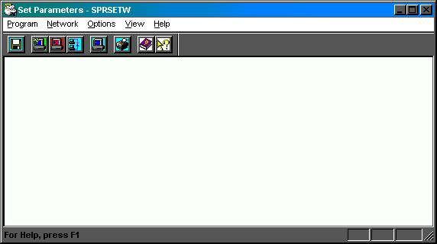
It will probably ask permission to create the hosts file in C:\gnuspool the first time it is run. (This is the GNUspool Windows Interface hosts file, not to be confused with a hosts file in C:\Windows).
Next select the menu entry Network - Add New Host to obtain a dialog such as the following:
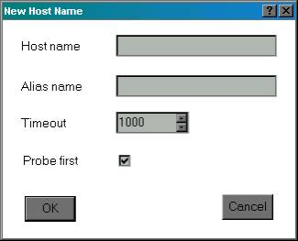
Enter the host name to be used (or an IP address) in the top box.
If the host name is quite long, add an alias name in the second box. This should be provided if the host name was given as an IP address only. If an alias name is given, then this will be used in any screen display referring to that host.
Leave the other two boxes "Timeout" and "Probe first" as they are for the moment.
Press OK to complete and the display should now look something like the following:
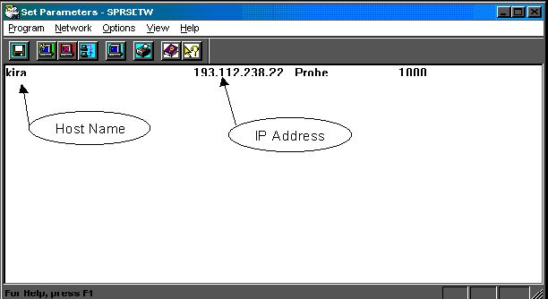
Repeat this for each host to be added. Note that they do not all have to be online at the time.
Next one should be set as the primary Unix server. This server should be online. To do this, select the line and the menu option Network - Set as Server.
It is possible that you may be asked for your password at this point it the Unix host has been set up to require it (this may possibly be a separately-specified interface password).
After you have set the server, save the information using Program - Save File.
The display should now look like the following.
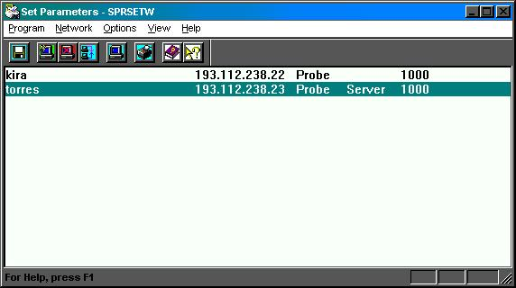
Having done this, exit the program using Program - Exit. You will be prompted to save the hosts file if you have not already done so.
You should now be able to run spqw to obtain a display similar to that shown peviously.

How files are printed via GNUspool
There are two ways in which files can be sent to GNUspool for printing.
- A Unix host can be set up as an LPD server using the xtlpd software. This acts as a server receiving files sent using the LPD protocol and converts them to GNUspool jobs. This is more fully described in the System Reference Manual.
- Printing can be performed using the automatic print to file facility provided for in Windows, with a file name denoting a given combination of options and the files automatically sent to the Unix server running GNUspool using sprserv.
The second method is the one described here. However even if you choose to use the first method, you may also want to use using spqw to monitor jobs and printers on the Unix machines.

Windows system entry files
The method by which files are sent via using sprserv is to use the facility whereby file names may be provided as additional entries under Ports in the WIN.INI file.
Sprserv adds these entries when asked to as an option in one of its menus, there is no need for you to edit the file yourself.
For example on the system on which this manual was typed, the following appears in the WIN.INI file.
[Ports]
LPT1:=
LPT2:=
LPT3:=
COM1:=9600,n,8,1,x
COM2:=9600,n,8,1,x
COM3:=9600,n,8,1,x
COM4:=9600,n,8,1,x
FILE:=
C:\X.PRN=
C:\gnuspool\Y.PRN=
This provides for two additional "ports". When a windows printer driver is installed, these are seen in the port selection box thus:
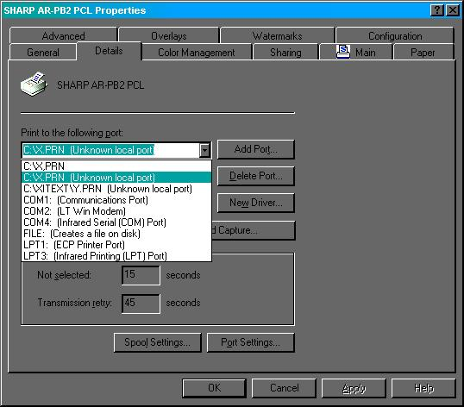

Then in the sprserv list we have the entries:
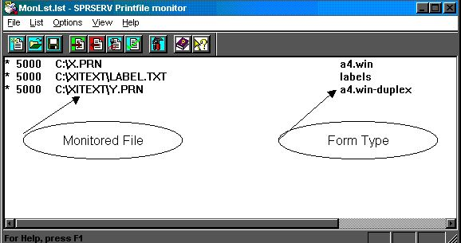
Use is made of "form type suffixes" to control the handling of incoming Windows jobs, often by doing nothing. However on our printer we can print in "duplex" or double-sided mode and this is achieved by the suffix win-duplex as opposed to win, which in turn is achieved by printing to the port C:\XITEXT\Y.PRN rather than C:\X.PRN, the default.
The list of files to monitor is saved and reloaded each time sprserv is started from the Startup program group.

Windows Programs
The following Windows programs are provided:
Sprsetw | Configures host information on the PC.
Spqw | Displays the state of job queues on one or more hosts and the status of printers. Several windows can be used to display different selections of jobs and printers.
Sprserv | monitors files for printing. It may also be used to print jobs by "drag and drop".
Optionally, the installation procedure may install the Windows API for use with Visual C/C++, which is documented in the API manual.
The following sections document the 3 basic Windows programs.

Sprsetw
Many of the facilities of sprsetw have already been described above. The common menu entries are all provided for on the toolbar and via keyboard shortcuts.
Sprsetw creates and maintains two files, normally in C:\XiText, namely the hosts file and xitext.ini containing various options.

Program Menu
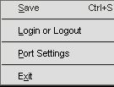
The Save option (shortcut Ctrl-S) saves the current host and parameter file settings. This is also available on the toolbar.
Login or Logout enables you to log in as a different user, with a password, or to log out your PC from the network. The "timeout" field in /etc/Xitext-hosts on the Unix server gives an automatic log out time if your system is left unattended.
Port Settings enables you to set the TCP ports to alternative values in case the standard port numbers of 2000 etc are not suitable. These must correspond with the Unix host, or the product will not work. Please use these with extreme care.
Exit is used to quit from sprsetw. You will be prompted if the files have not been saved.
The following toolbar entry is available:
 | Is a shortcut for Save.

Login and logout
If Login or Logout is selected, the following dialog box is displayed:
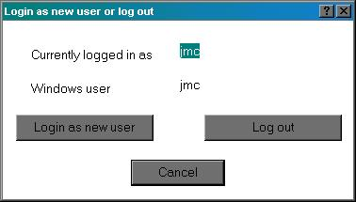
The current Unix and Windows user names are displayed.
Login as new user brings up a login dialog box as below. The Unix and Client host names are displayed, together with the current Windows user name. This may be mapped to a different user name on the Unix host. The password field should be the Unix password for that host or an interface access password if this has been set up.
Log out logs out the current user. If there is a default user name, or this is the user's default machine, then the default user will be logged back in.
The following is the "log in as new user" dialog.
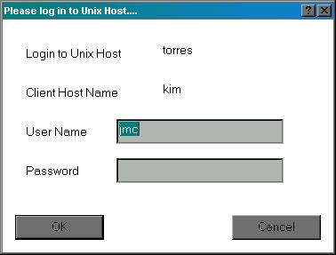
Cancel closes either dialog.

Port Settings
The Port Settings option brings up the following menu.
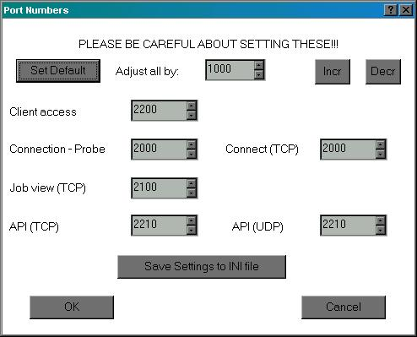
As advised, please be careful about setting these. It is common to adjust all by the same amount, and an option for doing this is provided.

Network Menu
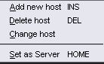
Add new host adds a new host as per the dialog above. The Insert key on the keyboard may be used as a shortcut and also the toolbar entry.
Delete host deletes the selected host entry. The Delete key may be used as a shortcut and also the toolbar entry.
Change host edits the selected host entry. Double-clicking the entry will bring up this option, as will the toolbar entry.
Set as server sets the selected host as server. The Home key may be used as a shortcut, as may the toolbar entry.
The following toolbar entries are available:
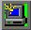 | Is a shortcut for New Host.
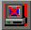 | Is a shortcut for Delete Host
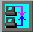 | Is a shortcut forChange Host
 | Is a shortcut for Set as Server

Options menu
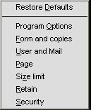
The options menu sets up certain options and defaults for use mostly by sprserv.
Restore Defaults restores the options to the defaults obtained from the server.
Program Options selects some global options for the interface.
Form and copies sets up default job title, form type, printer and number of copies.
User and Mail sets up a default "post to" user and flags for sending completion messages by mail or popup dialog.
Page sets up page delimiters and start and end pages.
Retain sets up whether jobs are retained on the queue after printing and for how long, and alternatively an earliest print time.
Security sets up class codes for jobs submitted.
Nearly all the dialogs are identical to the ones used by sprserv and are defined there. The function is to set up default values for when new entries are created in sprserv. The most commonly used one is Form and Copies for which there is a toolbar button:
 | Is a shortcut for Form and copies.

Program Options dialog
This takes the following form:
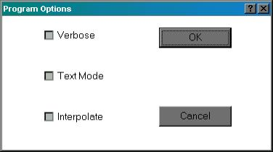
Verbose causes information about each submitted job to be displayed. This is mainly for debugging purposes and should probably be avoided.
Text Mode causes all jobs to be treated as text files, i.e. with carriage-return characters deleted.
Interpolate causes jobs derived from files with a given extension to append that extension as a form type suffix.
We think that you probably won't need any of the options here.

View and Help Menus
These take a standard form and are not documented here.
Please use the "About Sprsetw" entry to display details of the version number etc when raising any problem with sprsetw.

Sprserv
Sprserv runs continually to monitor a list of files for print jobs arriving in them. Incoming completion messages are also received and displayed by sprserv.
When one does, it is then sent to the Unix host, to the program xtnetserv running on that host, with the options associated with that file in the list.
Jobs which have been previously "unqueued" from within spqw and saved to the PC disk, and whose extension is .XTC, can be resubmitted and sent immediately to the server with the saved options by dragging and dropping from the Windows explorer.
Other files dragged and dropped are taken as being files to monitor.

File lists
Sprserv works on a current list of files and the file list is contained in one or more files, only one of which may be loaded at once. The last such list used is reloaded when sprserv is restarted.
You may switch between lists at any time, but in practice most of the time you will probably only use one continuously-running list.

File Menu
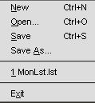
New(shortcut Ctrl-N) creates a new entry list of files to be monitored.
Open (shortcut Ctrl-O) opens an existing list.
Save (shortcut Ctrl-S) saves the existing list, prompting for a name if it was a new one.
Save As saves the list under a new name.
1 MonLst.lst up to 4 files may be named here, each file being a list of files to be monitored by sprserv. The first one on the list will be reloaded when sprserv is restarted.
Exit terminates sprserv. The currently-edited list of files will be saved if it has not been since it was last modified.
The following toolbar entries are available:
 | Is a shortcut for New List.
 | Is a shortcut for Open List
 | Is a shortcut for Save List

List Menu
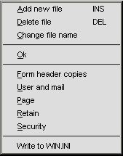
Add new file (shortcut Insert key) prompts for a new file to be added to the list. This is also available from the toolbar.
Delete file (shortcut Delete key) deletes the currently-selected file from the list. This is also available from the toolbar.
Change file name changes the file to be monitored on the currently selected line. It is also available from the toolbar and by double-clicking the line.
OK toggles the "OK to proceed" marker (the "*" on the left of the line).
Form header copies to Security adjusts the default settings for the current list with dialogs as given below for individual files.
Write to WIN.INI inserts an entry in WIN.INI as described earlier creating a new "Port".

Options menu
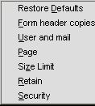
The options menu selects GNUspool job options for an individual selected file in the current list.
Restore Defaults restores the defaults as set up in the list menu.
Form header copies sets values for these fields and the printer. It is also available on a toolbar button.
User and mail sets values for the "post to user" and completion messages.
Page sets start and end pages and page delimiter.
Size Limit sets a limit on print job sizes.
Retain sets values for automatic deletion times if printed or not printed and an optional "hold until" time.
Security sets class code values for the job.
The most commonly used option is Form header copies for which there is a toolbar button:
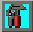 | Is a shortcut for Form header copies.

Form header copies
The following dialog is given if Formheader copies is selected:
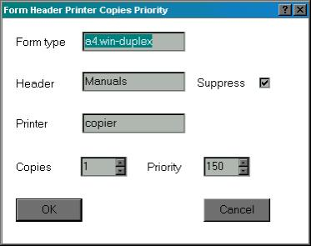
The desired form type should be entered in the top box.
The second box gives any job title required.
The checkbox indicates whether the banner page should be suppressed (remember that some printers may have this permanently turned on or off).
The printer goes in the next box.
The copies and priority may be adjusted using the scroll buttons on the right of the boxes, or the required value may be typed in directly.
Remember that your user id may be limited to a given subset of forms or printers - see the User Permissions table in spqw.

User and mail
This gives the following dialog:
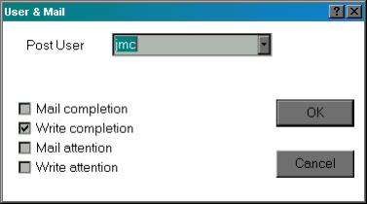
The "Post User" setting may be changed using the box at the top. Press the button at the right to get a list of possible users.
The four possible notification options are presented as checkboxes.
In the case of "write" sprserv will display messages as a message box.
We suggest you avoid "write" if many jobs are likely to be printed whilst your PC is unattended as the stream of message boxes which may result may lock up Windows.

Page options
This uses the following dialog.
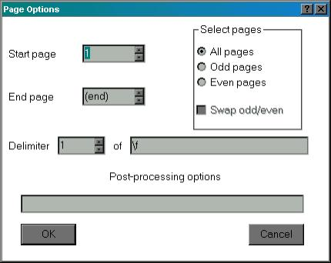
Start page and End page will apply to all printed jobs. We think you are most unlikely to require these, but are included for completeness.
Swap odd/even applies if Odd pages or even pages are specified and causes these to be swapped on alternate pages.
The Delimiter may get overridden by the printer setup file when the job is printed.
Post processing option are passed to the printer despooler processes as SPOOLFLAGS.

Job size
This is controlled by the following dialog
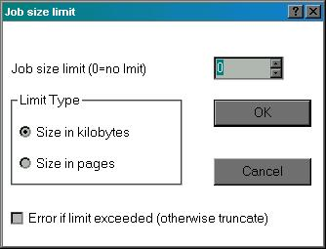
Set a limit in the first box, possibly using the scroll buttons to increment or decrement.
Set whether the size is limited to a given number of pages (as defined by the delimiter) or in kilobytes.
The final box determines whether the whole job should be rejected if it exceeds the limit or just truncated.

Retain options
These are controlled by the following dialog
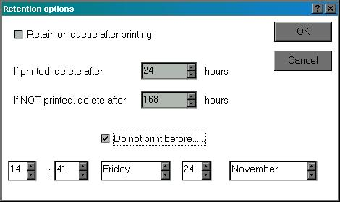

The first checkbox should be set if you want jobs to be retained with zero copies after printing.
The two times, adjustable by the scroll buttons, denote the times in hours to delete the job.
The first time gives the deletion time after printing if it has been retained on the queue. The second gives the time to delete the job if it hasn't been printed.
The final part gives a "hold time" for the job. Set the check box and adjust the earliest time for printing as required.

Security options
This is controlled by the following menu:
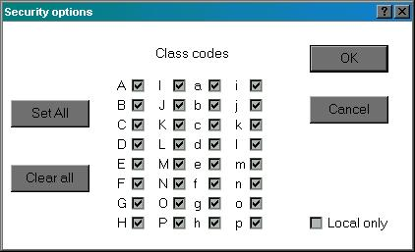
Click on the class code boxes to set or clear the relevant class code bits.
Set All will set all boxes, apart from the ones excluded by the user's default class code.
Clear All will clear all boxes.
Local only will make jobs local only to the host, so it will only be printed on printers hosted by that machine.
If the user has "Override Class Code" permission and his or her default class code has some bits cleared, then "Set All" will work in two stages.
- If some boxes are clear and the codes are not the default, then "Set all" will set them to the default codes.
- If the codes are the default, all boxes will be set.
"Clear All" works similarly, clearing to the default codes if they are not the default, and then clearing all.

View and Help Menus
These take a standard form and are not documented here.
Please use the "About Sprserv" entry to display details of the version number etc when raising any problem with sprserv.

Spqw
Spqw is an interactive monitoring tool with similar functionality to spq and xmspq only running under Windows.
The basic screen was shown earlier, however a variety of options enable multiple simultaneous different views of both job and printer lists to be displayed. For example in the display below similar jobs and printers to those shown earlier are divided into different windows for each host torres and kira.
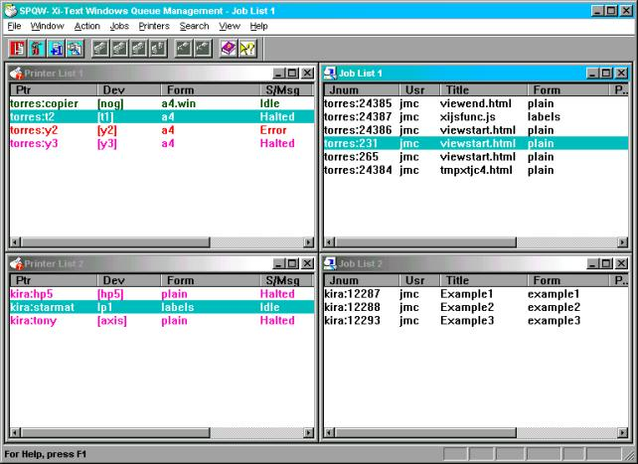
If this is a colour version of the manual, you will note that printers are displayed in different colours according to whether they are halted, idle, printing etc (and the colour scheme can be different in each window if required).
As with gspl-pq and gspl-xpq, the various windows are updated in real time to reflect changes to the state of jobs and printers.
Various options and operations may be invoked from the menus, toolbars, keyboard shortcuts and mouse right and double-click in various places.

Menu and toolbar options and commands
Options are available either to change the view of the jobs and printers being displayed, or to send commands to alter the state of jobs or printers.
All of the commands are available from the menus, some from the toolbar, some from keyboard shortcuts and some from a pop-up menu raised by a right-click on a job or printer.

File Menu
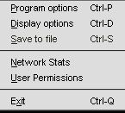
Program options (keyboard shortcut Ctrl-P) sets up certain options for the operation of spqw.
Display options (keyboard shortcut Ctrl-D) sets up certain default display options.
Save to file (keyboard shortcut Ctrl-S) saves the program and display options to file, for the next time spqw is run.
Network Stats reports on the connection status of Unix hosts.
User Permissions reports on the user's GNUspool permissions on the designated server.
Exit quits from spqw, prompting to save program and display options if the have not been saved.

Program Options
The program options consist of the following dialog:
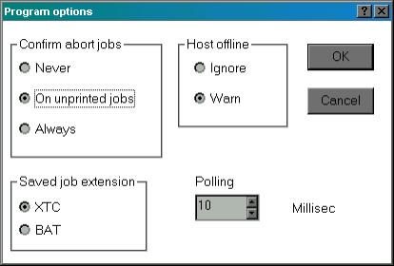
The options under Confirm abort jobs determine whether and in what circumstances the user is asked to confirm the deletion of jobs.
The option for Saved job extension determines what extension is given to a saved job when it is "unqueued" (see the job menu). This is mainly kept for historical reasons.
The option for Host Offline determines whether the user is warned about the host being offline.
The polling time sets how frequently certain conditions are tested for.

If you set confirmation on abort jobs and you try to abort (delete) a job, you will receive the message
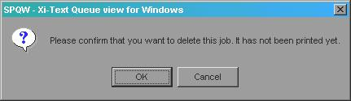
or if you set it to confirm for all jobs and it has been printed, you will receive the message
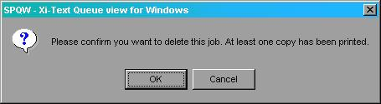

Display Options
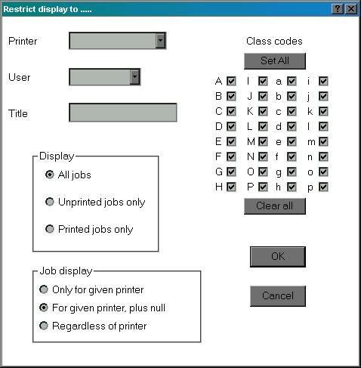
These set a greater or lesser restricted "view" as the default when a new job or printer window is created or, if saved to file, the next time spqw is run.
The Printer and User boxes allow you to select a printer or user from the drop-down list, or put in a pattern.
The Title box allows you to put in a title, possibly using a pattern.
The Display options can be used to display all jobs which otherwise match, just printed jobs or just ones which have not been printed.
If you have restricted the display to a given printer or printers, the Job Display choice determines whether jobs with no printer specified are included.
The Class Codes options may be used to limit the display to jobs and printers with a matching class code. The Clear All and Set All buttons may be used to assist (and work in two stages if the user has Override Class permission as described for sprserv).
Remember that this does not affect anything being displayed currently, it only affects subsequently displayed job or printer windows.

Network Stats
The network stats display reports on the status of all hosts configured with sprsetw, tracing the stages of connection.
If you select this option you will get a dialog box as follows:
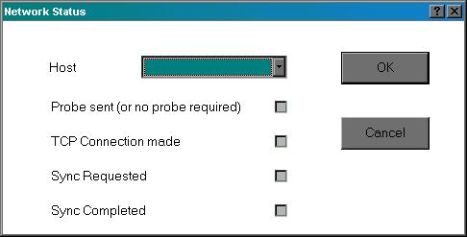
If you select the drop-down list at the top, you will get a list of hosts currently configured, thus:
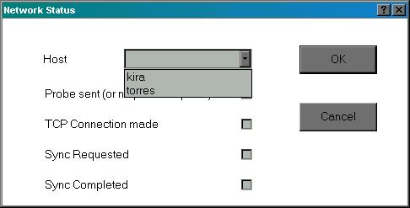
Then if you select one of the hosts, some or all of the check boxes will be filled in thus:
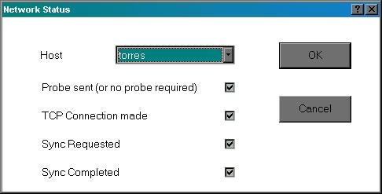

If all is well, all four boxes should be filled in. If the host is offline, probably only the first box will be filled in. If there is some other problem, then only the first two or three boxes will be filled in. Please ask us to help if that is the case.

User permissions
The User permissions menu select displays a dialog such as the following:
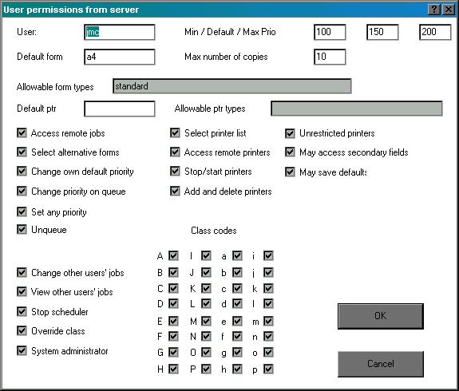
These are all derived from the user profile on the server. This user has complete access to the system.

Windows menu
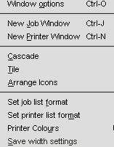
Window options (shortcut Ctrl-O) sets options on the current window, regarding which jobs or printers are displayed.
New Job Window (shortcut Ctrl-J) creates a new window to display jobs using the options in the current setting of Display Options on the File menu.
New Printer Window (shortcut Ctrl-N) creates a new window to display printers using the options in the current setting of Display Options on the File menu.
Cascade and Tile invoke the standard procedures for laying out sub-windows within the main frame.
Set job list format allows the user to define which fields of jobs are displayed.
Set printer list format allows the user to define which fields of printers are displayed.
Printer colours allows the user to define colours to highlight the state of printers.
Save width settings saves the current settings of widths of job or printer fields obtained by clicking and dragging column borders on the headers.

Window options
The following dialog is displayed
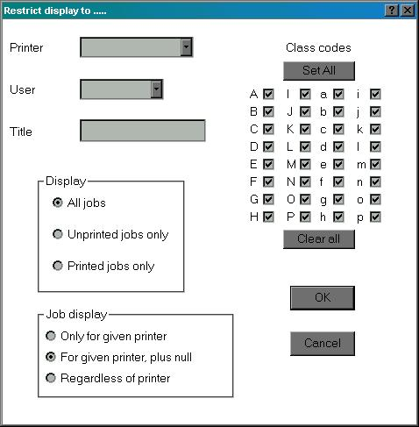
This is identical to the Display Options display, but applies immediately to the currently-selected job or printer window and does not affect any other job or printer window.

Set job list format
This selects which fields of each job are displayed on the job list. A dialog box is displayed with a scrolled list with each row corresponding to a column on the job list, thus:
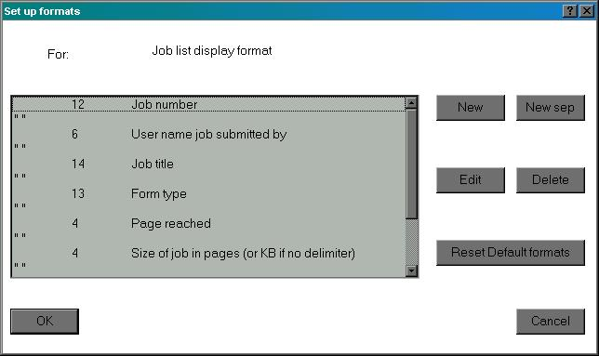

The order in which the fields are displayed can be varied by "dragging and dropping" rows in the list. Fields may be changed by selecting them and pressing Edit, or by double-clicking.
Most of the fields are separated by a single-space separator, but these can be changed as required.
New fields can be added by pressing New, or new separators by pressing New sep.
If you edit a field, you will receive a further dialog as follows:
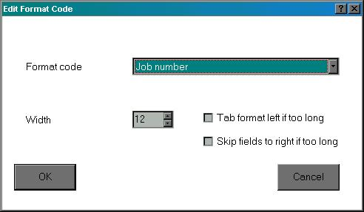
The Format code box in this dialog allows the user to select the required job field. If you press the button on the right, you will receive a list of options as follows:
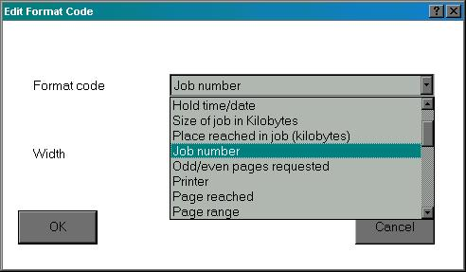
After selecting the code, select the width, possibly using the scroll buttons. (You may prefer to do this later by using the borders on the job list header).
The remaining two boxes in the dialog provide options for what happens if a given field entry is too long. You can opt to shift the whole field to the left, sacrificing the column on the left, or you can abandon the fields to the right.
If you choose to edit or create a separator, the dialog will take the form.
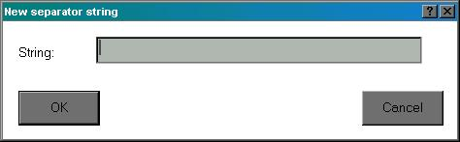
You can insert any string you like, but a null string will be replaced by a single space.
Once you have completed selecting the fields, you can invoke the Save to file option in the File menu to save your choices of columns and widths for the next time you use spqw.

7.3.3 Set Printer list format
This is almost identical to Set Job list format, with an identical dialog for printers.

Printer colours
The printer list can be set to display printers in various colours according to which state they are in, for example you might want idle printers in green, printing ones in blue, error ones in red etc.
Each printer list window can, if desired, have a different combination of colours and a further set of colours is saved with the program options and applied to each new printer window.
The printer colours option brings up a further sub-window set as shown.

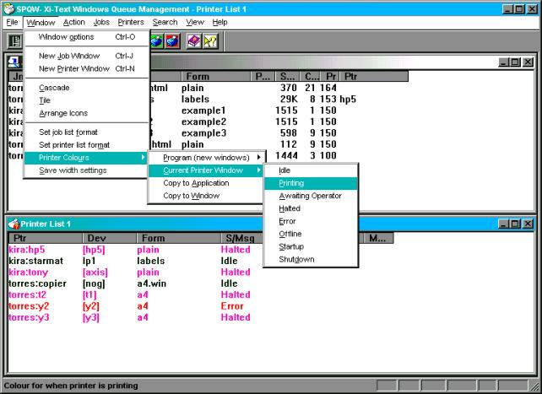
Selection of the final sub-menu brings up a standard Windows colour selection palette for the selected printer state.
Of the intermediate sub-menu, Program (new windows) sets up colours for new windows but does not change any existing display, Current printer window affects the currently-selected printer window, if any, otherwise they will be grayed out.
Copy to application copies the current set of colours of the currently-selected printed window to be copied to the program options as if they had been set up.
Copy to Window copies back the "program options set of colours" to the currently-selected printer window in case you are not happy with your changes or want to propagate the combination set in one printer window to another.

Save width settings
As well as under the Set Job List Format and Set Printer List Format options, the widths of the lists may be changed for a given window by dragging the borders of the column headers.
Click and drag the borders between the columns to reset the column widths. Or double-click to set to the width of the widest (although this won't do anything if nothing is currently being displayed).
The changes are temporary and apply to that window, however they can be saved into the job and printer list formats by selecting the Save width settings option.

Action Menu
This is a menu of specific actions on jobs or printers.
Note that in all cases you will need the appropriate access. For printers, this must be to the printer list itself and you must have privilege to perform the given option. For jobs the job must either be yours or you must have permission to "edit other users' jobs".
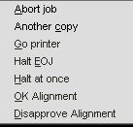
Abort job deletes a job from the queue, aborting printing if the job is being printed. This option is also available from the toolbar and the "right-click pop-up menu".
Another copy increments the number of copies by one. If the job has been saved on the queue, with copies zero, then this is the quickest way to reprint it. This is also available on the toolbar and the "right-click pop-up menu".
Go printer starts the selected printer. This is also available on the toolbar and the "right-click pop-up menu".
Halt EOJ halts the selected printer at the end of the current job if one is being printed or otherwise immediately. An indication is displayed if "various messages" is being displayed on the printer list if the current job being printed is the last one before halting. This is also available on the toolbar and the "right-click pop-up menu".
Halt at once halts the selected printer immediately, aborting any job currently being printed. This is also available on the toolbar and the "right-click pop-up menu".
OK Alignment approves the current alignment page if the printer is in "awaiting operator" state following printing an alignment page. This is also available on the toolbar and the "right-click pop-up menu".
Disapprove Alignment rejects the current alignment page if the printer is in "awaiting operator" state following printing an alignment page. This is also available on the toolbar and the "right-click pop-up menu".
The following toolbar entries are available:
 | Is a shortcut for Abort Job.
 | Is a shortcut for Another copy
 | Is a shortcut for Go Printer
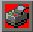 | Is a shortcut for Halt at end of job.
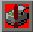 | Is a shortcut for Halt at once
 | Is a shortcut for OK Alignment
 | Is a shortcut for Disapprove Alignment

Jobs Menu
The following options apply specifically to jobs. In each case you will need to own the job or have the relevant permission.
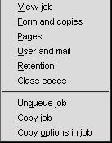
View job fetches and displays the text of the job in a new window. This is also available on the toolbar and in the "right-click pop-up menu". Note that the viewer only understands text format.
Form and copies selects the form type, title, printer, copies and priority of the job. This is also available on the toolbar and in the "right-click pop-up menu".
Pages sets start and end pages for the job. If the job was halted during printing there is a temporary start page of the "last print halted at" page.
User and mail set or reset the "post to user" and the "mail or write completion" flags.
Class codes sets the class codes for the job.
Unqueue job copies the selected job to a pair of files on the PC and deletes it.
Copy job is as for "unqueue" but does not delete the job.
Copy options in job copies all the current job attributes as being the defaults for the server.
The following toolbar entries are available:
 | Is a shortcut for Form and copies.
 | Is a shortcut for View Job

Viewing jobs
At the bottom right of the main spqw window, the markers STARTEND or HALTED will appear to indicate that the currently-displayed page is the current start, end or "halted at" page.
If you double-click on the job view window, then the following dialog is displayed (some of the options may be greyed out if inapplicable to the job or page being displayed).
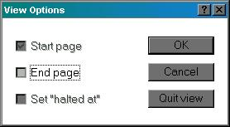
Start page causes the currently-displayed page to be reset as the start page.
End page causes the currently-displayed page to be reset as the end page.
Set "halted at" is only applicable if the job has been halted.
If you right-click on the job view window, you will receive a search window as follows:
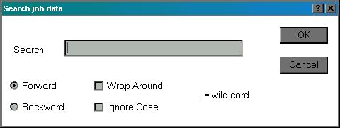
This can be used to find specific strings in the job.

Title, form, printer, copies, priority
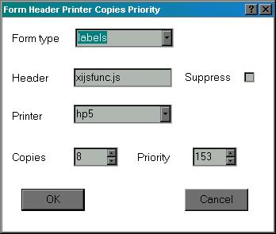
This causes the following dialog to be displayed:
The form type can be typed in as required or the button used to display a list of currently-known form types. The same is true of the printer box.
The printer box may be empty if you do not care which printer is used, or it may be a pattern with wild cards to select from a range of printers.
Copies and priority can be scrolled with the buttons provided. There may be a restricted range unless the user has "set priority to any value on queue".
Title may be any string selected by the user.
Suppress header may be ignored if the printer concerned is set to ignore all headers or force all headers.

Pages
This displays the following dialog
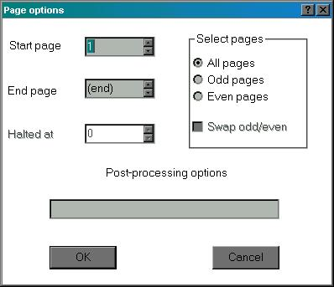
The "halted at" page will only be enabled if the job was halted during printing.
The "swap odd/even" will only be enabled if "odd pages" or "even pages" is set.
Note that unlike with sprserv and sprsetw, there is no option to set the delimiter, as once the job is queued, this may be automatically reset by the printer setup file.
Other options have all the same meanings as with sprserv and sprsetw.

User and mail
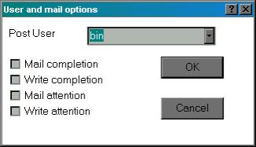
As with sprserv, this sets the "post to" user from a selection given by clicking on the "combo box" and the various notification flags.

Retain
This dialog is as follows:
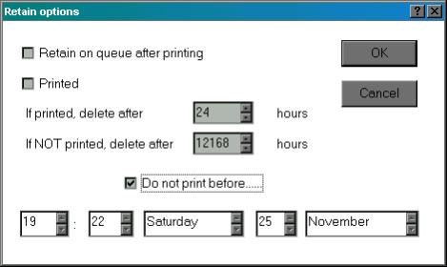
This enables the "retain on queue after printing" flag and the "hold until" time to be reset as required.
In addition the "has been printed" flag can be toggled if required, so you can "lie" about it having been printed or not.
Note that if you set the "has been printed" marker and the last print time is such that the "delete if printed" time has been exceed, the job may instantly disappear!

Security
This produces the following dialog.
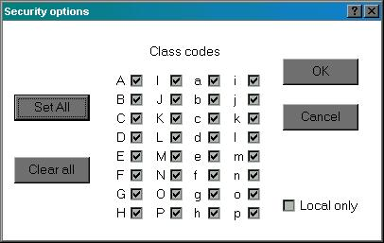

The effects of "Set all" and "Clear All" may be adjusted if the user has "Override Class" privilege, as described with sprserv.

Unqueue job
"Unqueuing" a job is taking a job off the queue, possibly editing it, saving to files so that it can be reinstated.
You need specific permission to unqueue a job, apart from the basic permission to access the job.
Jobs are "unqueued" in two pieces:
- The actual job file is put into one file, with suffix .xtj.
- Information about the job parameters are put into another file with suffix .xtc (or possibly .bat if so selected in the program options, but this is not recommended).
These are prompted for in turn. They don't have to be given the same name, but this is probably advisable.
The .xtc file can be "dragged and dropped" into sprserv to immediately resubmit the job.

Copy job
This is identical to "unqueue job" except that the job is not deleted.

Copy options in job
This copies the parameters in the currently-selected job to the current default settings.

Printer Menu
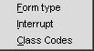
Form type sets the printer form type. This is also available from the toolbar and from the "right-click pop-up menu".
Interrupt sends a reschedule message to the printer. The current job is halted at the current page. If there is a higher-priority job or jobs for the printer, these will be printed before the original job is resumed.
Class codes sets class codes for the printer.
The following toolbar entry is available:
Is a shortcut for Set Form Type.

Printer form type
The printer form type dialog is as follows:
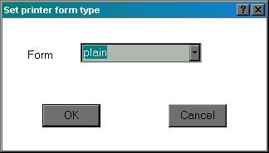

Either type in a new form type or use the button to select a form type form known form types on other printers and jobs.
This can only be done when the printer in question is not running.

Printer class codes
The printer class code dialog is as follows:
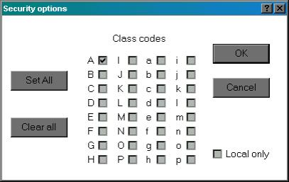
This is similar to the job class code dialog.
Note that making the printer local only will make it disappear from all windows.

Search menu
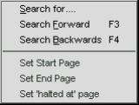
Search for searches for a job, printer or a string within a job depending on the currently-selected window.
Search forward (shortcut F3) reruns the last search, working forwards.
Search backward (shortcut F4) reruns the last search, working backwards.
Set Start Page to Set "halted at" page are only operative when job data is being displayed, and set the current start, end or "halted at" page to the currently-displayed page.

Search for jobs
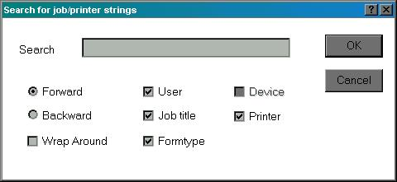
If the currently-selected window is a job window, the dialog from the Search for option is as follows:
Enter the search string in the box ("." is a wild card).
Select the fields to be searched out of user name, job title, printer and form type.
Also select search directory and whether wrap around is permitted.
The same dialog box is used if the currently-selected window is a printer window, only different boxes are enabled or disabled, thus:
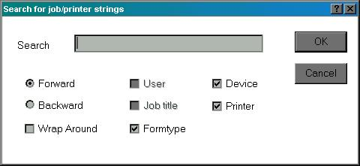
If the currently-selected window is a job view window the display will be as described earlier.

Right-click menus
The following menus are displayed if the right mouse button is clicked on a job or printer window. The job or printer under the mouse will be selected, and any option will apply to that.
The following is the job menu. It contains commonly-selected job options.
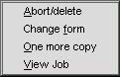
The following is the printer menu, similarly containing commonly-selected printer options.
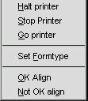

View and Help Menus
These take a standard form and are not documented here.
Please use the "About Spqw" entry to display details of the version number etc when raising any problem with spqw.

