ГУАП

КАФЕДРА № 43

ОТЧЕТ   
ЗАЩИЩЕН С ОЦЕНКОЙ

ПРЕПОДАВАТЕЛЬ­­

|  |  |  |  |  |
| --- | --- | --- | --- | --- |
|  |  |  |  | Н.А. Соловьева |
| должность, уч. степень, звание |  | подпись, дата |  | инициалы, фамилия |

|  |
| --- |
| ОТЧЕТ О ЛАБОРАТОРНОЙ РАБОТЕ №1 |
| ПОСТРОЕНИЕ И НОРМАЛИЗАЦИЯ. |
| по дисциплине: КОНСТРУИРОВАНИЕ ИНФОРМАЦИОННЫХ СИСТЕМ |
|  |
|  |

РАБОТУ ВЫПОЛНИЛ

|  |  |  |  |  |  |
| --- | --- | --- | --- | --- | --- |
| СТУДЕНТ ГР. № | 4631 |  |  |  | С.А. Гришин |
|  |  |  | подпись, дата |  | инициалы, фамилия |

Санкт-Петербург 2018

**Каталог интернет-магазина**

1. **Концептуальная модель базы данных**

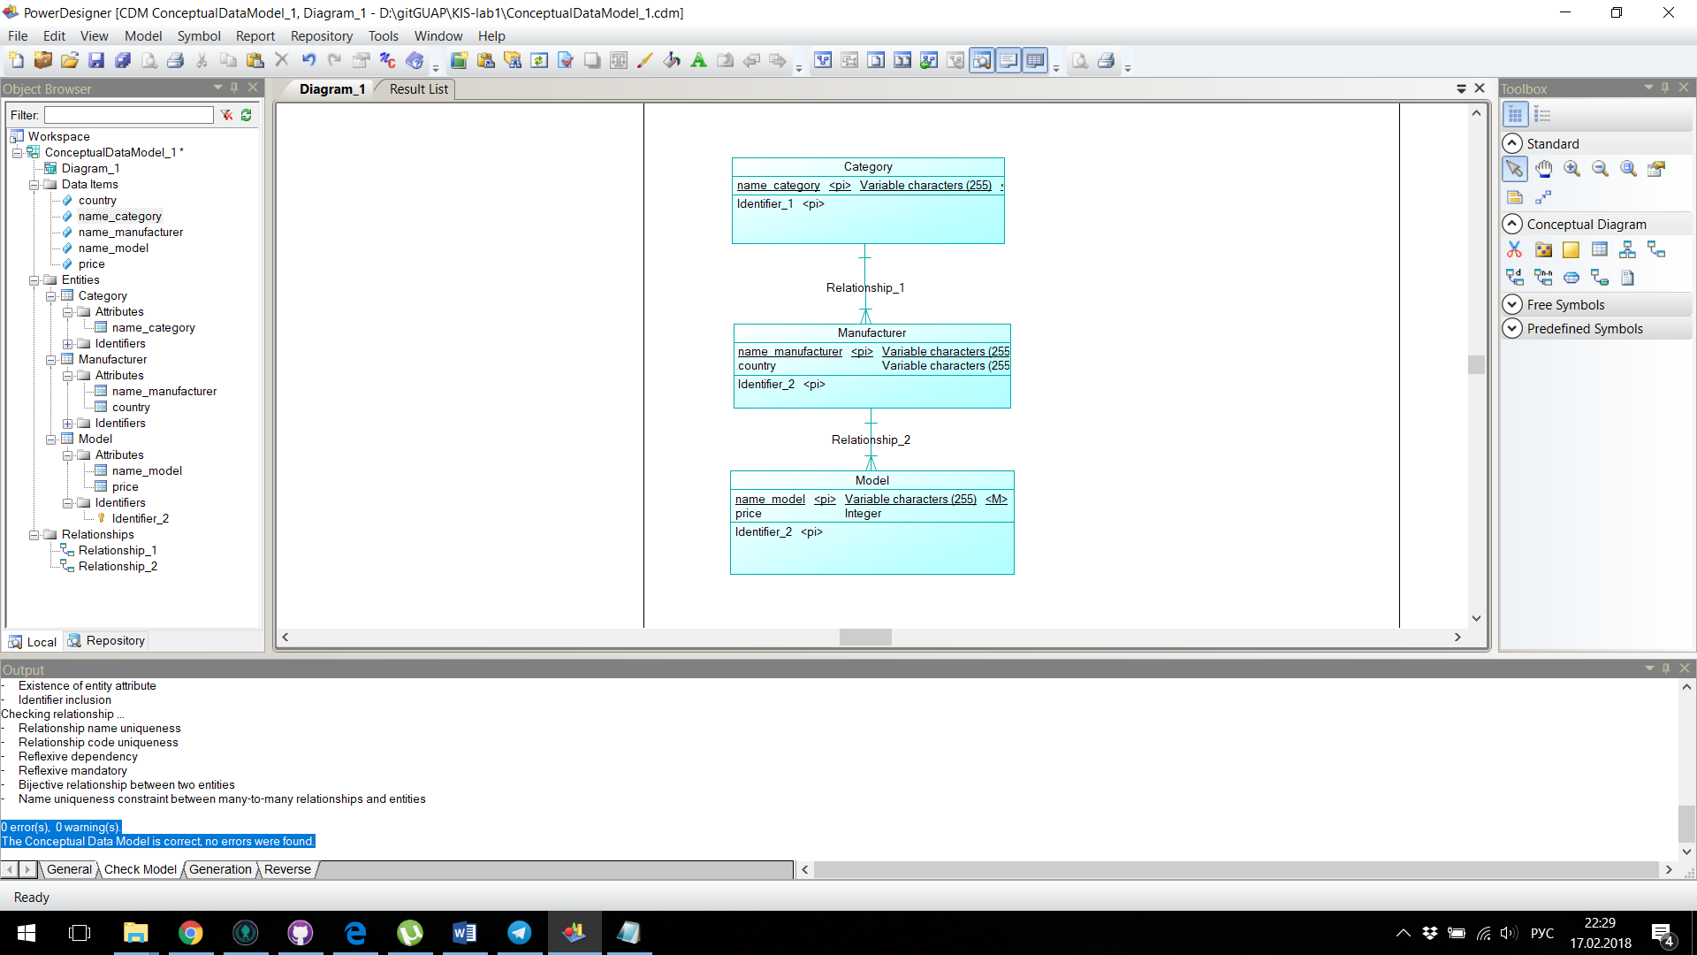

1. **Проверка на ошибки**

Checking package ...

- Circular dependency

- Circularity with mandatory links

- Shortcut potentially generated as child table of a reference

Checking data item ...

- Data Item name uniqueness

- Data Item code uniqueness

- Data Item not used

- Data Item used multiple times

- Detect differences between data item and associated domain

- Detect inconsistencies between check parameters

- Precision > Maximum Length

- Undefined data type

- Invalid data type

- Incompatible format type

Checking entity ...

- Entity name uniqueness

- Entity code uniqueness

- Entity name maximum length

- Entity code maximum length

- Existence of attributes

- Number of serial types > 1

- Existence of identifiers

- Existence of relationship or association link

- Redundant inheritance

- Multiple inheritance

- Parent of several inheritances

- Redefined primary identifier

Checking entity attribute ...

- Entity Attribute name uniqueness

- Entity Attribute code uniqueness

Checking identifier of entity

- Identifier name uniqueness

- Identifier code uniqueness

- Existence of entity attribute

- Identifier inclusion

Checking relationship ...

- Relationship name uniqueness

- Relationship code uniqueness

- Reflexive dependency

- Reflexive mandatory

- Bijective relationship between two entities

- Name uniqueness constraint between many-to-many relationships and entities

0 error(s), 0 warning(s).

The Conceptual Data Model is correct, no errors were found.

1. **Физическая модель базы данных**

