**EECE 433 – Hassan Khalil – LAB 3 ER – 202320225 – 2/10/2024**

**Exercise 1:**

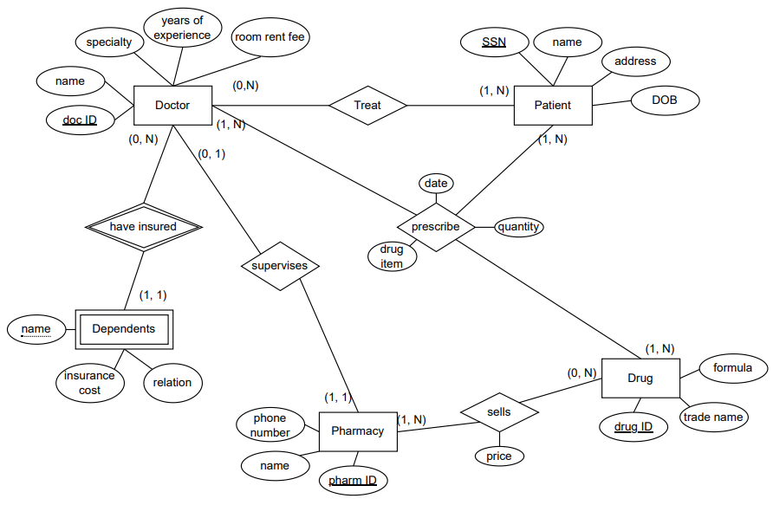

**Exercise 2:**

Assumptions:An owner needs to own at least one property; double function where an employee needs to be assigned to a sales office to manage it, thus the manages function being connected to the ‘assigned’ function.

**Exercise 3:**

Assumptions: A borrower doesn’t need to borrow a book at all times; a publisher needs to have published at least 1 book; a borrower borrows a book that is found in the library, not directly from the library (not ternary).