# **Responsive Data Driven Filter Grid & Data Card Component**

Pick your tools, construct the Filter Grid & Data Card Component in a scalable format.

**Requirements:**

* Filter Grid Component: 3 columns for desktop, 2 for mobile.
* Data Card vars:
  + String: ID
  + Array: Tags
  + String: Title
  + String: Image URL
  + String: Description
  + Boolean: featured
  + Sample DATA:

{   
 "id":"Nerium",  
 "tags":["CMS Selection", "Experience Design"],  
 "image":"http://herodigi....jpg",  
 "title":"Nerium: Reimagining the digital CX for Nerium International",  
 "description":"As Nerium Internation....",  
 "featured":0  
 },

* Content cards flip on *hover* for desktop, flip on *tap* for mobile. 3D CSS transform.
* Filters are compounding, if Tag #1 & Tag #2 are selected, only show cards with both tags. If no filters are selected, show all cards. Filters distribute as shown below, and become a dropdown on mobile.
* Parse JSON for populating your content from: [**https://s3-us-west-1.amazonaws.com/hero-engineering-public/interview/fe-code-challenge.json**](https://s3-us-west-1.amazonaws.com/hero-engineering-public/interview/fe-code-challenge.json)
* Use a framework of your choice to populate & filter the cards (React, Vue or Angular)
* All cards must be uniform in height, and support any amount of content. Note the text truncation in the mockup below.
* Filters are buttons on desktop, dropdown on mobile
* Provide public github link to your finished project
* Mockups below

**Data Card Component**

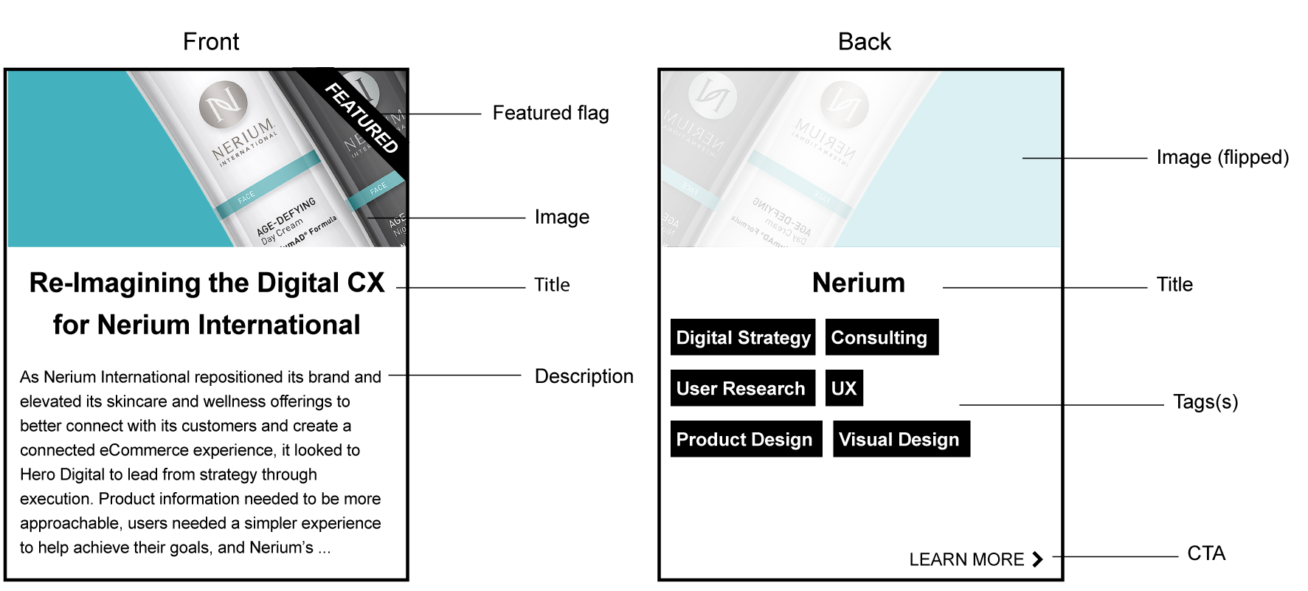

**Filter Grid Component Desktop**



**Filter Grid Component mobile (wireframe)**

