配置daemon文件,使得默认IP不再是172.17开头.

{

"registry-mirrors": ["https://registry.docker-cn.com","https://hgsvtt76.mirror.aliyuncs.com"],

"bip":"192.168.1.5/24",

"flxed-cidr":"10.20.0.0/16",

"flxed=cidr-v6":"2001:db8::/64",

"mtu":1500,

"default-gateway":"10.20.1.1",

"default-gateway-v6":"2001:db8:abcd::89",

"dns":["10.20.1.2","10.20.1.3"]

}

Docker守护进程的C/S,默认仅监听linux socket格式的地址

,/var/run/docker.socket;如果使用TCP套接字,编辑

/etc/docker/daemon.json

hosts:[“tcp://0.0.0.0:23755”,”unix:///var/run/docker.sock”]

或者docker –H|--host

1. docker启动失败 问题处理, "storage-driver":"devicemapper"放在末尾.,ss -tnl

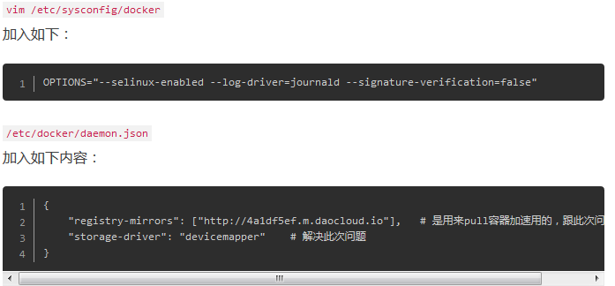

Docker 存储卷,volume

两种类型 :

1. bind mount volume

docker dun –it –v HOSTDIR:VOLUMEDIR –name bbox2 busybox

docker inspect –f {{.Mounts}} bbox2

查看bbox容器的卷,卷标识及挂载的主机目录

1. docker-managed volume

docker run –it –name bbox1 –v /data busybox

docker inspect –f {{.Mounts}} bbox1