|  |  |  |
| --- | --- | --- |
| Benjamin VIAL |  | COMP 371 – Final Project Report |
| 29590765 | Instructors: | Sudhir P. MUDUR  Charalambos POULLIS |
|  | Pages: | 6 |

**Purpose**

The application presented in this report is an extension of a graphics engine, written using the following:

* C++ 11
* OpenGL 3.3 (core profile)
* GLEW 2.1.0
* GLFW 3.2.1
* GLM 0.9.8.5

Its main goal was to provide learning grounds for modern OpenGL graphics programming. Following is a list of implemented concepts and techniques.

**Implemented concepts and techniques**

|  |  |  |
| --- | --- | --- |
| **Category** | **Concept or technique** | **Comments** |
| Lighting | Phong lighting model | Ambient, diffuse, and specular lighting |
| Lighting | Rim lighting | Additional lighting around the edges of an entity, dependent on camera position |
| Lighting | Day and night cycle | Dynamic sun and moon positions, dynamic light source color dependent on time of day |
| Lighting | Fog scattering and absorption | Squared exponential fog factor, color dependent on time of day |
| Shadows | Shadow mapping | Two-pass shadow computations for point shadows, using cubemap textures and grid-based PCF |
| Collision | Collision detection | Bounding spheres and pair-wise detection, O(n2) |
| Collision | Collision resolution | Arbitrary deciding on a model to stay stationary until collision is resolved |
| Animation | Keyframe animation | Frame-dependent running animation |
| Animation | Constrained pathing | Frame-dependent entity pathing bound to the rendered ground texture |
| Modelling | Hierarchical modelling | Joint-based hierarchical modelling |
| Other | Skybox | Color dependent on fog density and time of day |
| Other | Grass | Billboard, star-shaped polygons instantiated and warped in the fragment shader |
| Other | Particle effects | Falling rain |
| Other | Procedural generation | Pseudo-random entity placement, orientation, and pathing |
| Other | Frame rate display | Window title updated periodically with current FPS |
| Architecture | Optimized VAO binding | Reduced number of VAO switches by having all cube-based, modelling entities share a unique VAO |
| Architecture | Object-oriented code | Focus on reusability and flexibility (to a lesser extent towards the end!) |

**User input**

Custom implementation controls are listed below.

|  |  |  |
| --- | --- | --- |
| **Input** | **Action** | **Comments** |
| = | Change shadow map PCF grid samples | Increase (hold SHIFT to decrease) |
| [ | Change shadow map maximum bias | Increase (hold SHIFT to decrease) |
| ] | Change shadow map minimum bias | Increase (hold SHIFT to decrease) |
| ; | Change shadow map PCF grid factor | Increase (hold SHIFT to decrease) |
| ' | Change shadow map PCF grid offset | Increase (hold SHIFT to decrease) |
| Y | Toggle fog |  |
| I | Toggle rain |  |
| F | Toggle day and night cycle | Shader-generated grass animation is enabled if day and night cycle is enabled |
| V | Toggle shadow map debug quad | Render cubemap negative-Y texture |

Actions that are requisites for the project (as in, not extending assignment guidelines) are listed below for reference.

|  |  |  |
| --- | --- | --- |
| **Input** | **Action** | **Comments** |
| UP | Rotate scene around the X-axis | Upwards rotation |
| DOWN | Rotate scene around the X-axis | Downwards rotation |
| LEFT | Rotate scene around the Y-axis | Leftwards rotation |
| RIGHT | Rotate scene around the Y-axis | Rightwards rotation |
| ESCAPE | Quit application |  |
| SPACEBAR | Set main model position | Pseudo-random position, clamped to ground |
| 0 | Rotate head | Clockwise (hold SHIFT for counter-clockwise) |
| 1 | Rotate neck | Clockwise (hold SHIFT for counter-clockwise) |
| 2 | Rotate right shoulder | Clockwise (hold SHIFT for counter-clockwise) |
| 3 | Rotate right elbow | Clockwise (hold SHIFT for counter-clockwise) |
| 4 | Rotate right hip | Clockwise (hold SHIFT for counter-clockwise) |
| 5 | Rotate right knee | Clockwise (hold SHIFT for counter-clockwise) |
| 6 | Rotate left shoulder | Clockwise (hold SHIFT for counter-clockwise) |
| 7 | Rotate left elbow | Clockwise (hold SHIFT for counter-clockwise) |
| 8 | Rotate left hip | Clockwise (hold SHIFT for counter-clockwise) |
| 9 | Rotate left knee | Clockwise (hold SHIFT for counter-clockwise) |
| - | Rotate torso | Clockwise (hold SHIFT for counter-clockwise) |
| H | Toggle pathing | Animations are enabled if pathing is enabled |
| B | Toggle shadows |  |
| Z | Toggle lighting | Shadows are disabled if lights are disabled |
| X | Toggle textures |  |
| C | Toggle frame and grid |  |
| R | Toggle animations |  |
| U | Scale main model up | Clamped between 0.1f and 5.0f |
| J | Scale main model down | Clamped between 0.1f and 5.0f |
| P | Change rendering primitive | GL_POINTS |
| L | Change rendering primitive | GL_LINES |
| T | Change rendering primitive | GL_TRIANGLES |
| HOME | Reset camera position and rotation |  |
| END | Reset main model position, rotation, and scale |  |
| W | Transform main model | Clockwise rotation around Z-axis (hold SHIFT to move along positive X-axis) |
| A | Transform main model | Counter-clockwise rotation around Z-axis (hold SHIFT to move along negative X-axis) |
| S | Transform main model | Clockwise rotation around Y-axis (hold SHIFT to move along positive Z-axis) |
| D | Transform main model | Counter-clockwise rotation around Y-axis (hold SHIFT to move along negative Z-axis) |

**Architecture**

Because the architecture turned into a hefty beast over the last few months, and because of a wish of keeping this report concise, it has been resumed into the UML class diagram below, which hopefully conveys the strategy employed for concept encapsulation. Implicit relationships have been left out for the sake of legibility.

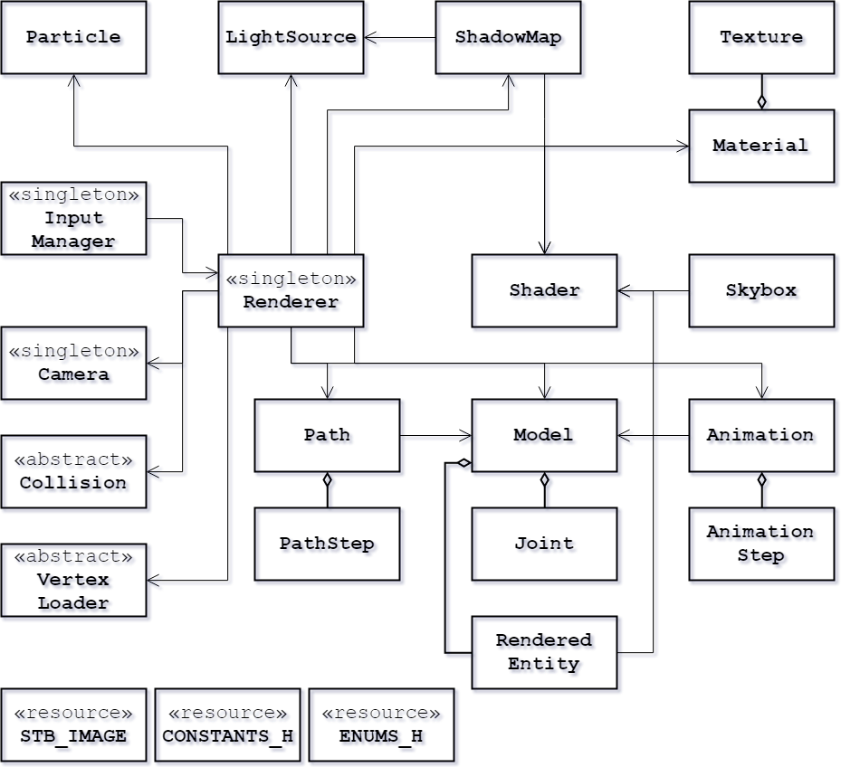

**Challenges and obstacles**

Implementing hierarchical modeling was the first road block encountered during the development of this application. Eventually, a map for a given model was established between an entity and its parent, provided they make up the same joint. The model matrix for the entity is then computed by pushing model matrices, excluding scaling, upon a stack, traversing the map until the pointer to a parent is null. The stack is then unwound, adding joint rotations in the process.

The next major obstacle was point shadows, and the difficulty in rendering a proper cubemap texture. Although a traditional, one-texture approach would have been fine for the requirements of assignment 2, it had already been decided at that point that a day and night cycle was to be implemented, which would be tremendously more difficult to do with a single texture. Eventually, the external tool RenderDoc (highly recommended: <https://renderdoc.org/>) was used to debug shader uniforms and the textures and buffers written to by the graphics pipeline.

Lastly, with the addition of several other models to the scene, frame rate began to drop, and time-dependent implementations began to behave erratically. It was decided to opt for a time step taken from the minimum of the time taken by the rendering loop, and the screen refresh rate (1/60). This solved some, but not all issues, and pathing kept on being severely affected by frame rate, sometimes causing the models to, for lack of a better expression, pirouette wildly in place before the path step was updated.

But, perhaps more than all of these, the main challenge was dealing with a mixture of constant self-criticism, the will to refactor code, and wanting to implement as many features as possible. This project provided the perfect learning grounds in the field of computer graphics, and it was difficult to cut down on features to polish the main requirements.

**Further development**

As they were implemented last, shader-warped blades of grass and particle effects could have been made prettier. Fog scattering and absorption would also have looked more natural if it had been calculated as a volume instead of a color on a flat texture, and if the skybox texture had been affected by it in a more arbitrary fashion (such that only the horizon was covered in a thick fog). Shadows suffer from severe perspective aliasing, which cannot be solved by simply tweaking bias and PCF sampling. Cascaded shadow maps seem like a reliable alternative.

Finally, because it seems like a constant, nagging voice in the back of my head, extensive refactoring should be done to the engine to allow for a more flexible and reusable structure. Building a graphics or game engine from scratch is a (very!) long-term project, and this course has been an excellent incentive towards pushing me in undertaking that endeavor.

**Final thoughts**

As a final note, I would like to share my gratitude for taking the risk to change the structure of the course, and how much I appreciate making all submissions individual. I believe the goals of the instructors, which were to encourage personal learning and to discourage unequal contributions, were reached far and beyond. Thank you for an excellent course.

UML class diagram drawn on *draw.io*.

Resource credits included in the credits/ folder.

*I certify that this submission is my original work and conforms to the Faculty’s Expectations of Originality.*

Benjamin Vial, on 2018-04-12