Bill Matching for Bill No PNE5162

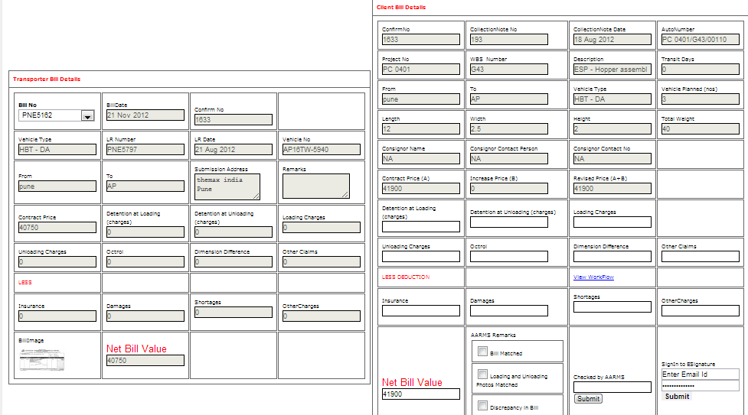

Trip Details for Bill No PNE5162

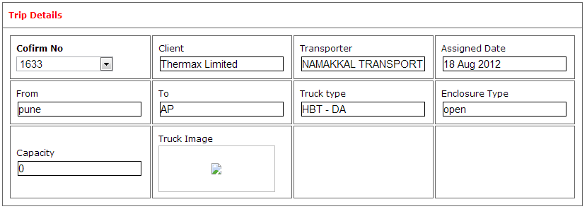

Shipping Details for Bill No PNE5162

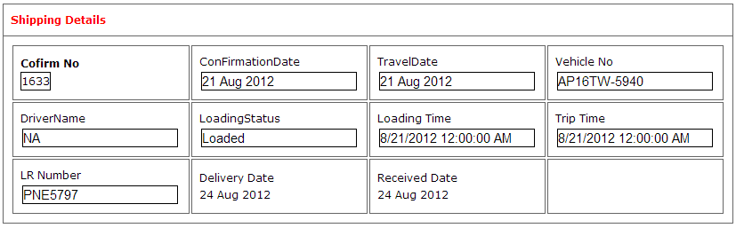

Bill Payment Submission for Bill No PNE5162

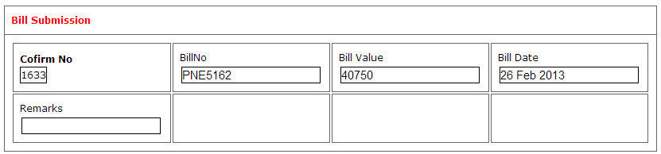

Bill Payment for Bill No PNE5162

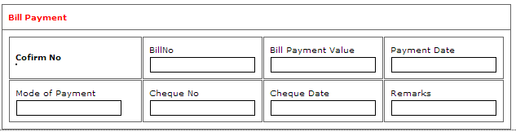

Loading Status Report

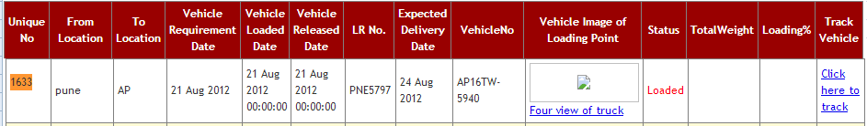

Collection Status Report



Bill Matching for Bill No PNE5154

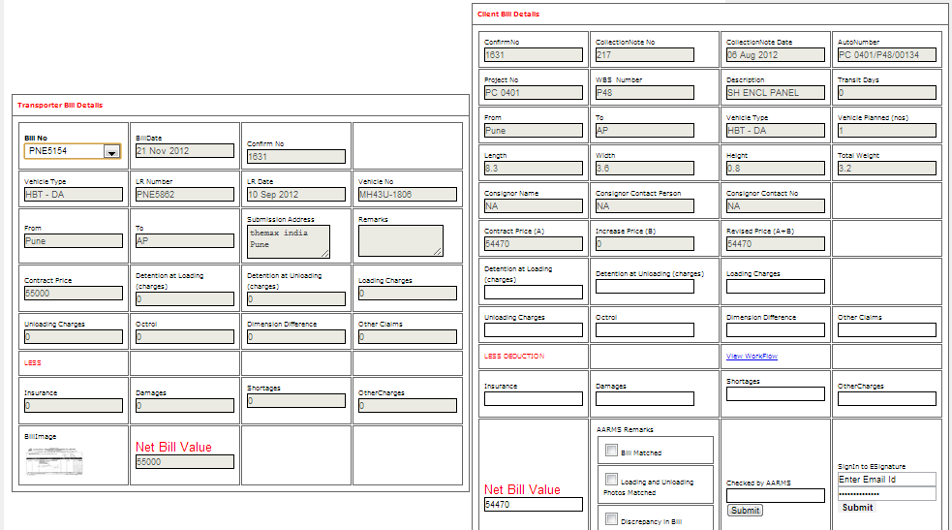

Trip Detaills

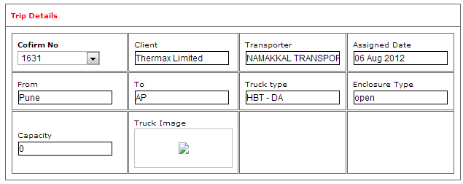  
Shipping Details

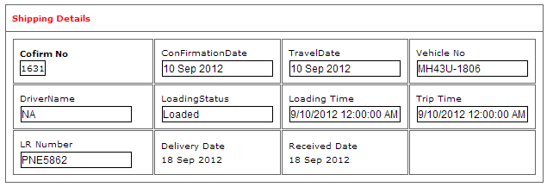

Bill submision

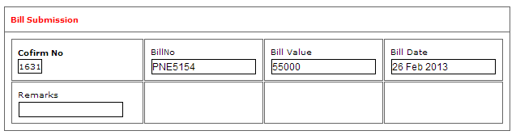

Bill Payment



Loading Status Report

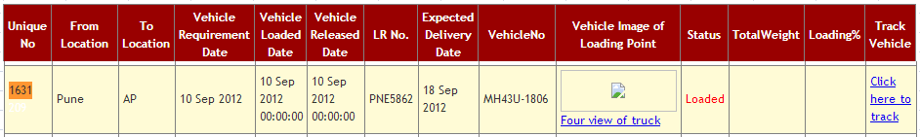

Collection Status Report



Bill Matching for Bill No PNE5040

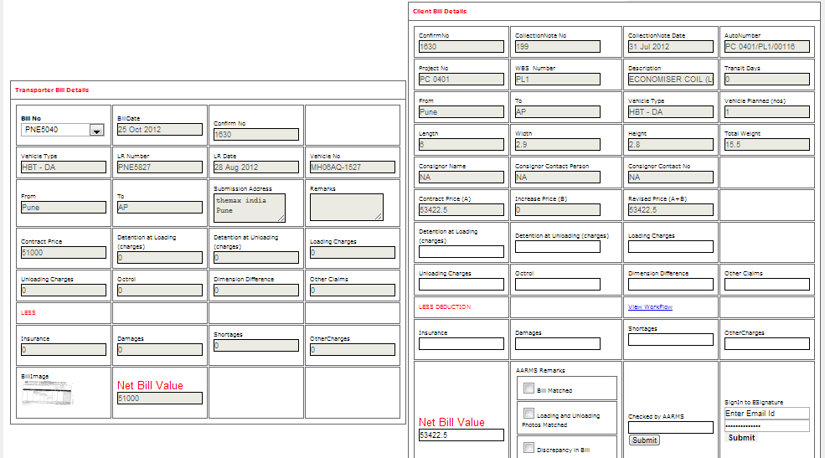

Trip Details

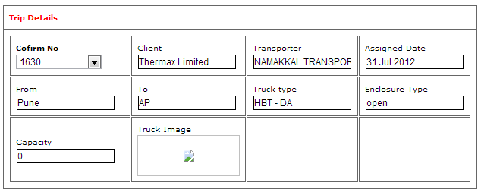

Bill Submission

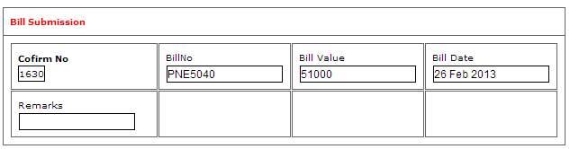

Bill Payment

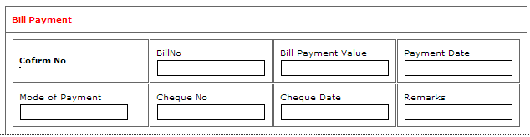

Loading Status Report

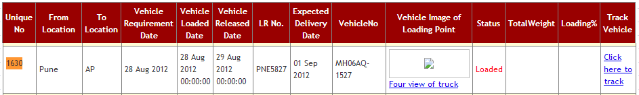

Collection Status Report



Bill Matching for Bill No PNE5190

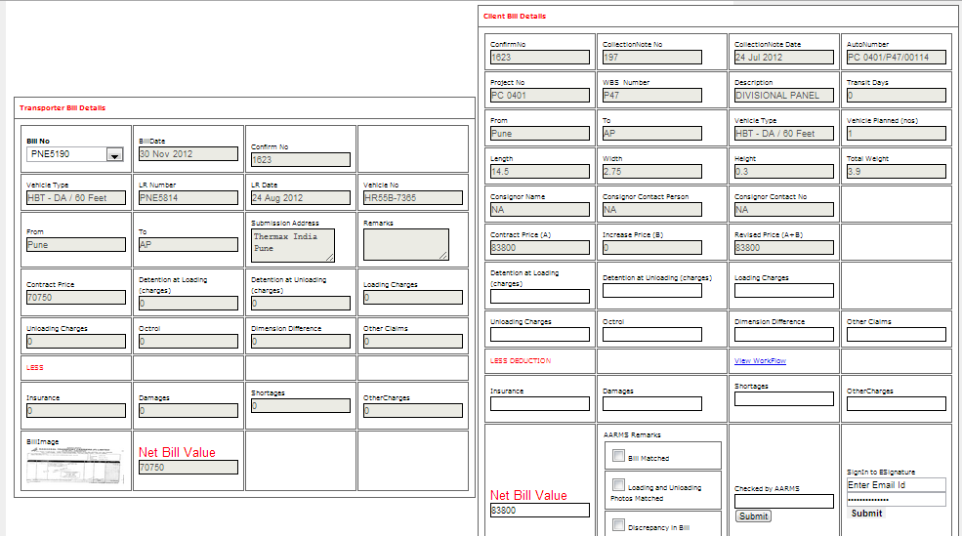

Trip Details

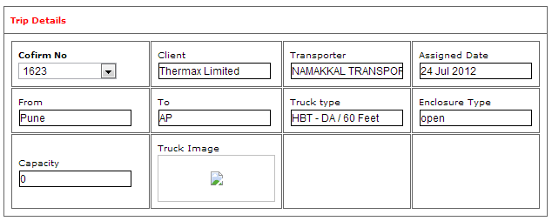

Shipping Details

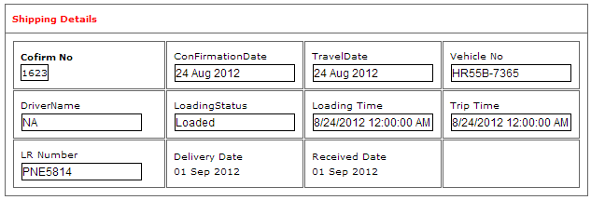

Bill Submission

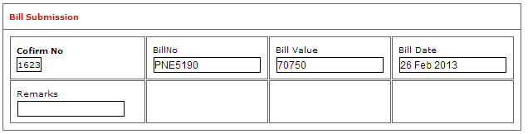

Bill Payment

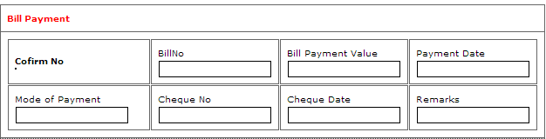

Loading Status Report

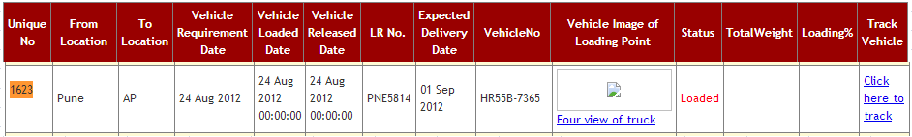

Collection Status Report



Bill Payment for Bill No PNE6705

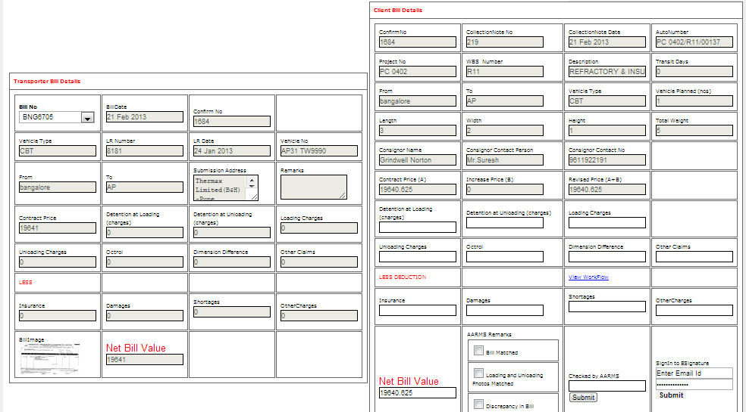

Trip Details

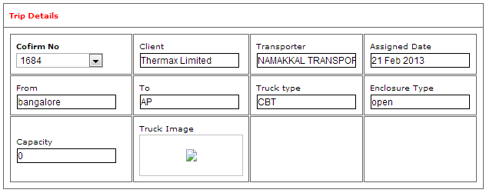

Shipping Details

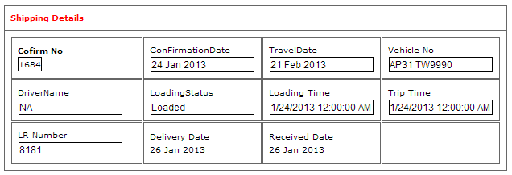

Bill Submission

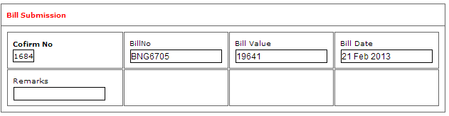

Bill Payment

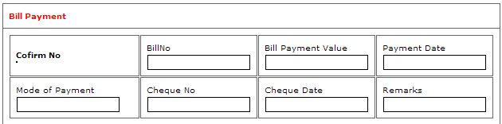

Loading Status Report

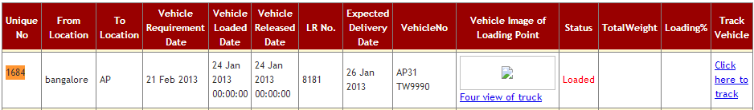

Collection Status Report



Bill Payment for Bill No PNE5030

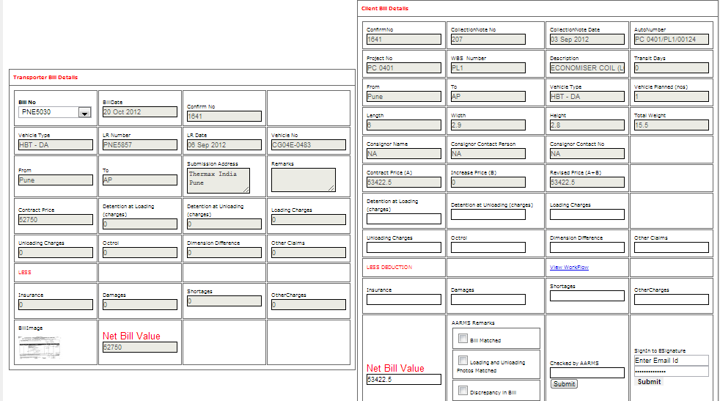

Trip Details

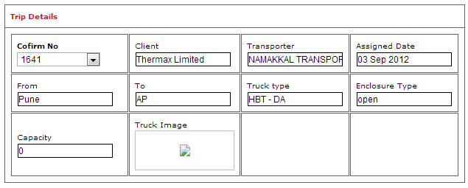

Shipping Details

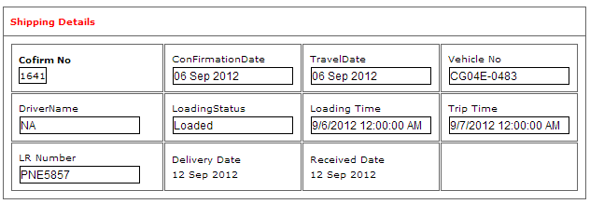

Bill Submission

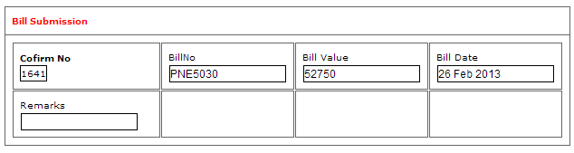

Bill Payment

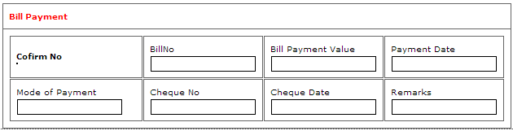

Loading Status Report

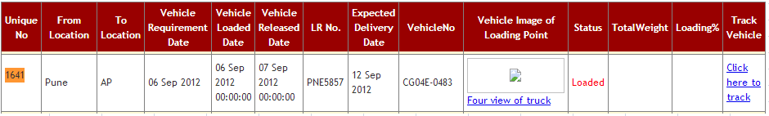

Collection Status Report



Bill Payment for Bill No PNE5029

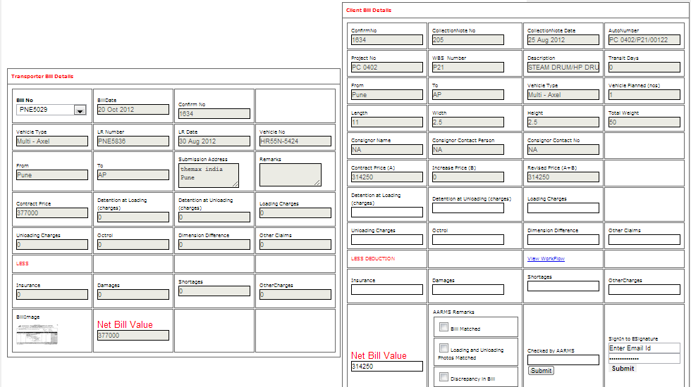

Trip Detais

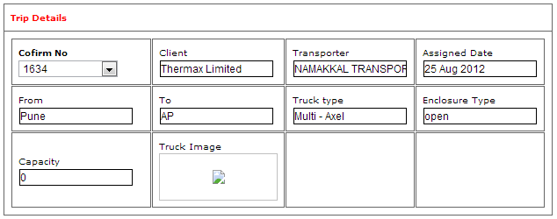

Shipping Details

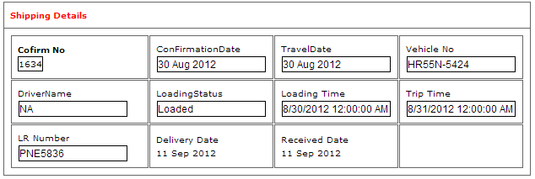

Bill Submission

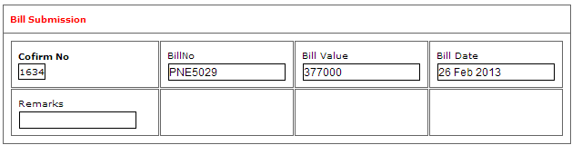

Bill Payment



Loading Status Report

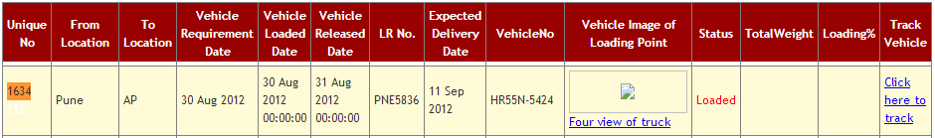

Collection Status Report



Bill Payment for Bill No PNE5038

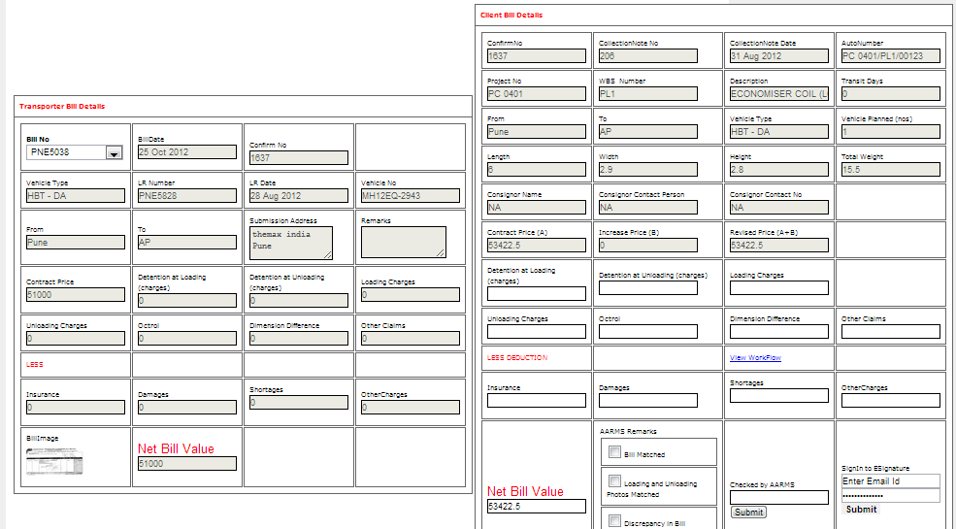

Trip Details

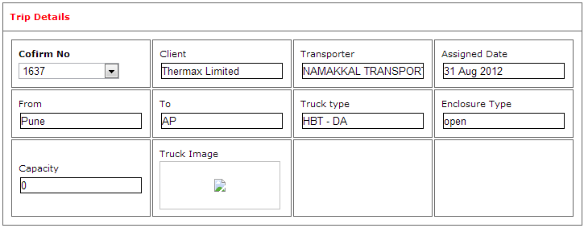

Shipping Details

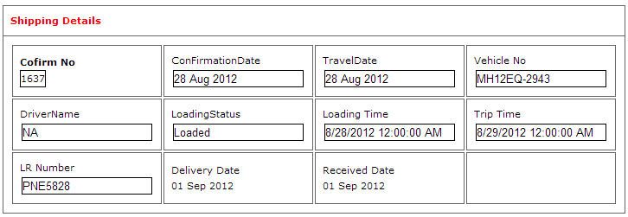

Bill Submission

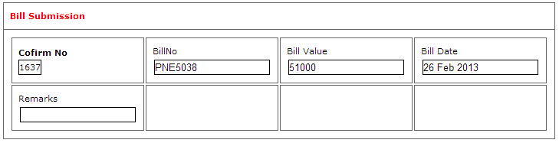

Bill Payment

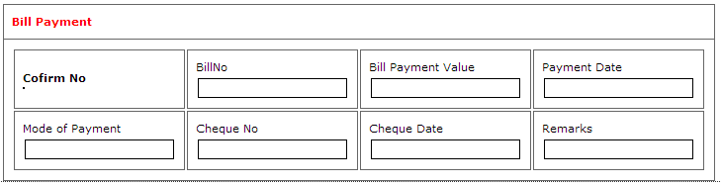

Loading Status Report

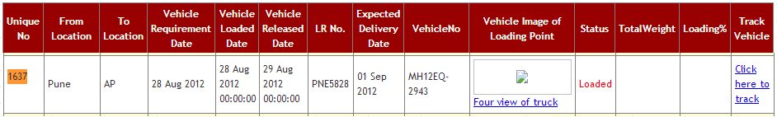

Collection Status Report



Bill Payment for Bill No PNE5269

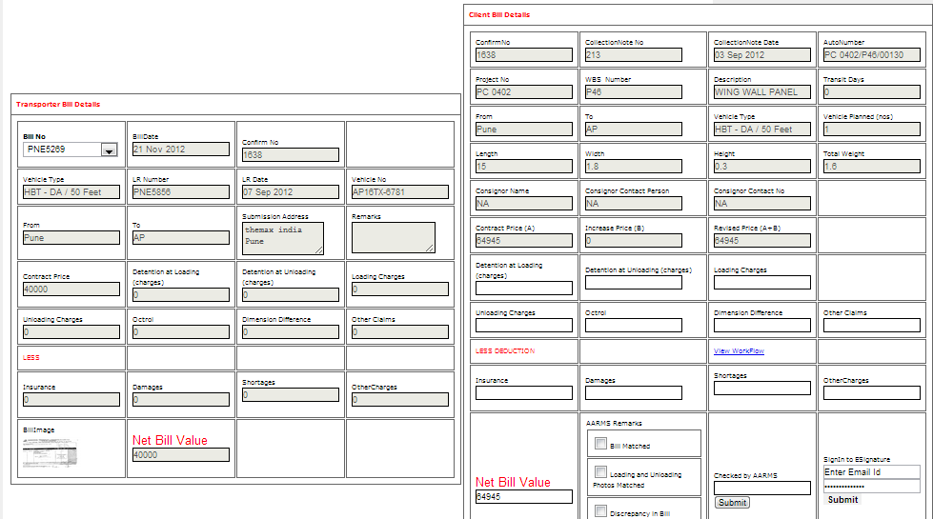

Trip Details

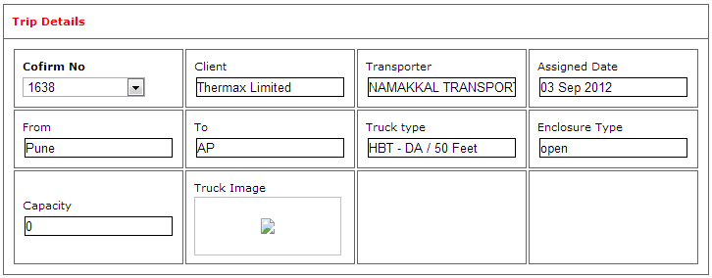

Shipping Details

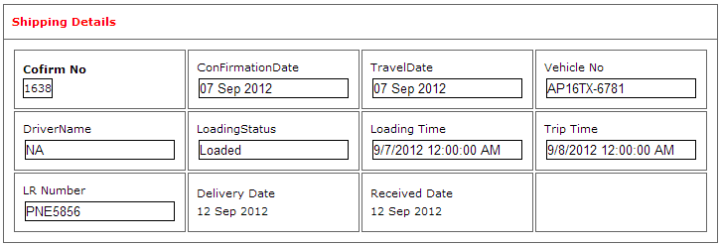

Bill submission

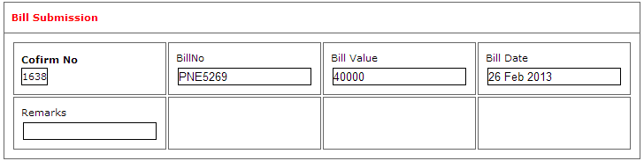

Bill Payment



Loading Status Report

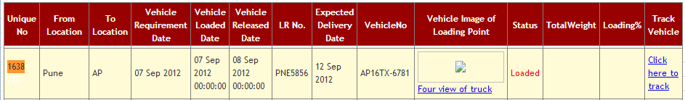

Collection Status Report



Bill Payment for Bill No PNE5035

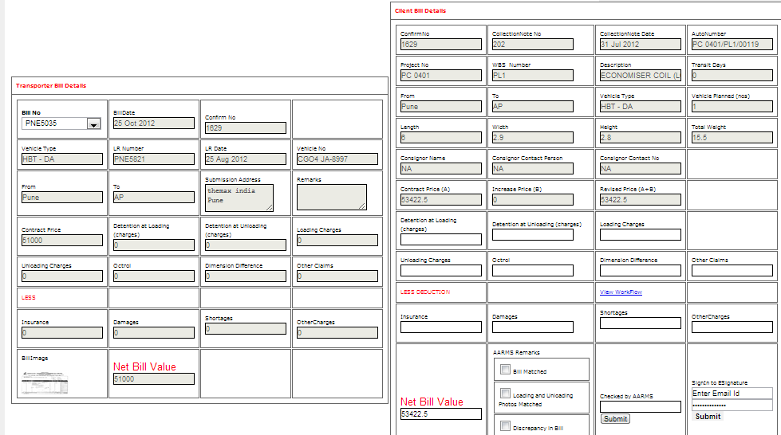

Trip Details

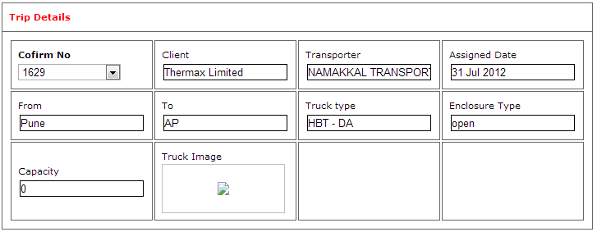

Shipping Details

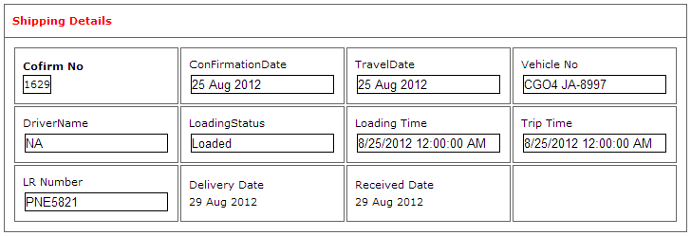

Bill Submission

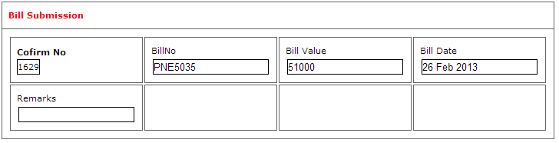

Bill Payment



Loading Status Report

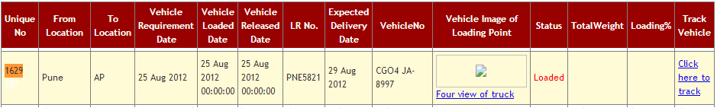

Collection Status Report

