CURRENT SCENARIO OF LOGISTICS INDUSTRY IN INDIA
Logistics is a quite an old concept, it has been becoming very efficient only after the wave of 1990s globalization. With the advent of intense competition coupled with globalization and liberalization forced both public and private firms committing themselves to make available to the customers, the right condition material, at the right place, at the right time, at the very lowest cost-may be a product or a service.
The World Bank in a recent survey connecting to compete: Trade logistics in global economy which conducts the LPI survey for every two years. The LPI is a multidimensional assessment of logistics performance, rated on a scale from one (worst) to five (best). The index uses more than 5,000 individual country assessments made by nearly 1,000 international freight forwarders to compare the trade logistics profiles of 155 countries.
Based on a worldwide survey of freight forwarders and express carriers, the Logistics Performance Index (LPI) is a benchmarking tool developed by the World Bank that measures performance along the logistics supply chain within a country. Allowing for comparisons across 155 countries, the index can helps in identify challenges and opportunities and improve their logistics-performances.
Technological progress and worldwide trade and investment liberalization are presenting new opportunities for countries to harness global markets for growth and poverty reduction. But with the advent of global supply chains, a new premium is being placed on being able to move goods rapidly, reliably, and cheaply. The ability to connect to the worldwide logistics web depends on a country's infrastructure, service markets, and trade processes.
The government and the private sectors in many developing countries should improve these areas - or face the large and growing costs of exclusion, said a World Bank report.
The Indian logistics industry has grew8-10% annually in between the periods of 2002-2007. There ate several factors are responsible for the growth of the logistics industry.
- The emergence of organized retail.
- Country’s tax regime policy.
- Growth in industry segments –automobiles, FMCG and pharmaceuticals.
- Improvement in infrastructure.
- Increase in foreign trade.

LIST OF TOP LOGISTICS COMPANIES OF INDIA:

TNT Express:
This company is a key leader in the international market in the sector of global express services. The company ensures safe and on time delivery of your documents, freight and parcels. The company offers time and day definite delivery in about 200 nations across the world. It operates 47 jet freighter aircraft and 26,000 road vehicles and has a network of 2,300 companies.
AFL :
One among the acknowledged leaders among the logistics companies in India is AFL. Through its domain of logistics services, the company has delivered world class service in India. In 1979,the company introduced the first ever courier service by forming an alliance with DHL World Wide Express. The company offers services like Logistics and warehousing, Courier Company and Custom Consultant.

DHL :
This company is one among the major logistics companies in India. It is a market leader globally in overland transport, air freight and international express. The company ranks No.1 in the world in contract logistics and ocean freight. The biggest logistics and express network in the world has a network in about 220 territories and countries,72,000 vehicles,350 Aircrafts,36 hubs and 4,700 bases.

Blue Dart :
This logistics company is South Asia's top integrated express package Distribution and Courier Company. The domestic network of the company covers about 21,340 locations and provides service to 220 countries by the company's sales alliance with DHL. It provides the best service like Free Pick up from Your location, Regulatory Clearances, Real Time Tracking, Free Computerized Proof of Delivery etc.

Gati :
The company is a key leader in then arena of express cargo delivery and a significant one in the supply chain management solutions and distribution in India since the year 1989.The company provides services like the Ware Housing, Express Cargo etc. Logistics Solutions of the company are Warehousing, Supply chain Management. The Distribution Solutions of the company are Gati Surface Express, Gati coast to coast and Gati Air Express etc.

Safexpress :
It is one of the largest express company in India. The company offers the best and integrated logistics solutions. In 2002 the Limca Book of Records declared the company as the Largest Logistics service Provider in India. The company has a network over 550 locations in 28 states and 7 countries. It has 3000 weather proof ISO-9002 vehicles.

Ashok Leyland :
The leading provider of logistic vehicles for the India Army is this company. It is a key leader in the tractor-tailers and multi axle trucks. The company manufactures buses, trucks, engines and special application vehicles in India. It is promoting a new company called Ashley Transport Services Ltd. for exchange of information and integrated services related to logistics in order to tackle the business of freight contractors.

Agarwal Packers and Movers:
This popular Indian logistics company provides logistic services like the home shifting, car packing etc. across India. The company believes in keeping technology and people and of course heart and soul in the movement of the individuals respective items. The company offers quality service in transportation and packing.

DTDC :
The biggest Domestic Delivery Network Company is DTDC. The company offers high class delivery service in about 3700 Indian locations and 240 international places. The company dispatches about 10 million parcels in a month. It also offers low cost for bigger parcels to US, UK, India, Nepal, Dubai and other places across the world.

First Flight:
This logistics company in India specializes in courier services worldwide. The multi-tracking programs of the company are Domestic, International, First Wheels, First Wings and many others. The overseas offices of the company are in Malaysia, Singapore, UK, US, UAE, Quatar, Oman.

The Indian logistics sector is growing at a rate of 20% comparing with the average logistics industry which is following growth of 10%. There is a great potential for the growth of the industry in India. The major opportunities are highlighted as below.

- Many large Indian companies started providing in house logistics services eg: Reliance and TATA.
- Indian shippers are now realizing that the customer service and the delivery performance are very much equally important.
- The government of india focusing on Infrastructure developments which include SEZ’s, FTWZ( free trade and warehousing zones) , PPP( private public partnerships).

EMERGING TRENDS IN INDIAN LOGISTICS INDUSTRY

Growth within the organised sector

The logistics and warehousing sector in India, till now, has been highly fragmented and characterised by the presence of numerous unorganised players. A large number of players have been providing services in individual segments like transportation, warehousing, packaging etc. In 2007, organised players accounted for only 6 per cent of the total US$ 100 billion Indian logistics industry However, changing business dynamics and the entry of global third party logistics players (3PL) has led to the remodelling of the logistics services in India. From a mere combination of transportation and storage services, logistics is fast emerging as a strategic function that involves end-to-end solutions that improve efficiencies.

Entry and expansion plans of logistics firms

- DHL and India-based the Lemuir Group entered into a 76: 24 joint venture – DHL Lemuir Logistics Private Ltd.
- Germany-based Rhenus AG and Hyderabad based Seaways Shipping Ltd have set up a joint venture – Seaways Rhenus Logistics Ltd.
- The UAE-based Swift Freight has forayed into the Indian market.
- Blue Dart Express is planning to add 1 million square feet of warehousing space to develop 58 warehouses across the country by 2010.
- The Future Group plans to develop 3 million square feet of warehouses by 2010.
- National Bulk Handling Corporation plans to set up 200 warehouses across the country by 2012.

Another trend witnessed over the last few years has been the entry of several large Indian corporate houses – such as the Bharti group, Tatas and Reliance Industries Limited – into the logistics sector. The Indian conglomerates foresee huge potential for specialised logistics and warehousing facilities, particularly in industries like retail. Companies like Bharti, Tata Realty & Infrastructure, GE Equipment Services and Reliance Logistics cater to the logistics needs of their own group companies as well as provide services to the other companies.

The growth of the organised sector would enable the industry to provide cost-effective and integrated logistics solutions in order to meet the ever-increasing demand. As per estimates, the market share of organised logistics players is expected to double from 6 per cent in 2007 to approximately 12 per cent by 2015.

Emerging concept of third party logistics

Third party logistics or 3PL is a concept where a single logistics service provider manages the entire logistics function for a company. Although still at a nascent stage, the Indian 3PL industry is growing at a rapid pace. Global sourcing activity and fierce competition amongst manufacturers to cut costs have made movement of materials rather complex, giving rise to the emergence of several third party logistics players.
Fuelled by the increasing trend of outsourcing, coupled with the rapid growth in the Indian manufacturing sector, 3PL is estimated to grow at about 30 per cent annually and become a US$ 30 billion industry by 2010.
nvestment Details/ PlanTyTaTable Table No.1
Firms | Investment Details/ Plans  (2007-09) (in US $ mn)
DHL | 250
TNT | 115
Gati | 200
Shreyas Shipping and Logistics | 350
Source : World bank report
The entry of large third party logistics (3PL) carriers – like Federal Express (FedEx) and DHL – and network expansion by the existing domestic players (such as Gati and Shreyas Shipping) have also contributed to the transformation of services and the business practices across this sector.

Table No.2
Public Sector Companies | Foreign Entrants | Private Sector
CentralWarehouse Corporation | DHL | Gati
Container Corporation  of India | Fed Ex | Safexpress
Food Corporation  of India | Blue Dart | Reliance  Corporation Logistics
 | TNT | Expiditors
Source :Google

Rapid growth of the warehousing sector

The role of a warehouse has also transformed from a conventional storehouse to an inventory management set-up with a greater emphasis on value added services. Warehouses now provide additional services like consolidation and breaking up of cargo, packaging, labelling, bar coding, reverse logistics etc. It has emerged as a critical growth driver, leading to large investments by logistics companies for the development of warehouses and logistics parks. Warehousing and related activities currently account for about 20 per cent of the total logistics industry.

However, it is estimated that by 2010, this proportion would increase to approximately. The traditional concept of establishing warehouses in the proximity of manufacturing facilities and raw material sourcing centres is also undergoing a transformation. Today, there is an increased trend of relocating warehouses near consumer markets.

Currently, the organised warehousing industry in India has a capacity of approximately 80 million metric tonnes (MT) and is growing at 35 to 40 per cent per annum. An investment of approximately US$ 500 million is being planned by various logistics companies for the development of about 45 million square feet of warehouse space by 2012.

Logistics parks – One-stop shop for logistics needs

The concept of a consolidated logistics centre can be traced back to the Foreign Trade Policy of 2004, which led to the development of Free Trade Warehouse Zones (FTWZ). While FTWZ were aimed at facilitating import and export of goods, the need for a one-stop shop that could additionally cater to the domestic market led to the development of logistics parks as a part of the infrastructure industry in 2005-6. A logistics park is a notified area that facilitates domestic and foreign trade by providing services like warehousing, cold storage, multimodal transport facility, container freight stations etc. This area also acts as a place where a company can unload cargo for distribution, redistribution, packaging and repackaging.

RECENT TRENDS IN INDIAN LOGISTICS INDUSTRY:

When comparing US logistics with the global logistics it accounts US$900 billion which is valued 25% of total global logistics 3.5US$ trillion. where as India is estimated to be around 13% of its GDP, which is valued around US$94 billion in 2006-07.

    - Air transport industry contributes over 0.2% of the GDP keeping the prices constant(1999-2000) Domestic air cargo has growing at CAGR of 12.80% where as international cargo traffic has been moving at 13%.. According to the planning commission, country’s cargo movement would grow about CAGR of 11.5% from 2007-08 to 2011-12.

    - Marine sector contributes over 0.2% of the GDP at a constant prices(1999-2000) major ports in India have handled about 463.84 tonnes of cargo in 2006-07 a growth of 9.51 that of the previous year.According to the planning commission of India , the shipping fleet will be increased up to 15mGRT by the end of 2011-2012.

    - The major plan of Indian railways is to develop Logistic parks which it has a potential to optimize the supply chain and reduces the cost .The Indian railways would have to innovate the new train services so that the customer shifts from road to rail.

    - Almost 80% of the products in India is transported through roads. One innovation could be the introduction of time tabled parcel trains and container trains which is essential to have few time tabled freight trains because it reduces the inventory levels and thereby improves customer satisfaction.

FUTURE OF LOGISTICS - THE INDIAN SCENARIO:

India’s logistics sector attracted investments worth Rs. 23,200 crore in first half of 2008, according to a study by Assocham”Trade logistics”2008. It outclassed some of the major sectors including aviation (Rs 20,890 cr), metals and mining (Rs 8500 cr) and consumer durables (Rs 6000 cr) among others. Among the factors cited by analysts for the rapid growth of Indian logistics include the growth of organized retail industry, commodity markets, growth in manufacturing and development of Special Economic Zones. (SEZ).

According to a report by Cushman and Wakefield”Trends in logistics”2009, real estate consultants, Indian logistics industry is expected to grow annually at the rate of 15 to 20%, reaching revenues of approximately $385 bn by 2015. Market share of organized logistics players is also expected to double to approximately 12% during the same period. The report said about 110 logistics parks spread over approximately 3,500 acres at an estimated cost of $1 bn are expected to be operational and an estimated 45 mn sq ft of warehousing space with an investment of $500 mn is expected to be developed by various logistics companies by 2012.

Demand for warehouses and logistics services are expected to accelerate further due to increase in foreign trade and the upcoming Maha Mumbai Special Economic Zone. Warehouse rentals in Panvel are expected to increase by 15 to 20% over the next two years. Proximity to textile and auto-component industry clusters and other manufacturing units has made Kolkata a major economic centre. Ten Special Economic Zones (SEZs) in the proximity of Kolkata have received in-principal approvals. This will result in major demand for logistics in this region.
There are plans for 4 logistics parks spread across approximately 400 acres. Centers like Haldia, Falta, Pargana, Dankuni, Kharagpur, Bantala and Durgapur are expected to witness substantial logistics activities in the near future. Five logistics parks are being set up in Hyderabad, spread across 220 acres and approximately 10 mn sq ft of warehouse space coming up by 2012. It scores high as a logistics destination as 10 it provides excellent connectivity to large markets in southern and western India and has established clusters of textile and engineering firms, as well as an important centre for the pharmaceutical industry.

Comparison of Indian logistics performance index with other countries:
Table No.3
Country | LPI Score
USA | 3.85
UK | 3.84
Singapore | 4.19
India | 3.07
China | 3.64
Mexico | 2.64

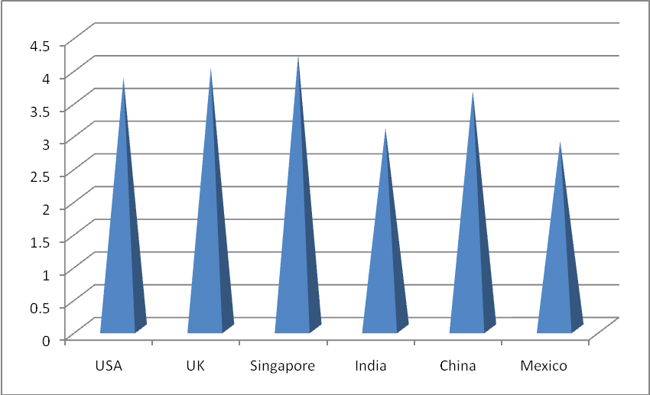
Fig.No-1 Source : World bank report on trade logistics 2007
The Logistics Performance Index (LPI) indicators provides the in-depth each country assessment of the logistics gap among countries. As the above graph shows that LPI scores of different countries and also the performance of developed countries comparing to the developing nations. Singapore-1st
USA- 9th
China-30th
India-39th
Top 10 countries LPI of low income group :
Table No-4
Country | LPI score
India | 3.07
Vietnam | 2.89
São Tomé and Principe | 2.87
Guinea | 2.71
Sudan | 2.71
Mauritania | 2.63
Pakistan | 2.62
Kenya | 2.52
Gambia | 2.52
Cambodia | 2.50

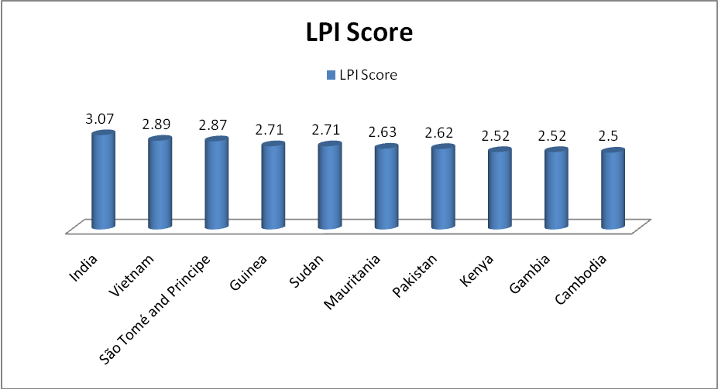
Fig.No-2 Source : World bank report on trade logistics 2007

The above graph clearly shows that India had performed much good when comparing with the other low income countries which India has ranked first having a LPI score of 3.07 when comparing with the other low income countries.
Logistics cost contributed from GDP in different countries :
Table No.5
Country | Logistics Cost/GDP
India | 13%
U.S. | 9.9%
Europe | 10%
Japan | 11.4%

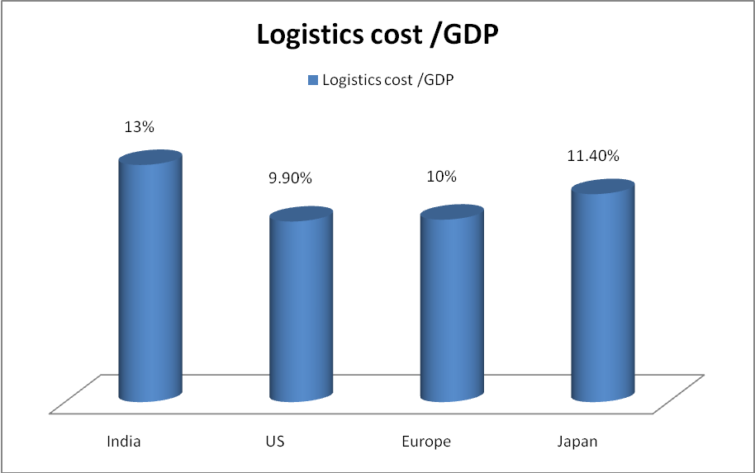
Fig.No-3 Source : World bank report on trade logistics 2007
The above graph shows that India logistic cost are very high comparing with the developed countries contributing the total GDP of 13%.High costs due to poor and under developed infrastructure , indirect tax regime policies and extensive industry fragmentation.

Share of 3PL in overall industry:
Table No.6
Country | Share of 3PL in overall Logistics
India | 10 %
U.S. | 57 %
Europe | 30 %
Japan | 80 %

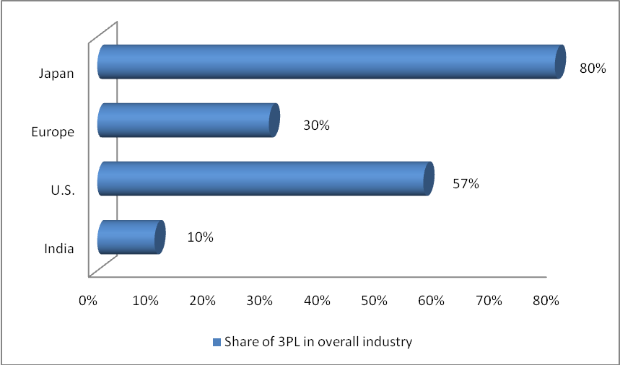
Fig.No- 4 Source : World bank report on trade logistics 2007

The above graph shows the share of Japan in 3pl is the highest when comparing with the other developed countries which it accounts for 80%. The share of india of 3pl is only 10% which shows 3PL service providers in india is very much less.

Logistics Activity by Organized Sector:
Table No.7
Country | %age of Logistics activity by organized sectors
USA | 57 %
Japan | 80 %
Europe | 40 %
India | 6 %
China | 10 %

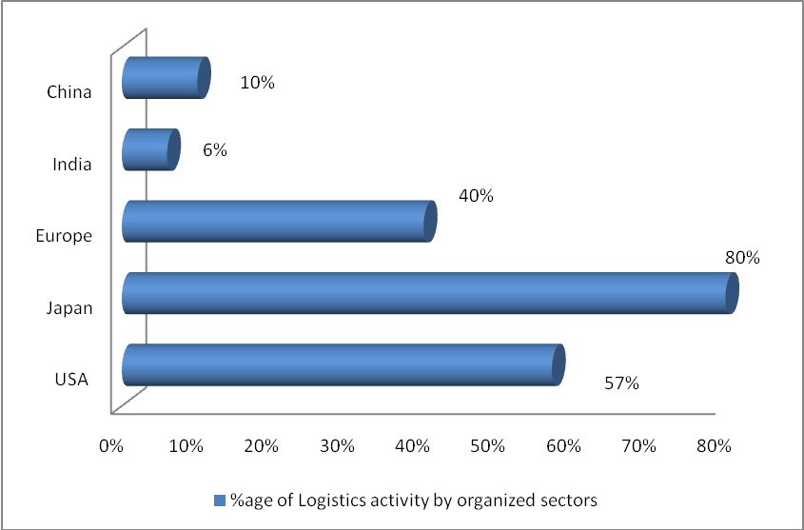
Fig.No- 5 Source : World bank report on trade logistics 2007

The above graph shows that the costs of logistics –warehousing costs inventory holding costs, transporatation costs, warehousing costs, packaging costs are much high in India as when comparing to china, Europe, USA and Japan.
Different modes of cargo movement in India :
Table No-8
Mode of Transportation | Percentage of total cargo movement
Air | 2.5 %
Sea | 20 %
Railway | 23 %
Road | 54.5 %

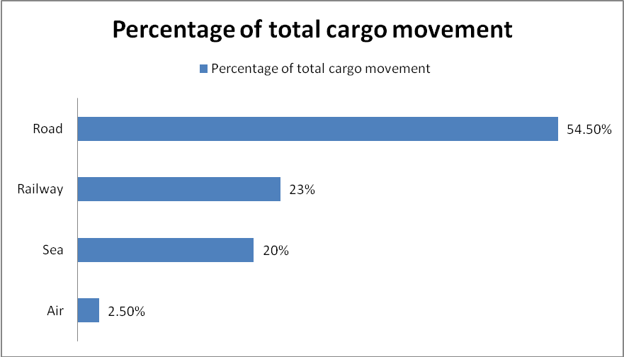
Fig.No- 6 Source : World bank report on trade logistics 2007

The Graph shows that the different modes of cargo movement in India .when comparing road with the rail , air and sea it was the ultimate choice because it covers all most all the area in India when comparing with other mode of transportation. Because of the poor infrastructure road is the best way of cargo movement as it covers rural , urban and hilly areas.Cargo movement through air is the least due to its high costs involved.

