**HALL BOOKING API**

**POST MAN DOCUMENTATION :** [**https://documenter.getpostman.com/view/36384119/2sA3kXE17M**](https://documenter.getpostman.com/view/36384119/2sA3kXE17M)

**DEPLOYED URL :**

**1.Creating a Room**

<http://localhost:4000/room/createroom>

**Method: POST**

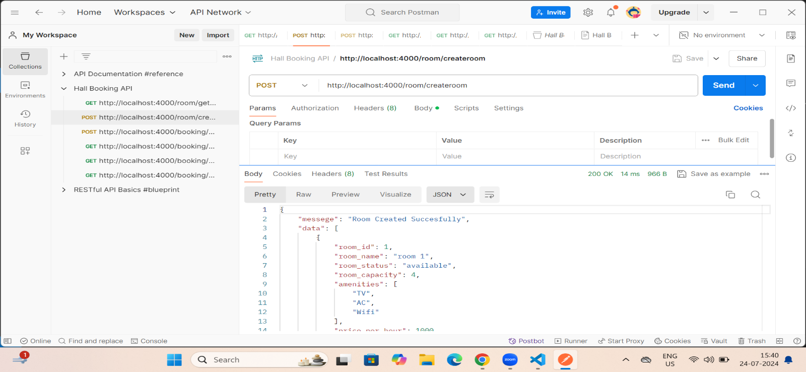

2.**Booking a Room**

<http://localhost:4000/booking/bookroom>

**Method: POST**

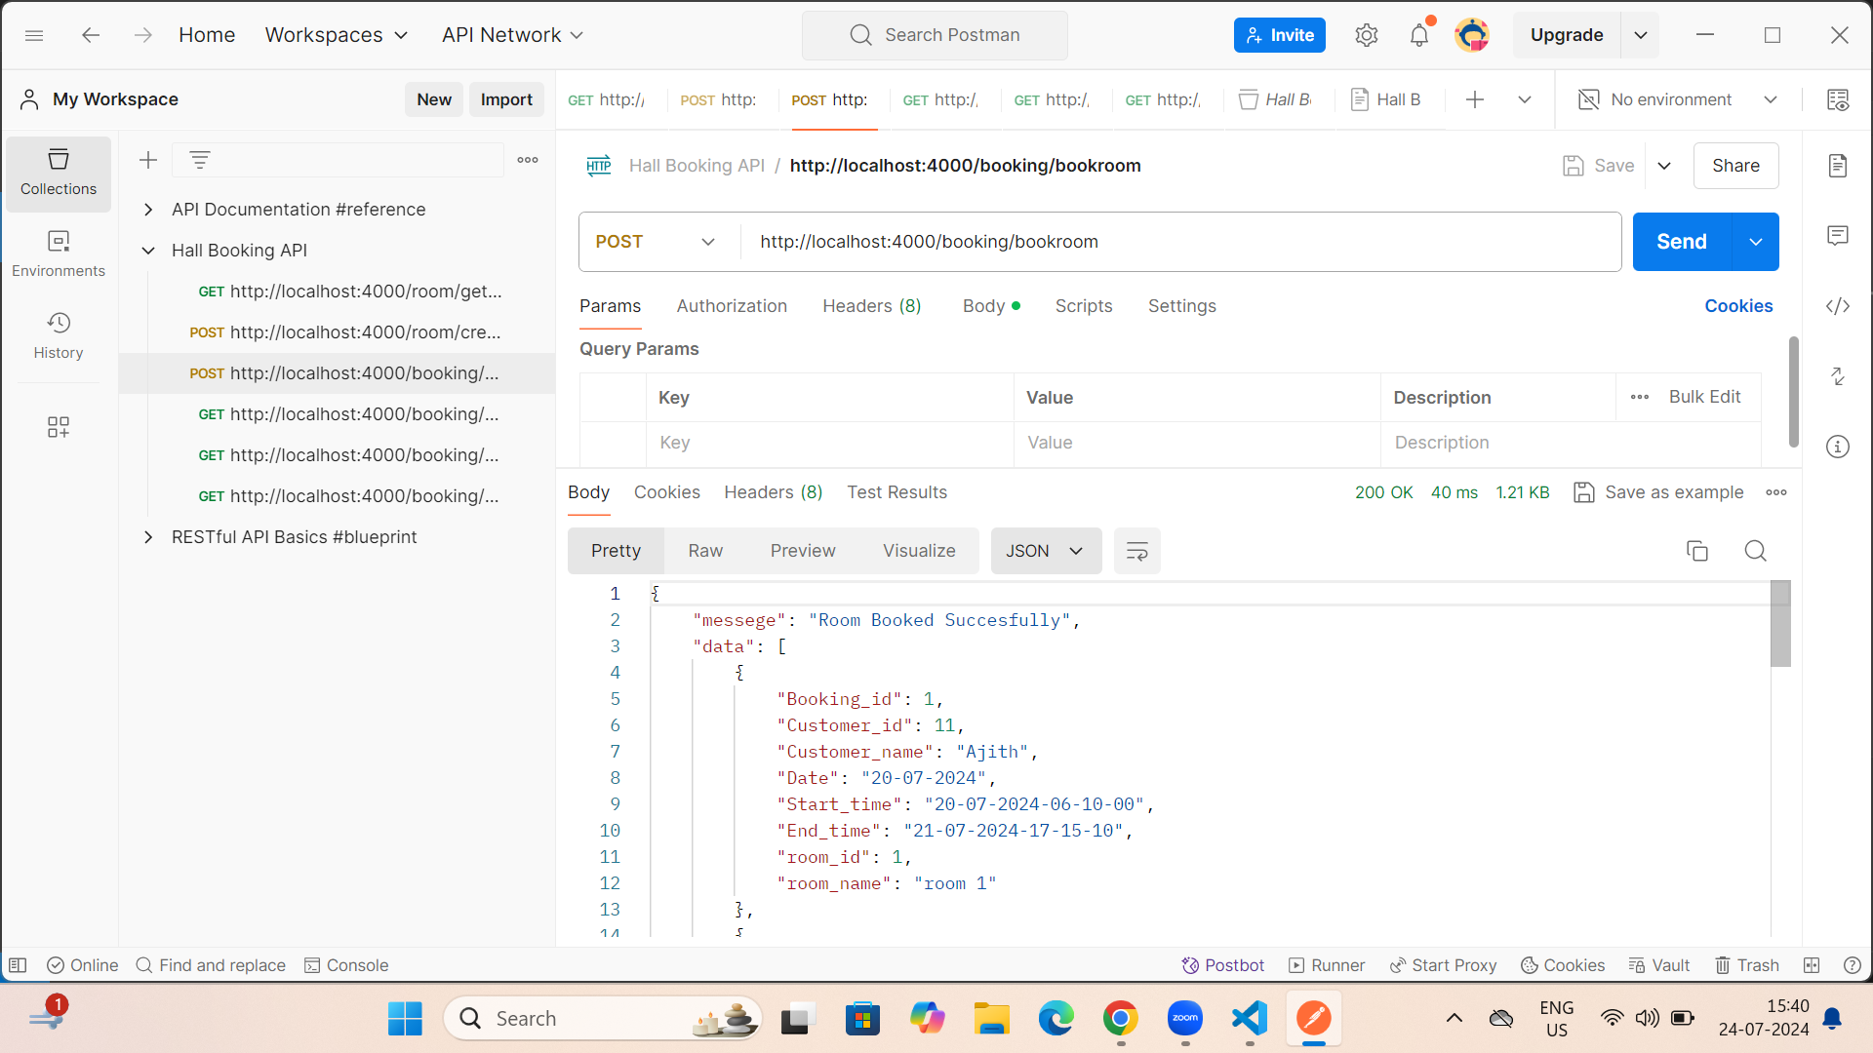

**3.Booked Room Details**

<http://localhost:4000/booking/bookedroomdetails>

**Method: GET**

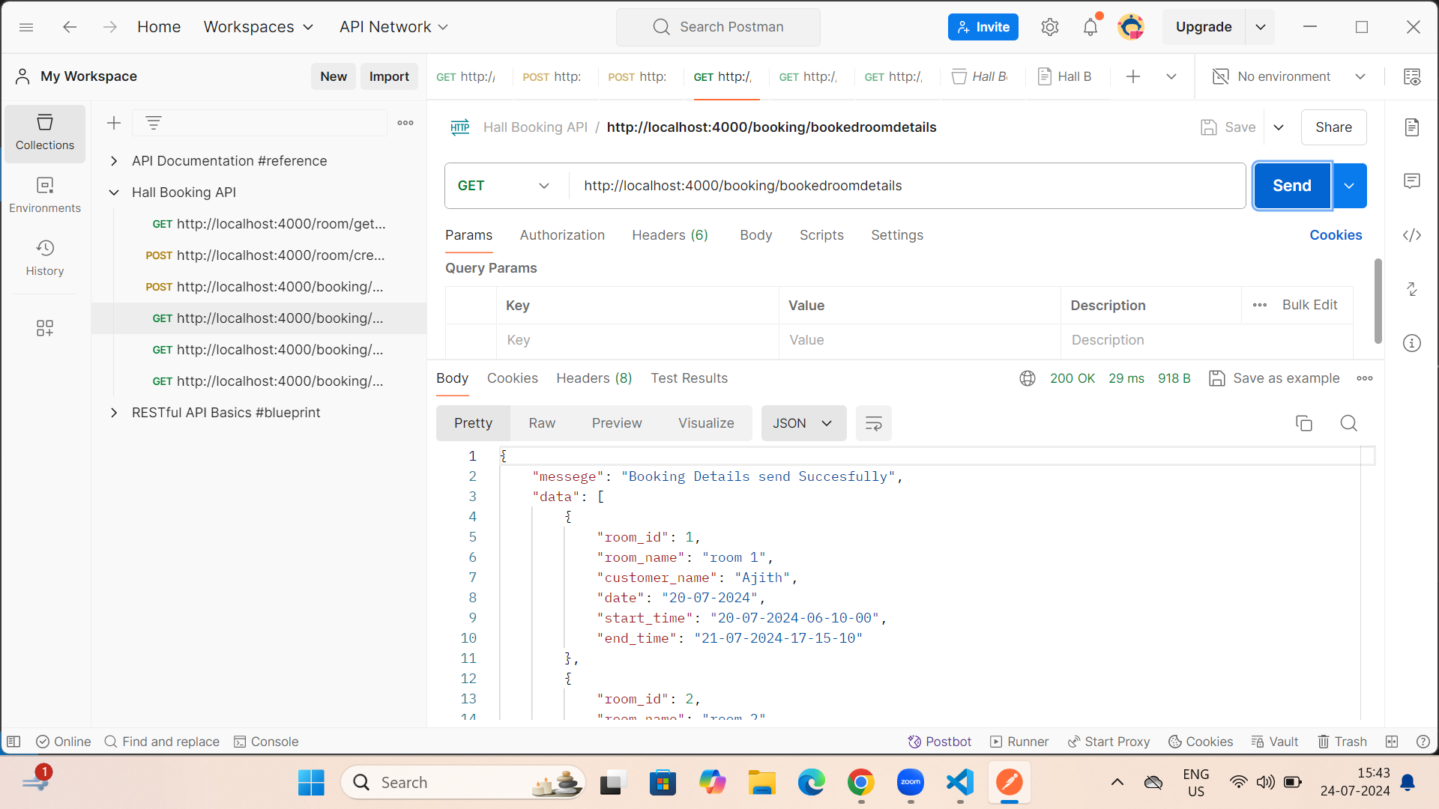

**4.Customer Details**

<http://localhost:4000/booking/getcustomerdata>

**Method: GET**

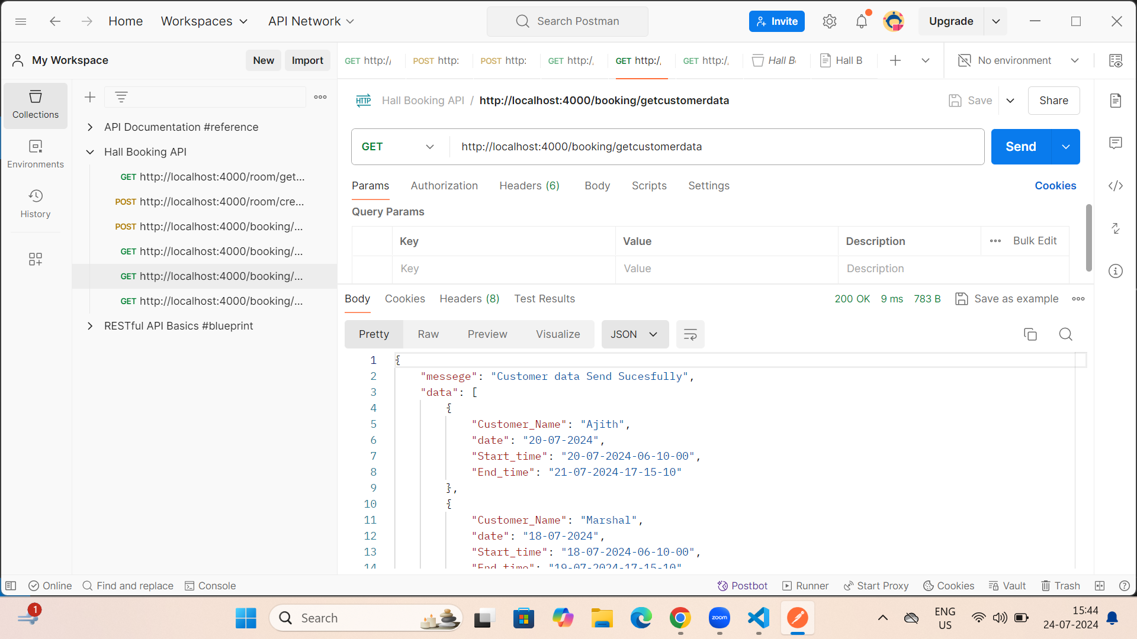

**5.How many times Customer Booked Room with Details**

<http://localhost:4000/booking/getcount/12>

**Method: GET**

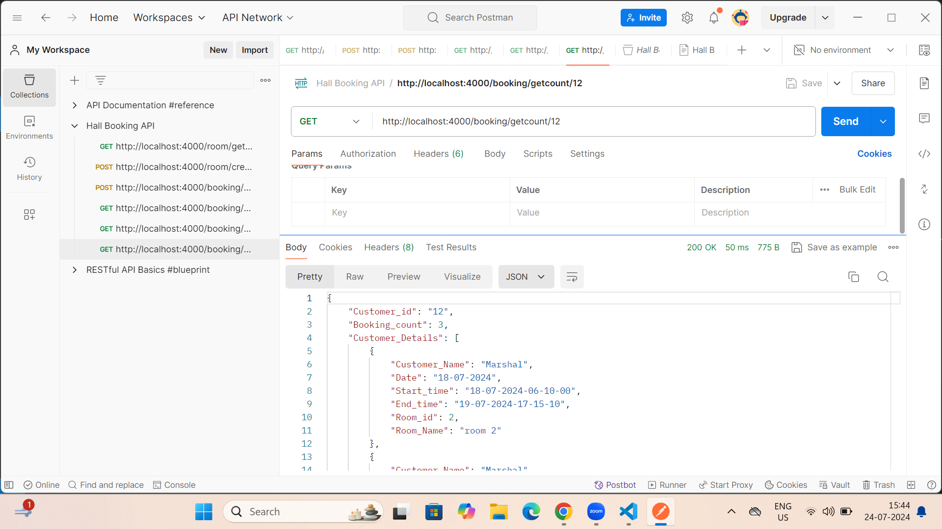

**6.Get Rooms Details**

<http://localhost:4000/room/getrooms>

**Method: GET**

